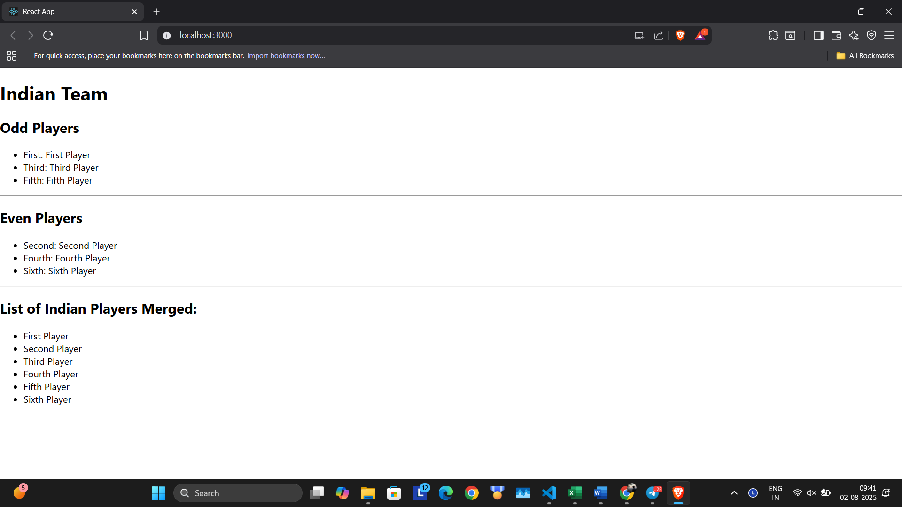

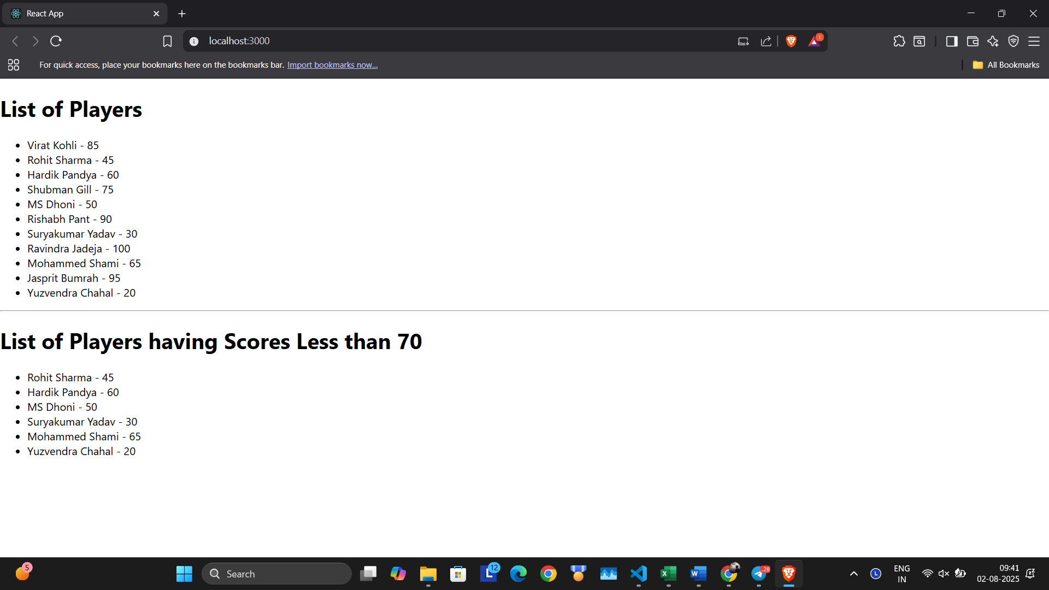

import React from 'react';

import ListOfPlayers from './components/ListOfPlayers';

import ScoreBelow70 from './components/ScoreBelow70';

import { OddPlayers, EvenPlayers, IndianPlayersList } from './components/IndianPlayers';

import ListOfIndianPlayers from './components/ListOfIndianPlayers';

const App = () => {

  const flag = true;  //change to true

  const players = [

    { name: 'Virat Kohli', score: 85 },

    { name: 'Rohit Sharma', score: 45 },

    { name: 'Hardik Pandya', score: 60 },

    { name: 'Shubman Gill', score: 75 },

    { name: 'MS Dhoni', score: 50 },

    { name: 'Rishabh Pant', score: 90 },

    { name: 'Suryakumar Yadav', score: 30 },

    { name: 'Ravindra Jadeja', score: 100 },

    { name: 'Mohammed Shami', score: 65 },

    { name: 'Jasprit Bumrah', score: 95 },

    { name: 'Yuzvendra Chahal', score: 20 }

  ];

  const IndianTeam = IndianPlayersList;

  if (flag === true) {

    return (

      <div>

        <h1>List of Players</h1>

        <ListOfPlayers players={players} />

        <hr />

        <h1>List of Players having Scores Less than 70</h1>

        <ScoreBelow70 players={players} />

      </div>

    );

  } else {

    return (

      <div>

        <div>

          <h1>Indian Team</h1>

          <h2>Odd Players</h2>

          <OddPlayers players={IndianTeam} />

          <hr />

          <h2>Even Players</h2>

          <EvenPlayers players={IndianTeam} />

        </div>

        <hr />

        <div>

          <h2>List of Indian Players Merged:</h2>

          <ListOfIndianPlayers IndianPlayers={IndianTeam} />

        </div>

      </div>

    );

  }

};

export default App;