PART 4: Car Income Monitoring System:

Using vertabelo physical data model has been created.

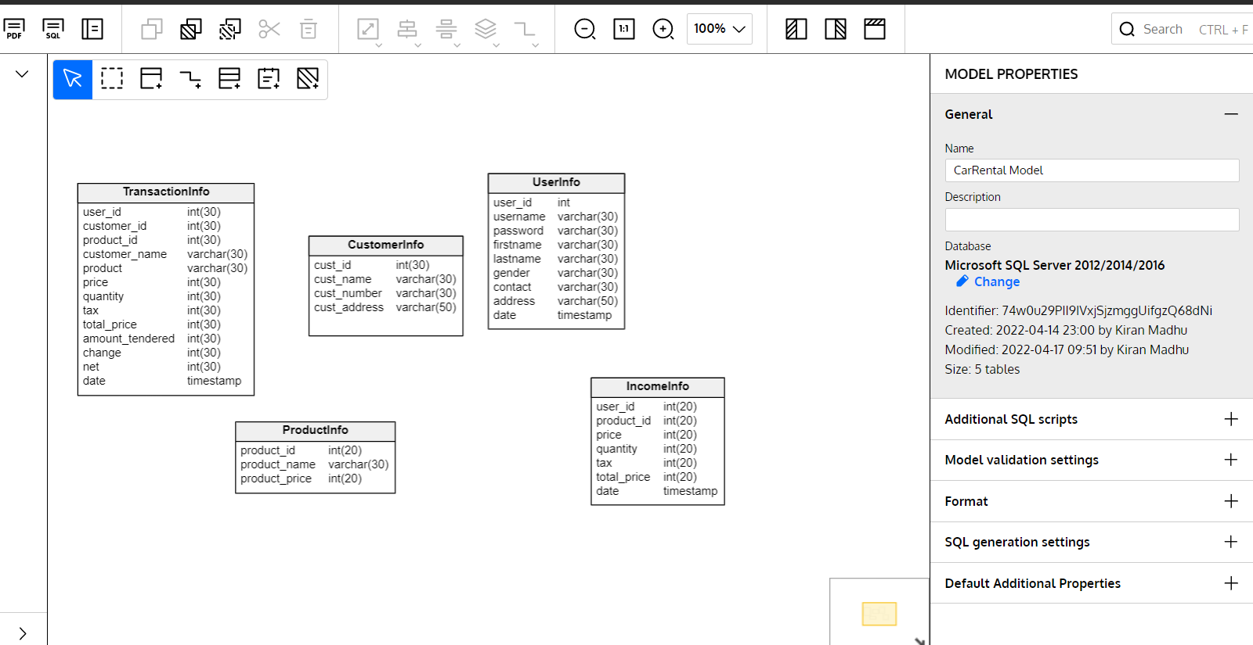

Sql script generated for vertabelo.

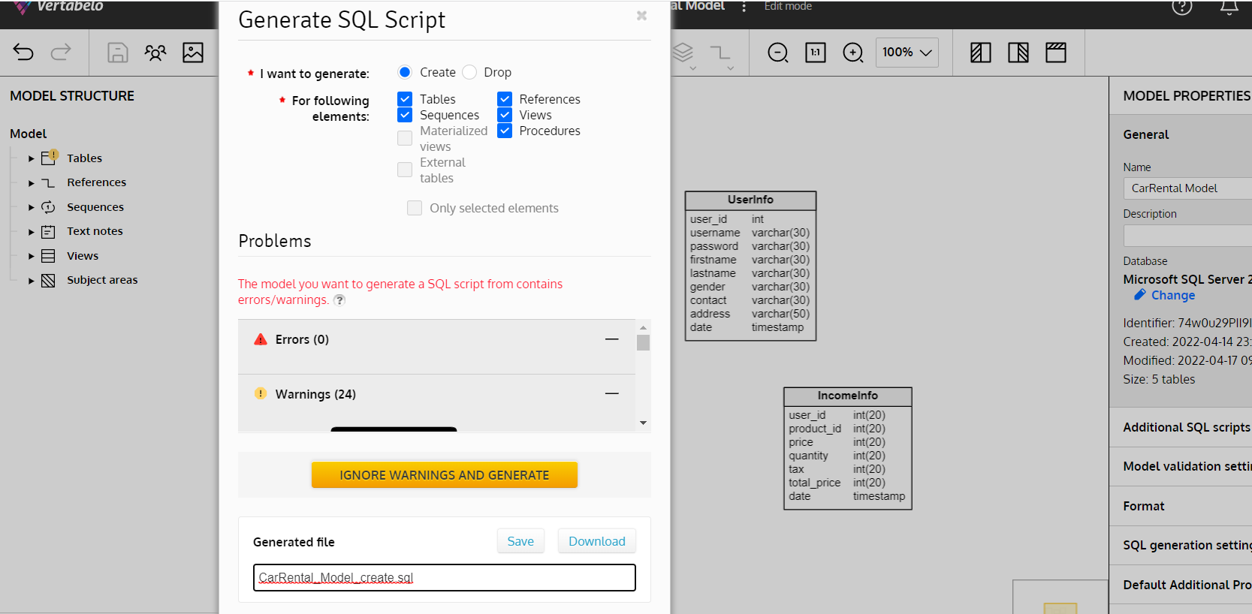

Generated sql file from vertabelo is loaded on mssql and executing all the create queries.

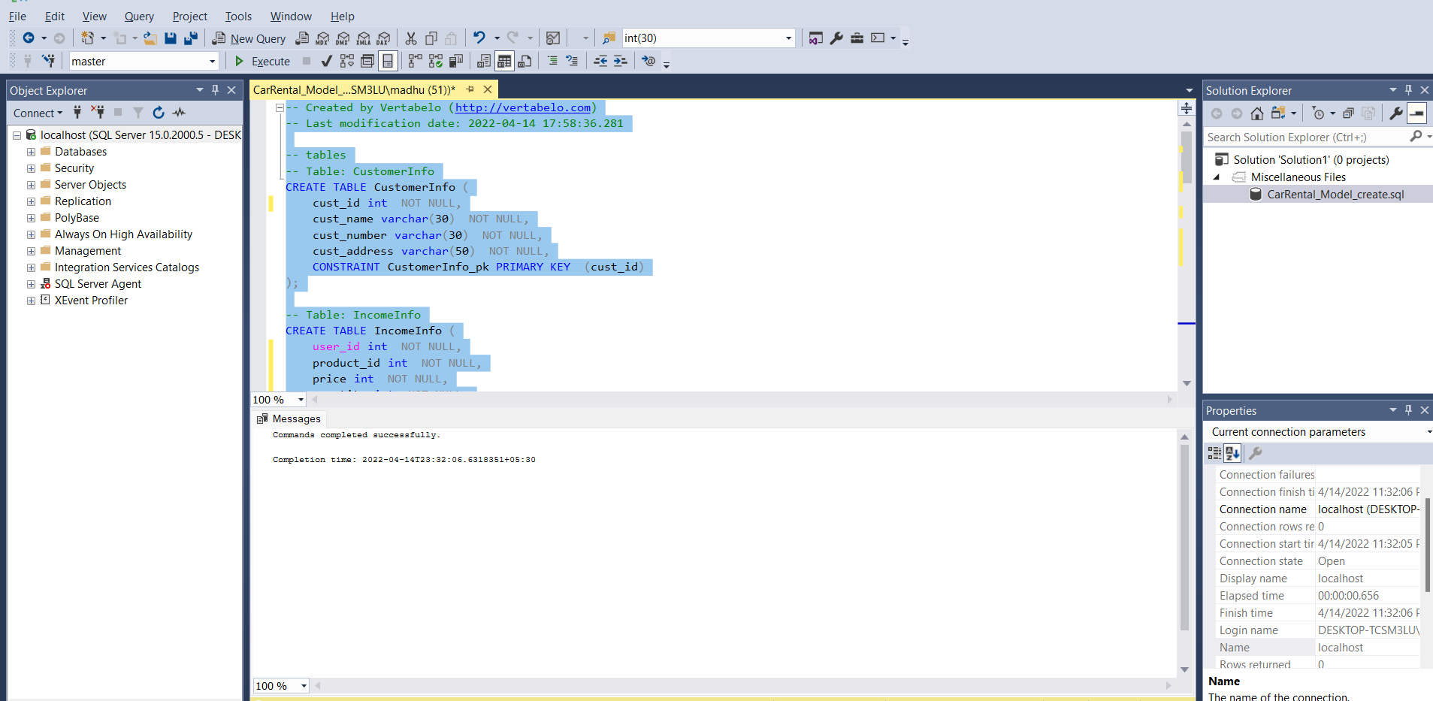

Inserting the customer info data.

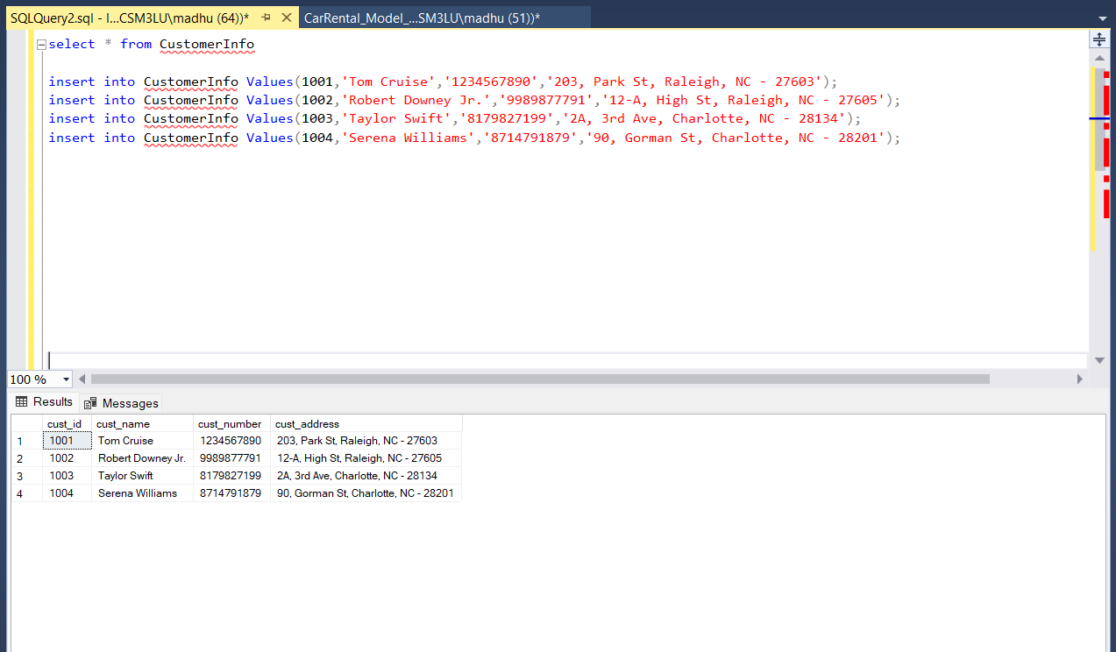

Collating the data and inserting the product info data in productInfo table and retrieving the data by using the select command.

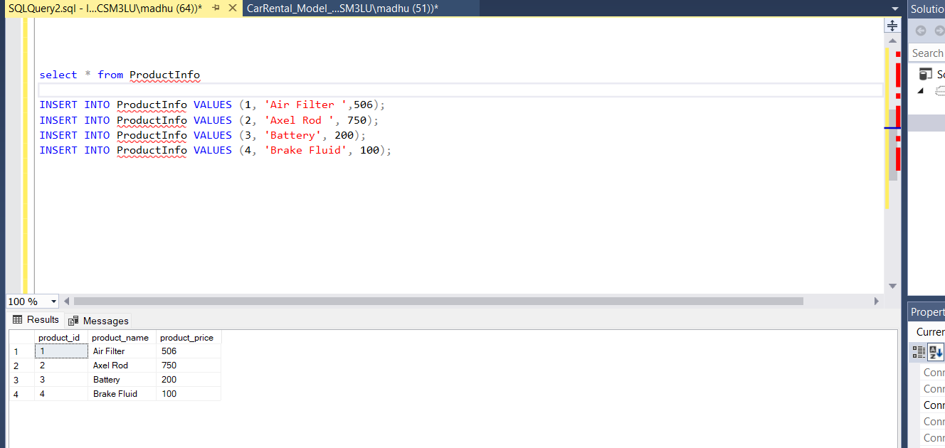

Now we are trying to insert the data of transaction information of which product has been purchased by whom and their details with all the prices and income we have received by selling those products into transactionInfo table.

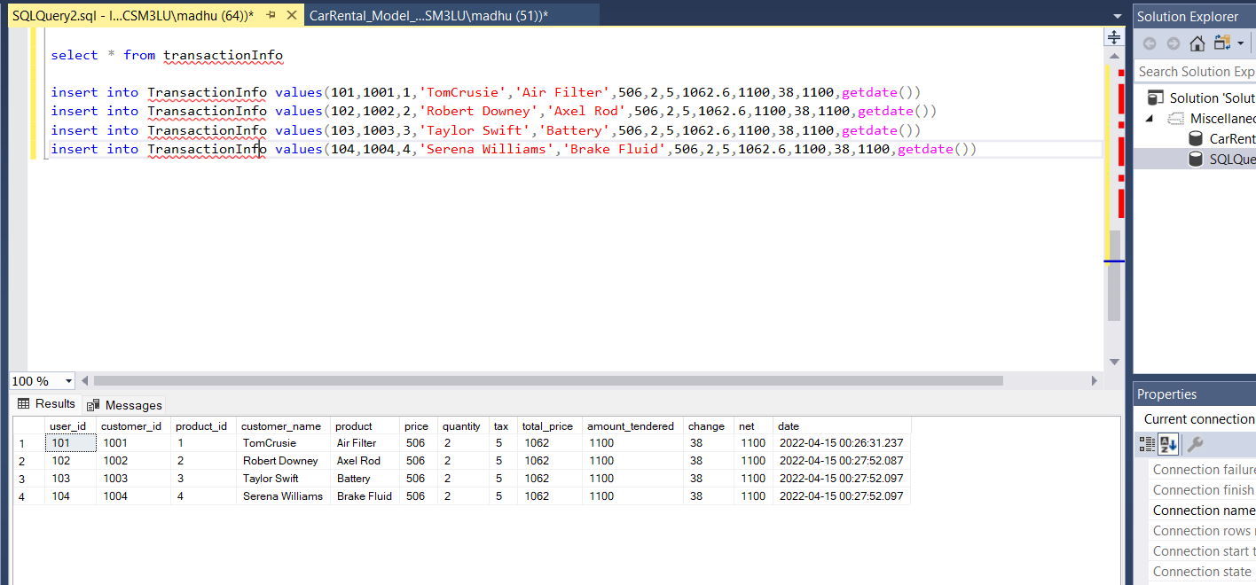

Two Insert statements:

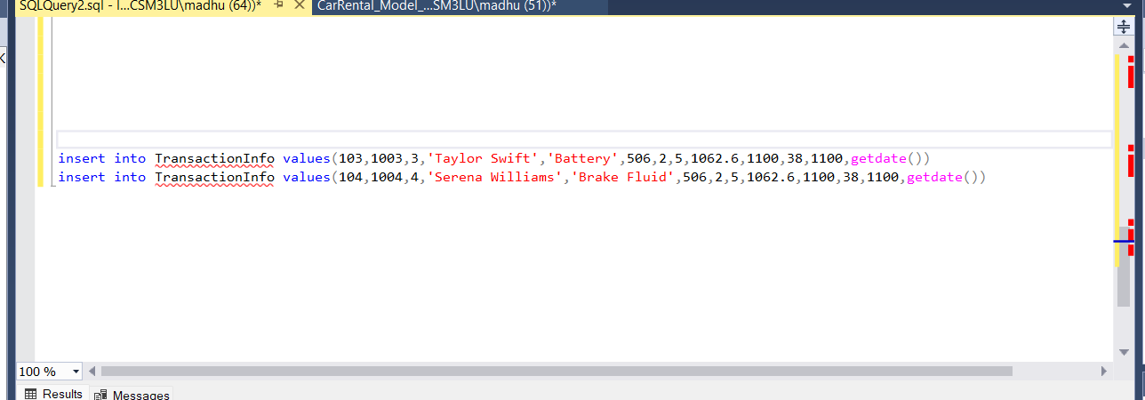

Two update statements and the updated data in select query.

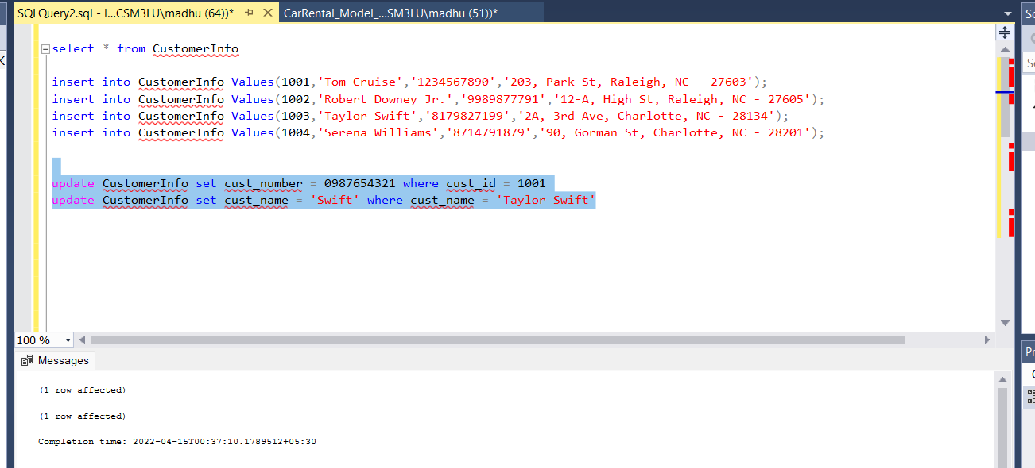

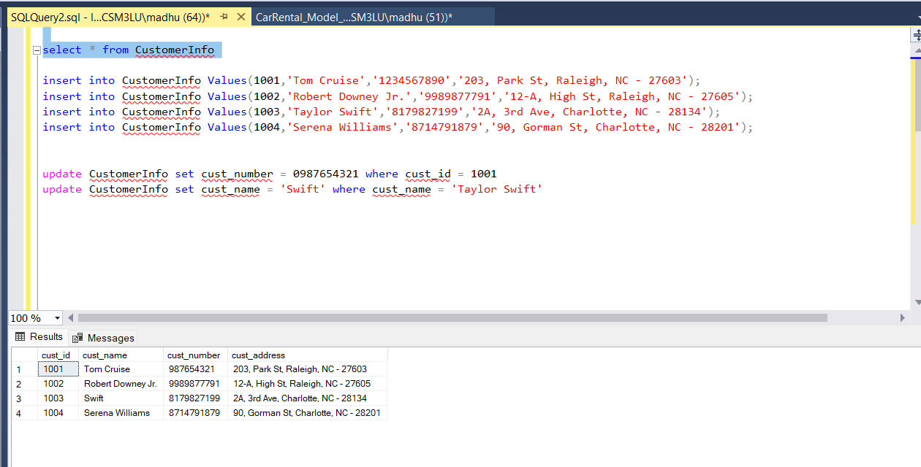

Delete Statement:

Deleting 1 record from the TransactionInfo table.

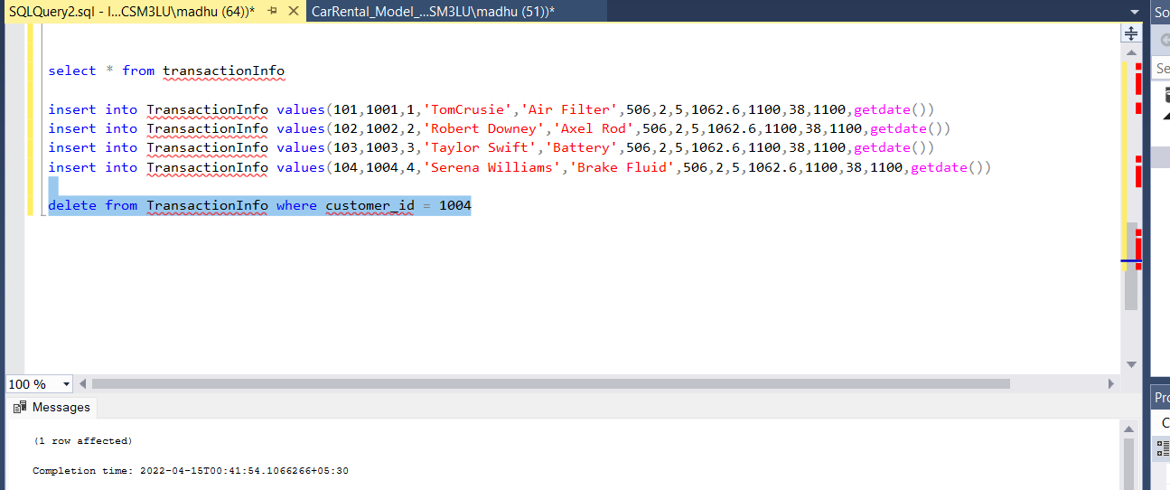

Select statement:

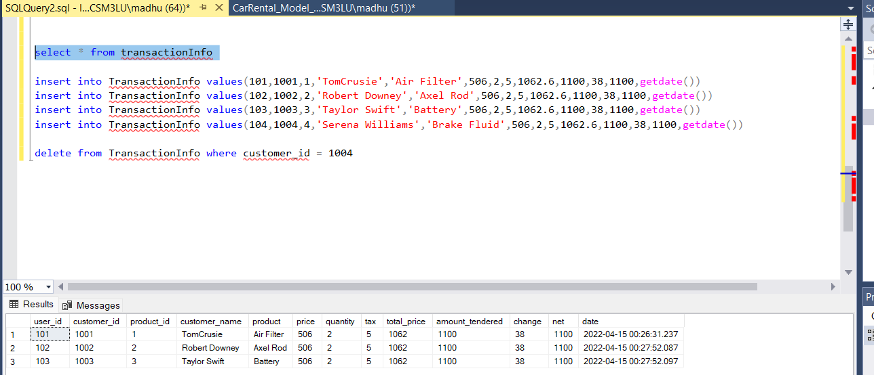

Join statements:

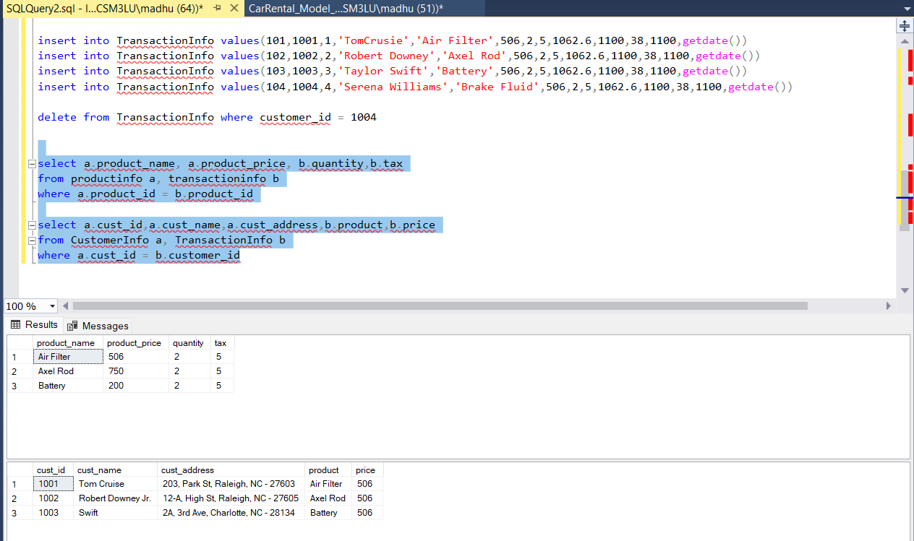

select a.product_name, a.product_price, b.quantity,b.tax

from productinfo a, transactioninfo b

where a.product_id = b.product_id

select a.cust_id,a.cust_name,a.cust_address,b.product,b.price

from CustomerInfo a, TransactionInfo b

where a.cust_id = b.customer_id

Summary Statements:

select a.cust_name,a.cust_address,b.product_name,c.price,c.quantity

from CustomerInfo a, ProductInfo b, TransactionInfo c

where a.cust_id = c.customer_id and b.product_id = c.product_id and a.cust_id = 1001

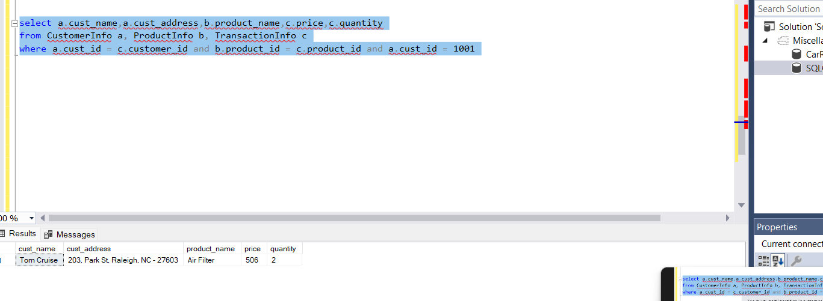

select a.cust_name,a.cust_address,b.product_name,c.price,c.quantity

from CustomerInfo a, ProductInfo b, TransactionInfo c

where a.cust_id = c.customer_id and b.product_id = c.product_id and a.cust_id = 1002

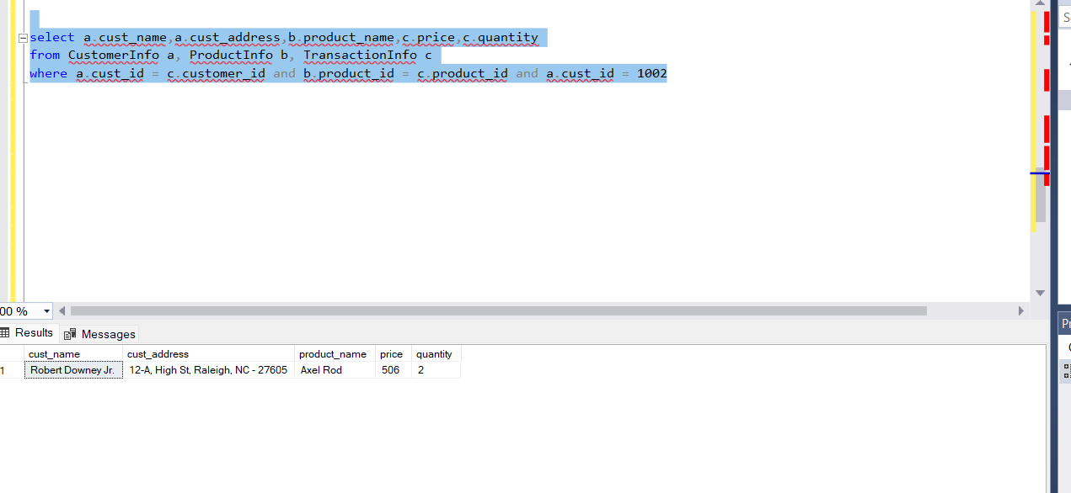

select a.cust_name,a.cust_address,b.product_name,c.price,c.quantity

from CustomerInfo a, ProductInfo b, TransactionInfo c

where a.cust_id = c.customer_id and b.product_id = c.product_id and a.cust_id = 1003

