**DATABASE SYSTEMS**

**PART 1**

**Car sales Income monitoring system:**

I have created the business that can track the income monitoring for car sales company located in United states. The comparison is done by comparing the income from three states such as Texas, New York and Illinois. For this income monitoring I have to create a database to store the data of three states income on different models (Mercedes, Bmw and Toyota). The data can be from the three states car companies where I will collect the data on each model of the car for each month and store it in the database. This process is done every month to check the income of the each state. I will compare the data that is retrieved from each state on their incomes for each model of the car sold. The value of the data is more efficient here as if some data is not relevant then there can be chance of loss to the company in terms of the income.

For this project I can collect the data or manually enter the data. I will collect the data such as number of cars sold for each model for each state then I will enter the data manually to be stored. I will use Mysql , Java and MangodB to build the model.

As a owner it is my responsibility to check on each states income accurately so as to keep track on how much the income is generated in the company year or month wise. My sales team will he responsible to monitor the income that is generated on each car model when sold.

**PART 2**

Car sales income monitoring system:

For my business, I will have the following entities:

User info- describes the ID numbers, Usernames, Passwords, First name, last name, gender, contact, address and date

Transaction info- Describes User ID,Customer ID, Product ID, Customer name etc

Customer info- ID, name, Contact and address of the customer

Income info- Describes the User ID, product ID, price , Quantity, Tax etc

Product info- Describes name of the product and price of the product .

USERS_TABLE

|  |  |  |  |
| --- | --- | --- | --- |
| FIELD NAME | DESCRIPTION | TYPE | LENGTH |
| USER_ID | Id number of user | Int | 30 |
| USERNAME | Sure name of the user | Varchar | 50 |
| PASSWORD | Password | Varchar | 50 |
| FIRSTNAME | Name of the user | Varchar | 50 |
| LAST_NAME | Sure name of the user | Varchar | 50 |
| GENDER | Gender of the user | Varchar | 30 |
| CONTACT | Contact number | Varchar | 50 |
| ADDRESS | Address of the user | Varchar | 50 |
| DATE | Date | Timestamp |  |

TABLE 2 TRANSACTION_TABLE

|  |  |  |  |
| --- | --- | --- | --- |
| FIELD NAME | DESCRIPTION | TYPE | LENGTH |
| USER_ID | Id number of the user | Int | 30 |
| COSTUMER_ID | Id number of the costumer | Int | 30 |
| PRODUCT_ID | Id number of the product | Int | 30 |
| COSTUMER NAME | Name of the costumer | Varchar | 30 |
| PRODUCT | Name of the product | Varchar | 30 |
| PRICE | Price | Int | 11 |
| QUANTITY | Quantity | Int | 11 |
| TAX | Tax | Int | 11 |
| TOTAL_PRICE | Total price | Int | 11 |
| AMOUNT_TENDERED | Cash on hand | Int | 11 |
| CHANGE | Change | Int | 11 |
| NET | Net | Int | 11 |
| DATE | Date | Timestamp |  |

TABLE 3 CUSTOMER_TABLE

|  |  |  |  |
| --- | --- | --- | --- |
| FIELD NAME | DESCRIPTION | TYPE | LENGTH |
| CUST_ID | Id number of the costumer | Int | 30 |
| CUST_NAME | Name of the costumer | Varchar | 50 |
| CUST_NUMBER | Contact number of the costumer | Varchar | 50 |
| CUST_ADDRESS | Address of the costumer | Varchar | 50 |

TABLE 4 INCOME_TABLE

|  |  |  |  |
| --- | --- | --- | --- |
| FIELD NAME | DESCRIPTION | TYPE | LENGTH |
| USER_ID | Users id | Int | 11 |
| PRODUCT_ID | Products id | Int | 11 |
| PRICE | Price | Int | 11 |
| QUANTITY | Quantity | Int | 11 |
| TAX | Tax | Int | 11 |
| TOTAL_PRICE | Total price | Int | 11 |
| DATE | Date | Timestamp |  |

TABLE 5 PRODUCT_TABLE

|  |  |  |  |
| --- | --- | --- | --- |
| FIELD NAME | DESCRIPTION | TYPE | LENGTH |
| PRODUCT_ID | Products id | Int | 11 |
| PRODUCT_NAME | Name of the product | Varchar | 50 |
| PRODUCT_PRICE | Price of the product | Int | 11 |

PART 3

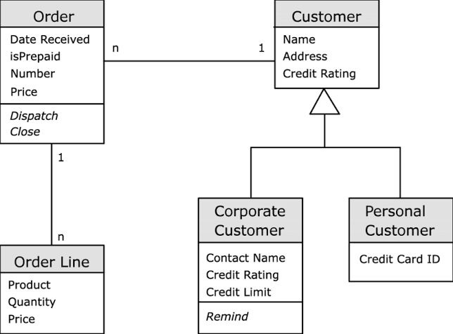

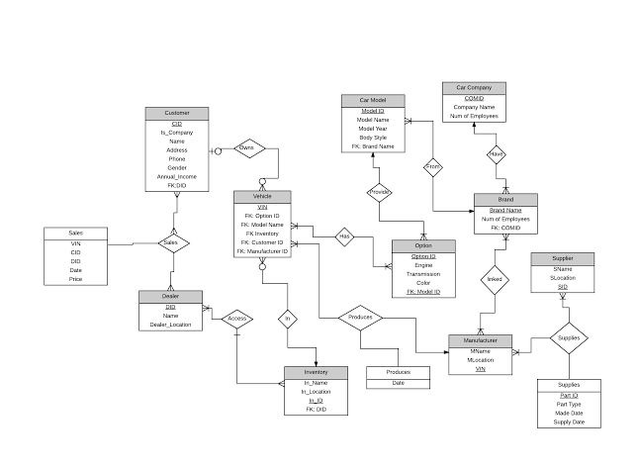

PART 4

Car Income Monitoring System:

Using vertabelo physical data model has been created.

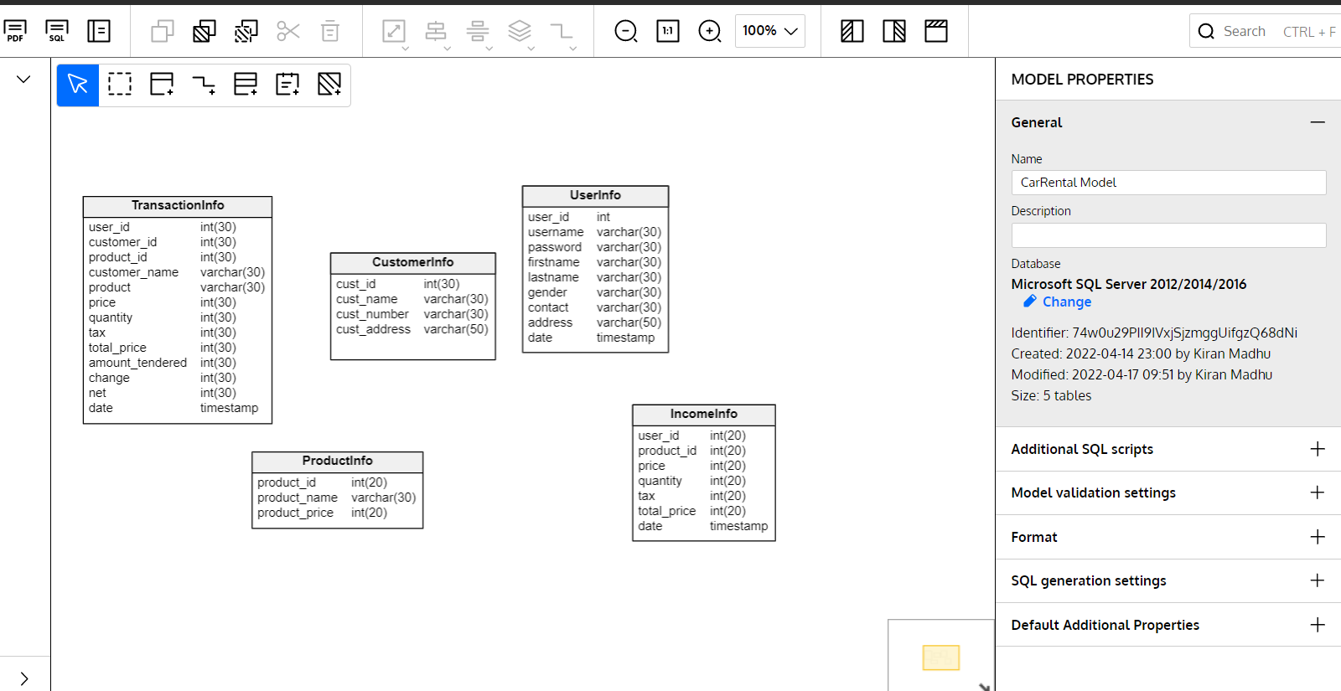

Sql script generated for vertabelo.

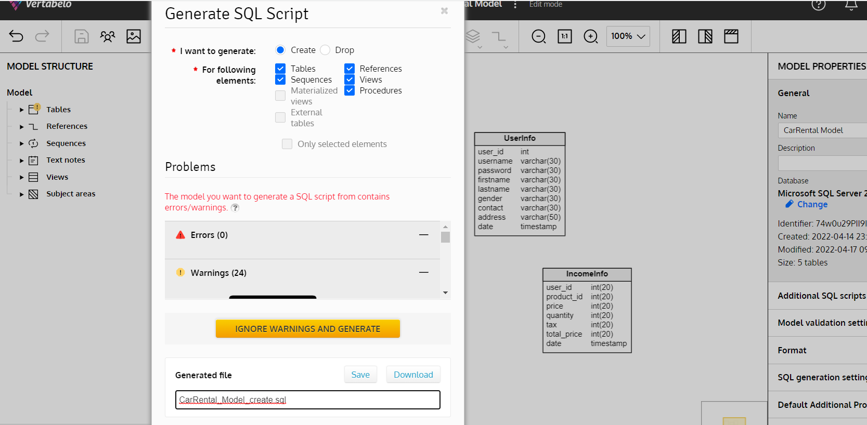

Generated sql file from vertabelo is loaded on mssql and executing all the create queries.

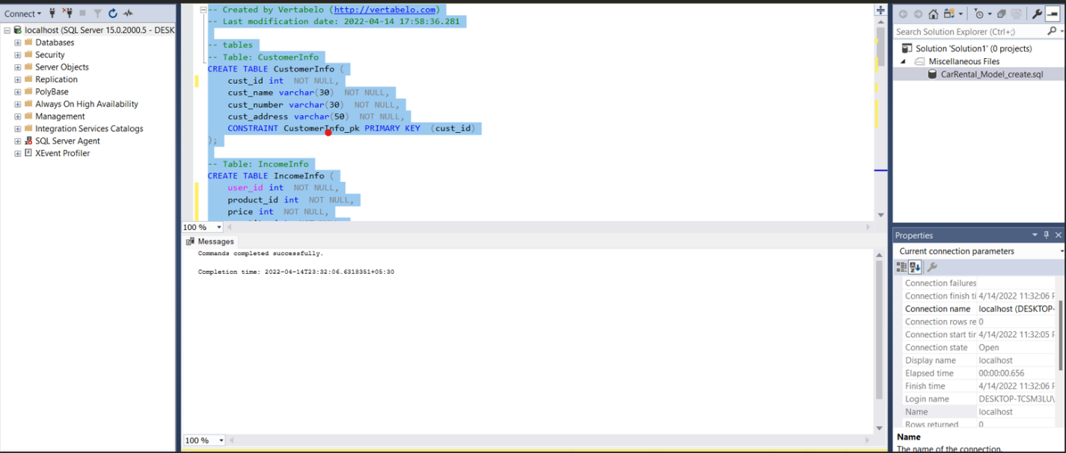

Inserting the customer info data.

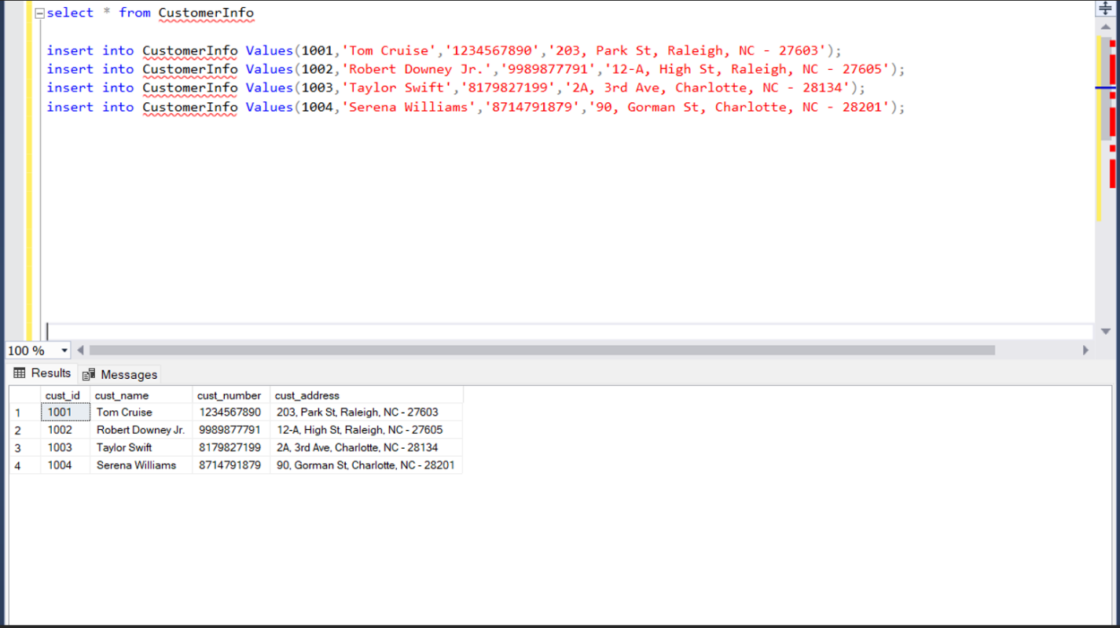

Collating the data and inserting the product info data in productInfo table and retrieving the data by using the select command.

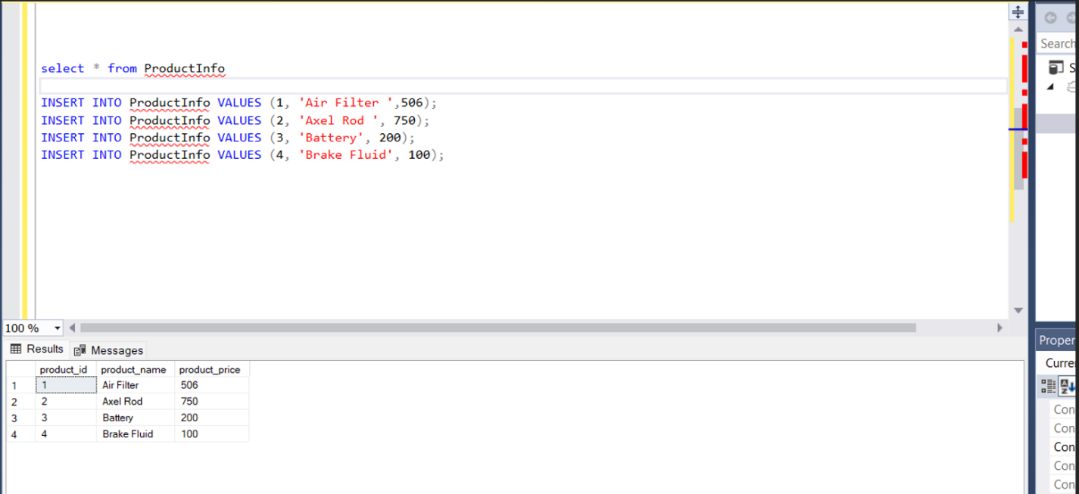

Now we are trying to insert the data of transaction information of which product has been purchased by whom and their details with all the prices and income we have received by selling those products into transactionInfo table.

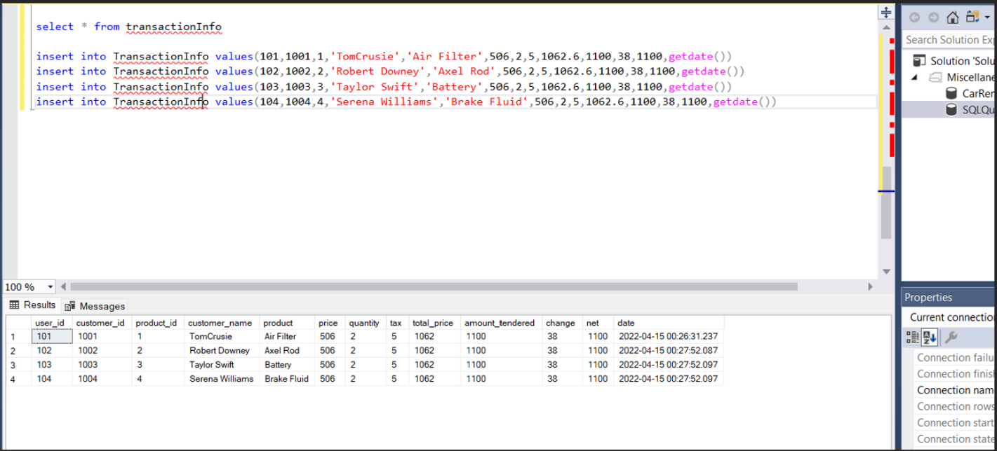

Two Insert statements:

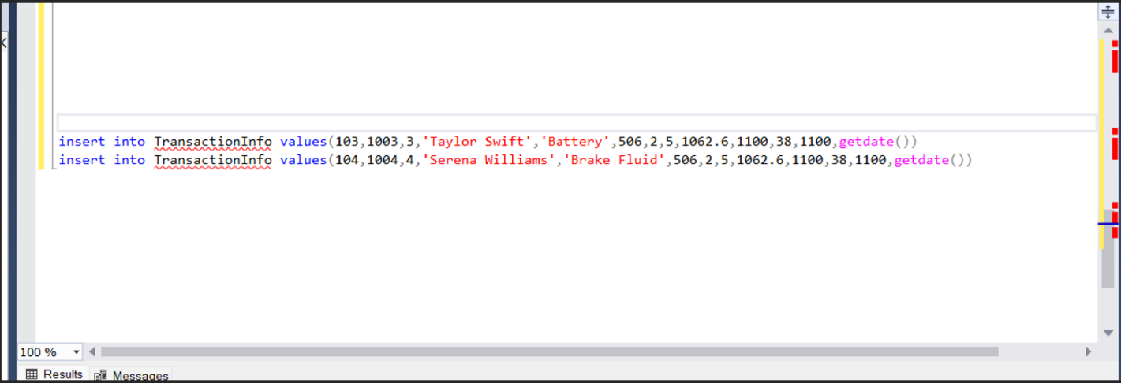

Two update statements and the updated data in select query.

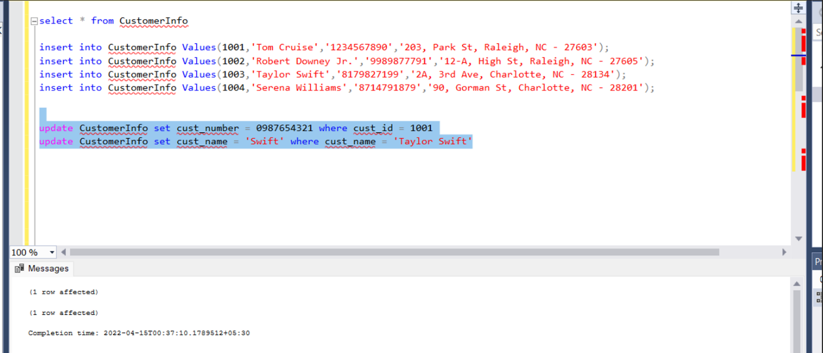

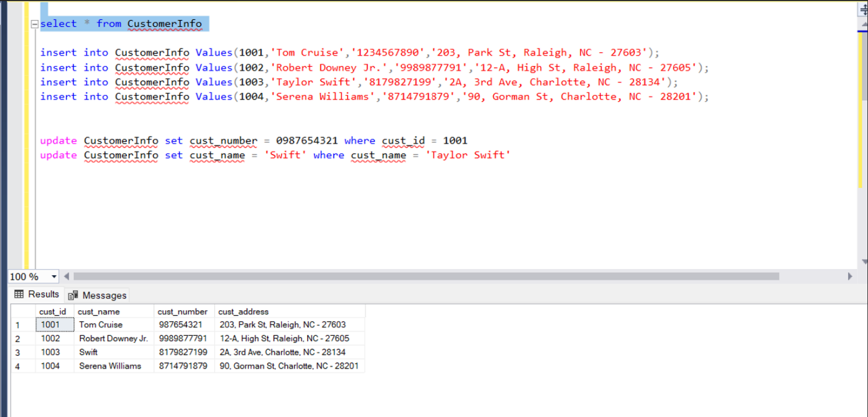

Delete Statement:

Deleting 1 record from the TransactionInfo table.

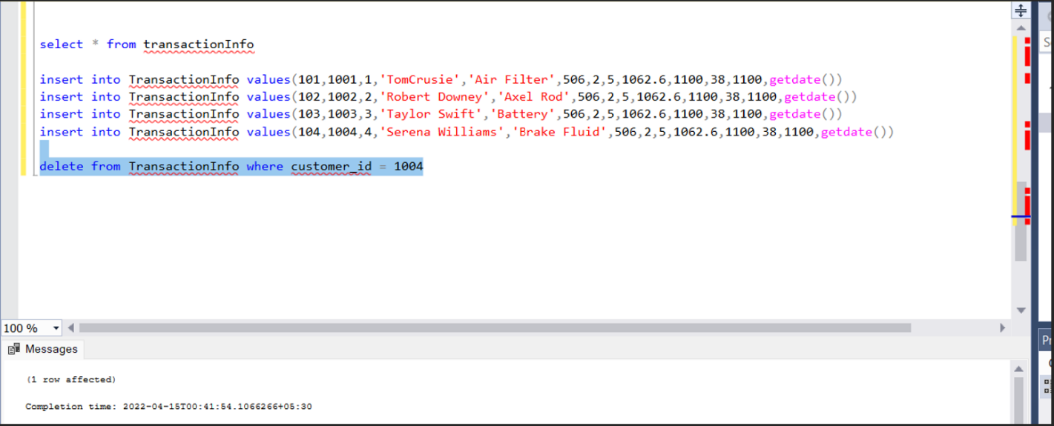

Select statement:

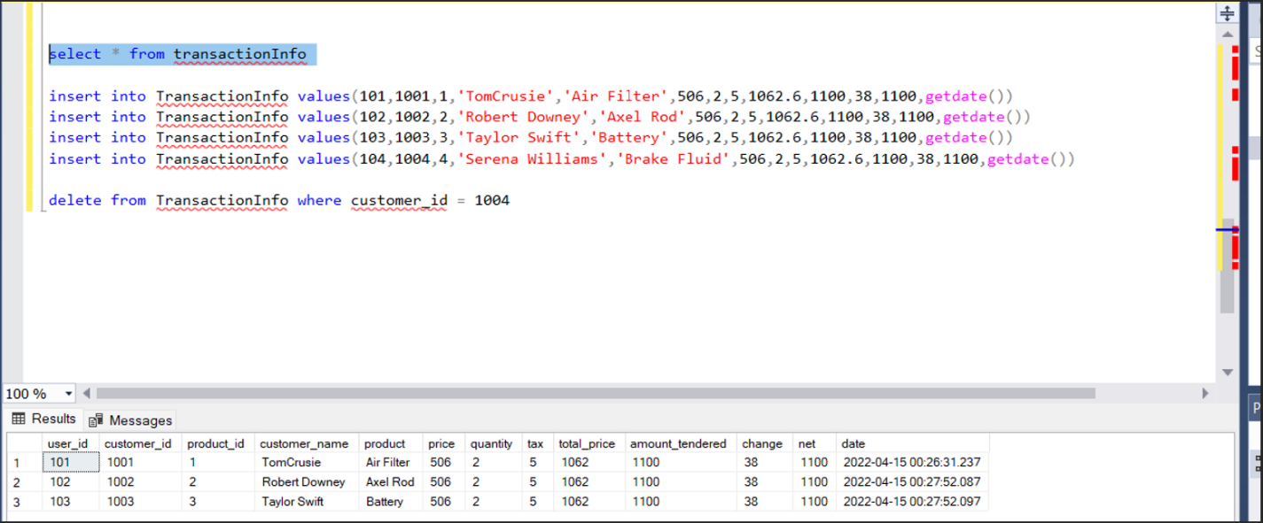

Join statements:

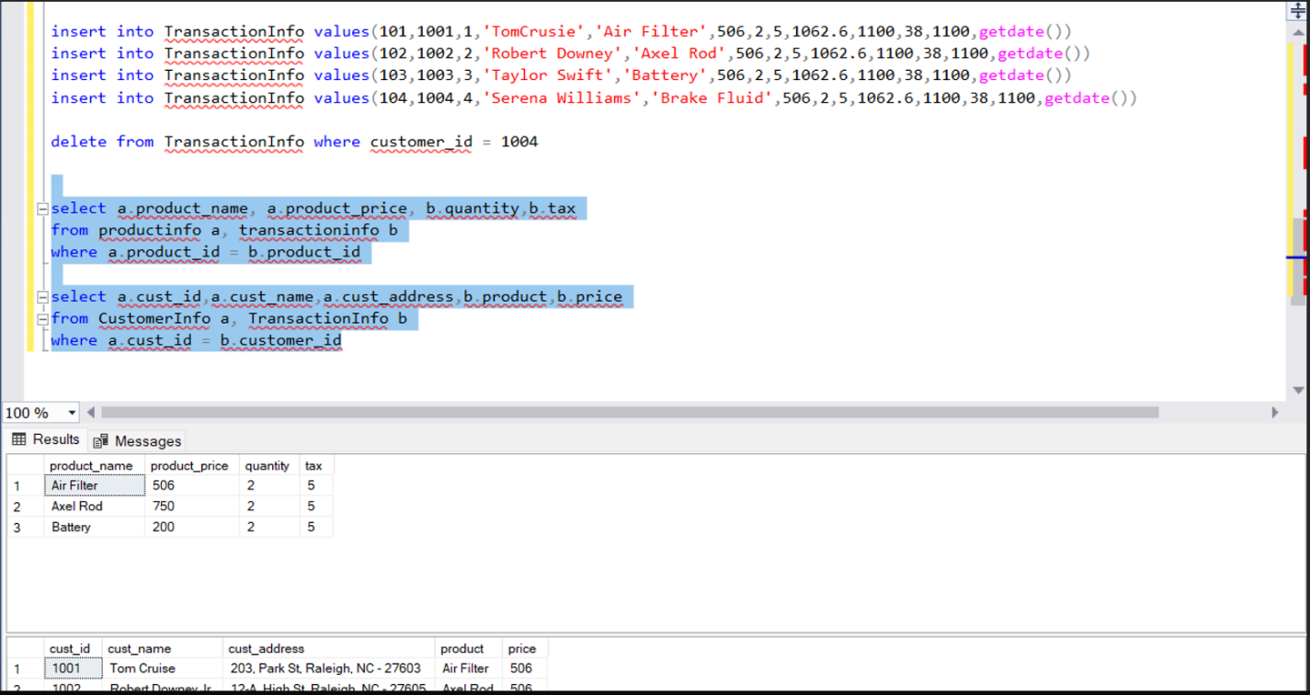

select a.product_name, a.product_price, b.quantity,b.tax

from productinfo a, transactioninfo b

where a.product_id = b.product_id

select a.cust_id,a.cust_name,a.cust_address,b.product,b.price

from CustomerInfo a, TransactionInfo b

where a.cust_id = b.customer_id

Summary Statements:

select a.cust_name,a.cust_address,b.product_name,c.price,c.quantity

from CustomerInfo a, ProductInfo b, TransactionInfo c

where a.cust_id = c.customer_id and b.product_id = c.product_id and a.cust_id = 1001

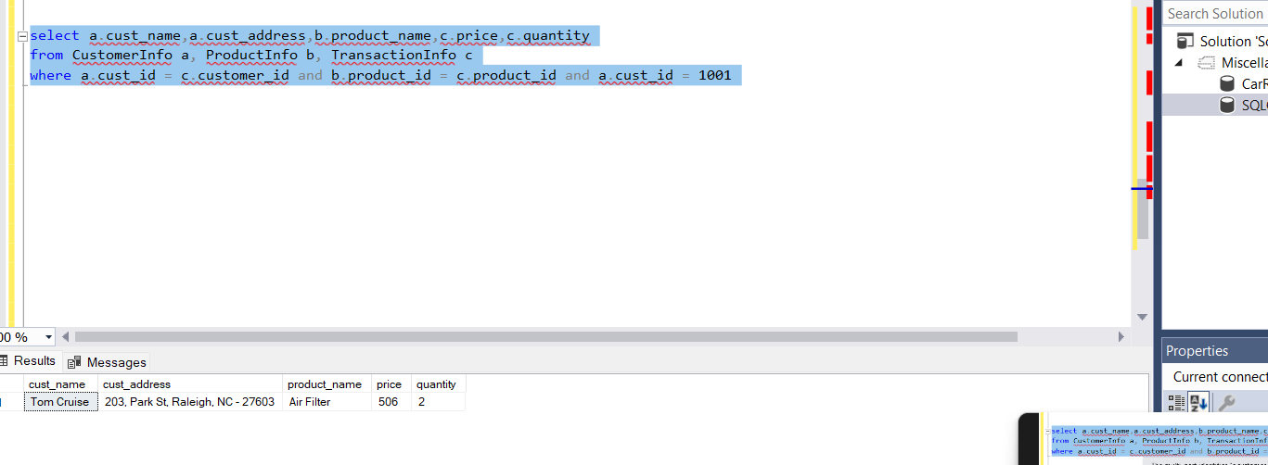

select a.cust_name,a.cust_address,b.product_name,c.price,c.quantity

from CustomerInfo a, ProductInfo b, TransactionInfo c

where a.cust_id = c.customer_id and b.product_id = c.product_id and a.cust_id = 1002

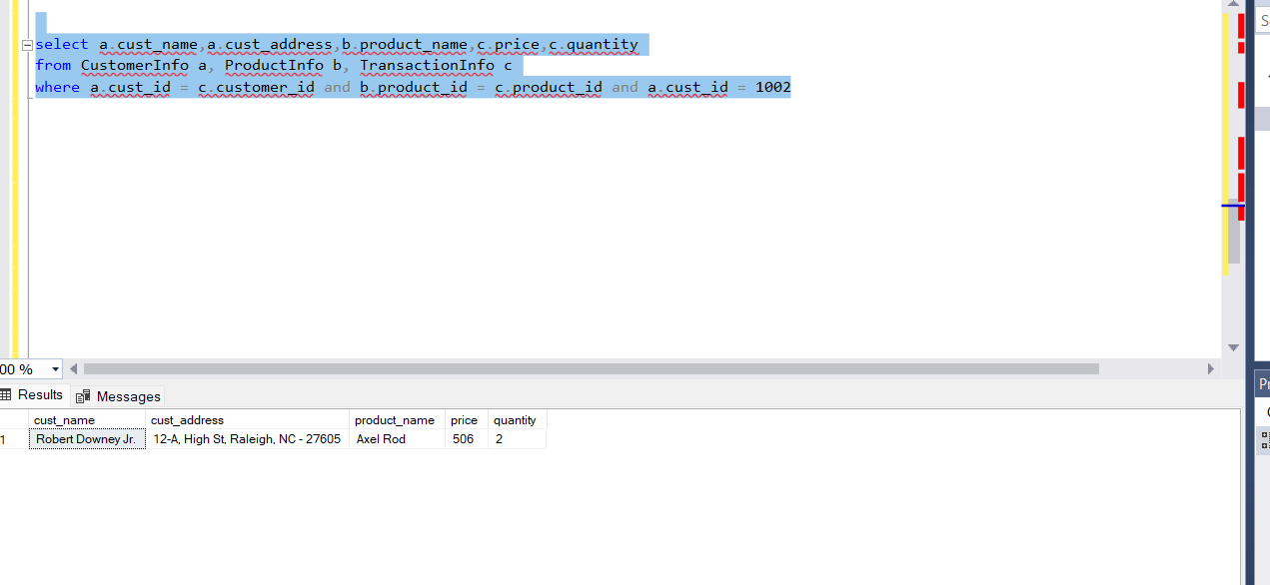

select a.cust_name,a.cust_address,b.product_name,c.price,c.quantity

from CustomerInfo a, ProductInfo b, TransactionInfo c

where a.cust_id = c.customer_id and b.product_id = c.product_id and a.cust_id = 1003

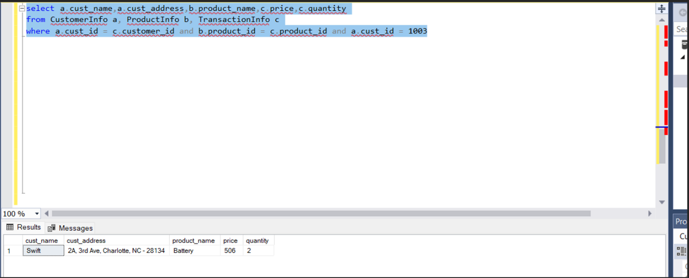

Github Link :-

https://github.com/Rohith191/FinalProjectDatabaseSystems