Cisco Packet Tracer Experiment
Screenshots

1. Network Topology
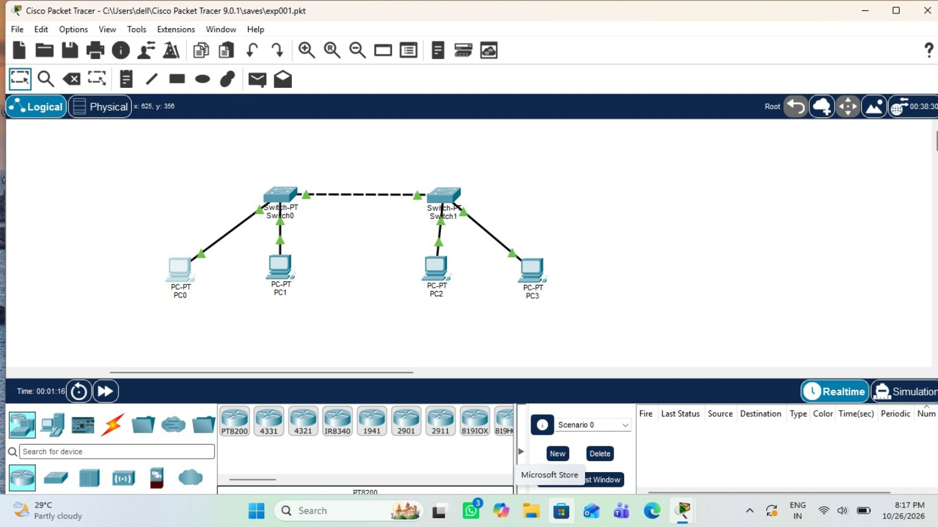

2. Ping Test Result
