Network Setup Using Hub in Cisco Packet Tracer

Network Topology
The network consists of one Hub (Hub-PT, Hub0) connected to four PCs (PC0, PC1, PC2 and PC3) using a star topology.
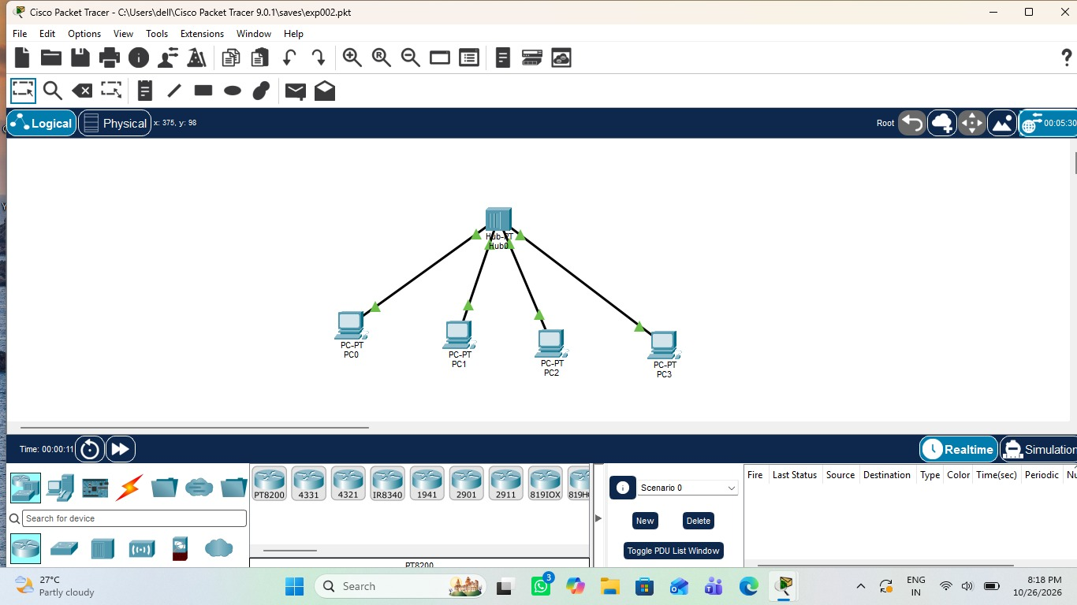
Figure 1: Star topology with Hub0 and four PCs in Cisco Packet Tracer

Connectivity Test (Ping)
From the Command Prompt of PC0, the command "ping 192.168.1.2" was executed to test connectivity. All 4 packets were sent and received with 0% loss, with a reply time of less than 1 ms and TTL of 128.
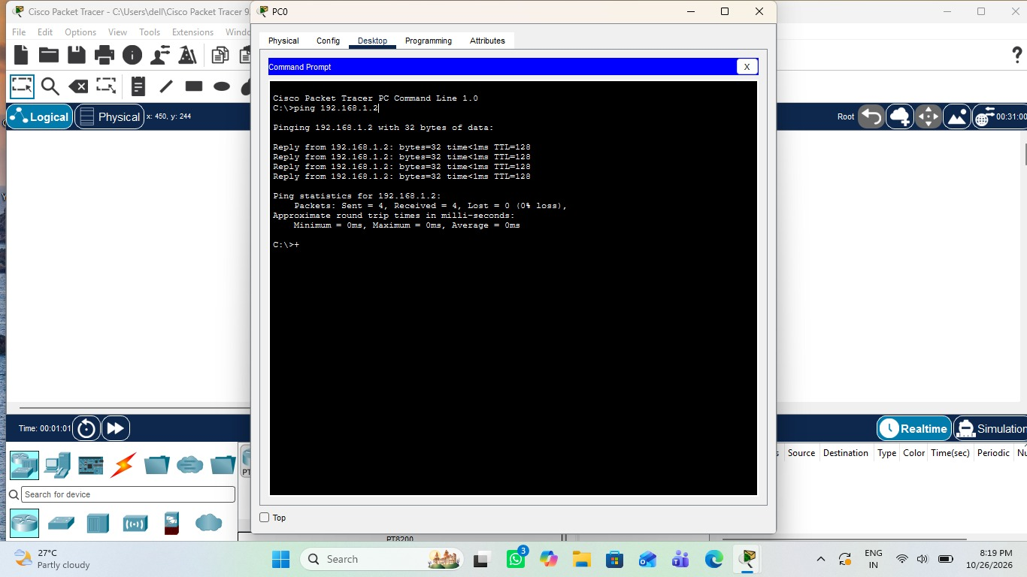
Figure 2: Successful ping from PC0 to 192.168.1.2

Result
The ping was successful, confirming that the PCs are properly connected through the hub and can communicate with each other.

