Network Setup Using a Switch in Cisco Packet Tracer

Network Topology
The network consists of one Cisco 2960-24TT switch (Switch0) connected to four PCs (PC0, PC1, PC2 and PC3) in a star topology.
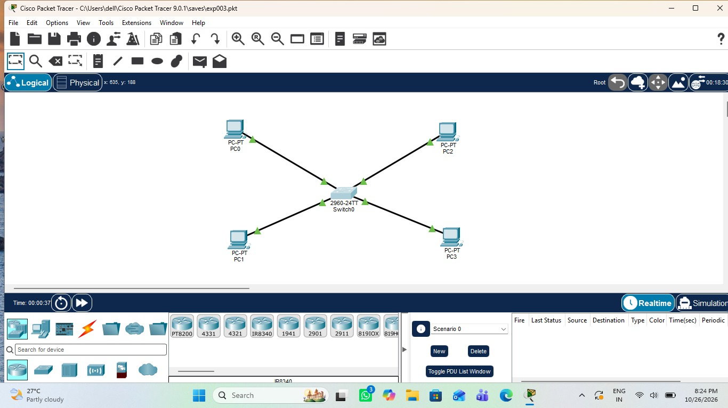
Figure 1: Star topology with Switch0 and four PCs

Connectivity Test (Ping)
From the Command Prompt of PC0, the command "ping 192.168.1.2" was executed. The first attempt, typed without a space ("ping192.168.1.2"), returned "Invalid Command". The corrected command sent 4 packets, and all 4 requests timed out (100% loss).
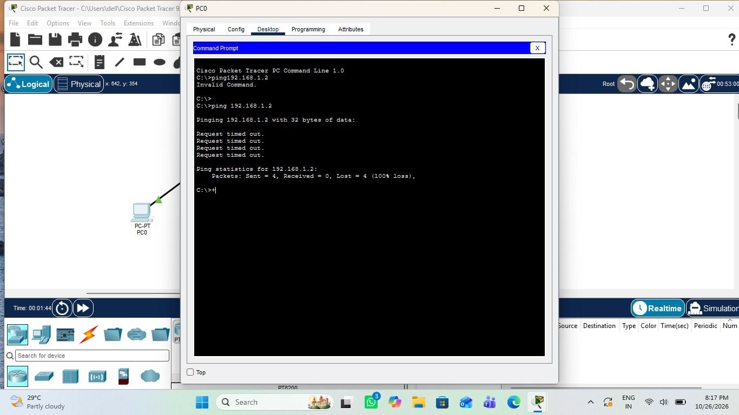
Figure 2: Ping from PC0 to 192.168.1.2 showing request timed out

Result
In this capture the ping did not succeed (4 sent, 0 received, 100% loss), so connectivity between PC0 and 192.168.1.2 was not confirmed.

