Connecting Two Switches in Cisco Packet Tracer

Network Topology
The network consists of two Cisco 2960-24TT switches (Switch0 and Switch1) connected to each other through a dashed link. PC0 and PC1 are connected to Switch0, and PC2 and PC3 are connected to Switch1.
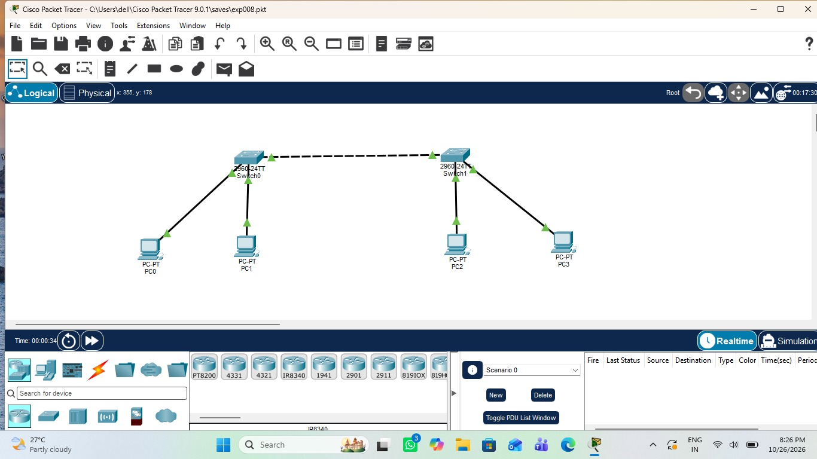
Figure 1: Topology with two switches and four PCs

Switch0 CLI Output
The CLI of Switch0 shows the switch hardware details and IOS version, followed by messages confirming that FastEthernet0/1, 0/2 and 0/3 changed state to up.
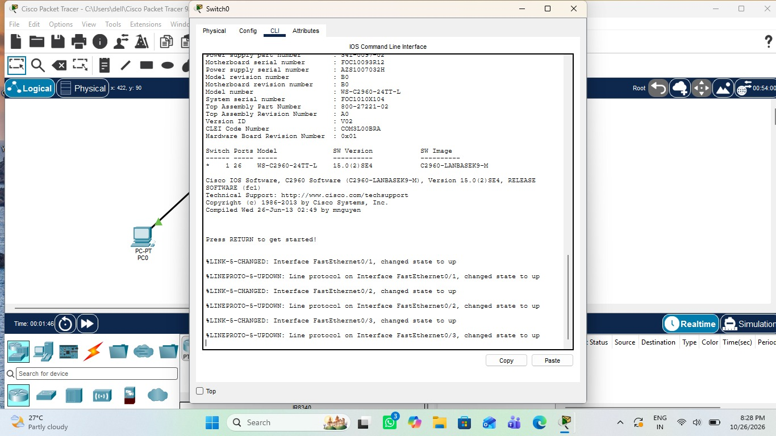
Figure 2: Switch0 IOS command line interface

Switch1 CLI Output
The CLI of Switch1 shows the same hardware details, followed by messages confirming that FastEthernet0/24, 0/1 and 0/2 changed state to up.
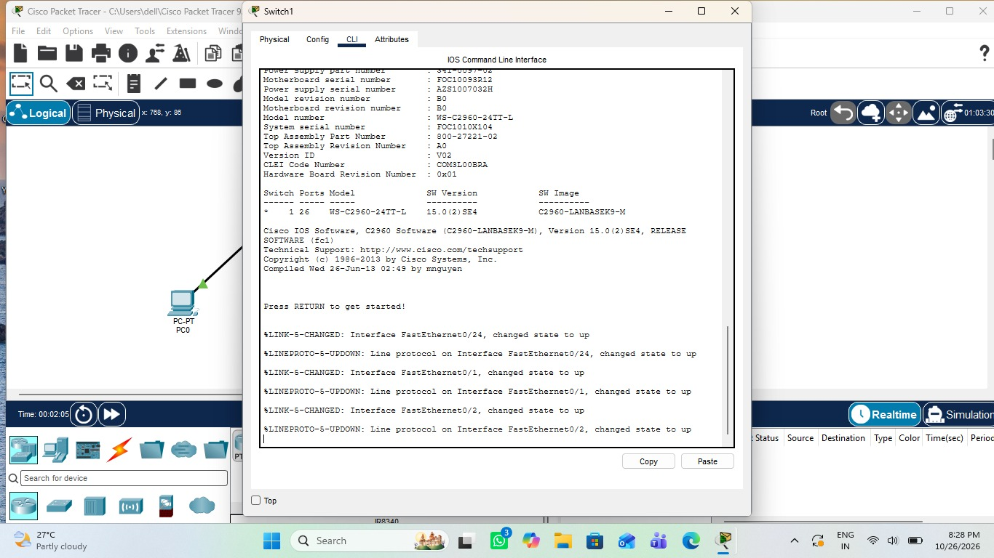
Figure 3: Switch1 IOS command line interface

Result
The interfaces and line protocols on both switches came up, confirming that the devices are correctly connected.

