Cisco Packet Tracer – Experiment 9
Network Topology and Ping Test

1. Network Topology
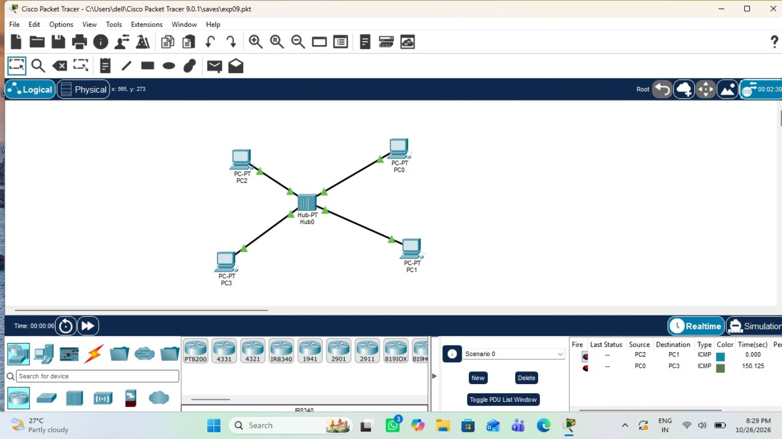

2. Ping Test Result
