# DESIGN OF HELICAL SPRINGS

A Technical Seminar Report

Submitted in partial fulfilment of the award of Degree of Bachelor of Technology Mechanical Engineering.

Submitted by

GONE ROHITH

18H65A0330

**DEPARTMENT OF MECHANICAL ENGINEERING**



**ANURAG GROUP OF INSTITUTIONS**

(An Autonomous Institution)

(Approved by AICTE, Accredited by NBA &Affiliated to JNTU, Hyderabad )

Venkatapur (V) Ghatkesar (M) Medchal (Dist), Telangana 501301

MAY, 2021

CERTIFICATE

This is to certify that the Technical seminar report entitled “DESIGN OF HELICAL SPRINGS ” Submitted by

GONE ROHITH

Department of Mechanical Engineering, ANURAG GROUP OF INSTITUTIONS, in partial fulfilment of the requirements for the award of Bachelor of Technology in MECHANICAL ENGINEERING, is a record of the bonafide work carried out by them during the academic year 2020-2021.

Certified further that the results presented in this thesis have been verified and found to be satisfactory. The work in this dissertation has not been submitted to any other University or Institute for the award of any degree.

|  |  |
| --- | --- |
| Internal Guide | Headof theDepartment |
| Mr. T. Naga Ravikanth |  |

# DECLARATION

# We, students of IV B.Tech, Department of Mechanical Engineering, ANURAG GROUP OF INSTITUTIONS ,hereby declare, that under the supervision of Internal guide, MR. T. Naga Ravikanth , Ass. Prof. We have carried out the project titled “DESIGN AND ASSEMBLY OF SOCKET AND SPIGOT JOINT” and submitted the report in partial fulfilment of the requirement for the award of Bachelor of Technology in Mechanical Engineering by the ANURAG GROUP OF INSTITUTIONS (Autonomous), Hyderabad during the academic year 2020-21

Date:

Place: Hyderabad

## 

ACKNOWLEDGEMENT

With great pleasure we want take this opportunity to express our heartfelt gratitude to the guide who helped in making this Technical seminar report work a grand success.

We extend our sincere and deep sense of gratitude, pleasure, gratefulness and indebtedness to acknowledge of DR. MADHU HOD , Department of Mechanical Engineering for his unstinted support, guidance and for keen interest evinced at all stages of our technical seminar report .We convey our sincere and earnest thanks for his continuous guidance and encouragement for the project.

We would like to thank the teaching and non-teaching staff of Mechanical Engineering Department for sharing their knowledge with us through out there course.

Last but not least, we express our sincere thanks to My guide Mr. T. Naga Ravikanth sir for his continuous care towards our achievement.

# DECLARATION

# Springs are used to store elastic energy and to release it when required. There is a wide range of types of spring that are readily available from specialist suppliers or that can be designed and manufactured fit for-purpose. The aim of this chapter is to introduce spring technology and to outline the principal steps in the design of helical compression, extension, and torsion springs. Introduction Springs are flexible devices used to exert force or torque and store energy. The force produced by a spring can be compressive or tensile and linear or radial, as in the case of a helical torsion spring clip used to hold a tube on the end of a pipe .

Helical spring is one of the common types of

spring used in mechanical systems. A designer must choose the right spring having greater strength and flexibility for use in the system. The designer can use synthetic tools to some extent, as they use only numerical optimization methods. Further, real time problems demand better spring designs. Hence dynamic optimal design is more desirable

Designed a helical spring using FUSION 360

software .Design variables are parameters that are chosen to describe the design of a system. Design variables are controlled by the designers. For computational

design optimization of helical spring, objective function and constraints must be expressed as a function of design variables.

Table of contents

|  |  |  |
| --- | --- | --- |
| S.no |  | Page no |
| 1 | Definition | 1 |
| 2 | Objective of springs | 1 |
| 3 | Measuring forces in springs | 1 |
| 4 | Storing energy | 2 |
| 5 | Spring materials | 2 |
| 6 | Spring manufacturing process | 3 |
| 7 | Helical spring | 3 |
| 8 | Stresses in helical spring | 3 |
| 9 | Design considerations | 5 |
| 10 | Dimensions of spring | 7 |
| 11 | Tools and commands used | 7 |
| 18 | Design procedure | 7 |
| 19 | Advantages and disadvantages | 13 |
| 20 | Applications | 13 |
| 21 | Conclusion | 14 |
| 22 | Reference | 15 |

Design of helical springs

## INTRODUCTION

Definition of spring: Spring act as a flexible joint in between two parts or bodies.

Objectives of Spring

Following are the objectives of a spring when used as a machine member:

1. Cushioning , absorbing , or controlling of energy due to shock and vibration.

Car springs or railway buffers To control energy, springs-supports and vibration dampers.

1. Control of motion

Maintaining contact between two elements (cam and its follower) In a cam and a follower arrangement, widely used in numerous applications, a spring maintains contact between the two elements. It primarily controls the motion.

Creation of the necessary pressure in a friction device (a brake or a clutch) A person driving a car uses a brake or a clutch for controlling the car motion. A spring system keep the brake in disengaged position until applied to stop the car. The clutch has also got a spring system (single springs or multiple springs) which engages and disengages the engine with the transmission system.

Restoration of a machine part to its normal position when the applied force is withdrawn (a governor or valve) A typical example is a governor for turbine speed control. A governor system uses a spring controlled valve to regulate flow of fluid through the turbine, thereby controlling the turbine speed.

1. Measuring forces

Spring balances, gages

1. Storing of energy

In clocks or starters The clock has spiral type of spring which is wound to coil and then the stored energy helps gradual recoil of the spring when in operation. Nowadays we do not find much use of the winding clocks.

Department of mechanical engineeringPage 1

Commonly used spring materials

One of the important considerations in spring design is the choice of the spring material. Some of the common spring materials are given below.

Hard-drawn wire:

This is cold drawn, cheapest spring steel. Normally used for low stress and static load. The material is not suitable at subzero temperatures or at temperatures above 293K.

Oil-tempered wire:

It is a cold drawn, quenched, tempered, and general purpose spring steel. However, it is not suitable for fatigue or sudden loads, at subzero temperatures and at temperatures above 453K.

When we go for highly stressed conditions then alloy steels are useful.

Chrome Vanadium:

This alloy spring steel is used for high stress conditions and at high temperature up to 493K. It is good for fatigue resistance and long endurance for shock and impact loads.

Chrome Silicon:

This material can be used for highly stressed springs. It offers excellent service for long life, shock loading and for temperature up to 523K.

Music wire:

This spring material is most widely used for small springs. It is the toughest and has highest tensile strength and can withstand repeated loading at high stresses. However, it can not be used at subzero temperatures or at temperatures above 293K.

Normally when we talk about springs we will find that the music wire is a common choice for springs.

Stainless steel:

Widely used alloy spring materials.

Phosphor Bronze / Spring

Brass:

It has good corrosion resistance and electrical conductivity. That’s the reason it is commonly used for contacts in electrical switches. Spring brass can be used at subzero temperatures.

Spring manufacturing processes

If springs are of very small diameter and the wire diameter is also small then the springs are normally manufactured by a cold drawn process through a mangle. However, for very large springs having also large coil diameter and wire diameter one has to go for manufacture by hot processes. First one has to heat the wire and then use a proper angle to wind the coils.

Two types of springs which are mainly used are, helical springs and leaf springs. We shall consider in this course the design aspects of two types of springs.

Helical spring

The figures below show the schematic representation of a helical spring acted upon by a tensile load F (Fig.1) and compressive load F (Fig.2). The circles denote the cross section of the spring wire. The cut section, i.e. from the entire coil somewhere we make a cut, is indicated as a circle with shade.If we look at the free body diagram of the shaded region only (the cut section) then we shall see that at the cut section, vertical equilibrium of forces will give us force, F as indicated in the figure. This F is the shear force. The torque T, at the cut section and it’s direction is also marked in the figure. There is no horizontal force coming into the picture because externally there is no horizontal force present. So from the fundamental understanding of the free body diagram one can see that any section of the spring is experiencing a torque and a force.

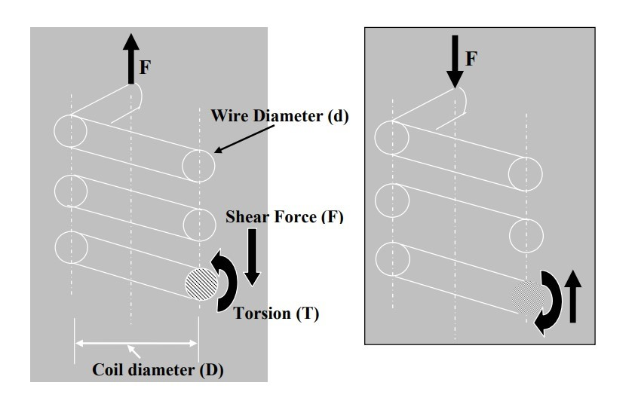

Shear force will always be associated with a bending moment. However, in an ideal situation, when force is acting at the centre of the circular spring and the coils of spring are almost parallel to each other, no bending moment would result at any Force section of the spring ( no moment arm), except torsion and shear force. The Fig.3 will explain the fact stated above.

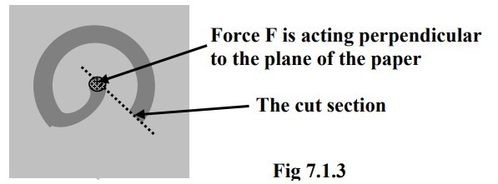

Stresses in the helical spring wire:

From the free body diagram, we have found out the direction of the internal torsion T and internal shear force F at the section due to the external load F acting at the centre of the coil.

The cut sections of the spring, subjected to tensile and compressive loads respectively. The broken arrows show the shear stresses ( τT ) arising due to the torsion T and solid arrows show the shear stresses ( τF )due to the force F. It is observed that for both tensile load as well as compressive load on the spring, maximum shear stress (τT + τF) always occurs at the inner side of the spring. Hence, failure of the spring, in the form of crake, is always initiated from the inner radius of the spring.

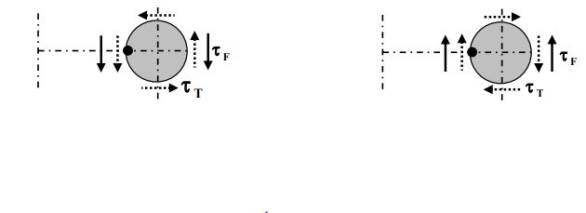

The radius of the spring is given by D/2. Note that D is the mean diameter of the spring. The torque T acting on the spring is

T = 𝐹×𝐷

2

𝜋𝑑4

If d is the diameter of the coil wire and polar moment of inertia, 𝐼 = ,

32

the shear stress in the spring wire due to torsion is

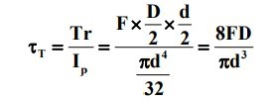

Average shear stress in the spring wire due to force F is

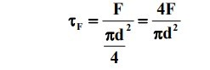

Therefore, maximum shear stress the spring wire is

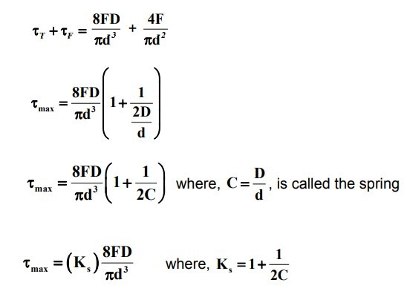

The above equation gives maximum shear stress occurring in a spring. Ks is the shear stress correction factor.

### DESIGN OF HELICAL SPRING, BY USING AUTO DESK FUSION 360

1. DESIGN CONSIDERATION OF HELICAL SPRINGS :

* Space into which the spring must fit and operate • Values of working forces and deflections
* Accuracy and reliability needed.
* Tolerances and permissible variations inspecifications.
* Environmental conditions such as temperature,pressure of corrosive atmosphere.
* Cost and qualities needed2. DIMENSIONS OF HELICAL SPRING :

|  |  |
| --- | --- |
| Diameter | 100.00 mm |
| Revolutins | 8 |
| Height | 300.00 mm |
| Angle | 0.0 deg |
| Section | Circular |
| Section position | On center |
| Section size | 100.00 mm |

1. TOOLS AND COMMANDS USED :

● Coil

● Sweep

● Intersecting curves

● Offset plane

● Mirror

● Combine

1. DESIGN PROCEDURE OF HELICAL SPRING :

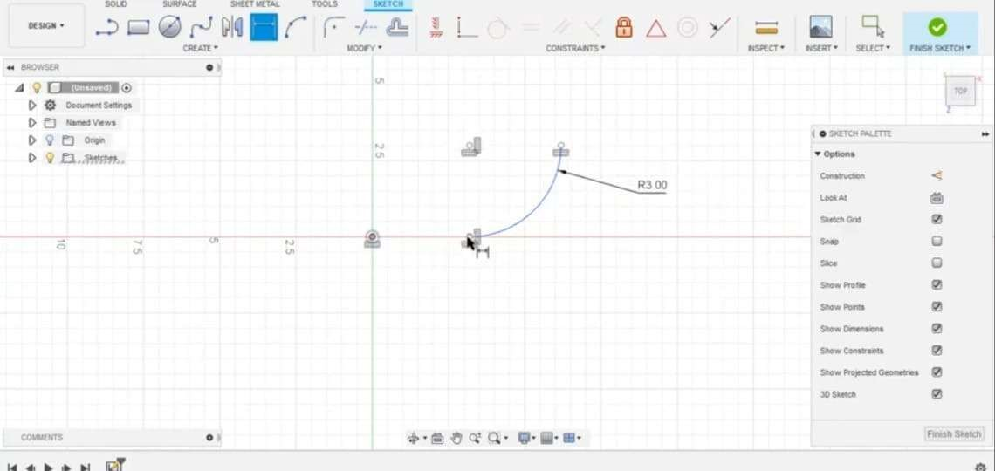

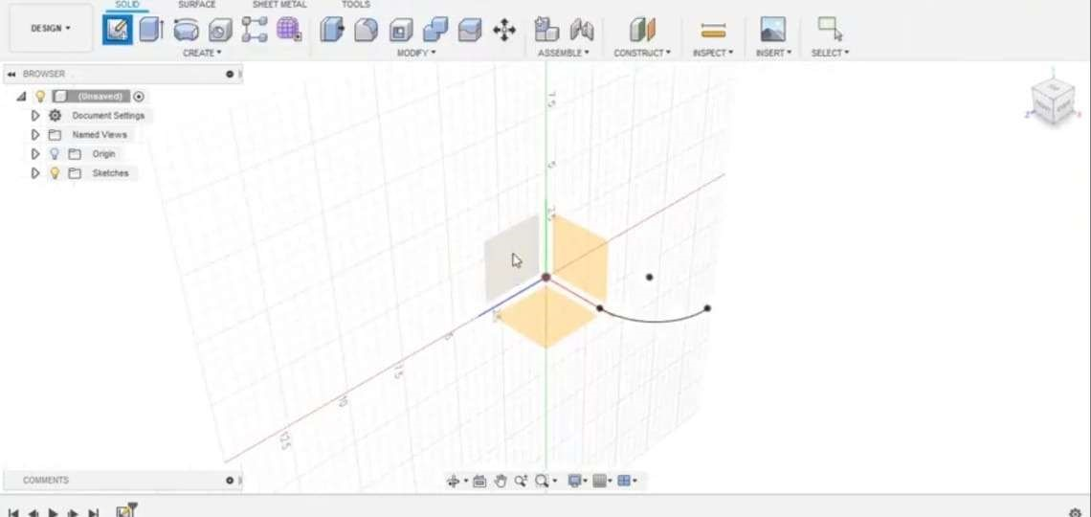

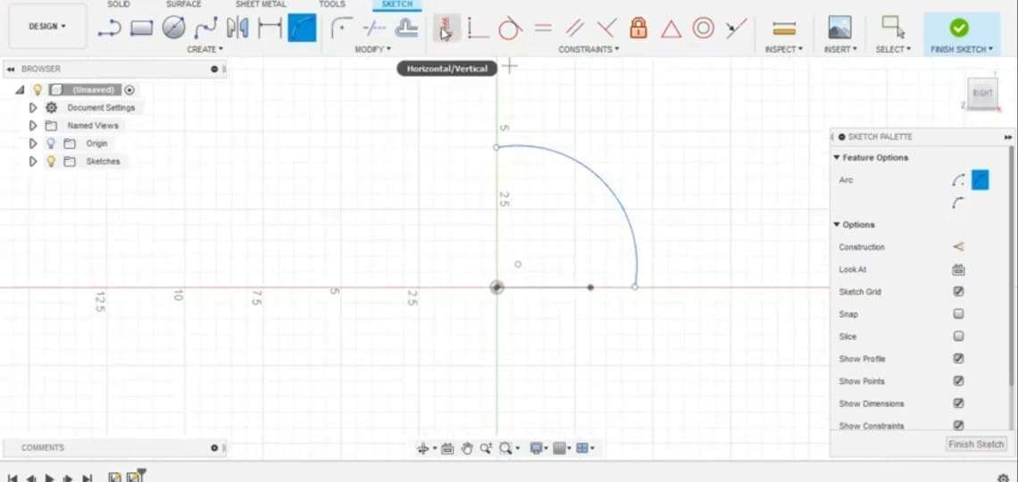

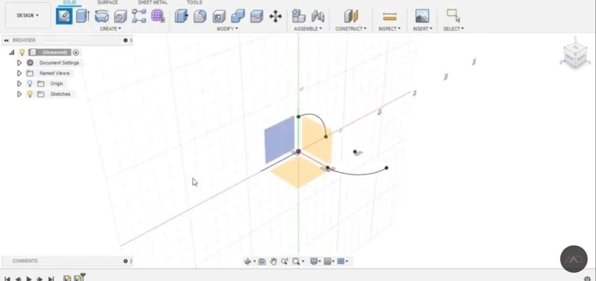

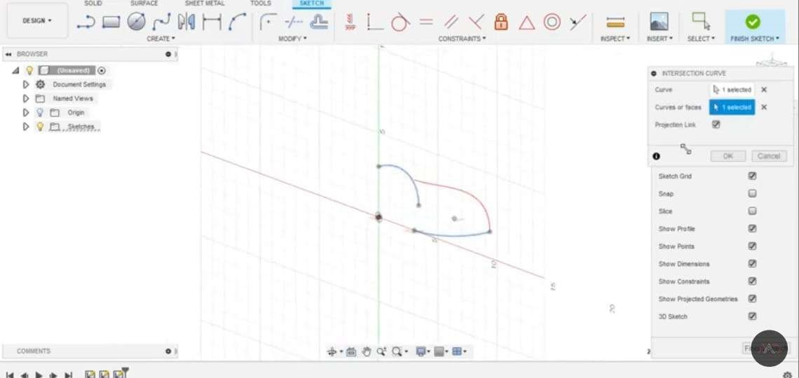

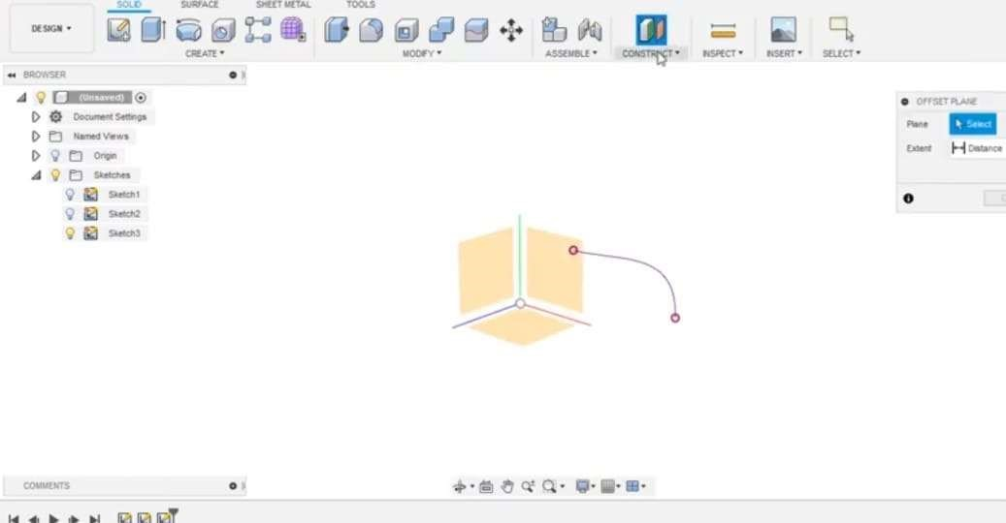

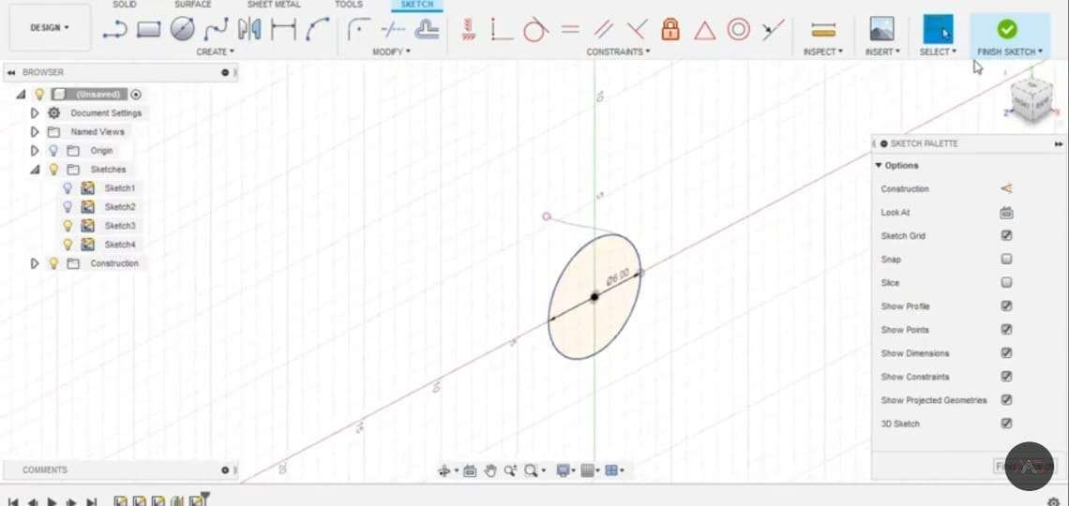

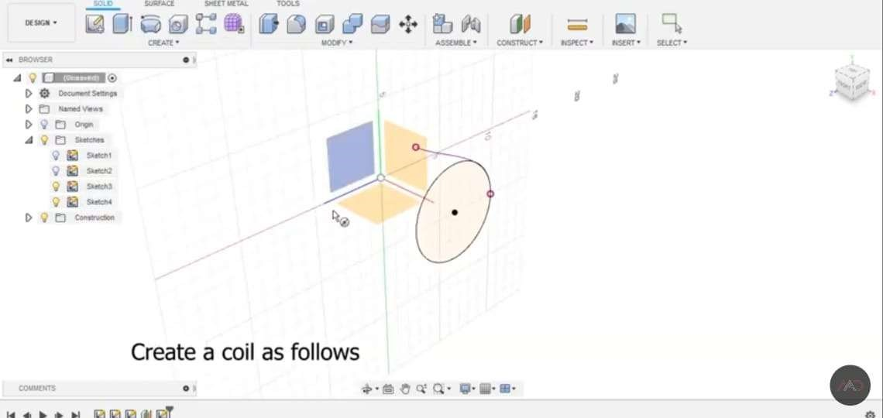

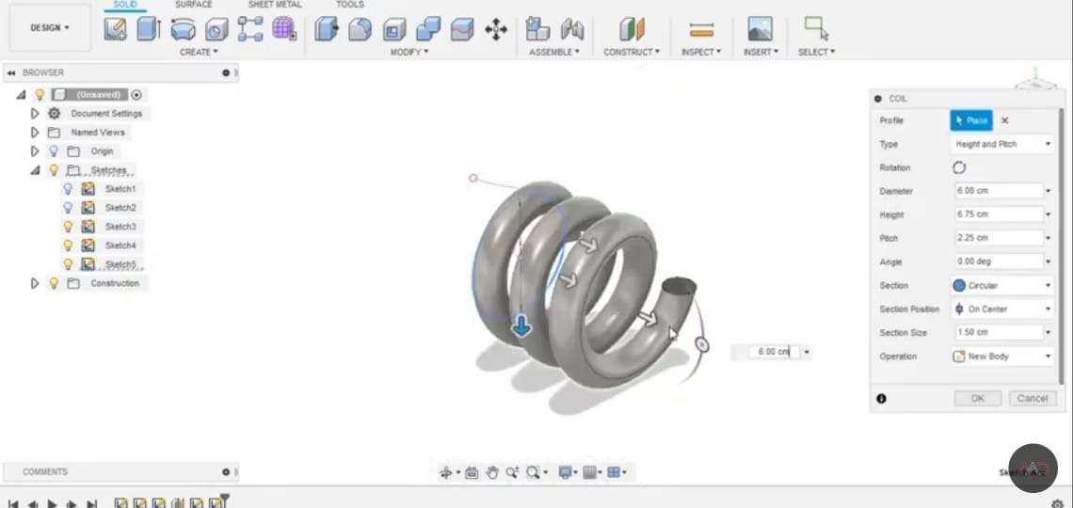

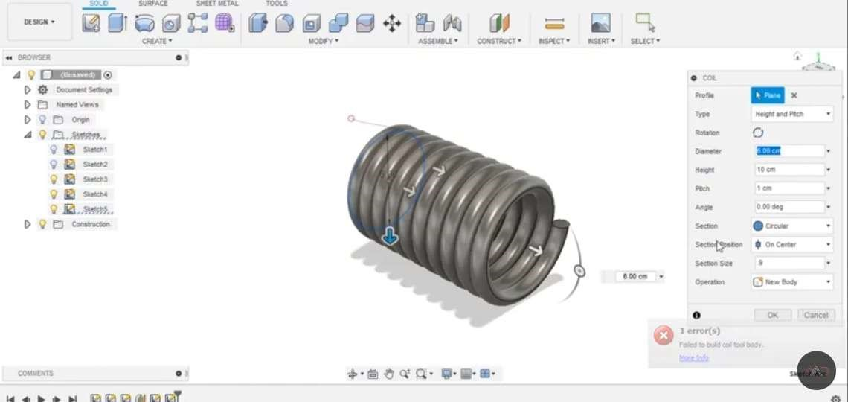

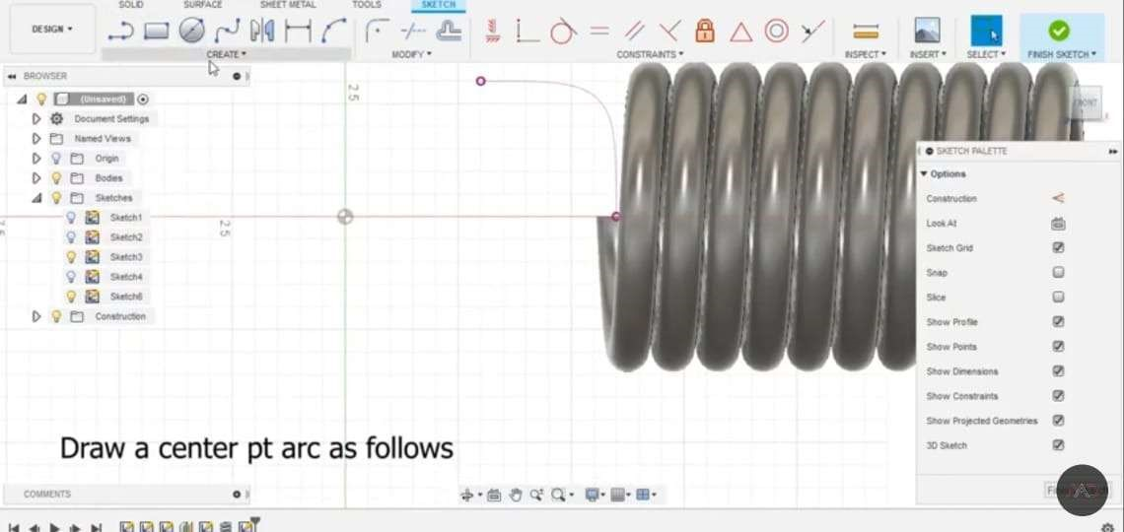

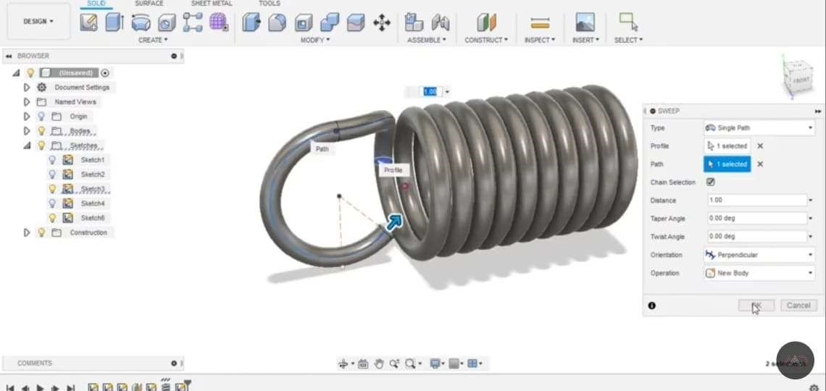

6.ADVANTAGES AND DISADVANTAGES OF HELICAL SPRINGS

Advantages :

● The helical springs have a good durability.

● These springs are specially designed with high precision.

● They have a decent dimensional stability.

● These springs have a rugged construction.  These types of springs have a high tensile strength

Disadvantages :

● If the deflection of the spring exceeds  some critical value than the spring will buckle.

● It is difficult to replace the spring .

● Once the spring is damaged it is difficult to repair.

7. APPLICATIONS OF HELICAL SPRINGS :

● To apply forces and controlling motion, as in brakes and clutches.  Measuring forces, as in the case of a spring balance.

● Storing energy, as in the case of springs used in watches and toys.

● Reducing the effect of shocks and vibrations in vehicles and machine foundations.

● Twisted helical springs are used in engine starters and hinges.

● Automobile suspension systems.

● Gun recoil mechanisms.

CONCLUSION

Thus the design of helical spring is done by using FUSION 360 software. Using particular dimensions and materials. The design produced by using libraries , commands and tools. Studied about the stresses induced in the helical springs. Studied about the springs principles and various materials used. Studied about the advantages , disadvantages and applications.

REFERENCES:

[1]. A Textbook of Machine design by RS. Khurmi

[2]. A Textbook of Machine design by JK.Gupta, S.Chand (25th Edition)

[3]. A Textbook of Design of machine members vol 1 by VB.Bandari

[4]. AUTOCAD FUSION 360 SOFTWARE