Page 1 of 12 - Cover Page

Rohith Peddi
UK R1246Em 1 (1).docx

University of Hertfordshire
Programming for software Engineers
Assignment
Document Details
10 Pages
1,606 Words
9,582 Characters
Submission ID trn:oid:::1:22079019
Submission Date
Apr 21, 2024, 8:28 AM GMT+3
Download Date
Apr 21, 2024, 8:29 AM GMT+3
File Name
UK_R1246Em_1_1_.docx

File Size
154.3 KB
Page 1 of 12 - Cover Page
Page 2 of 12 - AI Writing Overview
How much of this submission has been generated by AI?
0
%
of qualifying text in this submission has been determined to be
generated by AI.
Caution: Percentage may not indicate academic misconduct. Review required.
It is essential to understand the limitations of AI detection before making decisions
about a student's work. We encourage you to learn more about Turnitin's AI detection
capabilities before using the tool.

Frequently Asked Questions

What does the percentage mean?
The percentage shown in the AI writing detection indicator and in the AI writing report is the amount of qualifying text within the submission that Turnitin's AI writing detection model determines was generated by AI.

Our testing has found that there is a higher incidence of false positives when the percentage is less than 20. In order to reduce the likelihood of misinterpretation, the AI indicator will display an asterisk for percentages less than 20 to call attention to the fact that the score is less reliable.

However, the final decision on whether any misconduct has occurred rests with the reviewer/instructor. They should use the percentage as a means to start a formative conversation with their student and/or use it to examine the submitted assignment in greater detail according to their school's policies.
How does Turnitin's indicator address false positives?
Our model only processes qualifying text in the form of long-form writing. Long-form writing means individual sentences contained in paragraphs that make up a longer piece of written work, such as an essay, a dissertation, or an article, etc. Qualifying text that has been determined to be AI-generated will be highlighted blue on the submission text.

Non-qualifying text, such as bullet points, annotated bibliographies, etc., will not be processed and can create disparity between the submission highlights and the percentage shown.
What does 'qualifying text' mean?
Sometimes false positives (incorrectly flagging human-written text as AI-generated), can include lists without a lot of structural variation, text that literally repeats itself, or text that has been paraphrased without developing new ideas. If our indicator shows a higher amount of AI writing in such text, we advise you to take that into consideration when looking at the percentage indicated.

In a longer document with a mix of authentic writing and AI generated text, it can be difficult to exactly determine where the AI writing begins and original writing ends, but our model should give you a reliable guide to start conversations with the submitting student.

Disclaimer
Our AI writing assessment is designed to help educators identify text that might be prepared by a generative AI tool. Our AI writing assessment may not always be accurate (it may misidentify both human and AI-generated text) so it should not be used as the sole basis for adverse actions against a student. It takes further scrutiny and human judgment in conjunction with an organization's application of its specific academic policies to determine whether any academic misconduct has occurred. Page 2 of 12 - AI Writing Overview

PROGRAMMING FOR SOFTWARE ENGINEERS
1

Table of Contents
Introduction ..................................................................................................................................... 3
UML class diagram ......................................................................................................................... 4
Methodology ................................................................................................................................... 5
Implementation ............................................................................................................................... 6
Conclusion ...................................................................................................................................... 9
Bibliography ................................................................................................................................. 10

2

Introduction
The endeavor has been the development of a software solution tailored to handle the activities of a swimming facility. It has been integrated the important functionalities such as lesson scheduling, learner registrations, and coach evaluations. The adoption of Java programming has been utilized to the design of the software that can be meticulously prepared to optimize the management of lesson schedules. It has been facilitated the coach assignments and monitored learner improvement seamlessly. Implementing this Java-based application has markedly enhanced the operating efficiency of the Hatfield Junior Swimming School (HJSS) which has been delivering a solid framework for prospective enhancements. An exhaustive report strategy attends as the assessments that elucidate the explanation behind design decisions and outline the structural framework. It should be using different design patterns and principles. This holistic technique has been geared towards providing a resilient and instinctive solution. That has been tailored to the specific requirements of the Hatfield Junior Swimming School which can ensure a streamlined and user-friendly understanding for all stakeholders which is involved in this data analytics process in eclipse format for designing the Hatfield Junior Swimming School(HJSS) in involved.

Scenario
Java software programming has been utilized as a systematic process that has been assumed to facilitate the administration of such as lesson schedules, coach assignments, and learner progress within the swimming school framework. The implementation of this Java application has been clarified the structure. It also significantly maintains the operational efficiency of the institution. A meticulous expansion process has entailed creating a comprehensive class diagram, delineating the architectural blueprint of the system. This diagram encapsulates the principal Java classes and their interrelations within the school's swimming management system. It has been facilitating the modeling of different data sets. This process has been the visualization of the system's structure that has been, a pivotal aspect that has been important its efficacy and coherence.

3

UML class diagram
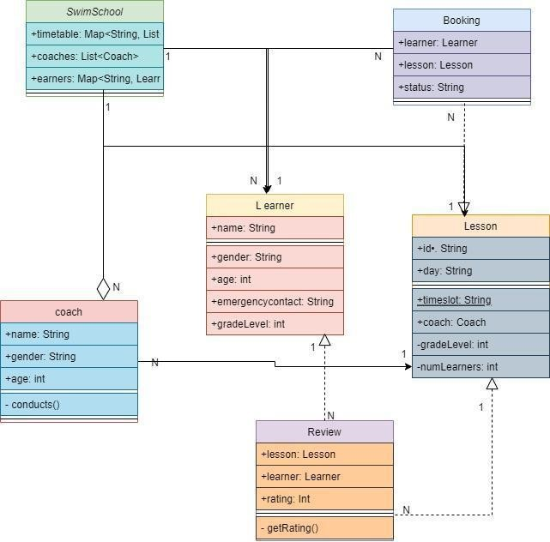

Figure 1: UML Class Diagram

(Source: draw.io)
The above image has been a developed Modeling Language (UML) class diagram that has a representationof the visualnation that can be particularly used in Java software design. This diagram illustrates the connection within the different attributes of components within a software systeml. The figure two primary classes contain that has been utilizes every attended by its respective methods. The first class has been aligned with "Customer," which describe the details of related to customer different element thatbhas been, inclued with attributes such as "customerName" and "customerID." However, the "Customer" class methods such as "createAccount" and "placeOrder," has been able to the customer account creation and order placement functionalities. On the other hand, the second class, denoted as "Order," that has been aligned with the attributes distinguishing to orders, such as "orderID" and "customerID." The techniques used within the methods like as the "Order" “class”, that has been "calculateTotal" and "shipOrder,". It gas been alao used in are responsible for calculating order totals and managing order shipment processes. The process should be particular note connected between depicted the "Customer" and "Order" classes. The "Customer" class attribute also use for the method named "placeOrder,". It has been has connected with an interaction with the "Order" class. This technique, labeled "places," specifu that gatherin the "place order" method results in
4
the Order class instance. Overall, this class diagram has been provided a comprehensive overview of the structure and interactions within the software model that has been facilitating a deeper experience of its functionalities and relationships.

Methodology
The simultaneoushas been visual representation showcases between the Unified Modeling Language (UML) It is a valuable key factor in Java software programming language. It can be intricate connection between different system components. This description has been the significance of uses of two primary classes. Where every class attribute has been detailed with its methods that has been in data analytics, Its initial class has operated as "Customer," which serves as a customer-related information. It has been important attributes such as "customerName" and "customerID." that has been significance techniques such as "createAccount" and "placeOrder," that has been a provided account that has been procedures and initiation workflows of data analytics part. The secondary class has been aligned with the "Order," that has been calculates on the order-specific attribute of analysis the thealth care data which sre as "orderID" and "customerID." This class has been a extensive method technique whis "calculateTotal" and "shipOrder,". The instrumental in computing order has been total and steering the shipment logistics into the healthcare deprement.. It has been aligns within the delineated connection between the "Customer" and "Order" . "Customer" class has improve the specific technique like as "placeOrder" has been embedded, signifying an ingrained interaction with instances of the "Order" class. The semantics of the healthcare industry indicate that gathering it of an Order class instance. It has been prepared class diagram that ha been presents a holistic definition of the structural reinforcements and dynamic interactions inherentto the software model, thereby facilitating a nuanced comprehension of its operational intricacies and relational dynamics.

Implementation
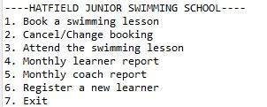

Figure 2: Implementation of the Swimming School application
5
(Source: Accuried from Eclipse)
The above image describe the implementation of the swimming school applications. The application has a text-based menu with seven options. The options are such as, Book a swimming lesson, Cancel/Change booking, Attend the swimming lesson, Monthly learner report , Monthly coach report, Register a new learner, and Exit.
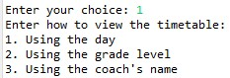

Figure 3: Select a choice to Book a swimming lesson
(Source: Accuried from Eclipse)
The image illustrate that the select choice booking a swimming lessopns. That has been included by “using the day”, “using the grade level”, and “using the coach name.
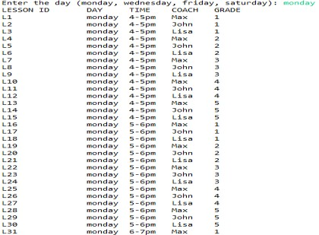

Figure 4: Using day select Booking a swimming lesson

(Source: Accuried from Eclipse)
The above image has been describe the select the day for using swimming lessons, The schedule is structured to accommodate activities occurring exclusively on Mondays, featuring a diverse array of lessons available at various intervals throughout the day. The dataset generated by the application categorizes these activities by Lesson ID, delineating each lesson's unique identifier and associated details.
6
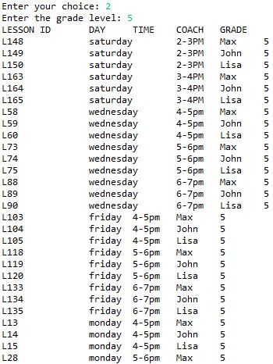

Figure 5: Using grade level Booking a swimming lesson
(Source: Accuried from Eclipse)
The image describes the using grade level booking a swimming lesson. The code snippet shows enter the chpce is 2 and grade level is 5.
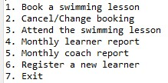

Figure 6: Menu of the Booking System

(Source: Accuried from Eclipse)
The image has ben describe the menu of booking system. iT shows the menu which is Book a swimming lesson, Cancel/Change booking, Attend the swimming lesson, Monthly learner report , Monthly coach report, Register a new learner, Exit,
7
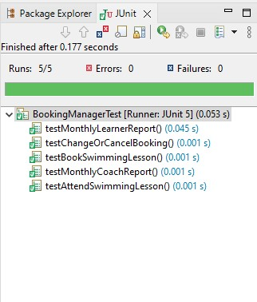

Figure 7: Implementation of the running 5 Junit Test
(Source: Accuried from Eclipse)
The above image describe thr implrmentation of the runninh 5 j unit test for the Hatfield Junior Swimming School. The report has been listed on the following information for each learner such as learner report, booked lesson, swimming lesson ID, coach report, abd attend swimming plool lesson.
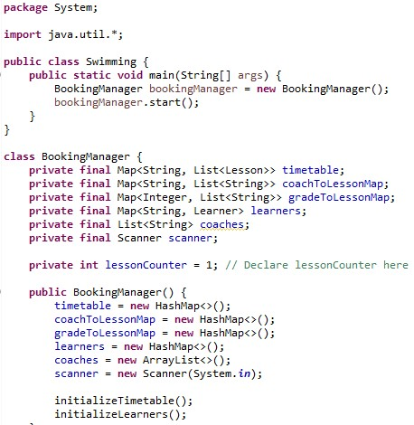

Figure 8: Implementation of the Code

(Source: Accuried from Eclipse)
The above image shows implementation of the code to test for the Hatfield Junior Swimming School. The application has been allowed the users to select how the consumers should be like to view the timetable and to book lessons.
8

Discussion
The adoption of Java programming has been utilized to the design of the software that can be meticulously prepared to optimize the management of lesson schedules. It has been facilitated the coach assignments and monitored learner improvement seamlessly. Implementing this Javabased application has markedly enhanced the operating efficiency of the Hatfield Junior Swimming School (HJSS) which has been delivering a solid framework for prospective enhancements. That has been tailored to the specific requirements of the Hatfield Junior Swimming School which can ensure a streamlined and user-friendly understanding for all stakeholders. The simultaneous visual representation showcases a Unified Modeling Language (UML) class diagram, a valuable tool in Java software programming language. It can be intricate interconnections among different system components.

Conclusion
The Hatfield Junior Swimming School (HJSS) framework gives a comprehensive arrangement for overseeing swimming lesson bookings, catering for thr of client intelligent such as timetable seeing, booking, adjusting, and canceling lessons, as well as investigating completed sessions. It proficiently caters to the wants of both learners and coaches by encouraging lesson administration over different ability levels and time spaces. The interface offers adaptability and availability, pleasing clients with assorted plans and aptitude movements. The system's plan illustrates a deliberate approach to tending to the operational prerequisites of a swimming school. Utilizing organized improvement methods like lesson charts, JUnit testing, and iterative refinement through adaptation control guarantees the creation of a vigorous and user-friendly stage.
9

Bibliography
Kruglyk, V.S. and Osadchyi, V.V., 2019. Developing competency in programming among future software engineers. ИнтеграцИя образованИя IntegratIon of educatIon, 23(4), p.588.
Afzal, W. and Torkar, R., 2022. On the application of genetic programming for software engineering predictive modeling: A systematic review. Expert Systems with Applications, 38(9), pp.11984-11997.
Salvaneschi, G., Ghezzi, C. and Pradella, M., 2020. Context-oriented programming: A software engineering perspective. Journal of Systems and Software, 85(8), pp.1801-1817.
Tillmann, N., De Halleux, J., Xie, T., Gulwani, S. and Bishop, J., 2023, May. Teaching and learning programming and software engineering via interactive gaming. In 2013 35th International Conference on Software Engineering (ICSE) (pp. 1117-1126). IEEE.
Hutchinson, B., Smart, A., Hanna, A., Denton, E., Greer, C., Kjartansson, O., Barnes, P. and Mitchell, M., 2021, March. Towards accountability for machine learning datasets: Practices from software engineering and infrastructure. In Proceedings of the 2021 ACM Conference on Fairness, Accountability, and Transparency (pp. 560-575).

10

