CASE 2 – PMO OFFICE
Git & GitHub Version Control Assignment
Planning & Inventory Project

Objective
To demonstrate centralized version control for a PMO planning and inventory project using Git and GitHub. The workflow includes creating the GitHub repository, adding an inventory Excel sheet, creating and synchronizing a local repository, adding additional files locally, committing the changes, and pushing the changes to the central GitHub repository.

Assignment Steps Completed
- Create a GitHub Account
- Start a new project called “PMO-Office”
- Add an Excel sheet for inventory
- Commit the changes
- Create a local repository on the laptop
- Add additional files to the local repository
- Commit the local changes
- Push the files to the central GitHub repository

Step 1 – GitHub Repository and Inventory Excel Sheet
A GitHub repository named PMO-Office was created. An Inventory.xlsx file was uploaded to the main branch and committed with the message “Add inventory Excel sheet”.
Result: The central repository contains Inventory.xlsx on the main branch.
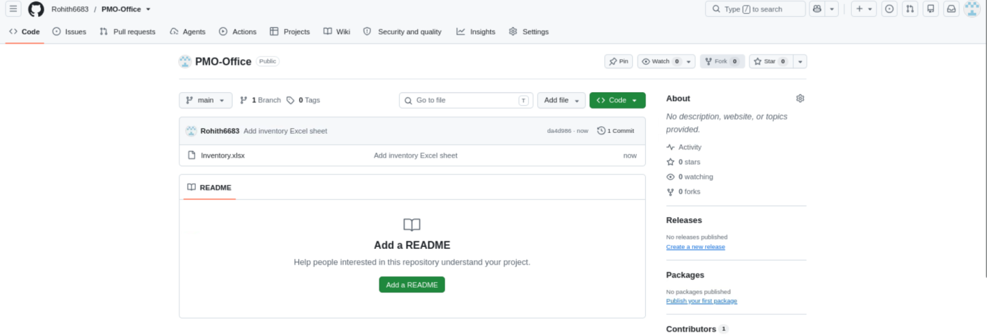
Screenshot 1 — GitHub PMO-Office repository with Inventory.xlsx committed

Step 2 – Create and Synchronize the Local Repository
The local PMO-Office directory was initialized as a Git repository and connected to GitHub.
Commands used:
mkdir PMO-Office
cd PMO-Office
git init
git remote add origin https://github.com/Rohith6683/PMO-Office.git
git remote -v
git fetch origin
git branch -M main
git reset --hard origin/main
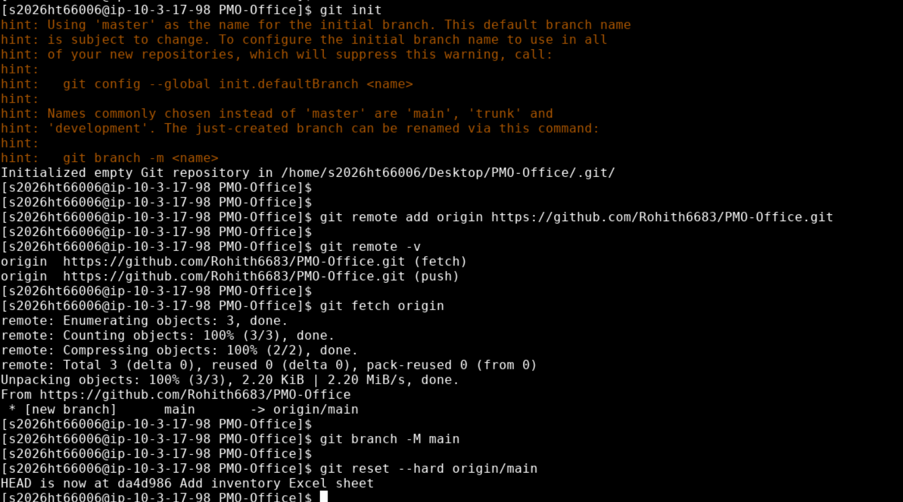
Screenshot 2 — Local repository initialized, remote configured, and synchronized with origin/main

Step 3 – Verify the Local Repository
The local repository was checked to confirm that it was synchronized with origin/main and that Inventory.xlsx was available locally.
Verification commands: git status and ls -l
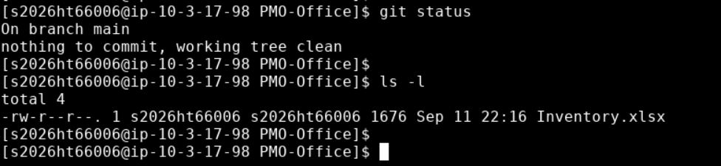
Screenshot 3 — Local repository verified clean with Inventory.xlsx present

Step 4 – Add Additional Files to the Local Repository
Three additional inventory files were created locally to simulate ongoing PMO inventory updates:
- Laptop_Inventory.csv
- Monitor_Inventory.csv
- Keyboard_Inventory.csv
The files were verified using the ls -l command.
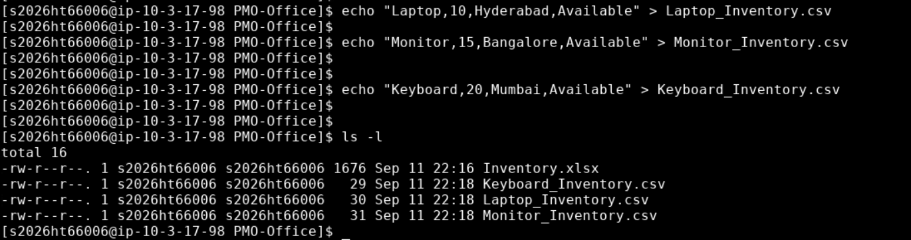
Screenshot 4 — Additional inventory files added to the local repository

Step 5 – Stage the Local Changes
The newly created files were added to the Git staging area.
Commands used:
git status
git add .
git status
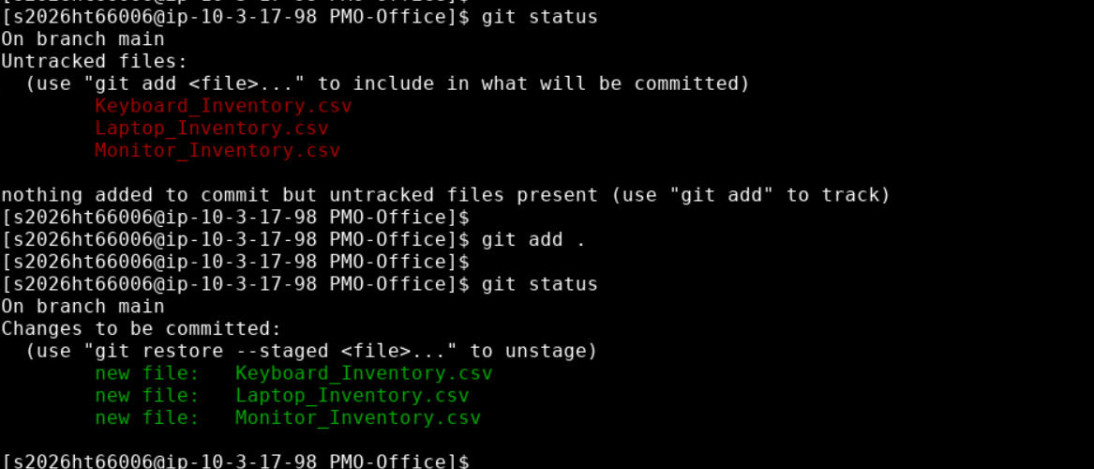
Screenshot 5 — New files staged using git add .

Step 6 – Commit the Local Changes
The staged inventory files were committed to the local Git repository.
Command used: git commit -m "Add local inventory files"
Commit created: 4659a40 – Add local inventory files
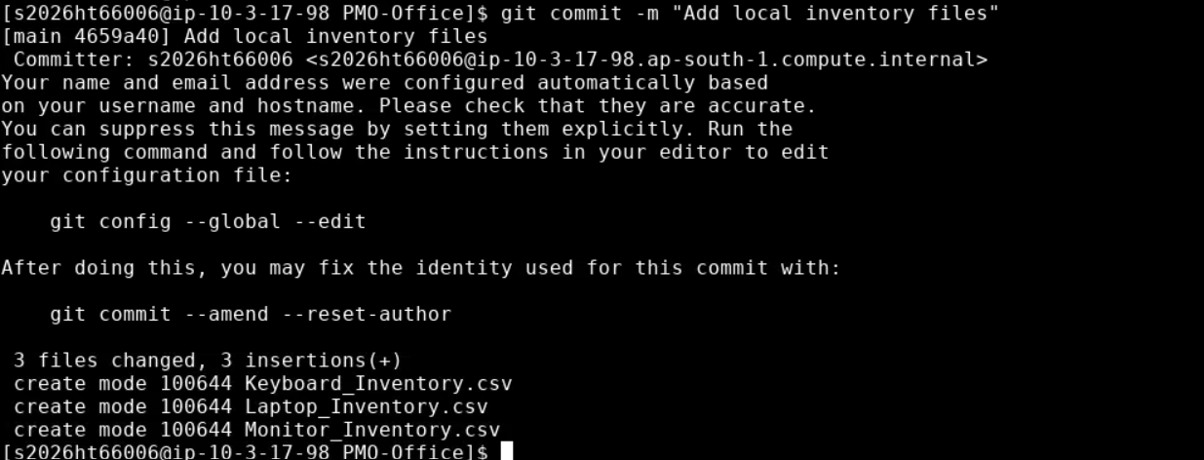
Screenshot 6 — Local changes committed as 'Add local inventory files'

Step 7 – Push the Local Changes to GitHub
The committed local changes were pushed to the central GitHub repository on the main branch.
Command used: git push -u origin main
Result: The push completed successfully and main was set to track origin/main.
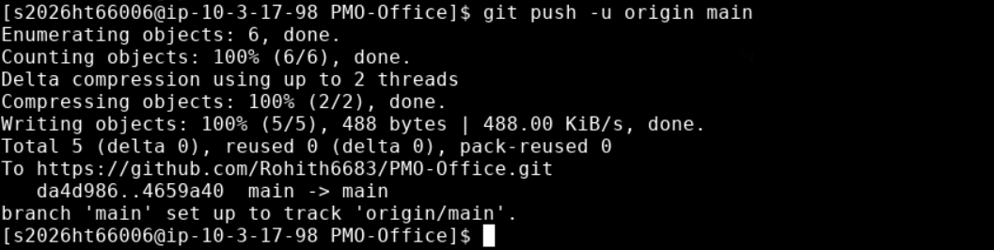
Screenshot 7 — Local main branch successfully pushed to GitHub

Final Verification – Files Available on GitHub
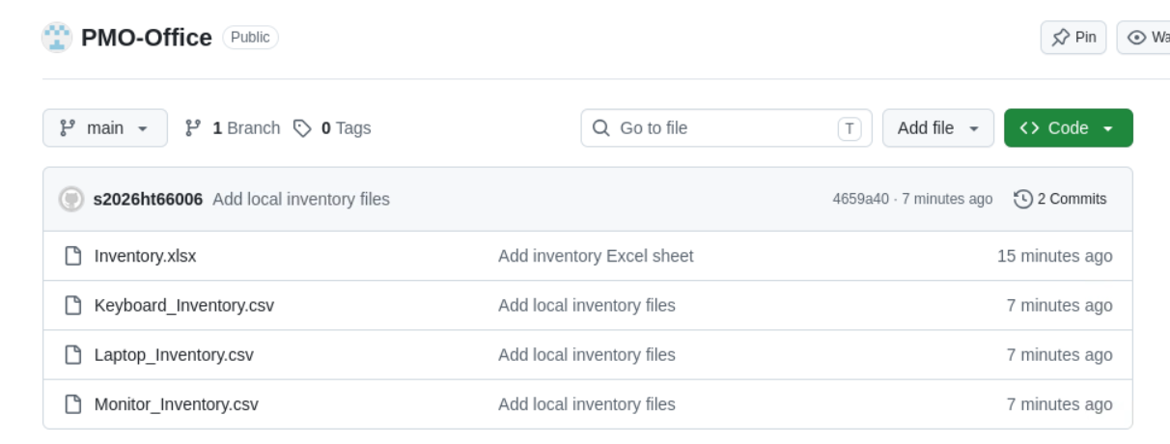
Final Repository Contents
File | Purpose
Inventory.xlsx | Initial inventory spreadsheet
Laptop_Inventory.csv | Laptop inventory data
Monitor_Inventory.csv | Monitor inventory data
Keyboard_Inventory.csv | Keyboard inventory data

Conclusion
Case 2 was completed successfully. The PMO-Office project demonstrates a complete Git/GitHub version-control workflow: inventory data was initially stored in GitHub, the repository was synchronized to a local laptop repository, additional inventory files were added and committed locally, and the final changes were pushed back to the central GitHub repository.

