CASE 1 – Git Branching, Merging and GitHub
Web-Dev Project

1. Objective
To create a Git repository for a Web-Dev project, create Java and JavaScript branches, make and update files on those branches, merge the branches into master, and push the branches to GitHub.

2. Create the Web-Dev Git repository
Commands:
cd Desktop
mkdir Web-Dev
cd Web-Dev
git init
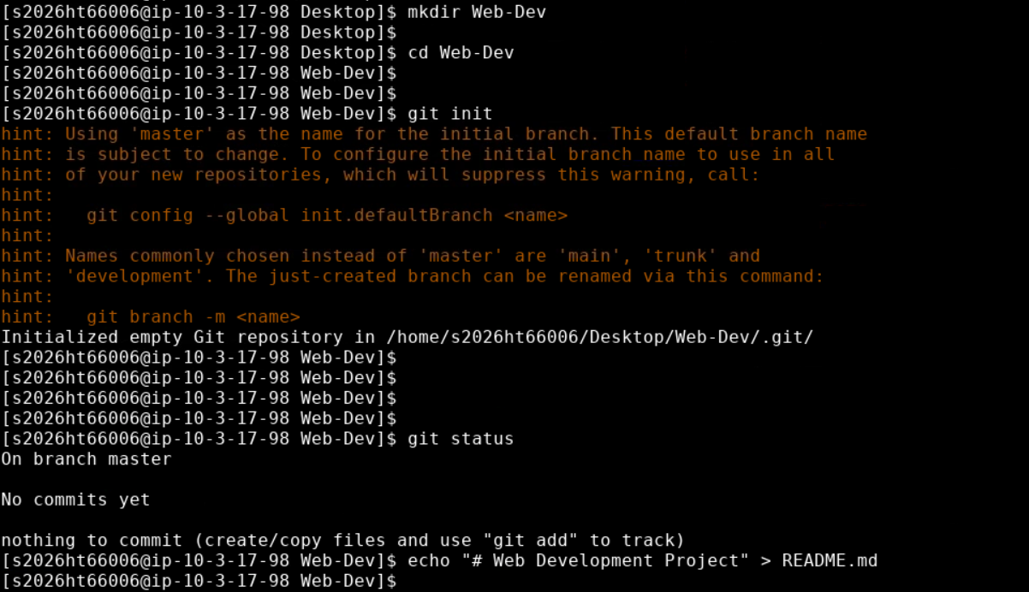
Result: A new Git repository was initialized in ~/Desktop/Web-Dev. The initial branch was master.

3. Create README and initial commit
Commands:
echo "# Web Development Project" > README.md
git add README.md
git commit -m "Initial Web-Dev project"
git status
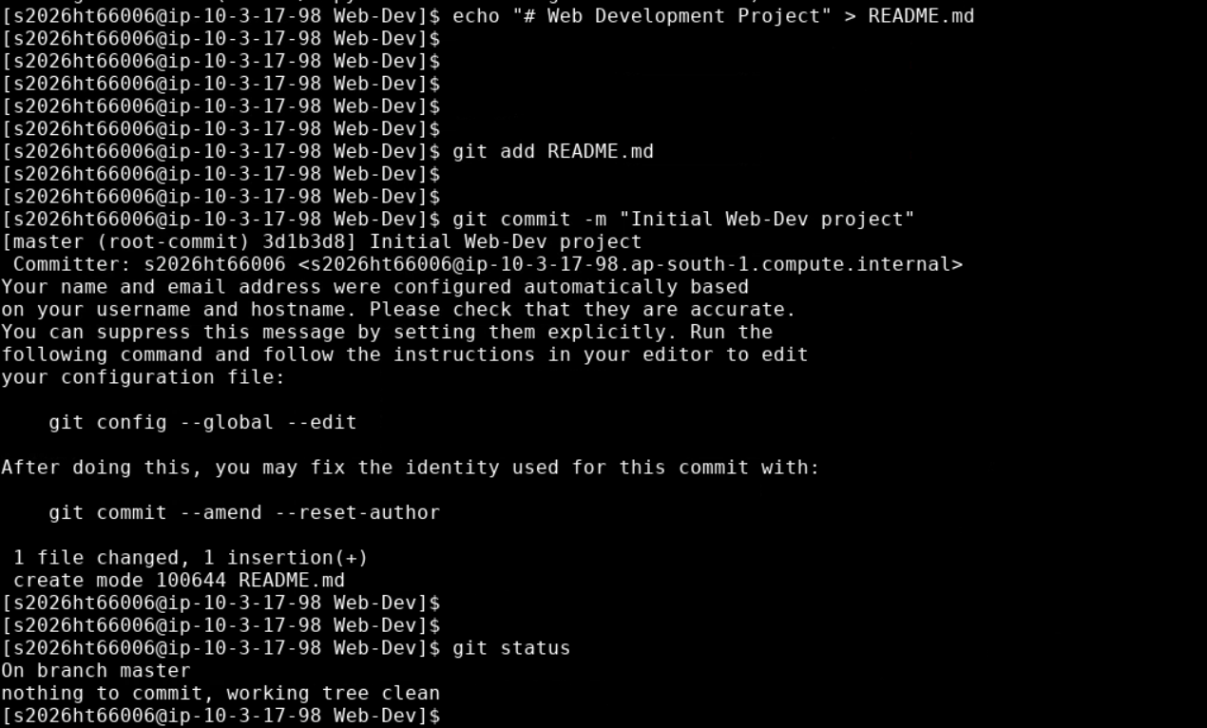
Result: The README was committed successfully and the working tree was clean.

4. Create Java branch
Commands:
git checkout -b Java

Result: The Java branch was created and checked out.

5. Create JavaTest.java – Version 1
Commands:
git add JavaTest.java
git commit -m "Java test script version 1"
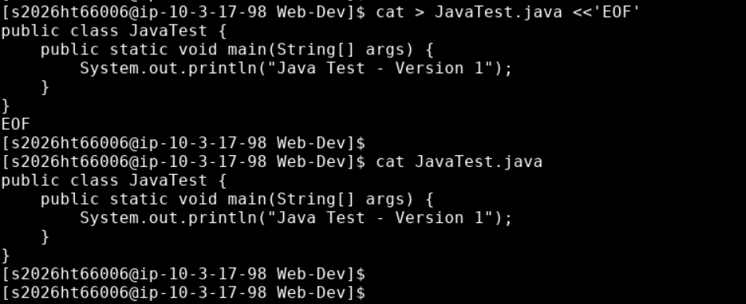 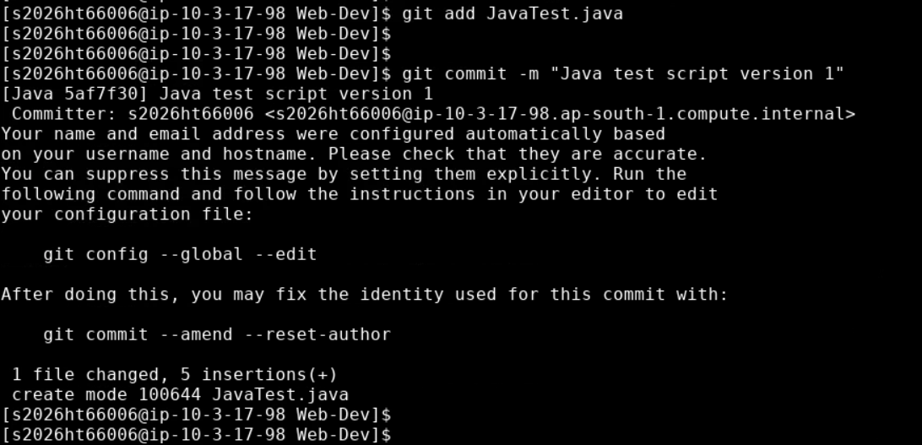
Result: JavaTest.java was created and committed as Version 1.

6. Update JavaTest.java – Version 2
Commands:
sed -i 's/Version 1/Version 2/' JavaTest.java
git add JavaTest.java
git commit -m "Update Java test script to version 2"
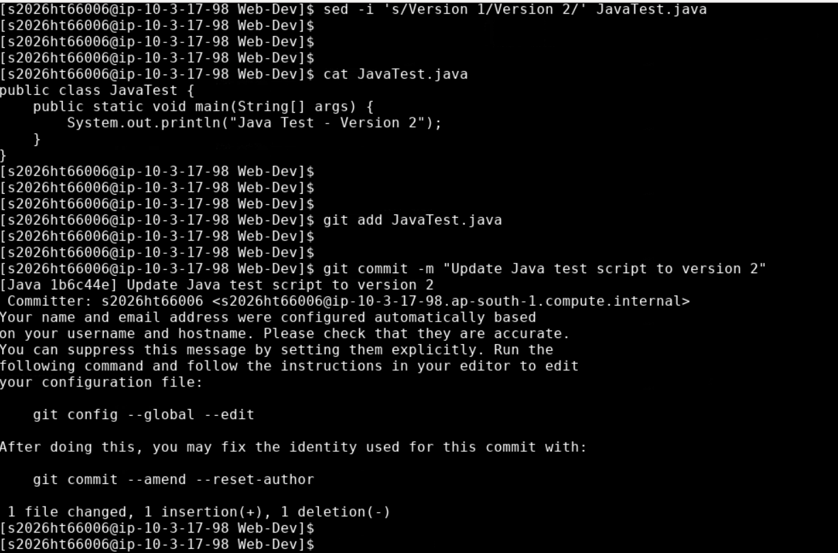
Result: The Java test script was updated to Version 2 and committed.

7. Create JavaScript branch
Commands:
git checkout master
git checkout -b JavaScript
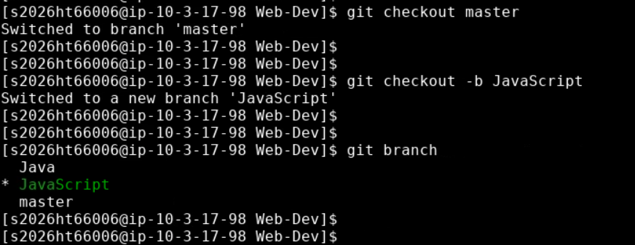
Result: The JavaScript branch was created from master.

8. Create and update JavaScriptTest.js
Commands:
git add JavaScriptTest.js
git commit -m "JavaScript test script version 1"
sed -i 's/Version 1/Version 2/' JavaScriptTest.js
git add JavaScriptTest.js
git commit -m "Update JavaScript test script to version 2"
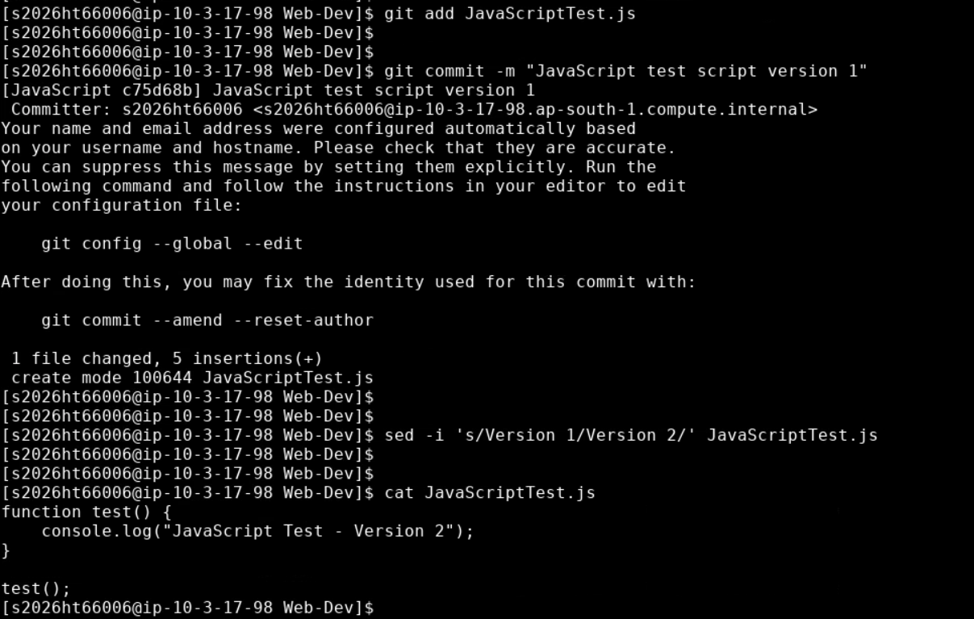 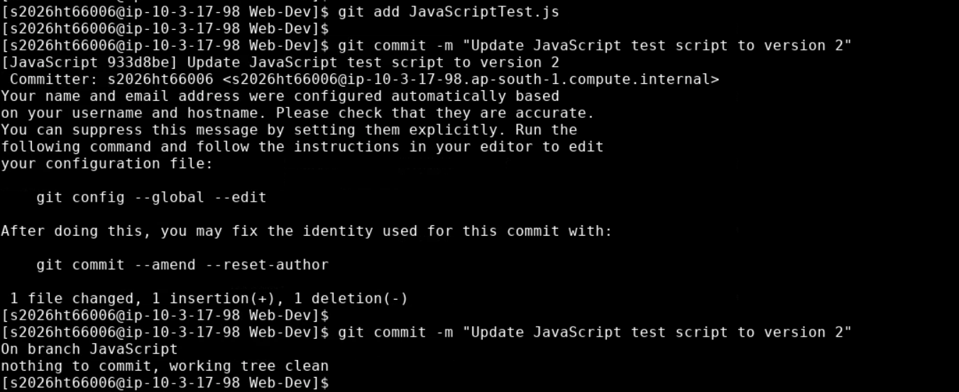
Result: JavaScriptTest.js was created as Version 1, updated to Version 2, and committed.

9. Merge Java into master
Commands:
git checkout master
git merge Java
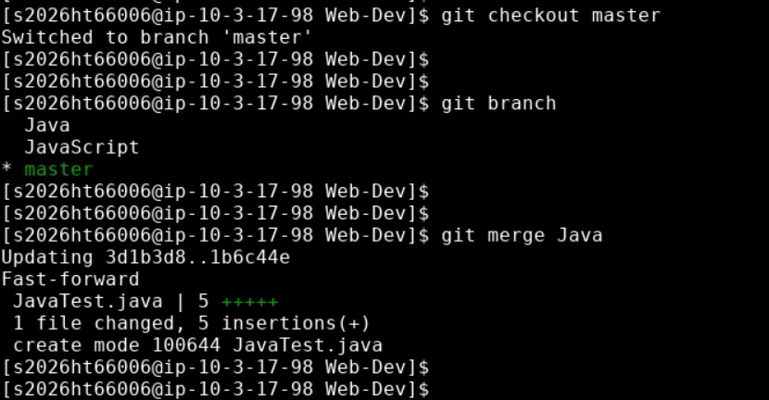
Result: JavaTest.java was merged into master.

10. Merge JavaScript into master
Commands:
git merge JavaScript
git status
git log --oneline --all –graph
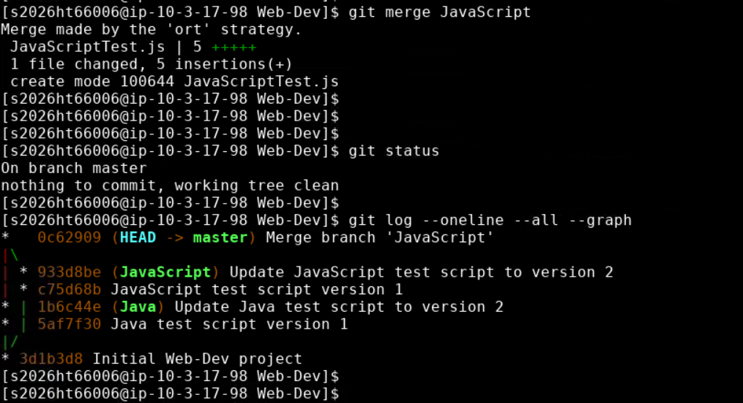
Result: JavaScriptTest.js was merged into master. The status was clean and the commit graph showed the merge.

11. Connect the local repository to GitHub
Commands:
git remote add origin https://github.com/Rohith6683/Web-Dev.git
git remote –v
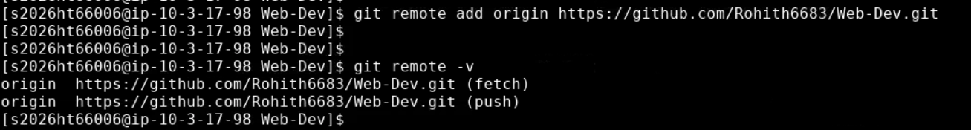
Result: The local Web-Dev repository was connected to the GitHub Web-Dev repository.

12. Push all branches to GitHub
Commands:
git push -u origin master
git push -u origin Java
git push -u origin JavaScript
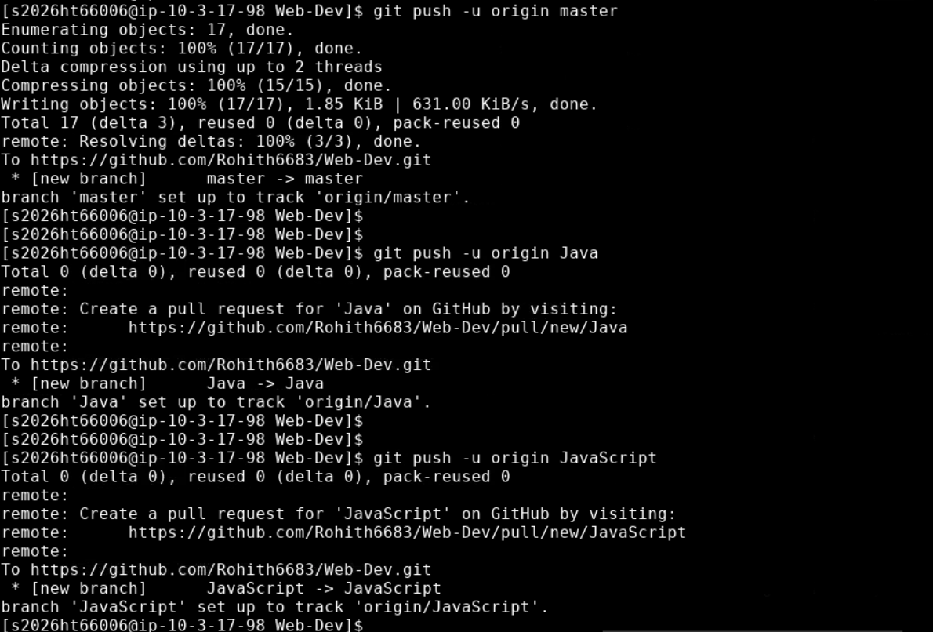
Result: All three branches were pushed successfully to GitHub.

13. Final branch verification
Commands:
git branch –a


Result: The final verification showed local branches Java, JavaScript and master, plus remotes/origin/Java, remotes/origin/JavaScript and remotes/origin/master.

14. Screenshots / Evidence
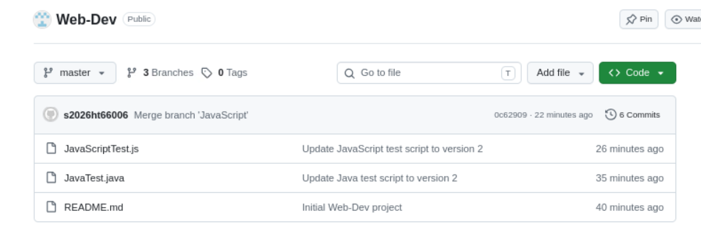
Figure 1 – GitHub Web-Dev master branch showing README.md, JavaTest.java and JavaScriptTest.js.
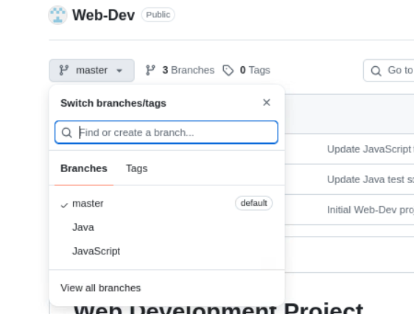
Figure 2 – GitHub branch selector showing master, Java and JavaScript.

15. Final Result
Case 1 was completed successfully. The Web-Dev repository was initialized, Java and JavaScript branches were created and developed independently, both branches were merged into master, and master, Java and JavaScript were pushed to GitHub. The final GitHub repository contains the three branches and the merged project files.

