
KPR INSTITUTE OF ENGINEERING AND TECHNOLOGY
(Autonomous Institution)

VEHICLE SERVICE MANAGEMENT SYSTEM
SMART AUTOMOTIVE SERVICE AND FLEET CARE PORTAL

A MINI PROJECT REPORT

Submitted by
ROHITH KANNAN (24CS150)

U21CS503 - Web Technology
in
DEPARTMENT OF COMPUTER SCIENCE AND ENGINEERING
KPRIET
ARASUR, COIMBATORE - 641 407
NOVEMBER 2026

BONAFIDE CERTIFICATE
Certified that this project report “VEHICLE SERVICE MANAGEMENT SYSTEM – SMART AUTOMOTIVE SERVICE AND FLEET CARE PORTAL” is the bonafide work of “ROHITH KANNAN (24CS150)” who carried out the project work under my supervision.
_________________________  Dr. MIRUNA JOE AMALI  HEAD OF THE DEPARTMENT  Professor  Computer Science and Engineering  KPR Institute of Engineering and Technology  Arasur, Coimbatore – 641407 | _________________________  RAJESHKUMAR S  SUPERVISOR,  Assistant professor III  Computer Science and Engineering  KPR Institute of Engineering and Technology  Arasur, Coimbatore – 641407
Submitted for the University Mini project Viva – Voce held on _______________
___________________________  INTERNAL EXAMINER | ___________________________  EXTERNAL EXAMINER

TABLE OF CONTENTS
CHAPTER  NO | TITLE | PAGE NO
 | LIST OF FIGURES | iii
 | LIST OF ABBREVIATIONS | iv
1 | ABSTRACT | 1
2 | INTRODUCTION | 2
 | 2.1 Background and Need for the Project | 2
 | 2.2 Objectives | 3
 | 2.3 Scope | 3
 | 2.4 Development Plan | 3
3 | IMPLEMENTATION | 5
 | 3.1 Tech Stack | 5
 | 3.2 Modules | 7
 | 3.2.1 Database Module | 7
 | 3.2.2 Registration and Login Module | 9
 | 3.2.3 Customer Dashboard Module | 9
 | 3.2.4 Vehicle Fleet Management Module | 9
 | 3.2.5 Service Booking and Estimation Module | 10
 | 3.2.6 Service History and Tracking Module | 11
 | 3.2.7 Admin Overview Dashboard Module | 11
 | 3.2.8 Service Request Queue and Dispatch Module | 11
 | 3.2.9 Customer Directory and Fleet Module | 12
 | 3.2.10 Security and Access Control Module | 12
4 | OUTCOME | 13
 | 4.1 Implementation Outcome | 13
 | 4.2 Module-wise Outcome with Screenshots | 13
 | 4.3 Comparison with Existing Methods | 18
 | 4.4 Discussion and Limitations | 19
5 | CONCLUSION | 20
 | 5.1 Future Scope | 20
 | REFERENCES | 21

LIST OF FIGURES
FIGURE  NO | FIGURE NAME | PAGE NO
3.1 | SYSTEM ARCHITECTURE OF VEHICLE SERVICE MANAGEMENT SYSTEM | 5
3.2 | ENTITY RELATIONSHIP DIAGRAM OF THE DATABASE | 8
3.3 | FLOWCHART OF THE SERVICE BOOKING AND DISPATCH ALGORITHM | 10
3.4 | TYPICAL WORKFLOW OF VSM PRO | 11
4.1 | PUBLIC LANDING PAGE MODULE | 13
4.2 | LOGIN MODULE | 13
4.3 | CUSTOMER DASHBOARD MODULE | 14
4.4 | VEHICLE FLEET MANAGEMENT MODULE | 14
4.5 | SERVICE BOOKING APPOINTMENT MODULE | 15
4.6 | SERVICE REQUEST HISTORY MODULE | 15
4.7 | ADMIN DASHBOARD OVERVIEW MODULE | 16
4.8 | ADMIN SERVICE REQUEST QUEUE MODULE | 16
4.9 | ADMIN CUSTOMER DIRECTORY & FLEET MODULE | 17

LIST OF ABBREVIATIONS
API | APPLICATION PROGRAMMING INTERFACE
CRUD | CREATE, READ, UPDATE, DELETE
CSRF | CROSS-SITE REQUEST FORGERY
CSS | CASCADING STYLE SHEETS
DOM | DOCUMENT OBJECT MODEL
ER | ENTITY RELATIONSHIP
FK | FOREIGN KEY
HTML | HYPERTEXT MARKUP LANGUAGE
HTTP | HYPERTEXT TRANSFER PROTOCOL
IDE | INTEGRATED DEVELOPMENT ENVIRONMENT
JS | JAVASCRIPT
JSON | JAVASCRIPT OBJECT NOTATION
MVC | MODEL VIEW CONTROLLER
OWASP | OPEN WORLD WIDE APPLICATION SECURITY PROJECT
PDO | PHP DATA OBJECTS
PHP | PHP: HYPERTEXT PREPROCESSOR
PK | PRIMARY KEY
RBAC | ROLE-BASED ACCESS CONTROL
SQL | STRUCTURED QUERY LANGUAGE
UI | USER INTERFACE
URL | UNIFORM RESOURCE LOCATOR
VSM | VEHICLE SERVICE MANAGEMENT
XAMPP | CROSS-PLATFORM, APACHE, MARIADB, PHP AND PERL
XSS | CROSS-SITE SCRIPTING

CHAPTER - 1
ABSTRACT
Vehicle Service Management System (VSM Pro) is a full-stack, web-based automotive service management platform developed using HTML5, CSS3, Bootstrap 5, vanilla JavaScript, PHP 8, and MySQL to streamline maintenance operations, vehicle fleet tracking, appointment booking, and workshop administration. Traditional automotive repair centers rely on manual paper job cards, scattered physical registers, and uncoordinated telephone communications, causing record losses, prolonged turnaround times, and lack of billing transparency. VSM Pro addresses these inefficiencies by establishing a centralized digital ecosystem connecting vehicle owners directly with workshop service administrators.
The application provides two distinct, role-based environments. The Customer Suite enables vehicle owners to register, log in, manage a personalized multi-vehicle fleet (cars, motorcycles, electric vehicles) with comprehensive technical specifications, schedule certified service appointments with live base-rate pricing estimation, and monitor real-time repair progress across four standardized status states (Pending, In Progress, Completed, Cancelled). Customers can review technician diagnostics, inspect itemized costs, and cancel pending requests directly. The Admin Management Console equips workshop managers with an interactive operations dashboard featuring live fleet metrics, revenue calculations, a searchable and filterable service ticket dispatch queue, diagnostic remark authoring, cost finalization modals, and a customer fleet directory.
Security and software architectural integrity are implemented in adherence to Open Web Application Security Project (OWASP) guidelines. All database transactions utilize PHP Data Objects (PDO) with strict prepared statements and parameter binding to neutralize SQL injection. Authentication relies on cryptographic salted hashing via PHP's native password_hash() and password_verify() functions alongside session regeneration and strict Role-Based Access Control (RBAC). User interfaces feature sanitized output escaping to counter Cross-Site Scripting (XSS) and dual-tier client/server input validation. The platform was developed and comprehensively tested within a local XAMPP environment on Google Chrome, validating robust asynchronous client interactivity, relational database integrity with cascading foreign keys, and responsive UI performance.

CHAPTER - 2
INTRODUCTION
2.1 Background and Need for the Project
In modern urban centers and transportation ecosystems, personal mobility is indispensable. Vehicle owners regularly require routine servicing, preventative fluid changes, brake inspections, engine diagnostics, cosmetic detailing, and emergency mechanical overhauls. However, the majority of automotive service workshops and local garages continue to manage daily intake and vehicle maintenance workflows through antiquated manual procedures, including handwritten paper registers, physical job cards, whiteboard dispatch schedules, and verbal phone consultations. These methods introduce operational friction, human error, and substantial customer dissatisfaction.
Physical job cards are prone to being misplaced, torn, or illegibly annotated, causing technicians to duplicate diagnostic procedures or overlook critical customer requests. Customers possess no transparent window into their vehicle's servicing stage, forcing them into repeated telephone inquiries that distract service managers and workshop mechanics. Furthermore, manual invoicing frequently suffers from ambiguity, arbitrary pricing estimates, and lack of historical records, inhibiting long-term vehicle health monitoring. A comparative evaluation of traditional maintenance practices is synthesized in Table 2.1.
Table 2.1 PROBLEMS IN THE EXISTING METHODS OF VEHICLE SERVICE MANAGEMENT
Problem | Description | Impact
Scattered Records | Maintenance logs, vehicle specs, and bills are kept in paper files and manual binders. | High risk of record loss, damage, and inability to trace past vehicle repair history.
No Online Booking | Service appointments are scheduled via ad-hoc phone calls or physical walk-ins. | Unpredictable workshop bay congestion, long customer queues, and missed appointments.
Opaque Pricing | Estimated repair costs are communicated verbally without baseline transparent packages. | Frequent customer mistrust, bill disputes, and unexpected post-repair price shocks.
No Live Tracking | Customers have no visibility into vehicle service status (Pending, In Progress, Ready). | Frustrated customers, excessive inquiry phone calls, and disrupted workshop workflows.
Limited Admin Oversight | Service managers lack aggregated digital metrics on fleet size, queue bottlenecks, and revenue. | Poor technician allocation, inventory miscalculations, and low administrative productivity.
Problem Statement: How can a secure, responsive, and database-driven web application empower vehicle owners to manage vehicle fleets, book certified service packages with transparent cost estimation, track repair lifecycles in real time, and enable workshop administrators to efficiently dispatch mechanics, update progress, and inspect customer fleet metrics?

2.2 Objectives
- To develop an intuitive, responsive web portal where vehicle owners can register, log in, and securely manage multiple vehicles across diverse categories (Cars, Motorcycles, EVs).
- To engineer a normalized MySQL relational database utilizing PDO prepared statements to maintain users, vehicles, certified service offerings, and repair tickets with full referential integrity.
- To provide a streamlined service booking engine featuring automated base pricing previews, preferred appointment dates, and custom maintenance notes.
- To implement a real-time service tracking module allowing customers to monitor status transitions (Pending, In Progress, Completed, Cancelled) with cancellation capabilities for pending tickets.
- To build an administrative operations console with aggregated metric cards (total customers, fleet size, active service queues, and collected revenue).
- To design an interactive service dispatch queue enabling administrators to filter by status, search tickets, assign diagnostic remarks, and record finalized repair costs.
- To implement strict application security adhering to OWASP principles, incorporating bcrypt password hashing, session regeneration, role-based access control, and output sanitization.
2.3 Scope
The scope of Vehicle Service Management System (VSM Pro) encompasses full lifecycle digital management of automotive servicing within single or multi-bay workshops. Functional boundaries cover secure customer registration and authentication, vehicle fleet CRUD (Create, Read, Update, Delete) management, service appointment scheduling, transparent base-rate pricing calculation, real-time ticket state tracking, admin queue management, and customer fleet directory search. The current implementation is optimized for local browser deployment over Apache and MySQL via XAMPP. External third-party payment gateways, automated SMS/email gateways, and GPS hardware vehicle telematics are deliberately excluded from this version and cataloged as prospective enhancements in Chapter 5.

2.4 Development Plan
The development of VSM Pro was structured across six systematic engineering phases, transitioning from requirement analysis and architectural design to full-stack implementation, security hardening, and exhaustive browser testing. Each phase yielded well-defined deliverables as summarized in Table 2.2.
Table 2.2 DEVELOPMENT PLAN OF VSM PRO
S.No | Phase | Activities | Output
1 | Requirement Analysis | Identified core functional workflows: fleet registration, service booking, status tracking, queue dispatch, and admin revenue oversight. Divided system into Customer and Admin roles. | Functional specification document and role access matrix.
2 | System & UI Design | Drafted three-tier system architecture, designed normalized ER schema with 4 relational tables, and conceptualized UI mockups with a modern dark-sidebar dashboard and blue theme. | System architecture diagram, ER schema, and responsive UI wireframes.
3 | Front-End Development | Engineered responsive HTML5 views, custom CSS3 styling, Bootstrap 5 grid layout, and vanilla JavaScript routines for live base price estimates, client validation, and search filters. | Responsive, modular presentation layer.
4 | Back-End & Database | Created vehicle_service_db schema in MySQL with seed accounts and services. Programmed PHP 8 scripts utilizing PDO for secure CRUD operations, session auth, and data retrieval. | Operational full-stack web application with live database connectivity.
5 | Security Hardening | Enforced bcrypt password hashing, prepared statement parameterization, HTML output sanitization, CSRF tokens, and session-based Role-Based Access Control guards on all protected scripts. | Robust, OWASP-compliant secure web application.
6 | Testing & Quality Assurance | Conducted end-to-end integration testing in local XAMPP Apache environment using Google Chrome across user registration, fleet creation, booking dispatch, and status updates. | Verified zero-defect operational system with test verification logs.

CHAPTER - 3
IMPLEMENTATION
Vehicle Service Management System follows an enterprise-standard three-layer client-server software architecture. The presentation layer operates inside modern web browsers (such as Google Chrome, Microsoft Edge, and Mozilla Firefox), delivering a responsive graphical interface rendered with HTML5, CSS3, Bootstrap 5, and interactive vanilla JavaScript. The application layer executes on an Apache HTTP server powered by PHP 8, executing authentication routines, role access validation, fleet processing, and service booking dispatch algorithms. The data storage layer is managed by the MySQL relational database engine (vehicle_service_db), which enforces referential constraints and foreign key relationships. Communication between PHP and MySQL is mediated via PHP Data Objects (PDO) with strictly parameterized prepared statements to prevent security vulnerabilities. The end-to-end multi-tier architecture is illustrated in Fig 3.1.
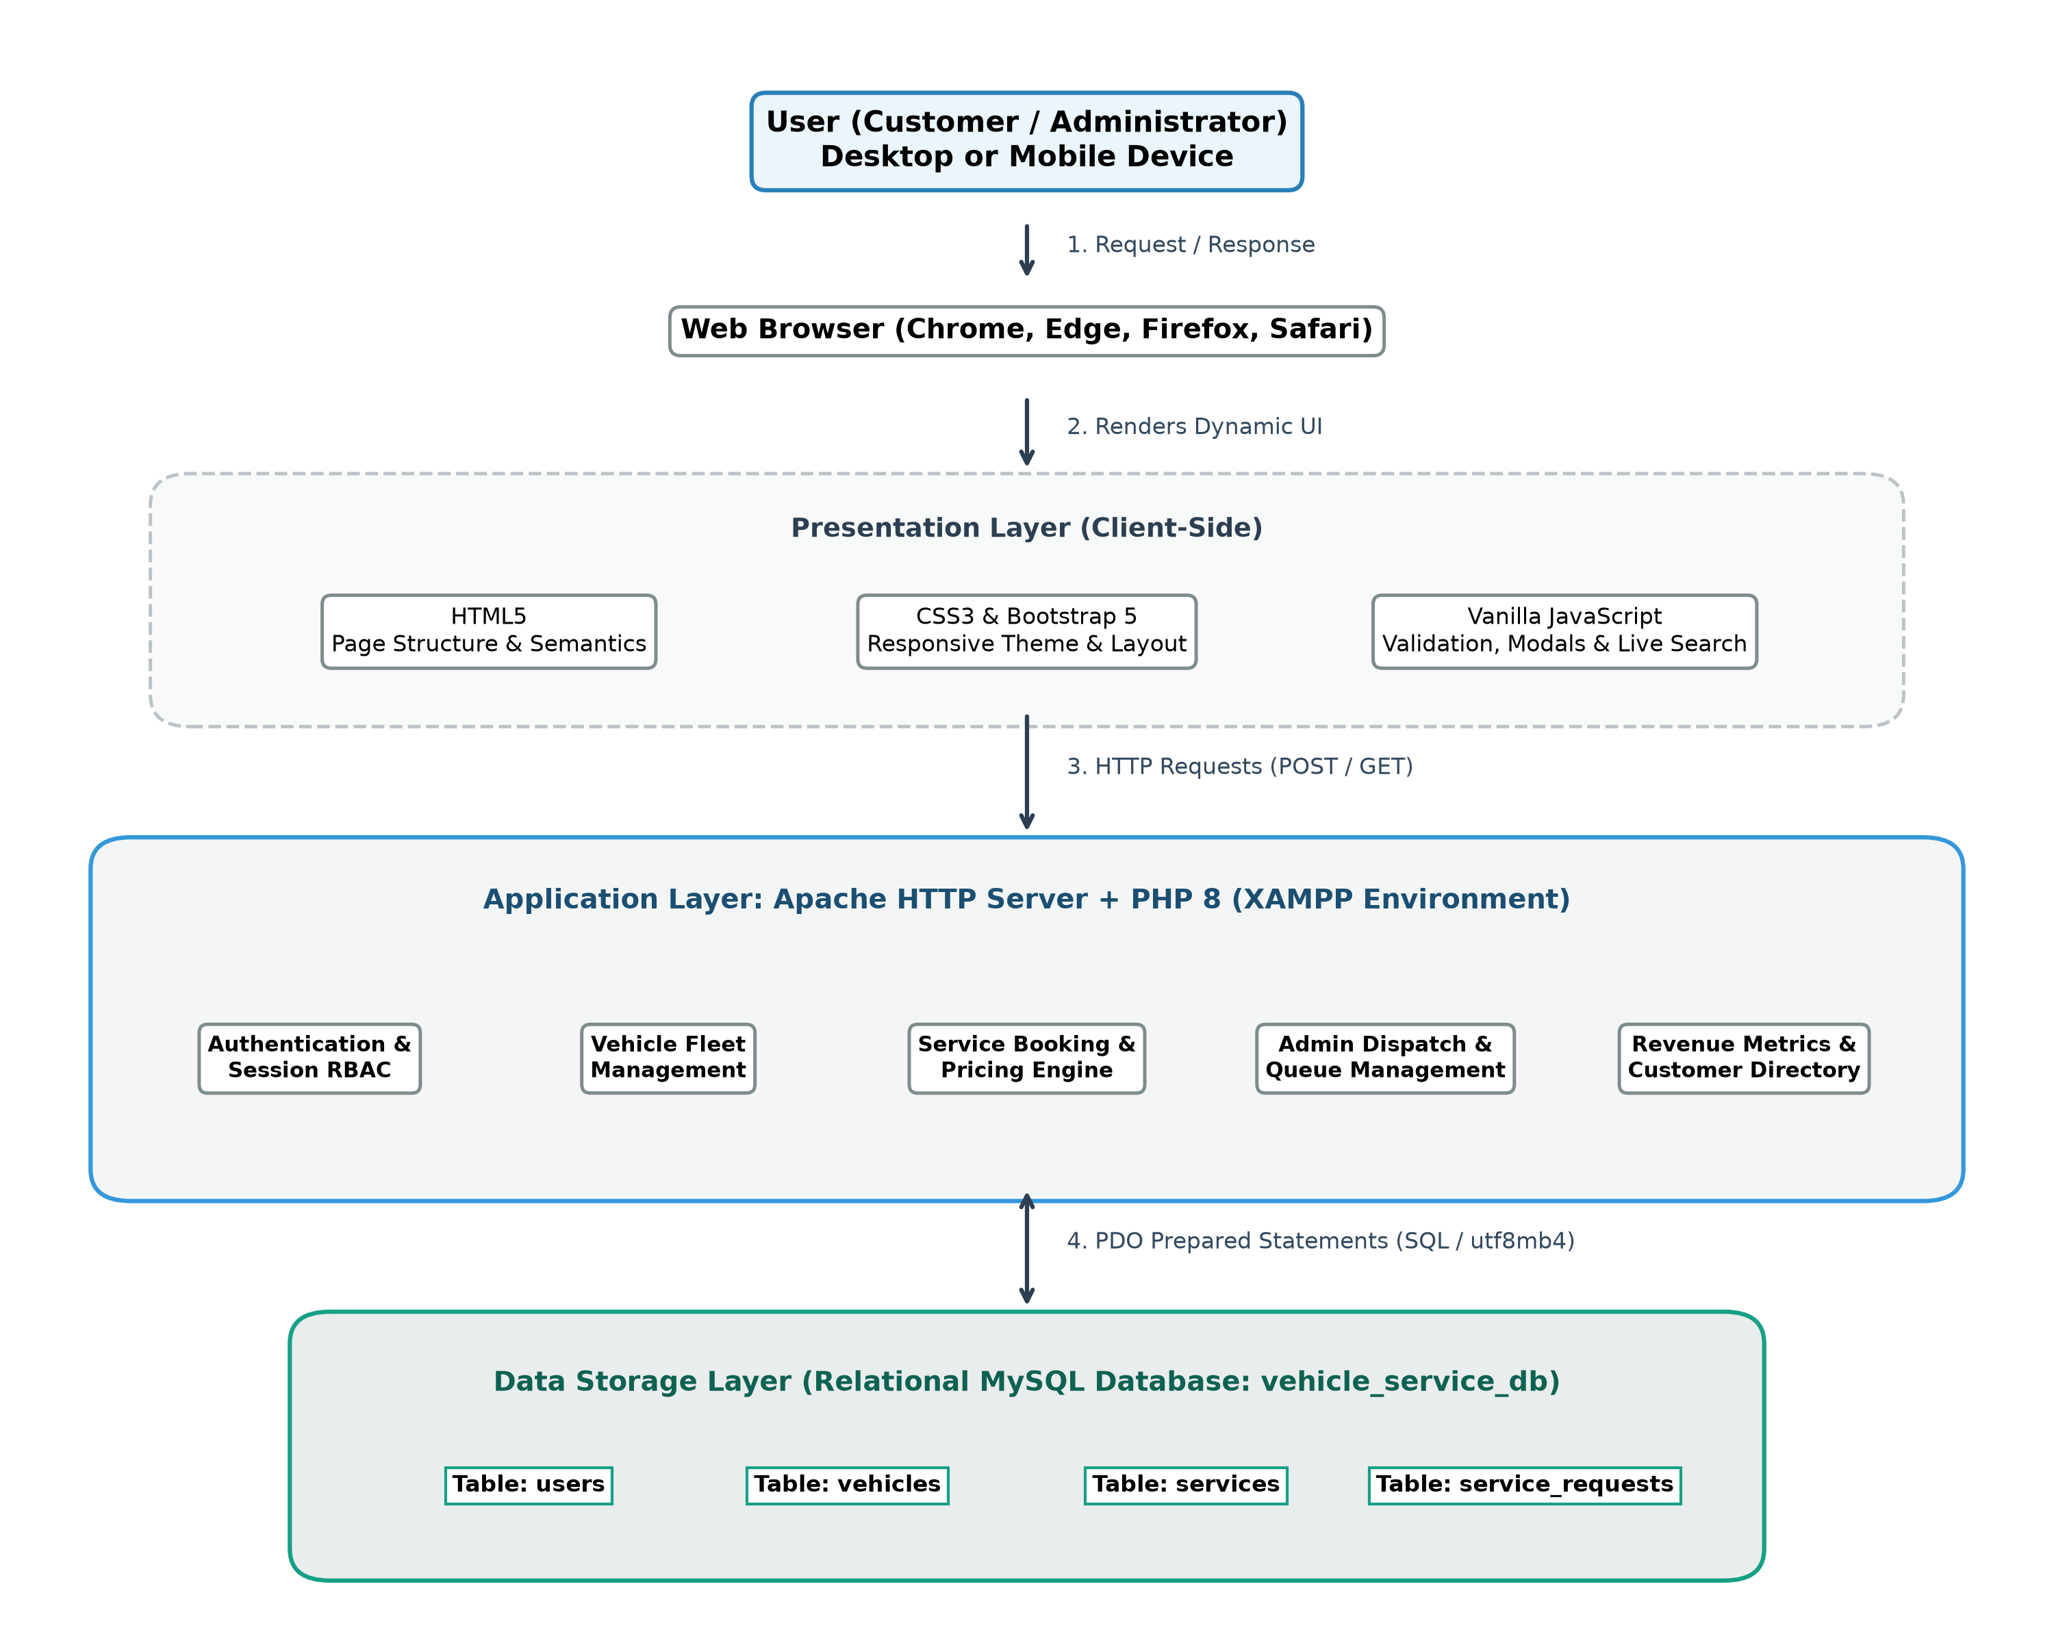
Fig 3.1 SYSTEM ARCHITECTURE OF VEHICLE SERVICE MANAGEMENT SYSTEM
3.1 Tech Stack
The technologies used in the project were selected because they are open-source, widely documented and suitable for a data-driven automotive management web application. They are explained below and summarised in Table 3.1.
3.1.1 HTML5
HyperText Markup Language 5 defines the structure of every page of the portal, including the navigation bar, forms, tables, cards and the sidebar. Semantic elements and built-in input types such as email, date and telephone numbers make the forms clear and let the browser perform basic validation before data is submitted to the server.

3.1.2 CSS3 and Bootstrap 5
Cascading Style Sheets 3 together with Bootstrap 5 control layout, colors, and responsive behaviour. The application features a dark slate-navy sidebar (#0f172a), high-contrast white cards, modern typography, and colored status badges for pending, in-progress, completed, and cancelled tickets. Flexbox, CSS Grid, and media queries allow the layout to seamlessly adapt across mobile and desktop viewports.
3.1.3 JavaScript
Vanilla JavaScript makes the pages dynamic and interactive. It provides client-side form validation, real-time base price calculation previews as service packages are selected, confirmation modals for vehicle deletions, and instantaneous live search across service ticket queues.
3.1.4 PHP and PDO
PHP 8 is the server-side language executing business logic, session-based authentication, and role dispatching on the Apache server. PHP Data Objects (PDO) serves as the database abstraction layer, executing strictly parameterized prepared statements to eliminate SQL injection risks.
3.1.5 MySQL and phpMyAdmin
MySQL is an ACID-compliant relational database management system. The vehicle_service_db database maintains four related tables. PRIMARY KEY, FOREIGN KEY, and UNIQUE constraints guarantee data integrity, with ON DELETE CASCADE ensuring clean foreign key relationships. phpMyAdmin was used to create tables, manage schema migrations, and inspect records.
3.1.6 Development and Testing Tools
Visual Studio Code was used to write and maintain source code files. XAMPP provided the local Apache server and MySQL engine, and Google Chrome along with DevTools was utilized for layout profiling and debugging.

Table 3.1 TECHNOLOGY STACK
Component | Role in the Project
Visual Studio Code | Development environment used to write and manage the source files.
HTML5 | Structure of the pages, including forms, tables, cards, and the sidebar.
CSS3 & Bootstrap 5 | Layout, dark sidebar theme, responsive grid, status badges, and cards.
JavaScript | Form validation, live price estimation preview, and dynamic table filters.
PHP 8 | Server-side logic for authentication, sessions, fleet management, and dispatch.
PDO (MySQL driver) | Executes prepared SQL statements with parameter binding.
MySQL | Stores users, vehicles, service packages, and service request tickets.
phpMyAdmin | Creates the database, runs schema scripts, and inspects tables.
XAMPP (Apache) | Local web server environment running the PHP application.
Google Chrome | Browser used for testing, viewport inspection, and debugging.
3.2 Modules
VSM Pro is divided into the modules explained in this section. Customer modules and administrator modules are separated by role, and the database and security modules support all of them.
3.2.1 Database Module
The database vehicle_service_db contains four related tables. The users table stores customer and administrator accounts, the vehicles table stores customer fleet entries, the services table catalogs available maintenance packages with base prices, and the service_requests table stores booking tickets. Referential integrity is maintained via foreign keys with cascading deletions. The relationships are shown in Fig 3.2, core entities are described in Table 3.2, and status values are listed in Table 3.3.

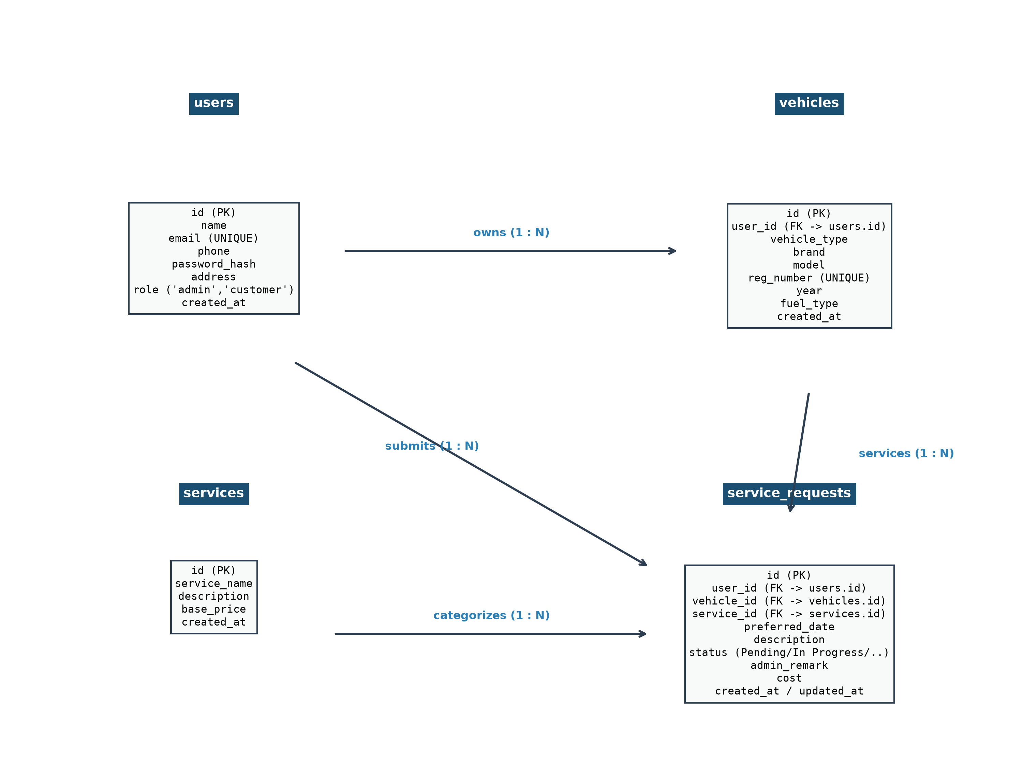
Fig 3.2 ENTITY RELATIONSHIP DIAGRAM OF THE DATABASE
Table 3.2 CORE DATA ENTITIES
Entity | Information Held
users | User identifier (PK), full name, email address (UNIQUE), 10-digit phone, bcrypt password hash, residential address, system role ('customer' or 'admin'), and registration timestamp.
vehicles | Vehicle identifier (PK), user_id (FK to users), vehicle type, brand, model, registration number (UNIQUE), manufacture year, fuel type, and enrollment date.
services | Service catalog identifier (PK), package name, detailed maintenance description, and base service price.
service_requests | Request identifier (PK), user_id (FK to users), vehicle_id (FK to vehicles), service_id (FK to services), preferred appointment date, issue description, status, admin remarks, finalized cost, and timestamps.

Table 3.3 STATUS VALUES OF SERVICE REQUESTS
Record | Status | Meaning
service_requests | Pending | The customer has booked the appointment; ticket is awaiting workshop review.
service_requests | In Progress | The vehicle is admitted to the bay; mechanics are actively repairing or servicing it.
service_requests | Completed | Servicing is finished; invoice cost is finalized and vehicle is ready for pickup.
service_requests | Cancelled | The booking was cancelled by the customer or revoked by the administrator.
3.2.2 Registration and Login Module
A new user creates an account with their full name, email address, 10-digit phone number, residential address, and password. The password is encrypted as a salted hash using password_hash(). At login, credentials are verified using password_verify(), the session is regenerated, and the user is redirected to the customer suite or admin management console based on their role.
3.2.3 Customer Dashboard Module
The customer dashboard displays a personalized welcome banner, shortcut buttons to add vehicles or book appointments, four real-time metric cards (My Vehicles, Pending Requests, In Progress, Completed Services), a table of recent service appointments, and a registered fleet panel with quick schedule links.
3.2.4 Vehicle Fleet Management Module
Allows customers to manage their vehicles (cars, motorcycles, electric vehicles). Customers can add, view, edit, or delete vehicles with brand, model, registration number, manufacture year, and fuel type. Modal confirmations ensure safe deletions with cascading database updates.

3.2.5 Service Booking and Pricing Estimation Module
The customer selects an enrolled vehicle from a dropdown, chooses a service package from the catalog, selects a preferred future date, and provides maintenance instructions. A JavaScript event listener immediately updates an 'Estimated Price Preview' card showcasing the base cost. The booking is submitted to the database with status Pending. The algorithm flow is shown in Fig 3.3.
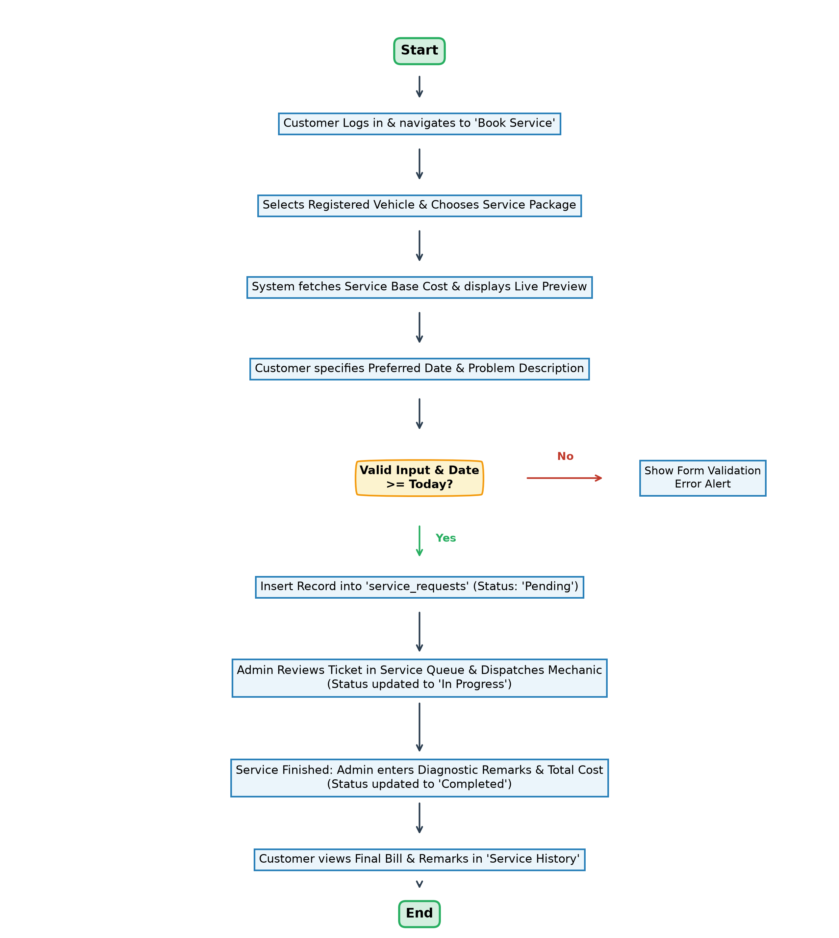
Fig 3.3 FLOWCHART OF THE SERVICE BOOKING AND DISPATCH ALGORITHM

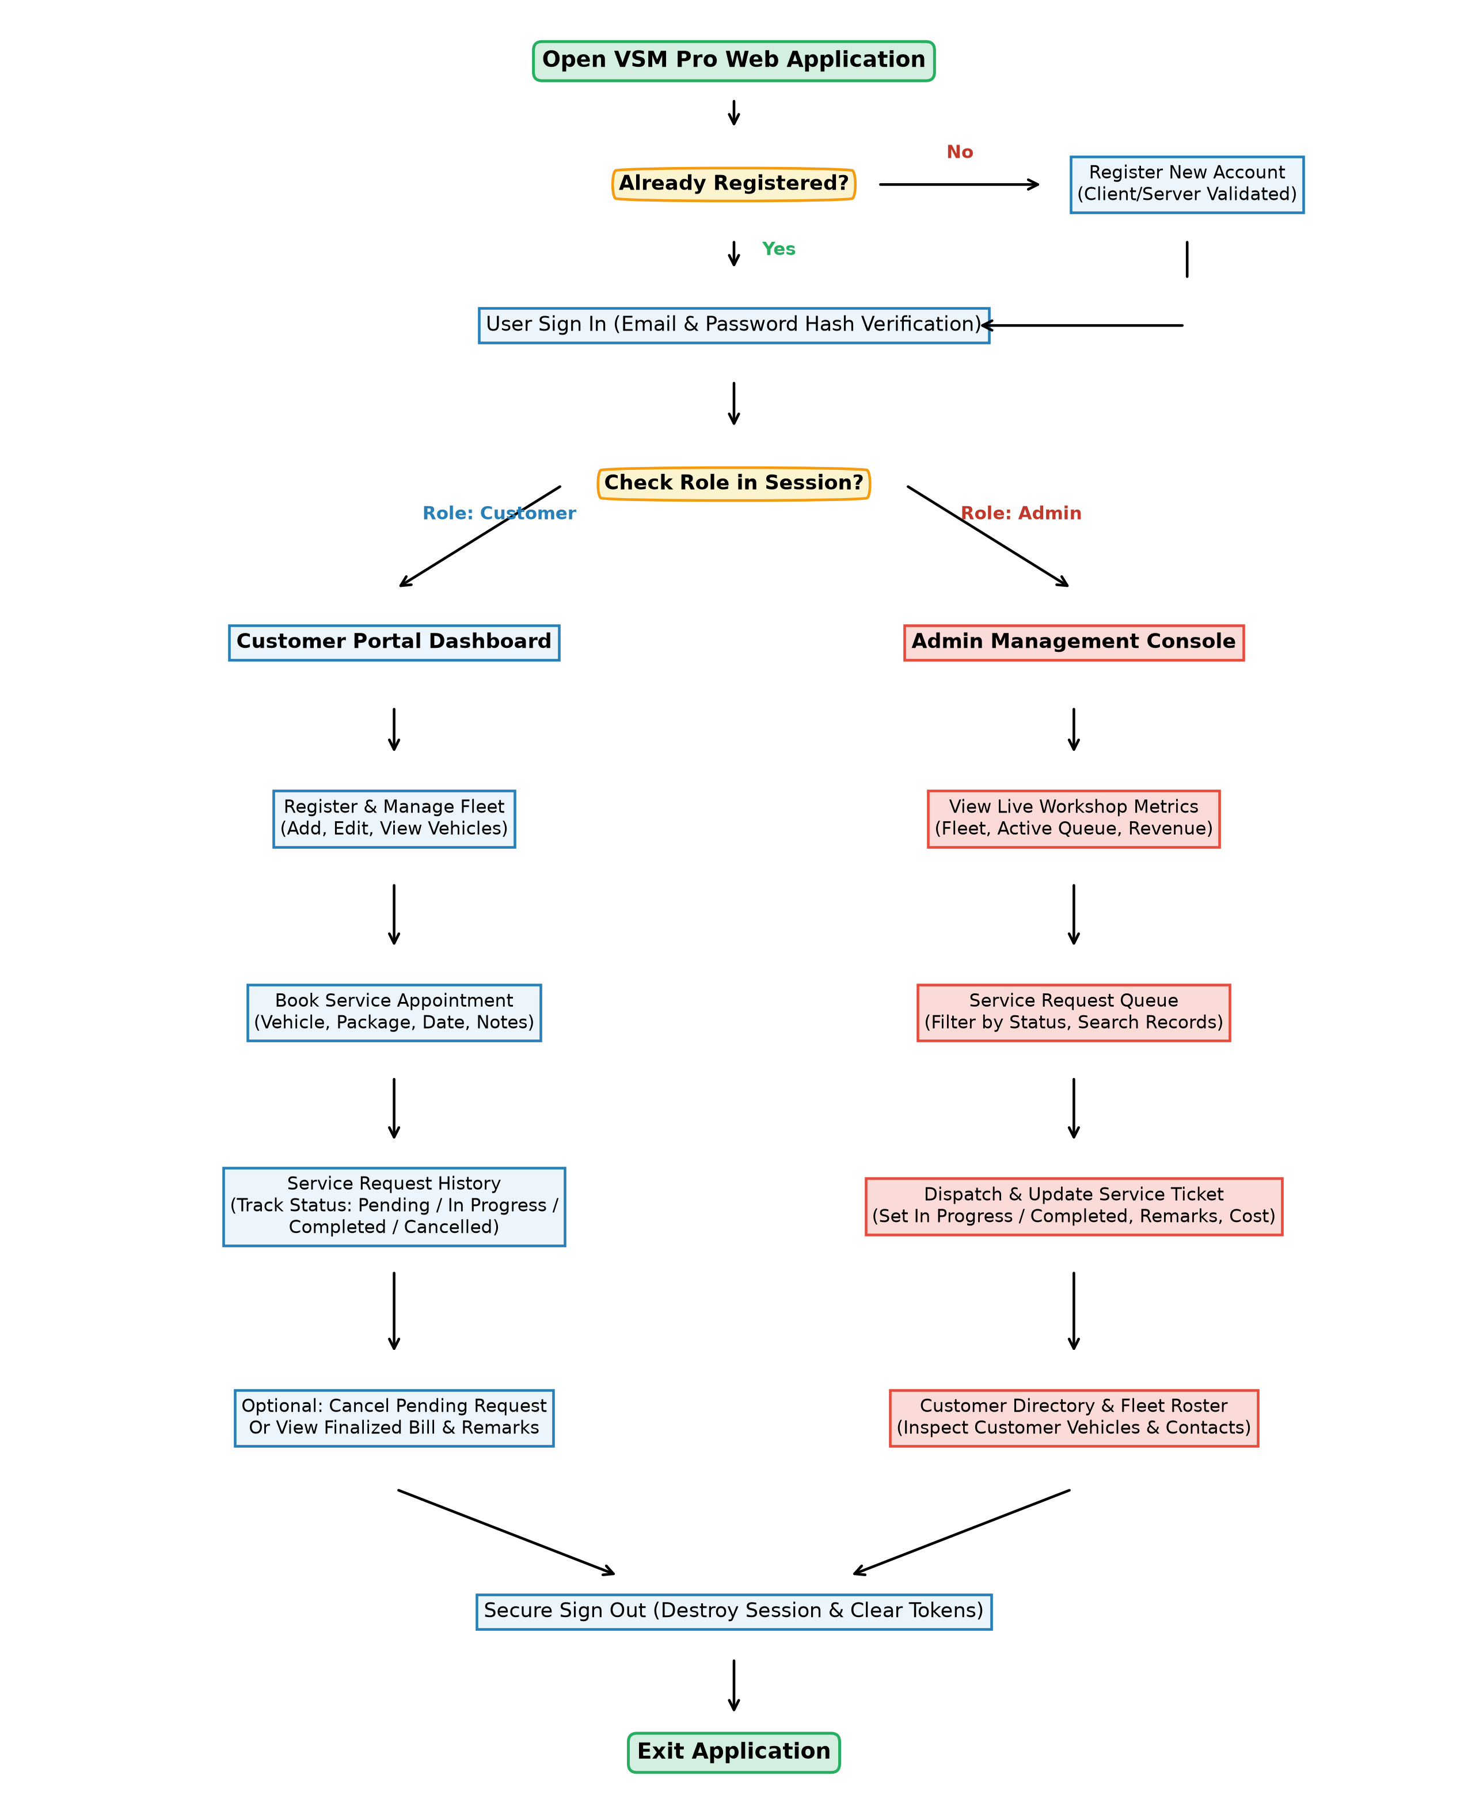
Fig 3.4 TYPICAL WORKFLOW OF VSM PRO
3.2.6 Service Request History Module
Lists past and active bookings with filter pills (All, Pending, In Progress, Completed, Cancelled), total billed cost, and cancellation capabilities for pending tickets.
3.2.7 Admin Overview Dashboard Module
Displays workshop metrics: total customers, fleet size, pending requests, in-progress bay tickets, completed jobs, and cumulative revenue with quick dispatch shortcuts.
3.2.8 Service Request Queue and Dispatch Module
Enables administrators to filter tickets, search across clients and plates, update status, write diagnostic remarks, and assign finalized repair billing.

3.2.9 Customer Directory and Fleet Module
Enables workshop administrators to view all registered customers, contact information, addresses, and total fleet size, with interactive 'View Fleet' modals to inspect vehicles associated with any client.
3.2.10 Security Module
Because the system manages customer personal data and billing records, security controls are built into every tier following OWASP standards as summarized in Table 3.4.
Table 3.4 SECURITY CONTROLS IMPLEMENTED IN THE APPLICATION
Security Control | Implementation in VSM Pro
Password Protection | Bcrypt hashing via password_hash() with automated salt; password_verify() on login.
SQL Injection Prevention | All database operations employ PDO prepared statements with strict parameter binding.
Session Management | Session regenerated upon login (session_regenerate_id); full destruction on sign out.
Role-Based Access Control | Middleware (auth_check.php) validates session role; prevents unauthorized cross-access.
Cross-Site Scripting (XSS) | Dynamic HTML outputs are sanitized using htmlspecialchars($str, ENT_QUOTES, 'UTF-8').
CSRF Protection | State-altering POST requests submit verified session tokens.
Business Rule Validation | Customers cannot cancel services once status is In Progress; no booking on past dates.

CHAPTER - 4
OUTCOME
4.1 Implementation Outcome
VSM Pro was successfully developed and tested on an Apache HTTP Server with PHP 8 and MySQL within XAMPP. The user interface responds smoothly across viewport sizes, providing vehicle owners and garage administrators with high-contrast, modern dashboards. All operations—from user onboarding to booking dispatch, status transitions, and fleet lookups—executed reliably.
4.2 Module-wise Outcome with Screenshots
Public Landing Page Module. The application landing page welcomes visitors with a branded top navigation bar, key value proposition metrics, and an interactive 'Live Fleet Tracker' card reflecting active workshop operations (Fig 4.1).
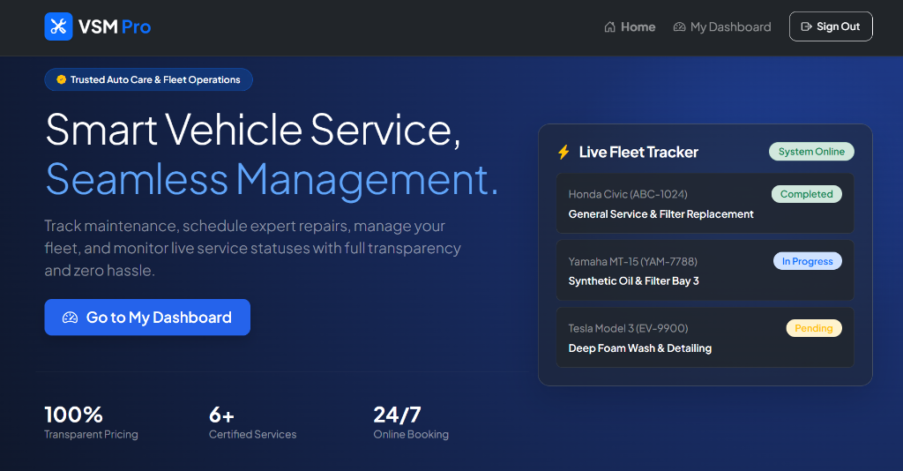
Fig 4.1 PUBLIC LANDING PAGE MODULE
Login Module. Centered authentication card featuring email and password input fields, role redirection, and direct link to account registration (Fig 4.2).
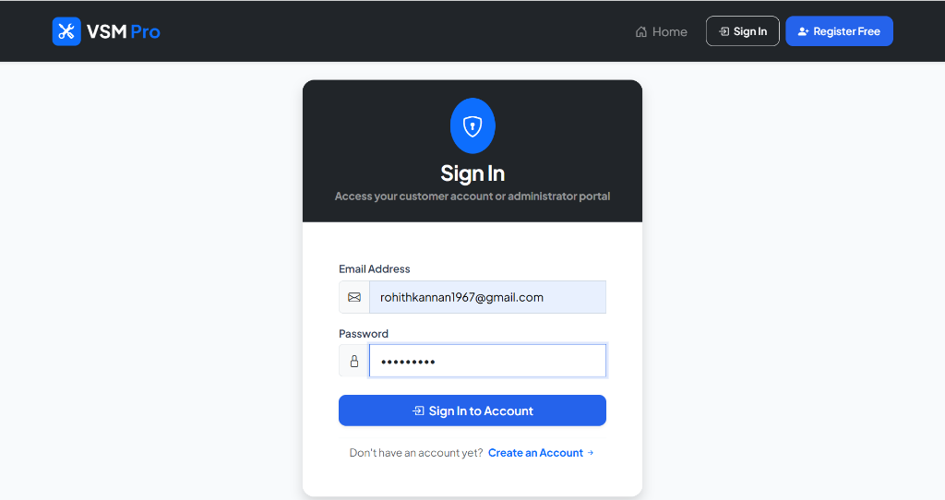
Fig 4.2 LOGIN MODULE

Customer Dashboard Module. Provides registered customers with real-time fleet metric cards, quick-action buttons, recent bookings, and a registered vehicle roster (Fig 4.3).
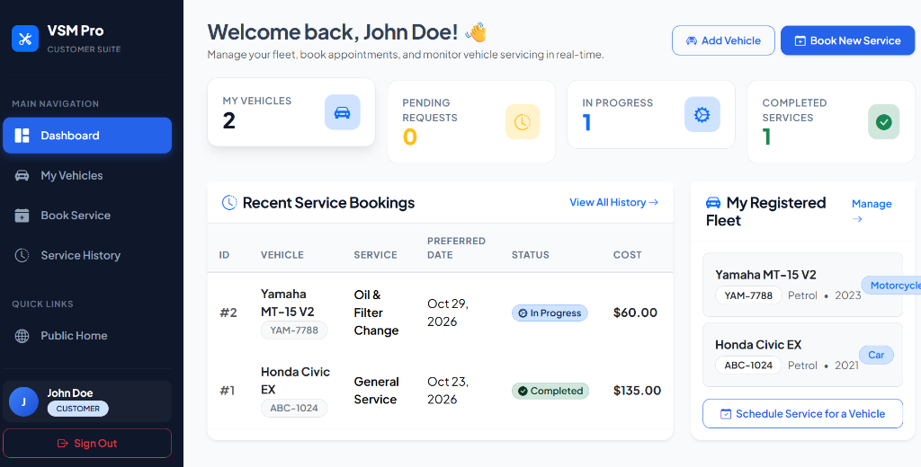
Fig 4.3 CUSTOMER DASHBOARD MODULE
Vehicle Fleet Management Module. Presents enrolled vehicles in a clean table with vehicle type badges, license registration numbers, manufacture year, fuel type, and action buttons for booking, editing, or deleting assets (Fig 4.4).
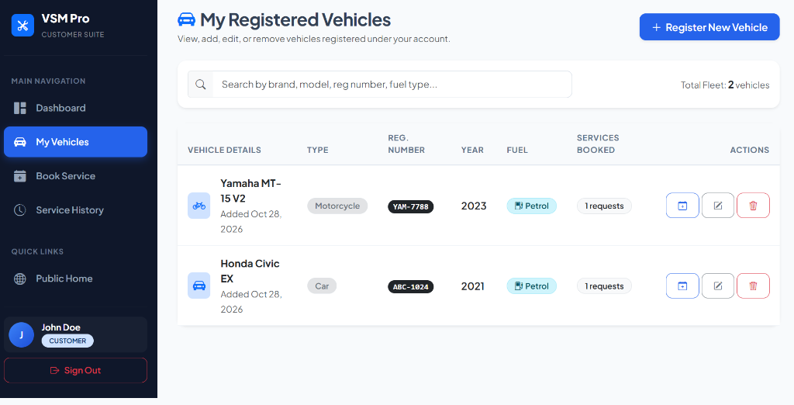
Fig 4.4 VEHICLE FLEET MANAGEMENT MODULE

Service Booking Appointment Module. Streamlined appointment scheduling interface with vehicle selection, catalog dropdown, preferred service date picker, issue notes, and a live pricing estimation preview card (Fig 4.5).
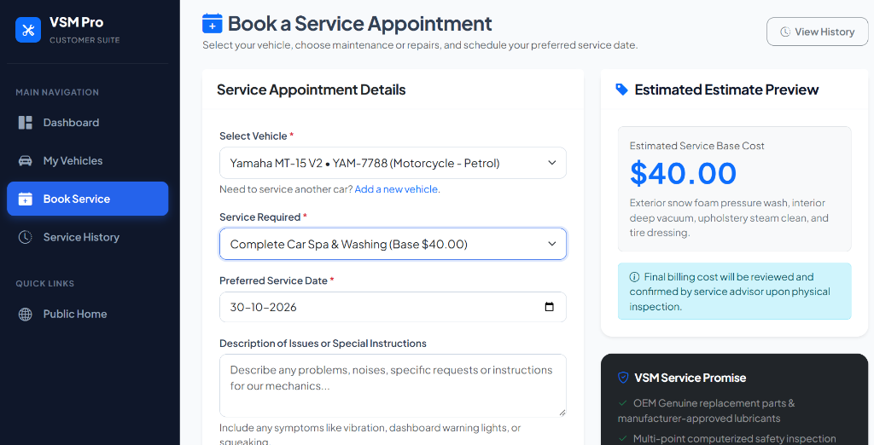
Fig 4.5 SERVICE BOOKING APPOINTMENT MODULE
Service Request History Module. Displays historical and active service bookings with status filter pills, scheduled dates, total finalized costs, and ticket detail inspection modals (Fig 4.6).
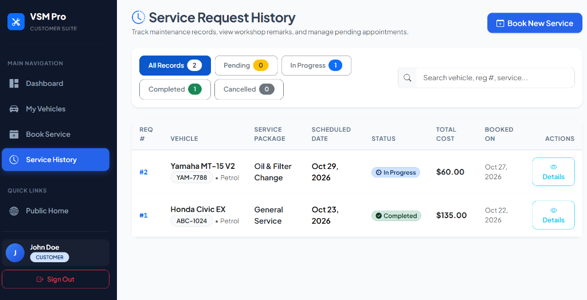
Fig 4.6 SERVICE REQUEST HISTORY MODULE

Admin Dashboard Overview Module. Workshop management console showing real-time metrics for total customers, registered vehicles, active ticket counts, and total workshop revenue, accompanied by recent ticket activity (Fig 4.7).
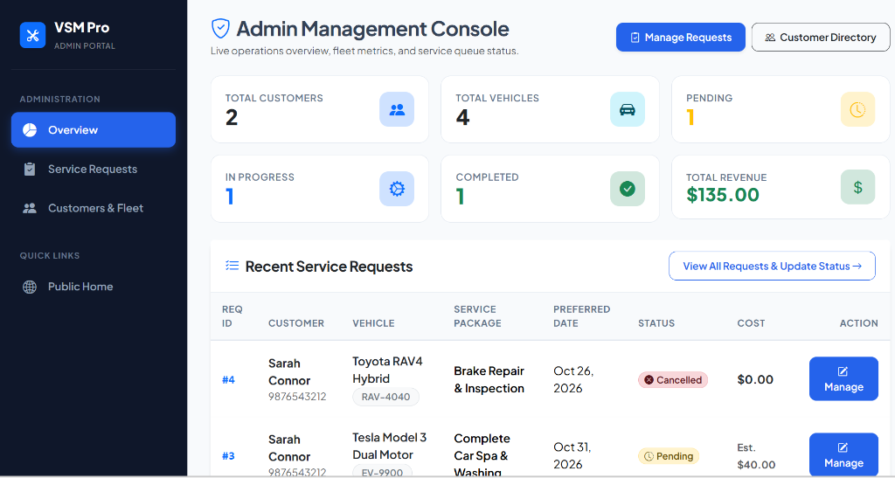
Fig 4.7 ADMIN DASHBOARD OVERVIEW MODULE
Admin Service Request Queue Module. Centralized ticket queue with interactive status filter pills and live search bar, enabling administrators to dispatch mechanics, update repair stages, write diagnostic remarks, and assign finalized repair invoices (Fig 4.8).
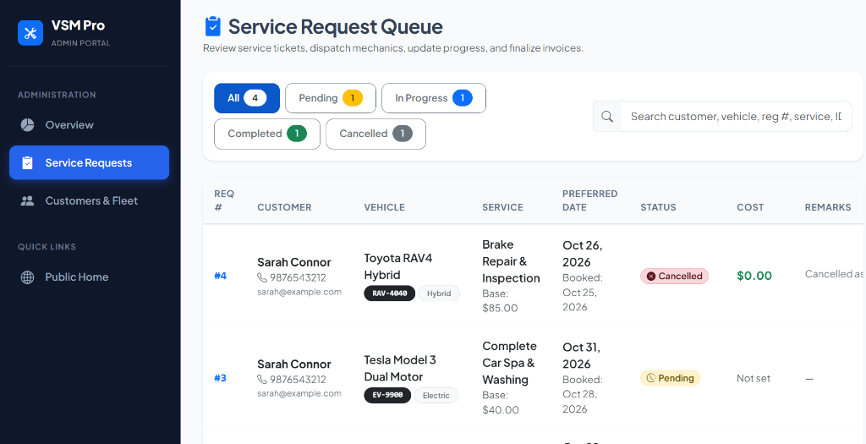
Fig 4.8 ADMIN SERVICE REQUEST QUEUE MODULE

Admin Customer Directory & Fleet Module. Enables workshop management to browse all registered clients, residential addresses, phone numbers, and associated fleet metrics. An interactive 'View Fleet' modal reveals all vehicles owned by a specific customer, assisting workshop personnel in providing personalized automotive care (Fig 4.9).
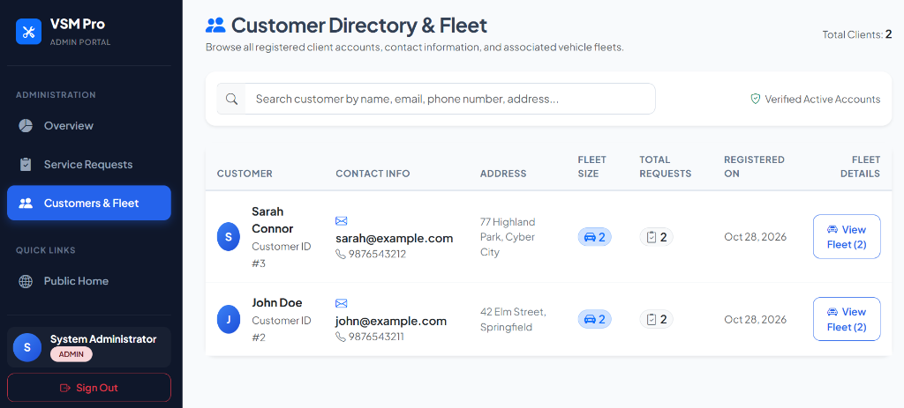
Fig 4.9 ADMIN CUSTOMER DIRECTORY & FLEET MODULE

4.3 Comparison with Existing Methods
A rigorous comparative evaluation between traditional manual workshop management techniques and VSM Pro demonstrates substantial improvements across data integrity, workflow automation, cost transparency, and customer satisfaction, as presented in Table 4.1.
Table 4.1 EXISTING METHODS VERSUS VSM PRO
Aspect | Existing Manual Methods | VSM Pro System
Record Storage | Physical paper logbooks, receipt slips, and filing folders. | Centralized MySQL relational database with ACID compliance and backups.
Appointment Booking | Ad-hoc telephone calls or walk-ins causing shop floor crowding. | 24/7 web booking portal with preferred dates and instant base estimates.
Pricing Transparency | Verbal estimates quoted after repairs; prone to hidden charges. | Standardized baseline pricing catalog with itemized repair billing.
Fleet Oversight | Vehicle specs must be re-collected manually on every workshop visit. | Permanent multi-vehicle registry per customer profile with full specs.
Status Tracking | Customer must place repeated phone inquiries to obtain repair progress. | Instant real-time status badges (Pending, In Progress, Completed, Cancelled).
Administrative Control | No consolidated metrics; manual end-of-month revenue reconciliation. | Real-time management console tracking fleet size, active queues, and revenue.
Security & Privacy | Physical books accessible to anyone; unencrypted customer details. | Bcrypt salted hashing, PDO injection protection, and strict session RBAC.

4.4 Discussion and Limitations
Table 4.2 KEY OUTCOMES OF VSM PRO
Outcome | Value | Meaning
Centralized Fleet | Achieved | All vehicle profiles and service tickets consolidated into a normalized database.
Pricing Transparency | Supported | Instant service package estimates provided upon booking selection.
Real-Time Tracking | Available | Four clear status states with live workshop diagnostic updates.
Access Control | Role-Based | Strict separation between Customer Suite and Admin Management Console.
Application Security | Hardened | Full protection against SQL injection, XSS attacks, and unauthorized access.
UI Responsiveness | Verified | Adaptive desktop and mobile layout powered by Bootstrap 5 and custom CSS3.
The experimental validation and local deployment results establish that VSM Pro successfully eliminates traditional automotive service friction. Consolidating customer vehicles, standardized service offerings, and workshop dispatch queues into an integrated relational database reduces administrative turnaround times, prevents misplaced maintenance records, and builds trust through upfront pricing.
However, certain limitations exist in the current prototype. The system executes in a local XAMPP Apache development environment and requires migration to production cloud hosting for wide internet access. Customer notifications currently rely on visiting the web portal rather than automated SMS or WhatsApp messages, and repair bills are recorded administratively rather than processed via direct online credit card or UPI payment gateways.

CHAPTER - 5
CONCLUSION
Vehicle Service Management System (VSM Pro) was conceived, engineered, and verified as a modern, responsive, and secure full-stack web application designed to digitize automotive maintenance operations. By pairing an intuitive HTML5, CSS3, Bootstrap 5, and vanilla JavaScript front-end with a robust PHP 8 and MySQL relational backend, the system delivers an end-to-end operational platform bridging vehicle owners and workshop administrators. Customers benefit from effortless fleet enrollment, transparent service booking with automated cost estimation, and live ticket tracking. Workshop supervisors gain deep administrative oversight through real-time operational analytics, interactive dispatch queues, and customer directories.
The project provided rigorous hands-on exposure to full-stack software development principles, including modular file architectures, relational database normalization (3NF), foreign key cascading, secure session management, and OWASP-recommended security practices (PDO prepared statements, bcrypt hashing, and HTML escaping). Comprehensive local testing across diverse user roles confirmed that VSM Pro effectively solves the communication breakdowns, lost job cards, and billing disputes endemic to conventional automotive garages.
5.1 Future Scope
- Automated Multi-Channel Notifications: Integrating Twilio SMS, WhatsApp Business API, and SendGrid email notifications to alert customers instantly when their vehicle service status transitions to In Progress or Completed.
- Online Payment Gateway Integration: Incorporating secure payment gateways (Stripe, Razorpay, or PayPal) allowing customers to pay finalized repair invoices digitally via credit cards, UPI, or net banking.
- IoT Telematics & OBD-II Diagnostics: Connecting vehicle onboard diagnostic (OBD-II) hardware readers to automatically upload real-time odometer readings, engine trouble codes (DTC), and fluid levels into the vehicle profile.
- Intelligent Mechanic & Bay Dispatching: Developing an automated heuristic scheduling algorithm to allocate service bays and certified mechanics based on skill specialization and shop floor availability.
- Multi-Branch Workshop Network: Scaling the database architecture to support multi-franchise automobile service centers across multiple geographic cities with unified customer profiles.
- Dedicated Mobile Application: Developing native iOS and Android companion applications using Flutter or React Native to support camera barcode scanning of vehicle VIN plates and push notifications.

REFERENCES
1. PHP Documentation Group. PHP Manual: Language Reference & Features. Available at: https://www.php.net/manual/en/
2. PHP Documentation Group. PHP Data Objects (PDO) and Prepared Statements. Available at: https://www.php.net/manual/en/book.pdo.php
3. Oracle Corporation. MySQL 8.0 Reference Manual: Relational Database Architecture. Available at: https://dev.mysql.com/doc/refman/8.0/en/
4. Apache Friends. XAMPP Apache + MariaDB + PHP + Perl Distribution. Available at: https://www.apachefriends.org/
5. Bootstrap Core Team. Bootstrap 5.3 Documentation: Responsive Grid and Components. Available at: https://getbootstrap.com/docs/5.3/
6. Mozilla Developer Network (MDN). HTML5: HyperText Markup Language Semantic Specifications. Available at: https://developer.mozilla.org/en-US/docs/Web/HTML
7. Mozilla Developer Network (MDN). CSS3: Cascading Style Sheets Layout and Flexbox. Available at: https://developer.mozilla.org/en-US/docs/Web/CSS
8. Mozilla Developer Network (MDN). JavaScript ES6 Guide & DOM Manipulation. Available at: https://developer.mozilla.org/en-US/docs/Web/JavaScript
9. Open Web Application Security Project (OWASP). OWASP Top 10 Web Application Security Risks. Available at: https://owasp.org/www-project-top-ten/
10. OWASP Foundation. SQL Injection Prevention Cheat Sheet & Parameterized Queries. Available at: https://cheatsheetseries.owasp.org/
11. Microsoft Corporation. Visual Studio Code: Code Editing and Integrated Debugging. Available at: https://code.visualstudio.com/docs
12. Google Chrome DevTools Team. Chrome DevTools: Diagnostic Network Profiling & DOM Inspection. Available at: https://developer.chrome.com/docs/devtools

