A **Capstone** Project report submitted

in partial fulfillment of requirement for the award of degree

**BACHELOR OF TECHNOLOGY**

in

**SCHOOL OF COMPUTER SCIENCE AND ARTIFICIAL INTELLIGENCE**

by

**2203A52125 ROHITH MACHARLA**

Under the guidance of

**Dr.Ramesh Dadi**

Assistant Professor, School of CS&AI.



SR University, Ananthsagar,Warangal,Telagnana-506371

# SR University

Ananthasagar, Warangal.



## CERTIFICATE

This is to certify that this project entitled “” is the bonafied work carried out **ROHITH MACHARLA** as a Major Project for the partial fulfillment to award the degree BACHELOR OF TECHNOLOGY in School of Computer Science and Artificial Intelligence during the academic year 2024-2025 under our guidance and Supervision.

### Dr.Ramesh Dadi Dr. M.Sheshikala

Assistant Professor Professor & Head,

SR University School of CS&AI,

Anathasagar,Warangal SR University

Ananthasagar, Warangal.

**Reviewer-1 Reviewer-2**

Name: Name:

Designation: Designation:

Signature: Signature:

## CONTENTS

**S.NO. TITLE PAGE NO.**

1. DATASET
2. METHODOLOGY
3. RESULTS

# DATASET

**Project -1**

"Personalized Health Fitness Tracker," which aims to analyze a dataset containing health and fitness metrics to potentially predict or classify fitness-related outcomes. The dataset includes features such as age, gender, weight, height, heart rate metrics, workout type, and calories burned, among others. The notebook employs Python libraries like pandas, matplotlib, seaborn, and scikit-learn to perform data exploration, preprocessing, and model evaluation. The code snippet also includes a performance comparison of multiple machine learning models (XGBoost, Random Forest, SVM, and Decision Tree) using metrics like accuracy, precision, recall, and F1-score, visualized through bar plots. The primary goal appears to be developing a predictive model for personalized fitness tracking, leveraging the dataset's rich features.

**Project – 2**

The AGE AND GENDER PREDICTION implements a deep learning model for age and gender prediction using the UTKFace dataset of facial images. It employs TensorFlow and Keras to construct a convolutional neural network (CNN) for simultaneous binary gender classification (Male/Female) and age regression. The script handles dataset downloading via Kaggle, performs exploratory data analysis (EDA) with visualizations like age histograms and gender charts, preprocesses images, trains the model, and evaluates performance through accuracy, loss, and mean absolute error (MAE). Statistical tests (T-test, Chi-square) validate predictions, and external image testing demonstrates real-world utility, making it a robust solution for facial attribute prediction. This aligns with your prior interest in UTKFace-based age and gender prediction, where you explored similar CNN architectures.

**Project – 3**

The baby cry detection system using the Donate-a-Cry Corpus dataset, classifying cries into five categories (belly_pain, burping, discomfort, hungry, tired) with machine learning models in Google Colab. It extracts MFCC audio features, applies data augmentation to balance classes, and evaluates Random Forest, XGBoost, KNN, SVM, and Gradient Boosting models using accuracy, F1-score, confusion matrices, and cross-validation, providing a robust framework for audio-based cry classification. This connects to your interest in health-related predictive modeling, like the prior age/gender prediction project (April 14, 2025, 11:12), but shifts focus to audio processing for infant care applications.

# 

# 

# METHODOLOGY

**Project – 1**

**Dataset Preparation:** The dataset, personalized_health_fitness_dataset1.csv, has 1800 rows and 15 columns, with numerical (e.g., Age, BMI) and categorical (e.g., Gender) features. data.head(), data.shape, and data.describe() show structure and stats; data.info() reveals missing values, signaling preprocessing needs.

**Data Preprocessing:** Missing values in columns (e.g., Age, Gender) shown by data.info() require imputation (e.g., mean, mode). Skewness analysis, notably BMI (1.101836), suggests normalization to handle skewed data, improving model readiness.

**Feature Extraction:** Features like Weight, Calories_Burned, and Workout_Type are selected. Numerical features are prioritized, categorical ones need encoding (e.g., one-hot). BMI reflects prior feature engineering for modeling.

**Model Architecture:** XGBoost, Random Forest, SVM, and Decision Tree models target a categorical variable (e.g., Workout_Type). Ensemble models handle complexity, SVM suits high dimensions, and Decision Tree offers interpretability, set up via scikit-learn.

**Model Training:** Using train_test_split, models (xgb_clf, rf_clf, etc.) are trained on preprocessed features, with the test set held for evaluation, enabling performance comparison.

**Performance Evaluation:** Accuracy, precision, recall, and F1-score (weighted averages) are plotted in 2x2 matplotlib bar plots for the four models, highlighting performance for fitness tracker selection, with weighted metrics suggesting class imbalance.

**Project -2**

**Dataset Acquisition:** UTKFace dataset is downloaded via Kaggle, with image filenames parsed into a DataFrame for age and gender, visualized through sample images and distribution charts.

**Preprocessing:** Images are resized to 48x48, grayscaled, rescaled, and split (80/20) into training/testing, with a custom generator for gender and age labels.

**Feature Extraction:** CNN’s convolutional layers extract features like edges from 48x48 grayscale images, bypassing manual feature engineering.

**Model Architecture:** CNN with four Conv2D, three MaxPooling2D, and Dropout layers splits into sigmoid (gender) and linear (age) outputs, using Adam optimizer.

**Training:** Trained 100 epochs with batch size 64, saving history and weights, using a custom generator for dual outputs.

**Evaluation Metrics:** Gender accuracy/loss and age MAE plotted; statistical tests (T-test, Chi-square) validate predictions, with external image results contextualized.

**Project – 3**

**Dataset Preparation:** The Donate-a-Cry Corpus dataset, stored in Google Drive, contains audio files labeled by cry type. Features and labels are extracted, with sample counts per class printed to assess distribution.

**Preprocessing:** MFCCs, deltas, and delta-deltas are extracted from 16kHz audio, augmented (noise, pitch shift, time stretch) for minority classes, and downsampled for the 'hungry' class to balance data, followed by label encoding and feature normalization.

**Feature Extraction:** Extracts 120 features per audio (40 MFCCs, 40 deltas, 40 delta-deltas) using librosa, capturing spectral and temporal characteristics critical for cry classification.

**Model Architecture:** Five models—Random Forest, XGBoost, KNN, SVM, and Gradient Boosting—are configured with tuned hyperparameters (e.g., RF: 200 trees, XGBoost: max_depth=5), using class weights to handle imbalance.

**Model Training:** Models are trained on an 80/20 train-test split, with class weights applied; Random Forest and XGBoost incorporate feature importance analysis, enhancing interpretability.

**Performance Evaluation:** Accuracy and F1-scores are computed, visualized via confusion matrices, and validated with 5-fold cross-validation, summarizing model performance to identify the best classifier for cry detection.

**RESULTS**

**Project – 1 [Personalised Health Fitness Tracker]**

**SCATTER PLOT**

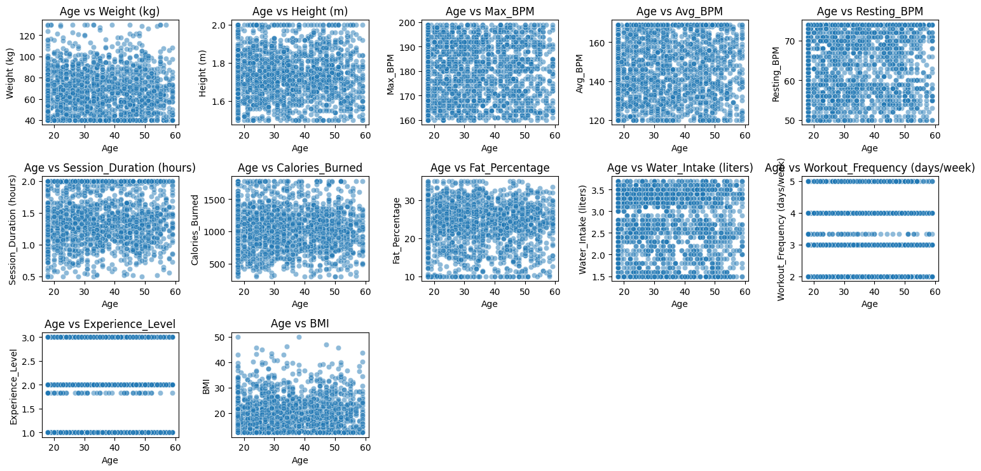

The image contains a 5x2 grid of scatter plots depicting the relationship between Age and various health/fitness metrics from a dataset. Each plot shows Age on the x-axis and metrics like Weight (kg), Height (m), Max BPM, Avg BPM, Resting BPM, Session Duration (hours), Calories Burned, Fat Percentage, Water Intake (liters), Workout Frequency (days/week), Experience Level, and BMI on the y-axis. The plots reveal trends, such as increasing variability in weight and calories burned with age, and discrete levels in experience, with dense data points indicating distribution patterns across age groups.

**HISTOGRAM**

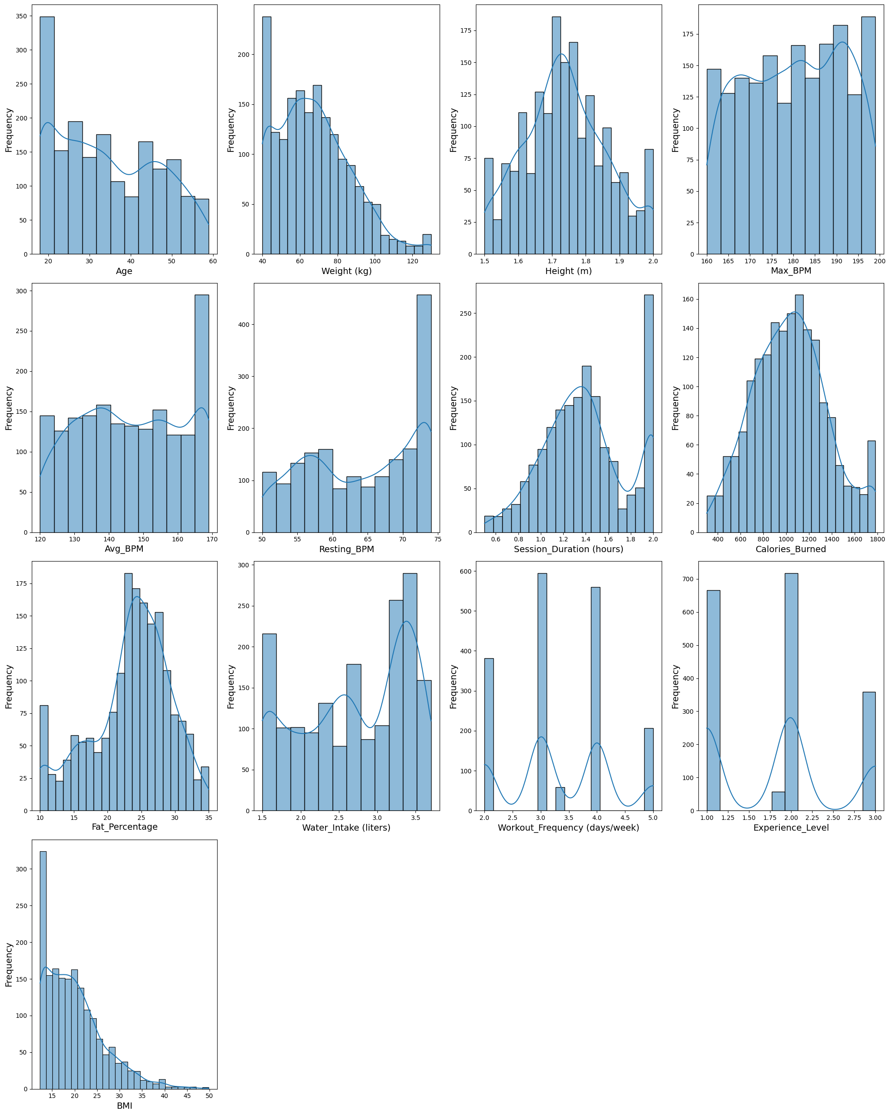

The image displays a 5x2 grid of histograms illustrating the frequency distributions of various health/fitness metrics from a dataset. Each histogram plots frequency against metrics such as Age, Weight (kg), Height (m), Max BPM, Avg BPM, Resting BPM, Session Duration (hours), Calories Burned, Fat Percentage, Water Intake (liters), Workout Frequency (days/week), and BMI, with overlaid curves highlighting distribution trends. The plots reveal the spread and central tendencies of these metrics, indicating, for example, a peak around 20-30 for Age and a right-skewed distribution for Calories Burned.

**BOX PLOT**

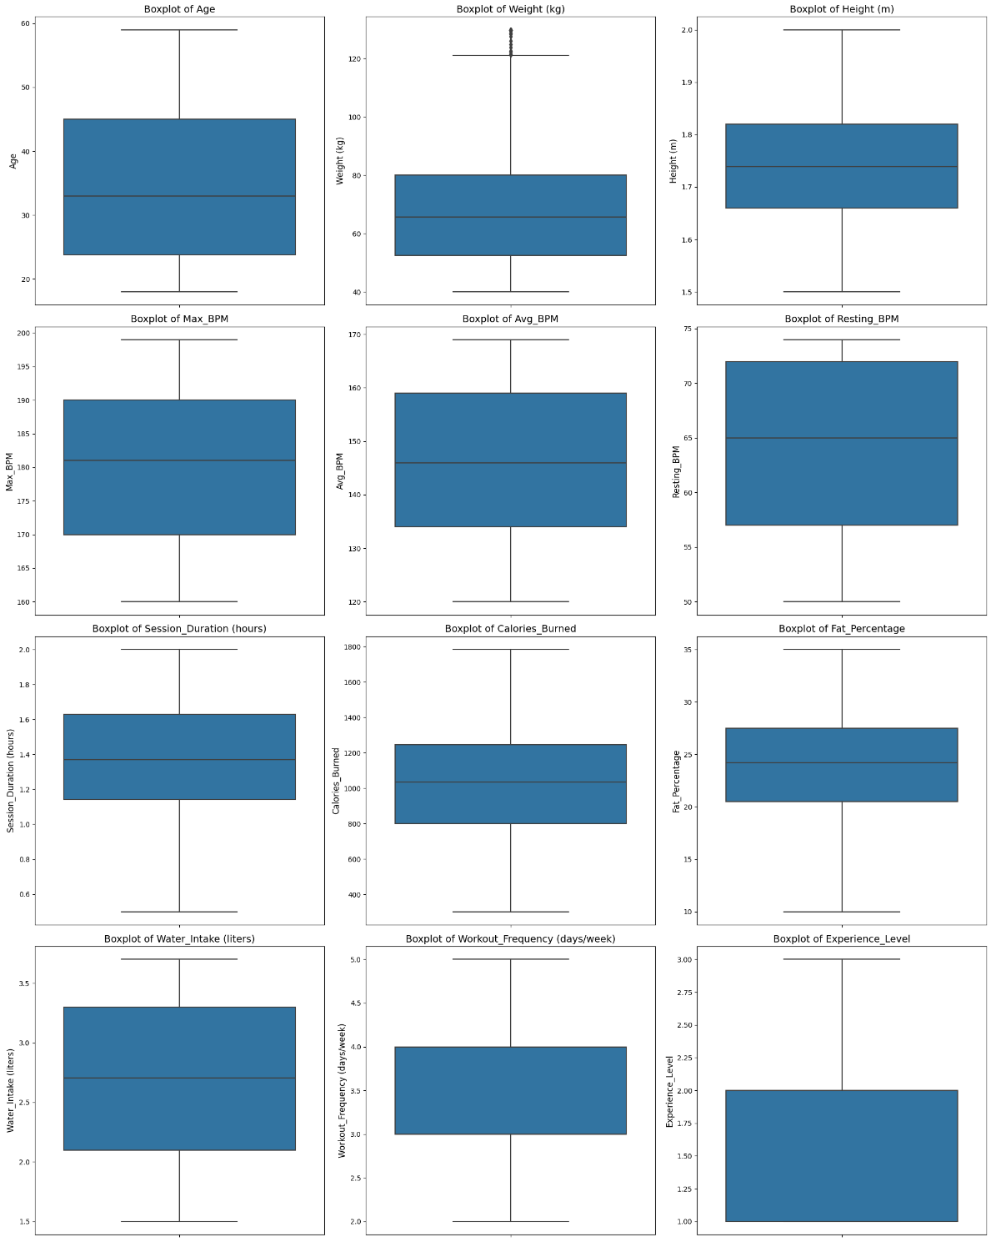

The image shows a 5x2 grid of boxplots summarizing the distribution of various health/fitness metrics from a dataset. Each boxplot represents metrics such as Age, Weight (kg), Height (m), Max BPM, Avg BPM, Resting BPM, Session Duration (hours), Calories Burned, Fat Percentage, Water Intake (liters), Workout Frequency (days/week), and Experience Level, displaying median, quartiles, and potential outliers. The plots indicate central tendencies and variability, with tight interquartile ranges for metrics like Height and wider ranges for Calories Burned, suggesting diverse data spread across the population.

**SVM (support vector machine):**

|  |  |  |  |  |
| --- | --- | --- | --- | --- |
|  | **Precision** | **recall** | **F1-score** | **support** |
| **0** | **0.49** | **0.70** | **0.58** | **47** |
| **1** | **0.55** | **0.58** | **0.56** | **50** |
| **2** | **0.75** | **0.56** | **0.64** | **54** |
| **3** | **0.70** | **0.57** | **0.63** | **49** |
| **accuracy** |  |  | **0.60** | **200** |
| **Macro avg** | **0.62** | **0.60** | **0.60** | **200** |
| **Weighted avg** | **0.63** | **0.60** | **0.60** | **200** |

**Decision Tree Classifier:**

| **Class** | **Precision** | **Recall** | **F1-Score** | **Support** |
| --- | --- | --- | --- | --- |
| **0** | **0.62** | **0.74** | **0.68** | **47** |
| **1** | **0.62** | **0.46** | **0.53** | **50** |
| **2** | **0.67** | **0.72** | **0.70** | **54** |
| **3** | **0.71** | **0.71** | **0.71** | **49** |
|  |  |  |  |  |
| **Accuracy** |  |  | **0.66** | **200** |
| **Macro Avg** | **0.66** | **0.66** | **0.65** | **200** |
| **Weighted Avg** | **0.66** | **0.66** | **0.65** | **200** |

**Random forest:**

| **Class** | **Precision** | **Recall** | **F1-Score** | **Support** |
| --- | --- | --- | --- | --- |
| **0** | **0.49** | **0.70** | **0.58** | **47** |
| **1** | **0.55** | **0.58** | **0.56** | **50** |
| **2** | **0.75** | **0.56** | **0.64** | **54** |
| **3** | **0.70** | **0.57** | **0.63** | **49** |
|  |  |  |  |  |
| **Accuracy** |  |  | **0.60** | **200** |
| **Macro Avg** | **0.62** | **0.60** | **0.60** | **200** |
| **Weighted Avg** | **0.63** | **0.60** | **0.60** | **200** |

**XG Boost:**

| **Class** | **Precision** | **Recall** | **F1-Score** | **Support** |
| --- | --- | --- | --- | --- |
| **0** | **0.63** | **0.72** | **0.67** | **47** |
| **1** | **0.69** | **0.68** | **0.69** | **50** |
| **2** | **0.78** | **0.72** | **0.75** | **54** |
| **3** | **0.81** | **0.78** | **0.79** | **49** |
|  |  |  |  |  |
| **Accuracy** |  |  | **0.72** | **200** |
| **Macro Avg** | **0.73** | **0.72** | **0.73** | **200** |
| **Weighted Avg** | **0.73** | **0.72** | **0.73** | **200** |

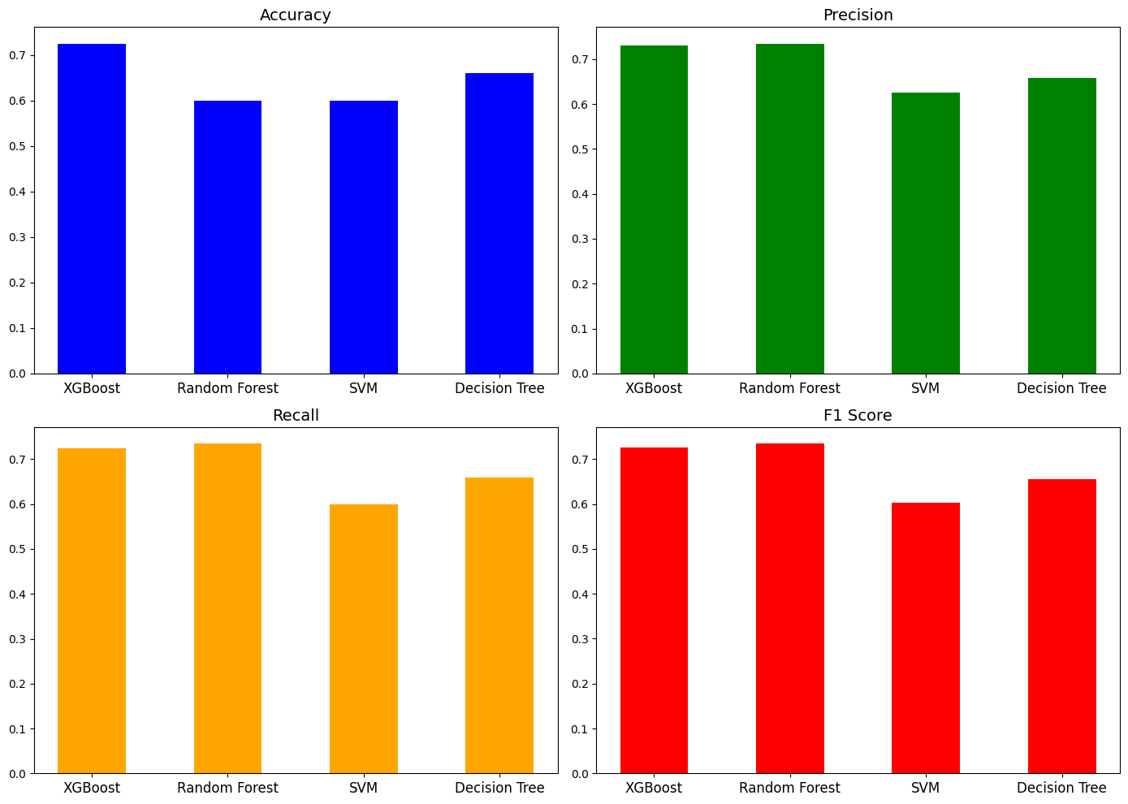

**Project – 2 [AGE AND GENDER PREDICTION]**

**HistPlot on Age Distribution**

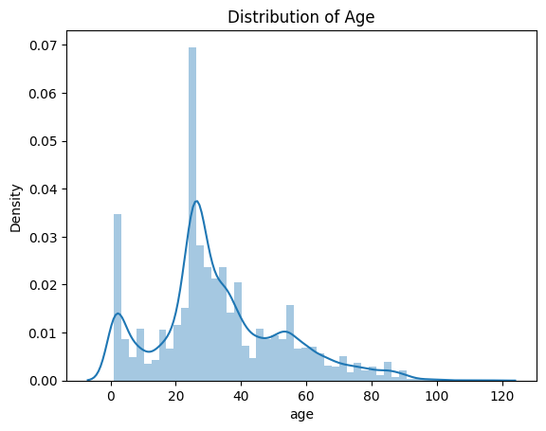

The plot titled "Distribution of Age" is a density histogram showing the distribution of age values in a dataset, with age on the x-axis (ranging from 0 to 120) and density on the y-axis (up to 0.07). It exhibits a bimodal distribution with peaks around 0-10 and 20-40 years, a significant drop around 10-20 years, and a gradual decline thereafter, with an overlaid curve highlighting the density trend, indicating a concentrationof younger individuals and a secondary peak in young adulthood.

**Gender Distribution**

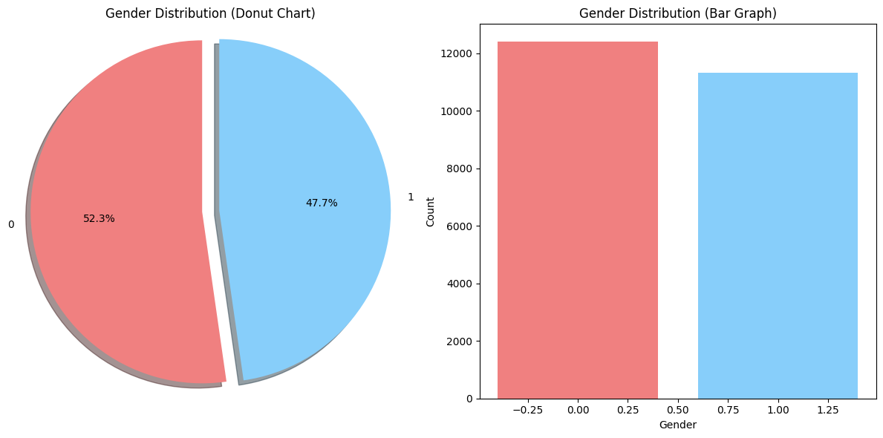

The image presents two visualizations of gender distribution: a donut chart and a bar graph. The donut chart shows 52.3% (red) for one gender and 47.7% (blue) for the other, with a white center creating a donut effect. The bar graph displays the same data with counts on the y-axis (up to 12,000) and gender on the x-axis (0 to 1), where the red bar (approximately 10,000) and blue bar (approximately 9,000) reflect the proportional split, confirming a slight majority for one gender.

**Accuracy and Loss Curves of Gender**

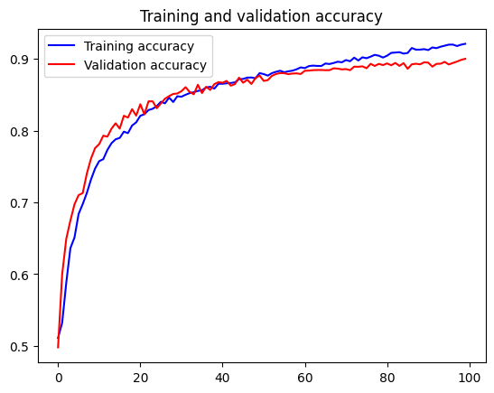 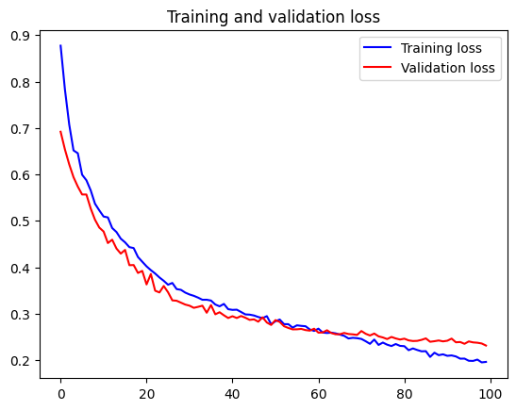

**Accuracy and Loss Curves of Age**

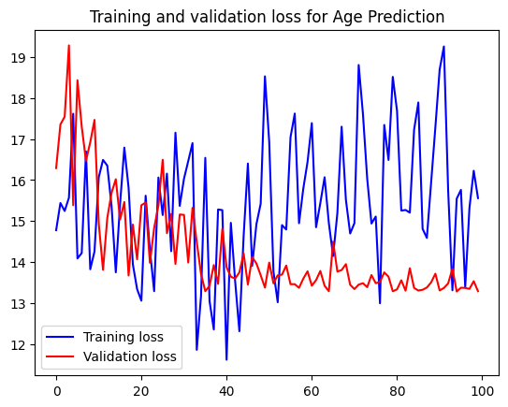 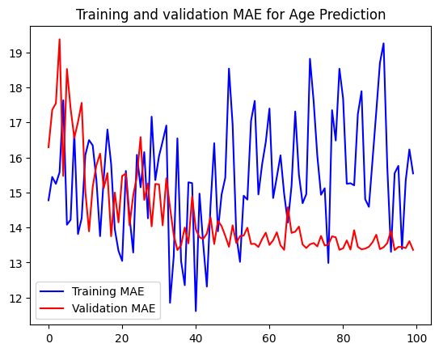

**Prediction by using the Model**

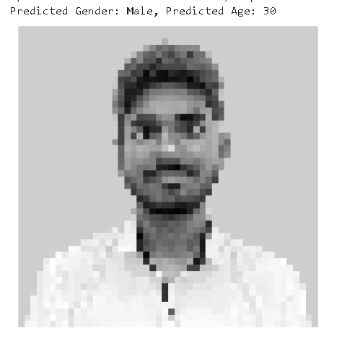

Statistical Analysis of Test Set Predictions

========================================

T-test: Difference in age prediction errors between genders

T-statistic: -0.467, P-value: 0.640

No significant difference in age prediction errors between male and female groups.

Chi-square: Association between predicted gender and binned predicted ages

Chi2 statistic: 0.000, P-value: 1.000, Degrees of freedom: 0

No significant association between predicted gender and binned predicted ages.

ANOVA: Differences in age prediction errors across true age ranges

F-statistic: 16423.793, P-value: 0.000

Significant differences in age prediction errors across true age ranges.

Z-test: Gender prediction accuracy vs. random guessing

Z-statistic: 54.724, P-value: 0.000

Gender prediction accuracy significantly better than random guessing.

External Image Prediction Context

Predicted Gender: Female, Test Set Accuracy for this Gender: 0.877

Predicted Age: 30, Test Set MAE for Similar Ages (±5 years): 3.450

**Project-3 [BABY CRY DETECTION]**

WAVEFORMS OF ALL THE CATEGORIES OF BABY CRIES

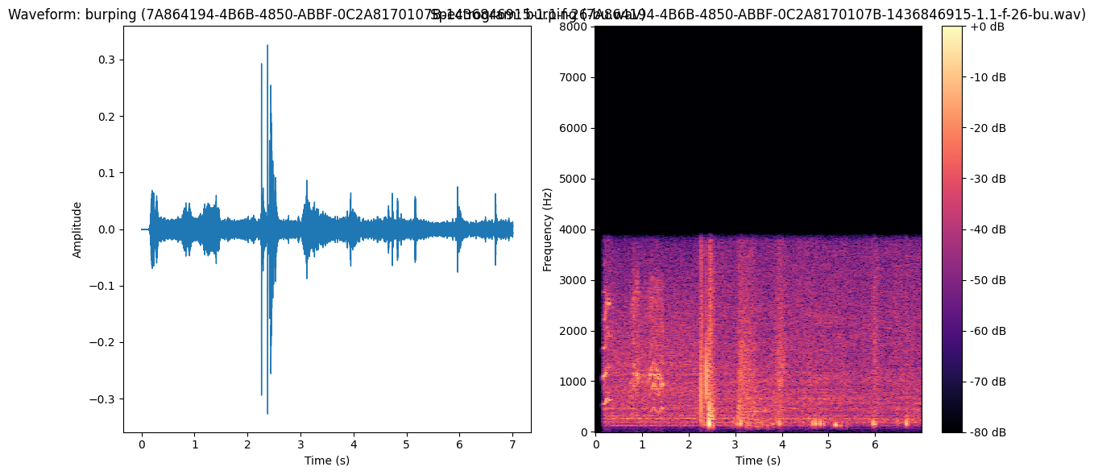

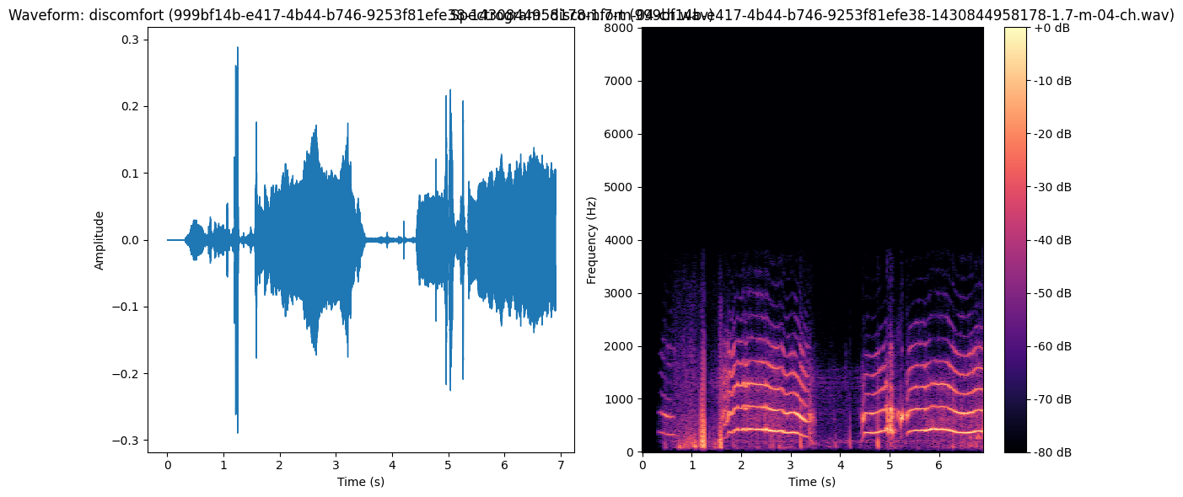

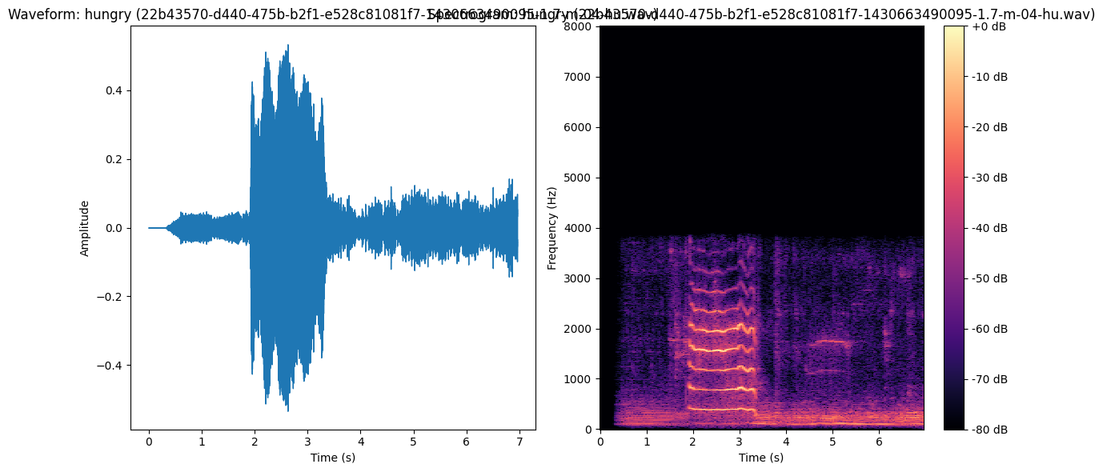

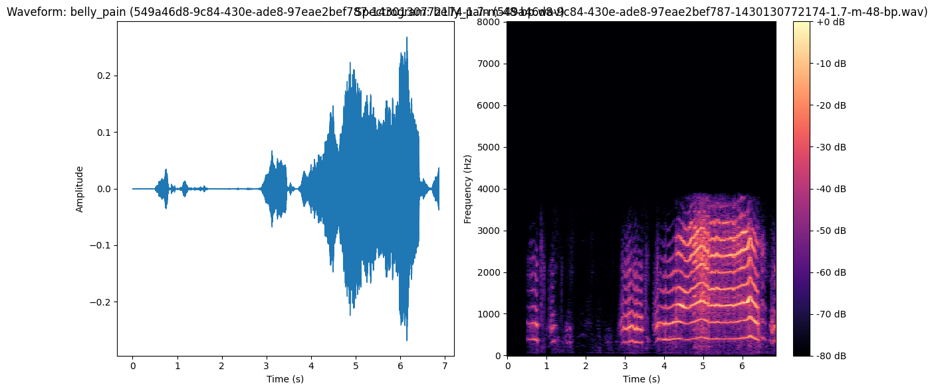

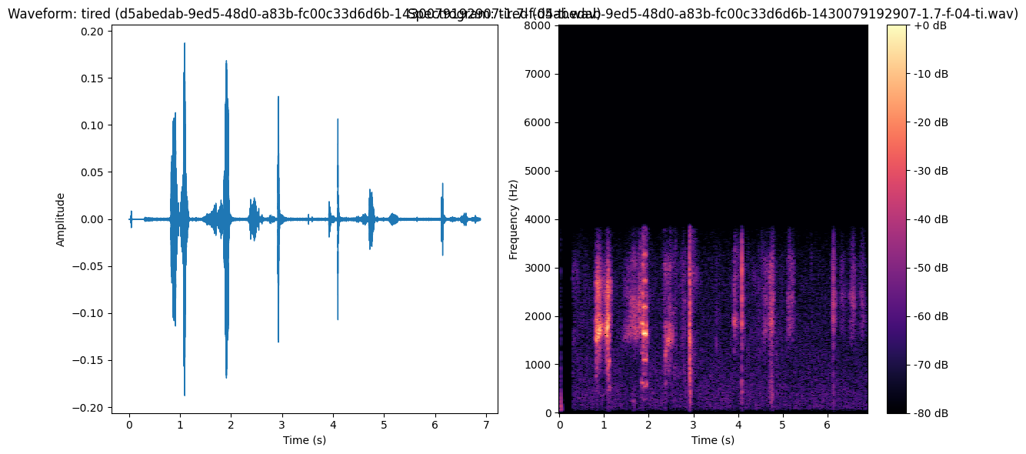

**AUDIO FORM:**

The waveform is complex and shows variations in amplitude throughout the duration.

Periods of higher amplitude correspond to louder sounds, while periods of lower amplitude correspond to quieter sounds.

The different shapes and patterns in the waveform indicate changes in the sound's characteristics over time. For example, we can visually identify potential distinct sound events or phonemes based on changes in the wave's structure.

**MFCC:**

**x-axis**: Represents time, but the scale is different from the waveform. It appears to go up to approximately 9 or 10 units (likely frame

s or short-time windows of the audio).

**y-axis:** Represents the different MFCC coefficients. The plot shows multiple horizontal bands, each corresponding to a different MFCC feature. Typically, the lower-indexed MFCCs capture more of the overall spectral shape, while higher-indexed ones capture finer details.

**Random Forest :**

| **Class** | **Precision** | **Recall** | **F1-Score** | **Support** |
| --- | --- | --- | --- | --- |
| **belly_pain** | **0.82** | **0.90** | **0.86** | **20** |
| **burping** | **0.85** | **0.85** | **0.85** | **20** |
| **discomfort** | **0.64** | **0.85** | **0.73** | **27** |
| **hungry** | **1.00** | **0.30** | **0.46** | **20** |
| **tired** | **0.78** | **0.88** | **0.82** | **24** |
| **Accuracy** |  |  | **0.77** | **111** |
| **Macro Avg** | **0.82** | **0.76** | **0.74** | **111** |
| **Weighted Avg** | **0.80** | **0.77** | **0.75** | **111** |

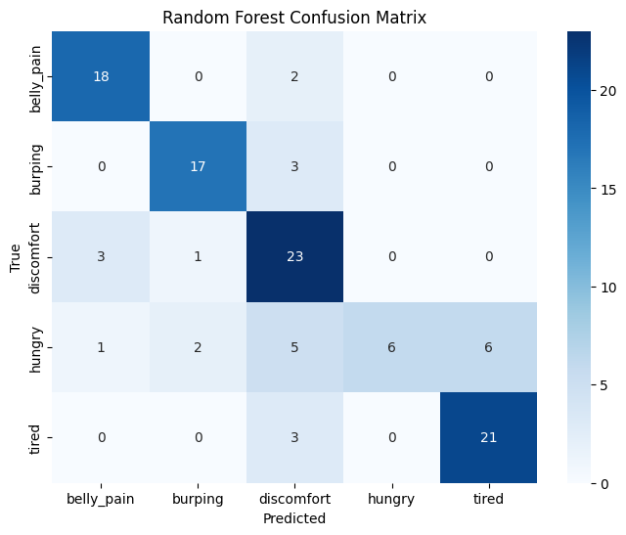

**XG Boost:**

| **Class** | **Precision** | **Recall** | **F1-Score** | **Support** |
| --- | --- | --- | --- | --- |
| **belly_pain** | **0.94** | **0.85** | **0.89** | **20** |
| **burping** | **0.81** | **0.85** | **0.83** | **20** |
| **discomfort** | **0.70** | **0.78** | **0.74** | **27** |
| **hungry** | **0.62** | **0.50** | **0.56** | **20** |
| **tired** | **0.77** | **0.83** | **0.80** | **24** |
| **Accuracy** |  |  | **0.77** | **111** |
| **Macro Avg** | **0.77** | **0.76** | **0.76** | **111** |
| **Weighted Avg** | **0.77** | **0.77** | **0.76** | **111** |

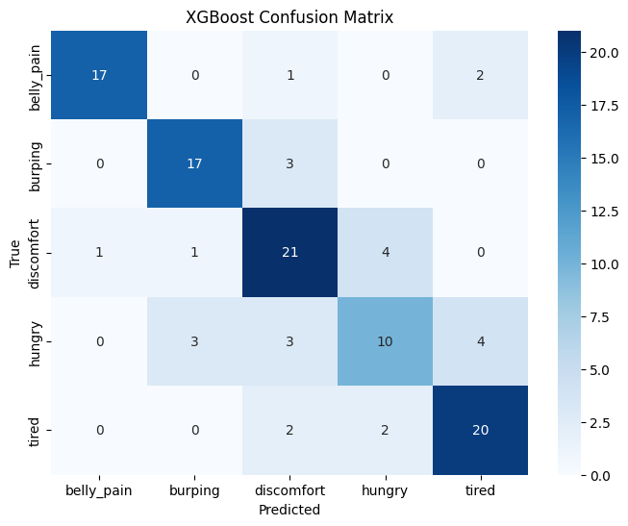

**Neural Network:**

| **Class** | **Precision** | **Recall** | **F1-Score** | **Support** |
| --- | --- | --- | --- | --- |
| **belly_pain** | **0.94** | **0.80** | **0.86** | **20** |
| **burping** | **0.86** | **0.90** | **0.88** | **20** |
| **discomfort** | **0.86** | **0.89** | **0.87** | **27** |
| **hungry** | **0.69** | **0.55** | **0.61** | **20** |
| **tired** | **0.76** | **0.92** | **0.83** | **24** |
| **Accuracy** |  |  | **0.82** | **111** |
| **Macro Avg** | **0.82** | **0.81** | **0.81** | **111** |
| **Weighted Avg** | **0.82** | **0.82** | **0.82** | **111** |

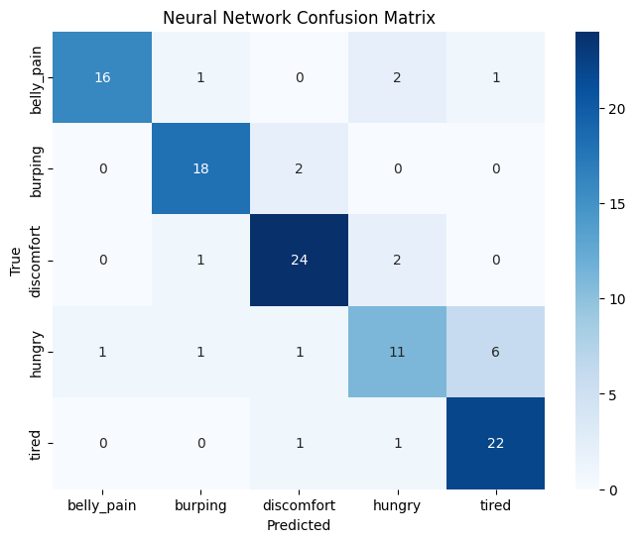

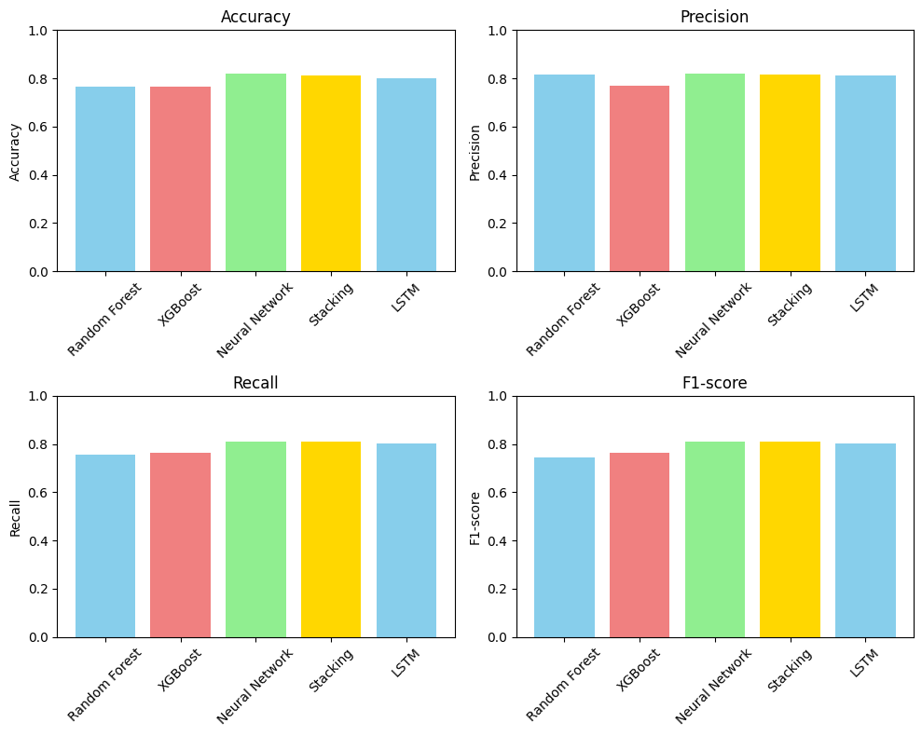

**Prediction**

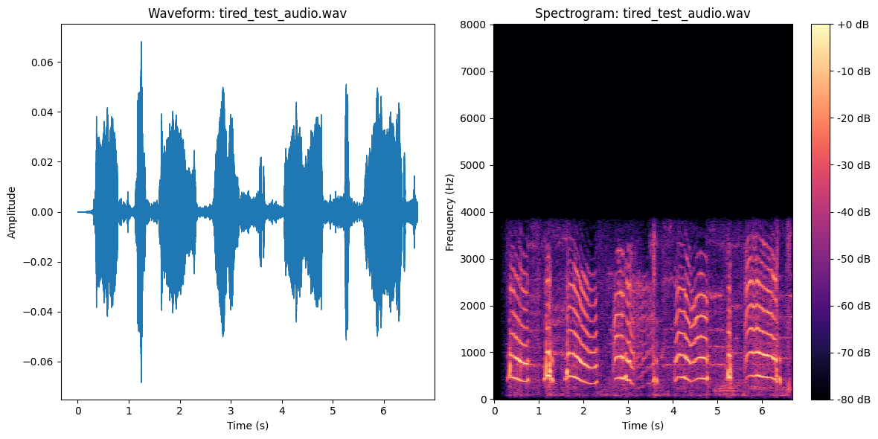

**Random Forest Prediction:**

Class: tired

Confidence: 0.7843

Class Probabilities:

belly_pain: 0.0309

burping: 0.0655

discomfort: 0.0595

hungry: 0.0598

tired: 0.7843

**XGBoost Prediction:**

Class: tired

Confidence: 0.9945

Class Probabilities:

belly_pain: 0.0011

burping: 0.0010

discomfort: 0.0015

hungry: 0.0019

tired: 0.9945

**Neural Network Prediction:**

Class: tired

Confidence: 0.9999

Class Probabilities:

belly_pain: 0.0000

burping: 0.0000

discomfort: 0.0000

hungry: 0.0000

tired: 0.9999