
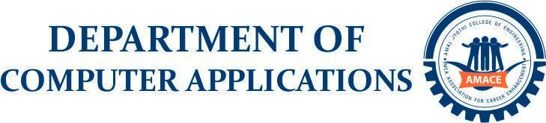
Scrum Master
Ajith G S
Assistant Professor
Department of Computer Applications
SAHAYI
20INMCA509 - Mini Project 2
Rohith R Nair
AJC22MCA-I050
INMCA2022-27 S8

rohithrnair2027@mca.ajce.in

ABSTRACT

SAHAYI is a web-based microfinance and governance platform designed to digitize the operations of neighborhood Self-Help Groups (Ayalkoottams) by replacing traditional paper-based record keeping with a secure and centralized digital system. The application streamlines essential activities such as member registration, weekly meeting management, attendance tracking, thrift savings collection, micro-loan application and approval, repayment monitoring, and financial reporting. Developed using ASP.NET Core Web API for the backend, React for the frontend, and SQL Server as the database, the platform provides a responsive and user-friendly interface with secure role-based authentication for administrators, office bearers, and members. The system enhances transparency, reduces manual errors, improves record accessibility, and enables efficient management of financial transactions through real-time data processing and reporting. By modernizing the day-to-day operations of self-help groups, SAHAYI aims to improve operational efficiency, accountability, and financial inclusion while establishing a scalable foundation for future enhancements, including mobile accessibility, offline synchronization, AI-assisted loan decision support, and a Malayalam AI chatbot.

