CSE 5330 DATABASE SYSTEMS

PHASE 5

Functionalities implemented in Phase 5:

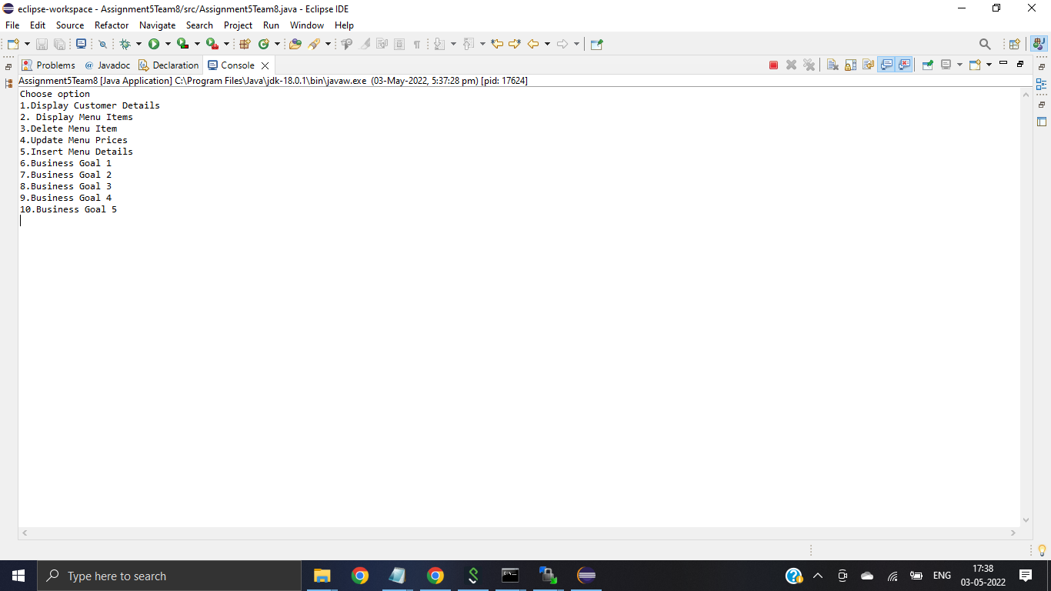

1. Displaying Customer Details:

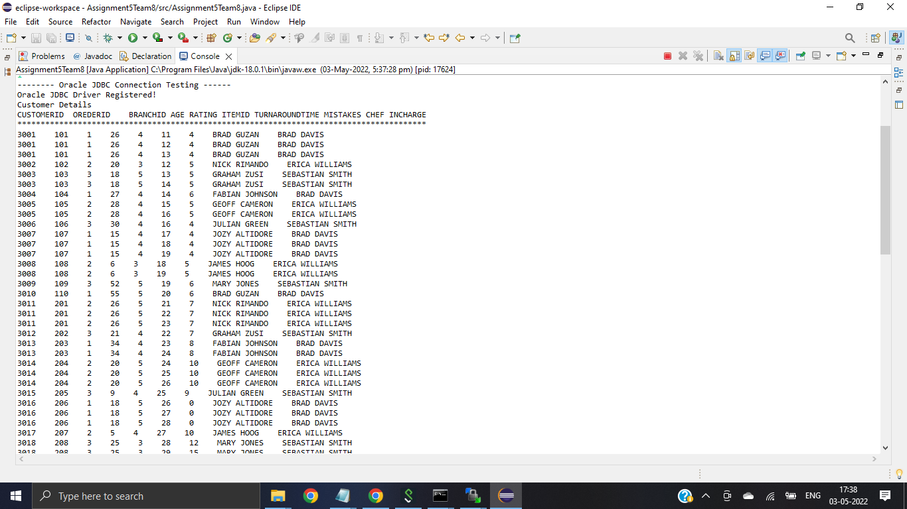

1. Displaying Menu items:

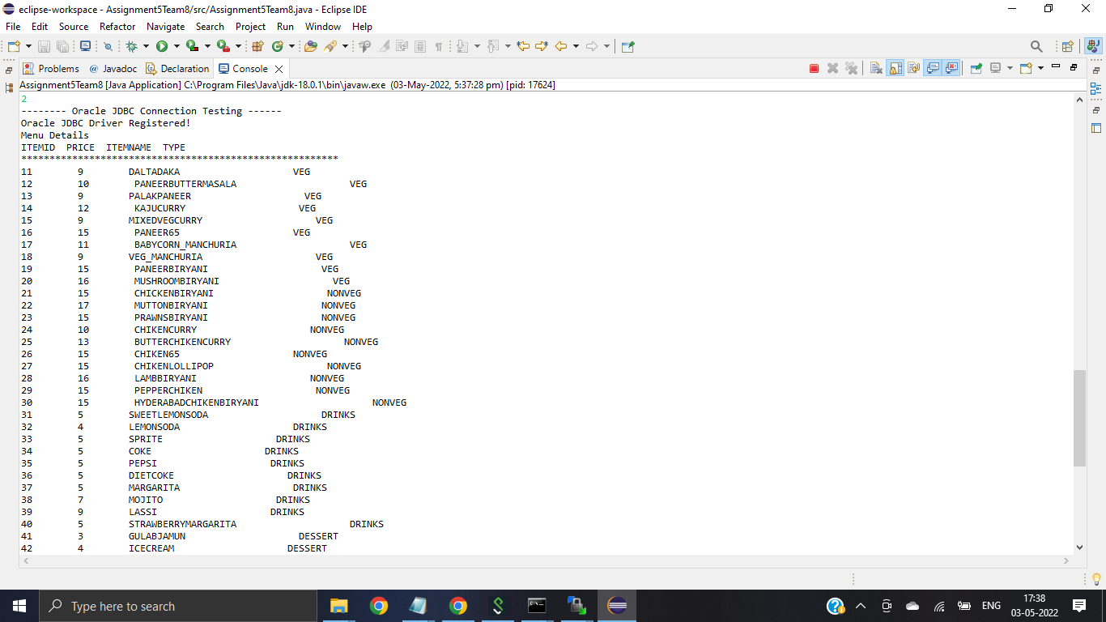

1. Deleting Menu item:

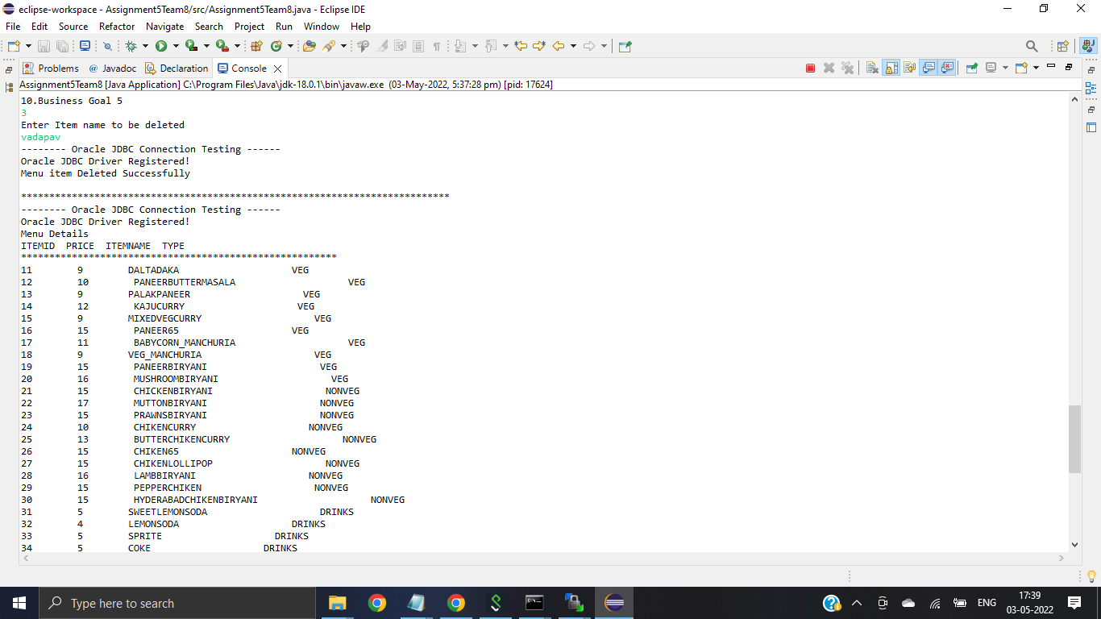

1. Updating Menu Price:

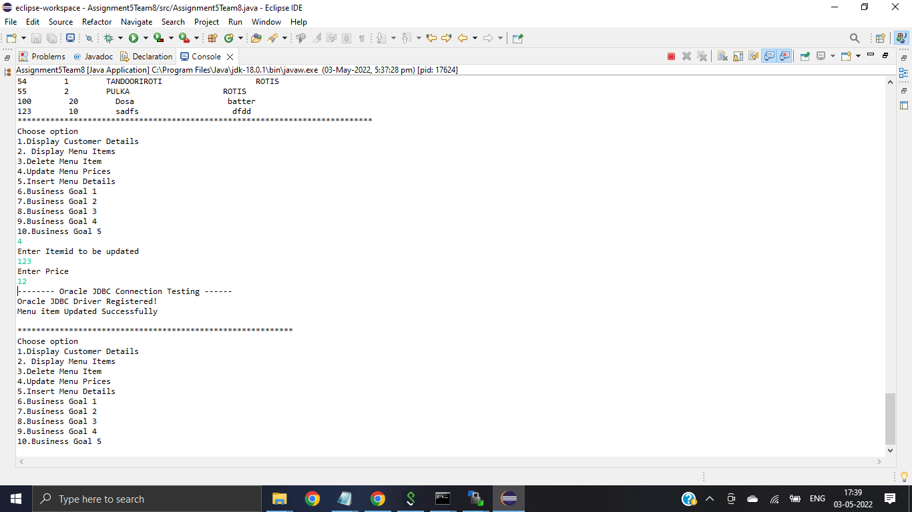

1. Insert new item into Menu:

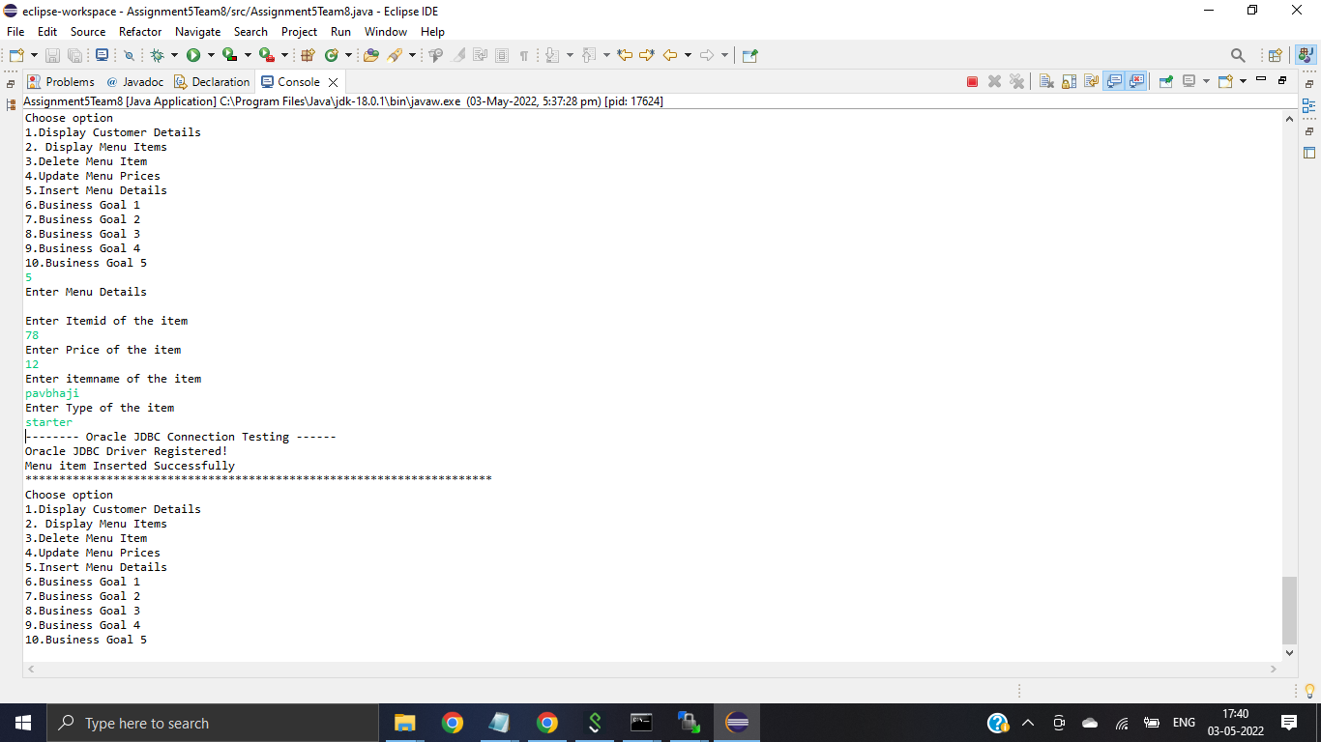

1. CUBE OPERATION TO FINDOUT SALES FOR EACH BRANCH UNDER INCHARGE AND CHEF:

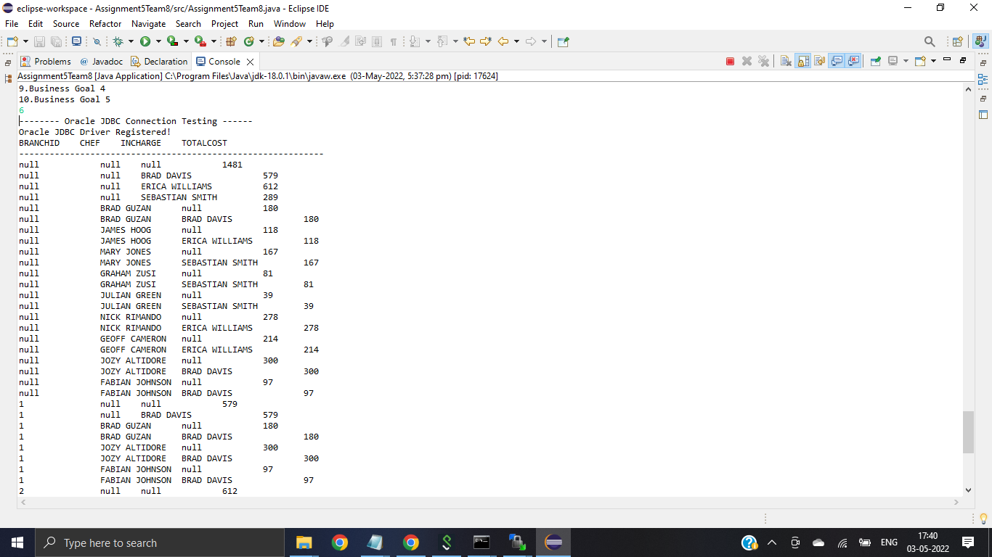

1. ROLLUP OPERATION TO FINDOUT RATING FOR EACH BRANCH UNDER INCHARGE,CHEF:

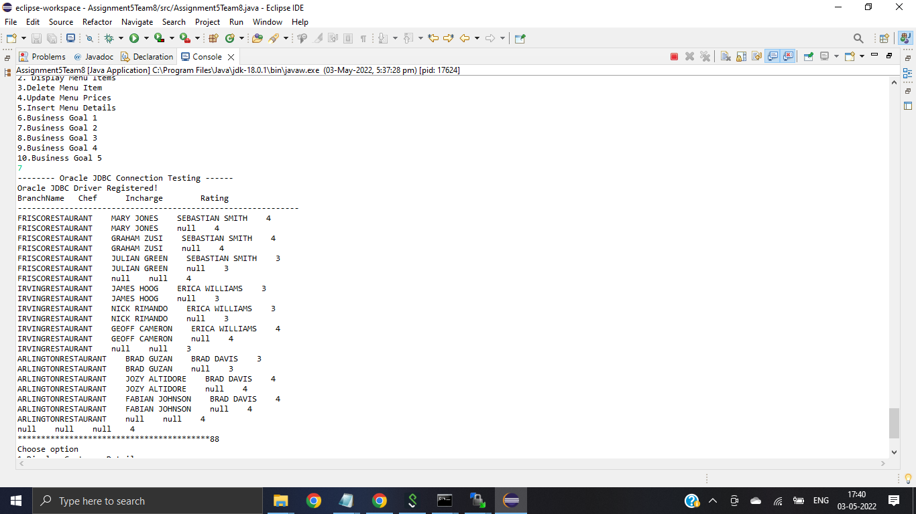

1. OVER BY CLUASE TO FINDOUT SALARY REPORTS IN EMPLOYEES:

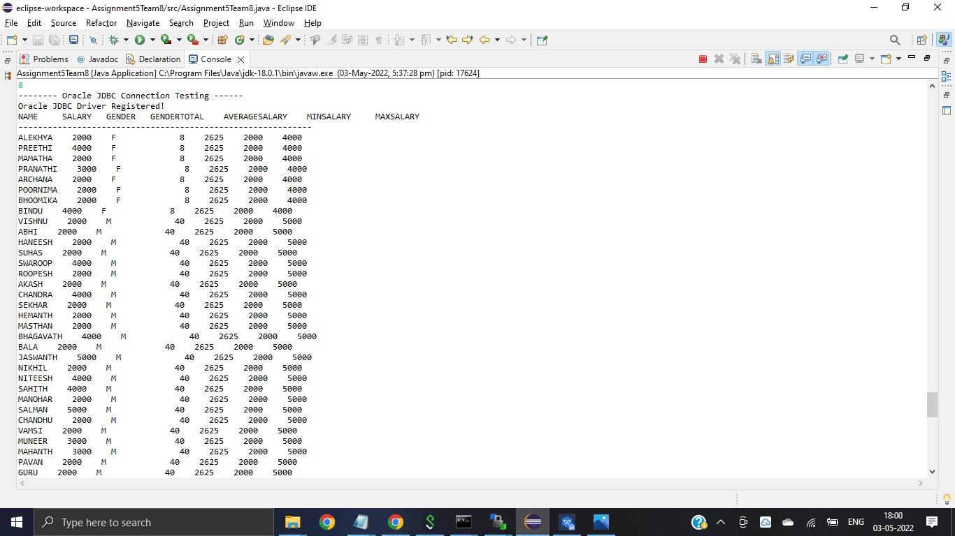

1. ORDERBY AND FETCH BY QUERY TO FINDOUT THE TOP COSTLY SOLD ITEM IN RESTAURANT:

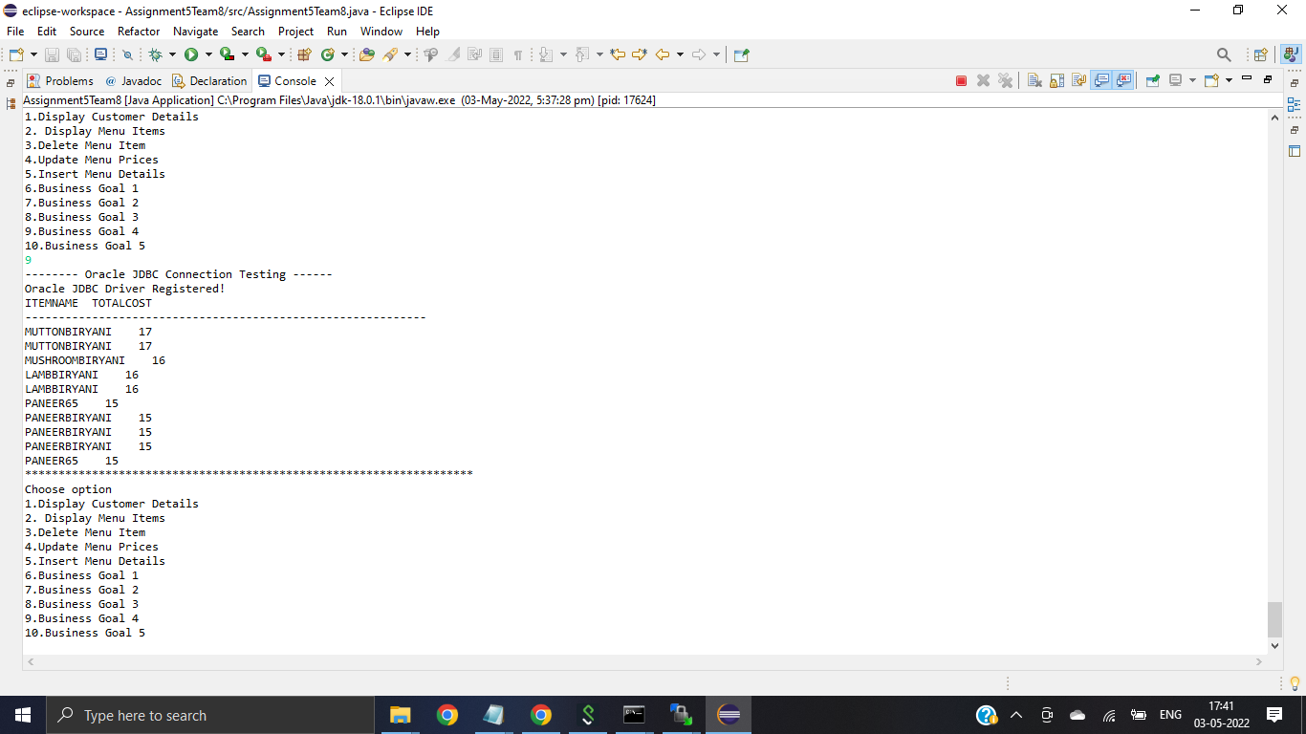

1. QUERY REGARDING BRANCH WITH HIGHEST RATING:

