**TAGORE ENGINEERING COLLEGE**

# RATHINAMANGALAM, CHENNAI-127.



**DEPARTMENT OF COMPUTER SCIENCE AND ENGINEERING**

# CCS371 – VIDEO CREATION AND EDITING

**Name :**

**Reg. No** :

**Branch :**

**Year :**

**Semester :**

**Anna University**∷**Chennai Regulation 2021**

**TAGORE ENGINEERING COLLEGE RATHINAMANGALAM, CHENNAI - 600 127**

**LABORATORY RECORD**

UNIVERSITY REGISTER NUMBER:

Certified that this is the bonafide record of work done by Mr./Ms. of Department in the laboratory and submitted for the University Practical Examination conducted on at TAGORE ENGINEERING COLLEGE, CHENNAI-127.

Record Marks:

# Lab In-charge Principal Head of the Department

**Internal Examiner External Examiner**

# VISION

To create an environment which is conducive to produce competent Computer Science Engineers through quality education and research-oriented education and equip them for the needs of the industry andsociety.

# MISSION

The Department strives to contribute to the expansion of knowledge in the discipline ofComputer Science and Engineering by

* Adopting an efficient teaching-learning process in concurrence with increasing industrial demands.
* Ensuring technical proficiency, facilitating to pursue higher studies and carry out Research & Development activities.
* Developing problem-solving and analytical skills with deep knowledge in thorough understanding of basic sciences and Computer Science Engineering.
* Infusing managerial and entrepreneurship skills to become ethical, socially responsible, and competitive professionals.

# PROGRAM SPECIFIC OBJECTIVES (PSOs)

1. Exhibit design and programming skills to build and automate business solutions using cutting edge technologies
2. Strong theoretical foundation leading to excellence and excitement towards research, toprovide elegant solutions to complex problems.
3. Ability to work effectively with various engineering fields as a team to design, build anddevelop system applications.

# PROGRAM OUTCOMES (POs)

Engineering Graduates will be able to:

1. **Engineering knowledge**: Apply the knowledge of mathematics, science, engineering fundamentals and an engineering specialization to the solution of complex engineering problems.
2. **Problem analysis**: Identify, formulate, review research literature, and analyze complex engineering problems reaching substantiated conclusions using first principles of mathematics, natural sciences, and engineering sciences.
3. **Design/development of solutions**: Design solutions for complex engineering problems and design system components or processes that meet the specified needs with appropriate consideration for the public health and safety, and the cultural, societal, and environmental considerations.
4. **Conduct investigations of complex problems**: Use research-based knowledge and research methods including design of experiments, analysis and interpretation of data, and synthesis of theinformation to provide valid conclusions.
5. **Modern tool usage**: Create, select, and apply appropriate techniques, resources, and modern engineering and IT tools including prediction and modeling to complex engineering activities withan understanding of the limitations.
6. **The engineer and society**: Apply reasoning informed by the contextual knowledge to assess societal, health, safety, legal and cultural issues and the consequent responsibilities relevant to theprofessional engineering practice.
7. **Environment and sustainability**: Understand the impact of the professional engineering solutions in societal and environmental contexts, and demonstrate the knowledge of, and need for sustainable development.
8. **Ethics**: Apply ethical principles and commit to professional ethics and responsibilities and norms of the engineering practice.
9. **Individual and team work**: Function effectively as an individual, and as a member or leaderin diverse teams, and in multidisciplinary settings.
10. **Communication**: Communicate effectively on complex engineering activities with theengineering community and with society at large, such as, being able to comprehend and write effective reports and design documentation, make effective presentations, and give and receive clear instructions.
11. **Project management and finance**: Demonstrate knowledge and understanding of the engineering and management principles and apply these to one‘s own work, as a member and leader in a team, to manage projects and in multidisciplinary environments.
12. **Life-long learning**: Recognize the need for, and have the preparation and ability to engagein independent and life-long learning in the broadest context of technological change

# COURSE OUTCOMES:

**CO1:** Compare the strengths and limitations of Nonlinear editing. **CO2:** Identify the infrastructure and significance of storytelling. **CO3:** Apply suitable methods for recording to CDs and VCDs.

**CO4:** Address the core issues of advanced editing and training techniques.

**CO5:** Design and develop projects using AVID XPRESS DV 4

# TABLE OF CONTENTS

|  |  |  |  |  |  |
| --- | --- | --- | --- | --- | --- |
| **Exp. No.** | **Date** | **Title of the Experiment** | **Page No.** | **Marks** | **Signature** |
| 1. |  | WRITE A MOVIE SYNOPSIS (INDIVIDUAL/TEAM WRITING) |  |  |  |
| 2. |  | PRESENT TEAM STORIES IN CLASS |  |  |  |
| 3. |  | SCRIPT/STORYBOARD WRITING (INDIVIDUAL ASSIGNMENT) |  |  |  |
| 4. |  | PRE-PRODUCTION: PERSONNEL, BUDGETING, SCHEDULING, LOCATION SCOUTING, CASTING, CONTRACTS & AGREEMENTS |  |  |  |
| 5. |  | PRODUCTION: SINGLE CAMERA PRODUCTION PERSONNEL & EQUIPMENT, DOCUMENTARY PRODUCTION |  |  |  |
| 6. |  | WRITING THE FINAL PROPOSAL: OVERVIEW, MEDIA TREATMENTS, SUMMARY, PITCHING |  |  |  |
| 7. |  | WRITE DOCUMENTARY & ANIMATION TREATMENT |  |  |  |
| 8. |  | POST-PRODUCTION: EDITING, SOUND DESIGN, FINISHING |  |  |  |

## Ex. No: 1 WRITE A MOVIE SYNOPSIS (INDIVIDUAL/TEAM WRITING)

**Date:**

## AIM

To develop skills in crafting a compelling movie synopsis that outlines the key elements of a film’s plot, characters, and themes.

## PROCEDURE

* 1. Choose a movie concept or idea to develop into a synopsis.
  2. Identify the main characters, settings, conflict, and resolution of the story.
  3. Write a concise summary that captures the essence of the film in a few paragraphs.
  4. Revise and refine the synopsis to ensure clarity, coherence, and engaging storytelling.

## FORMAT OF SYNOPSIS

**Title:** [Movie Title]

**Genre:** [Genre(s)]

**Logline:** [A concise one or two-sentence summary of the movie's central premise or conflict]

## SYNOPSIS

**Act 1:**

* Introduction of Main Characters: Briefly introduce the main characters and their backgrounds.
* Setting: Describe the period and location where the story takes place.
* Inciting Incident: Detail the event or circumstance that disrupts the protagonist's ordinary world and sets the story in motion.

## Act 2:

* Rising Action: Describe the series of events that propel the protagonist forward in pursuit of their goals.
* Conflict: Outline the main obstacles and challenges faced by the protagonist as they strive to overcome the central conflict.
* Subplots: Highlight any relevant subplots or secondary storylines that intersect with the main narrative.

## Act 3:

* Climax: Detail the highest point of tension in the story where the central conflict reaches its peak.
* Resolution: Describe how the conflict is ultimately resolved and the fate of the main characters.
* Conclusion: Reflect on the aftermath of the resolution and any lingering implications or themes.

**Themes**: [Identify the central themes explored in the movie, such as love, sacrifice, redemption, etc.]

**Tone**: [Describe the overall mood and tone of the movie, whether it's dark and gritty, light- hearted and comedic, etc.]

**Visual Style**: [Discuss the visual aesthetic of the film, including any notable cinematography, special effects, or stylistic choices.]

**Key Scenes**: [Highlight a few pivotal scenes that are crucial to the story's progression or emotional impact.]

## Key Characters:

[Protagonist]: [Description of the main character, including their motivations, strengths, and flaws.]

[Antagonist]: [Description of the main antagonist, including their goals, methods, and relationship to the protagonist.]

[Supporting Characters]: [Brief descriptions of other important characters and their roles in the story.]

## SYNOPSIS OF INTERSTELLAR

**Title:** Interstellar

**Genre:** Science Fiction, Drama

**Logline:** In a future where Earth is dying, a former NASA pilot embarks on a perilous journey through a wormhole to find a new habitable planet, facing time dilation, betrayal, and the mysteries of the cosmos.

## SYNOPSIS

**Act 1:**

* **Introduction of Main Characters:** Cooper, a farmer and former NASA pilot, struggles to survive in a world ravaged by ecological disaster. He's joined by his daughter Murphy, who believes her room is haunted.
* **Setting:** Earth, plagued by dust storms and famine, is on the brink of collapse.
* **Inciting Incident:** Cooper discovers a secret NASA facility led by Professor Brand, who offers him a chance to pilot a mission to save humanity.

## Act 2:

* **Rising Action:** Cooper, along with a team of scientists, embarks on the spacecraft "Endurance" through a wormhole near Saturn.
* **Conflict:** They encounter time dilation, betrayals, and the harsh realities of space exploration.
* **Subplots:** Murphy's struggle to decipher the ghostly messages leads to a breakthrough in saving humanity.

## Act 3:

* **Climax:** Cooper enters a black hole, unlocking the secrets of time and space, while Murphy solves the equation to ensure humanity's survival.
* **Resolution:** Humanity escapes Earth's doomed fate, finding a new home among the stars.
* **Conclusion:** Themes of love, sacrifice, and the human spirit resonate as the survivors face an uncertain future.

**Themes:** Love, sacrifice, resilience, exploration

**Tone:** Epic, poignant, thought-provoking

**Visual Style:** Visually stunning, cosmic landscapes, awe-inspiring special effects

**Key Scenes:** Cooper's departure from Earth, the time dilation on Miller's planet, Cooper's journey through the black hole

## Key Characters:

**Protagonist:** Cooper, is a determined pilot driven by love for his family and the survival of humanity.

**Antagonist:** The environmental catastrophe threatening Earth, and the challenges of space exploration.

**Supporting Characters:** Murphy, Professor Brand, Amelia Brand, Dr. Mann, Romilly

## RESULT

Thus, writing a movie synopsis requires careful consideration of storytelling elements to hook the audience and generate interest in the film was successfully done.

## Ex. No: 2 PRESENT TEAM STORIES IN CLASS

**Date:**

## AIM

To practice effective communication and presentation skills by sharing team stories with classmates.

## PROCEDURE

1. Choose a team project or experience to present to the class.
2. Structure the presentation with an introduction, main points, and conclusion.
3. Use visuals, anecdotes, and data to enhance the storytelling and engagement.
4. Practice delivering the presentation with confidence and clarity.
5. Encourage audience interaction and feedback during or after the presentation.

## STORY

**Title:** Interstellar: Odyssey of the Cosmos

**Genre:** Science Fiction, Adventure

**Logline:** In a universe on the brink of collapse, a team of diverse explorers embarks on a perilous journey through space and time to secure humanity's future, facing cosmic wonders and profound challenges along the way.

## Synopsis Act 1:

* **Introduction of Main Characters:** Dr. Amelia Brand, a visionary scientist, assembles a team of specialists, including Cooper, a former NASA pilot haunted by the loss of his family, and Romilly, a brilliant physicist with a penchant for adventure. Together, they prepare to embark on an unprecedented mission to find a new home for humanity.
* **Setting:** A future Earth ravaged by environmental catastrophe, juxtaposed with the advanced technology of a hidden NASA facility.
* **Inciting Incident:** The discovery of a wormhole near Saturn offers a glimmer of hope for humanity's survival, prompting the team to undertake a daring voyage into the unknown.

## Act 2:

* **Rising Action:** The team boards the spacecraft "Endurance" and ventures through the wormhole, encountering temporal anomalies and enigmatic celestial phenomena. As they navigate the vast expanse of space, tensions simmer and alliances are tested.
* **Conflict:** Internal strife threatens to derail the mission, exacerbated by the relentless pressures of cosmic exploration. Cooper's unresolved grief and Amelia's unwavering determination clash, leading to moments of profound introspection and growth.
* **Subplots:** Personal histories and hidden motivations come to light, deepening the bonds between the team members and shaping their shared destiny.

## Act 3:

* **Climax:** Cooper's selfless act of sacrifice propels him into the heart of a black hole, where he grapples with existential questions and confronts the mysteries of the cosmos. Meanwhile, Amelia grapples with a moral dilemma that challenges her convictions and tests her faith in humanity.
* **Resolution:** Cooper's journey yields crucial insights into the nature of reality, paving the way for humanity's salvation. As the team reunites and charts a course for a new world, they find solace in the bonds forged by adversity and the promise of a brighter tomorrow.
* **Conclusion:** Themes of resilience, redemption, and the indomitable spirit of exploration resonate as the crew of the "Endurance" embarks on a new chapter in the annals of human history, united in their quest for discovery and the pursuit of the unknown.

**Themes:** Exploration, sacrifice, redemption, unity

**Tone:** Epic, introspective, hopeful

**Visual Style:** Spectacular cosmic vistas, immersive CGI effects, intimate character moments

**Key Scenes:** The traversal of the wormhole, Cooper's journey through the black hole, Amelia's moment of moral reckoning

## Key Characters:

**Protagonist:** Cooper, a complex figure driven by a desire for redemption and a yearning for connection.

**Antagonist:** The existential threat posed by a collapsing universe, mirrored by the internal conflicts within the team.

**Supporting Characters:** Dr. Amelia Brand, Romilly, Doyle, and TARS, each grappling with their demons and striving to find their place in the cosmos.

**OUTPUT**

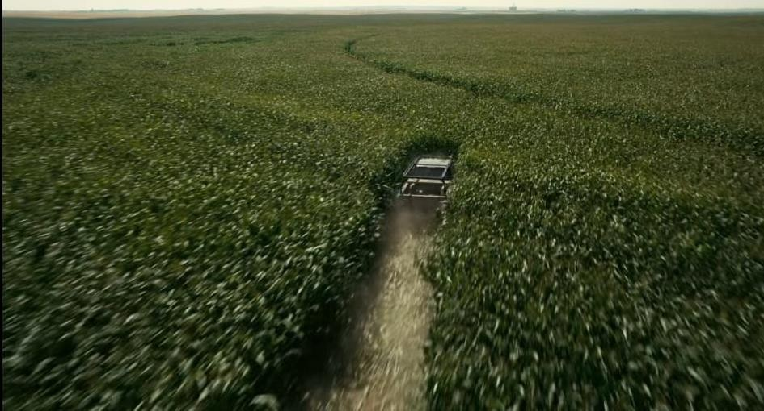

# RESULT

Thus, presenting team stories in class provides valuable practice in public speaking, storytelling and communication strategies were successfully done.

## Ex. No: 3 SCRIPT/STORYBOARD WRITING (INDIVIDUAL ASSIGNMENT)

**Date:**

## AIM

To develop skills in writing scripts and storyboards for visual media projects.

## PROCEDURE

1. Choose a concept or idea for a script or storyboard.
2. Outline the plot, characters, dialogue, and visual elements of the story.
3. Write a script using proper formatting and structure for screenplays.
4. Create a storyboard to visually represent scenes, camera angles, and transitions
5. Revise and refine the script and storyboard based on feedback and creative insights.

## SCRIPT

**Title:** "Interstellar: Echoes of the Cosmos"

**Act 1:** The Setup

* **Opening Scene:** A vast cosmic expanse, stars twinkling in the distance. The "Endurance" spacecraft drifts through space, its crew preparing for their mission.
* **Introduction of Protagonist:** Dr. Amelia Brand, a determined scientist haunted by the memory of her father's sacrifice, leads humanity's last hope for survival.
* **The Crew:** Cooper, Romilly, Doyle, and TARS, each with their expertise and baggage, join Amelia on the mission to find a new habitable planet.
* **The Wormhole:** A cosmic anomaly near Saturn offers a glimmer of hope for humanity's future. The crew embarks on a perilous journey through the wormhole, leaving behind everything they know.

**Act 2:** Unraveling the Unknown

* **Exploration:** The crew encounters strange new worlds, each presenting its challenges and dangers. Time dilation distorts their perception of time, adding to the complexity of their mission.
* **Conflict:** Tensions arise within the crew as they grapple with the enormity of their task and the sacrifices required. Personal demons and past traumas threaten to derail their mission.
* **Discovery:** Clues from the mysterious black hole and the revelations of time dilation lead the crew to question the nature of reality and their place in the universe.
* **The Antagonist Revealed:** A rogue scientist, Dr. Mann, poses a threat to the mission's success. His betrayal and manipulation jeopardize the crew's chances of survival.

**Act 3:** Confronting the Unknown

* **Crisis:** The crew faces their greatest challenge yet as they confront the truth behind Dr. Mann's deception. Amelia must make a difficult choice that will determine the fate of humanity.
* **Redemption:** Cooper's sacrifice leads to a revelation that transcends time and space, offering a glimmer of hope in humanity's darkest hour. The crew unites to overcome their differences and confront the true antagonist.
* **The Final Frontier:** In a climactic showdown, the crew confronts the forces that threaten to tear them apart. Through courage and sacrifice, they emerge victorious, paving the way for humanity's future among the stars.

## Act 4: A New Beginning

* **Resolution:** Humanity's journey comes full circle as they find a new home among the stars. Amelia reflects on the sacrifices made and the lessons learned, finding peace in the knowledge that their efforts were not in vain.
* **Epilogue:** The "Endurance" drifts through space, a beacon of hope in the vast expanse of the cosmos. The crew looks towards the future with optimism, ready to face whatever challenges lie ahead.
* **"Interstellar: Echoes of the Cosmos"** is a gripping tale of humanity's resilience in the face of adversity, exploring themes of sacrifice, redemption, and the search for meaning in the cosmos.

**OUTPUT**

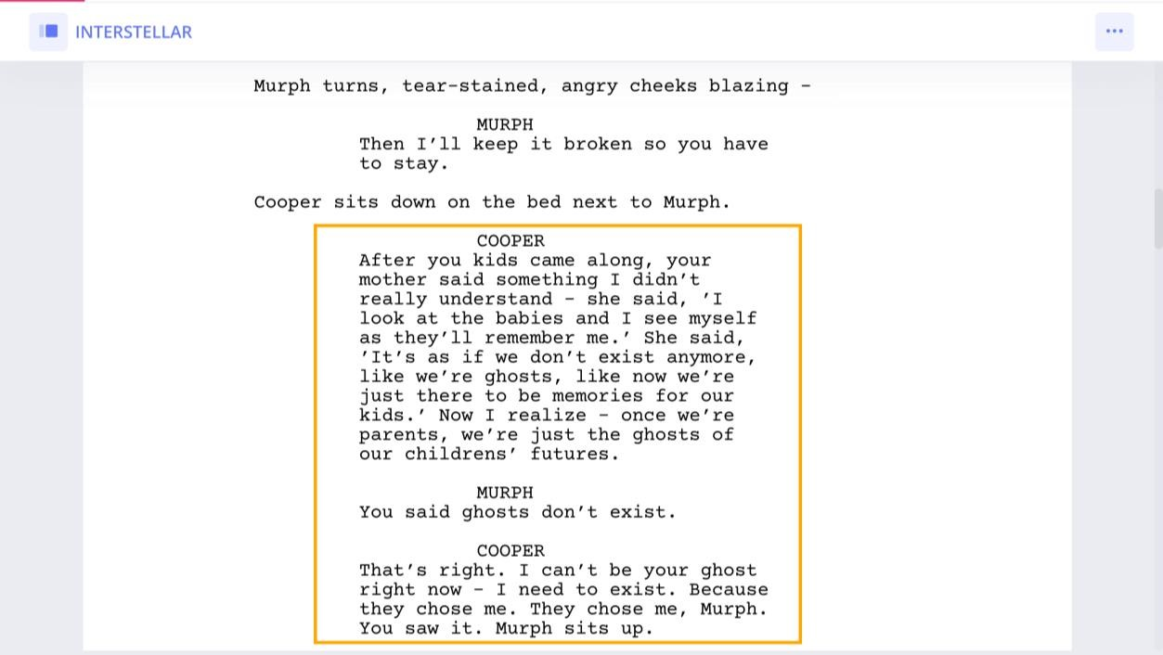



## RESULT

Thus, script and storyboard writing are essential skills for planning and executing visual media projects and they were effectively completed.

## Ex. No: 4 PRE-PRODUCTION: PERSONNEL, BUDGETING, SCHEDULING, DATE: LOCATION SCOUTING, CASTING, CONTRACTS &

**AGREEMENTS**

## AIM

To understand the key aspects of pre-production in media production, including personnel management, budgeting, scheduling, location scouting, casting, and contracts/agreements.

## PROCEDURE

1. Identify project personnel roles and responsibilities.
2. Create a budget that outlines expenses for personnel, equipment, locations, and other resources.
3. Develop a production schedule that includes timelines for preproduction, production, and post-production phases.
4. Conduct location scouting to find suitable filming locations.
5. Cast actors and secure contracts/agreements for their involvement in the project.

## PRE-PRODUCTION

**Title: "Interstellar: Echoes of the Cosmos"**

## Personnel:

* **Director:** A visionary director with a knack for blending science fiction with psychological depth, capable of creating a visually stunning and emotionally resonant film.
* **Screenwriter:** An experienced writer skilled in crafting intricate narratives and character- driven stories, capable of exploring themes of human resilience and existentialism.
* **Producer:** An adept producer tasked with overseeing the entire production process, managing finances, and ensuring the project stays on track within the allocated budget and timeline.
* **Director of Photography (DP):** A talented DP with expertise in capturing the awe-inspiring beauty of space and the intimacy of human drama, essential for bringing the cosmic journey to life on screen.
* **Production Designer:** A creative production designer responsible for designing intricate sets, props, and costumes that will transport audiences to distant galaxies and alien worlds.
* **Editor:** A meticulous editor who works closely with the director to shape the film's narrative, pacing, and emotional impact, ensuring a seamless and immersive viewing experience.
* **Casting Director:** A skilled casting director tasked with assembling a diverse and talented cast capable of embodying the complex characters and dynamic relationships at the heart of the story.

## Budgeting:

* Allocate funds for pre-production activities such as script development, concept art, and visual effects planning.
* Budget for production expenses including filming equipment, crew salaries, location fees, and special effects.
* Factor in post-production costs for editing, sound design, visual effects, and music composition.
* Include contingency funds to cover unexpected expenses or production delays.

## Scheduling:

* Develop a comprehensive production schedule outlining key dates for pre-production, filming, and post-production activities.
* Coordinate with the cast and crew to ensure availability and minimize scheduling conflicts.
* Allow flexibility in the schedule to accommodate changes in filming locations, weather conditions, and unforeseen challenges.

## Location Scouting:

* Identify potential filming locations that capture the grandeur and vastness of space, including desolate landscapes, futuristic cities, and alien worlds.
* Consider logistical factors such as accessibility, permits, and environmental conditions.
* Scout multiple options for each location to ensure the best possible filming environment and backup plans in case of unforeseen issues.

## Casting:

* Conduct auditions to find the perfect actors to portray the diverse array of characters, from intrepid explorers to enigmatic aliens.
* Look for performers who can convey the emotional depth and complexity of the story, while also embodying the spirit of adventure and discovery.
* Collaborate closely with the director and casting director to finalize casting decisions and ensure the ensemble cast is well-balanced and cohesive.

## Contracts & Agreements:

* Draft contracts for key personnel, including the director, screenwriter, producer, DP, production designer, editor, and casting director, outlining their roles, responsibilities, and compensation.
* Negotiate agreements with actors, specifying terms such as salary, contract duration, and potential bonuses.
* Ensure all contracts include provisions for intellectual property rights, confidentiality, and dispute resolution.
* Obtain necessary releases and permits for filming locations, securing permission from property owners and local authorities to ensure a smooth production process.

# OUTPUT

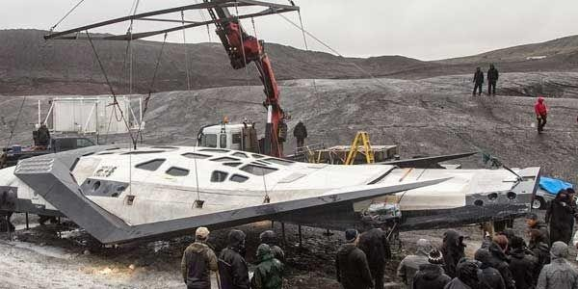

## RESULT

Thus, Pre-production involves strategic planning and organization to set the foundation for a successful media production project.

## Exp. No: 5 PRODUCTION: SINGLE CAMERA PRODUCTION PERSONNEL & DATE: EQUIPMENT, DOCUMENTARY PRODUCTION

**AIM**

To learn the techniques and processes involved in single-camera production and

documentary filmmaking.

## PROCEDURE

1. Set up the camera and audio equipment for single-camera production.
2. Plan and shoot scenes using techniques such as framing, lighting, and camera movements.
3. Conduct interviews or capture real-life footage for documentary production.
4. Record high-quality audio to complement the video footage.
5. Review and organize the footage for post-production editing.

## PRODUCTION

**Title: "Interstellar: Echoes of the Cosmos"**

## Personnel:

* **Director:** Leads the creative vision, ensuring fidelity to the original film while exploring new dimensions.
* **Producer:** Manages all aspects of production, from budgeting to coordination.
* **Camera Operator:** Captures stunning visuals of space using state-of-the-art equipment.
* **Sound Recordist:** Ensures clear and immersive sound quality throughout the documentary.
* **Production Assistant:** Supports the crew with various tasks to maintain efficiency.

## Equipment:

* **Camera:** High-resolution digital cinema camera for detailed cosmic imagery.
* **Lenses:** Wide-angle and telephoto lenses for diverse perspectives.
* **Sound Equipment:** Directional microphones and portable recorders for capturing ambient sounds.
* **Tripod and Stabilization:** Ensures smooth and steady shots in challenging conditions.
* **Accessories:** Essential gear for efficient filming in space.

## Documentary Production Process:

* **Pre-Production:** Researches scientific concepts, and develops a production plan, and storyboards.
* **Production:** Interviews experts and captures stunning footage of space.
* **Post-Production:** Edits footage into a captivating narrative, incorporating interviews and behind-the-scenes material.
* **Distribution:** Prepares the documentary for distribution through various channels, engaging with audiences to inspire curiosity about the cosmos.

# OUTPUT

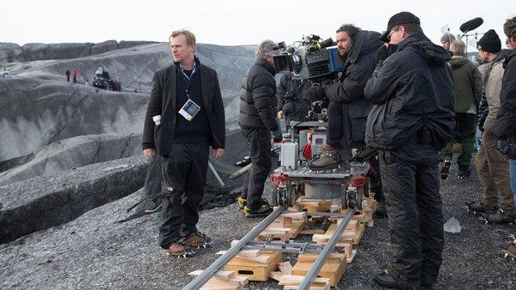

## RESULT

Thus, single-camera production and documentary filmmaking techniques offer creative opportunities to tell compelling stories through visual media.

## Ex. No: 6 WRITING THE FINAL PROPOSAL: OVERVIEW, MEDIA DATE: TREATMENTS, SUMMARY, PITCHING

**AIM**

To develop a comprehensive media production proposal that includes an overview, media treatments, summary, and pitching strategies.

## PROCEDURE

1. Define the project overview, including goals, target audience, and project scope.
2. Develop media treatments for different project concepts or ideas.
3. Summarize key points and highlights of the proposal.
4. Prepare pitching materials and strategies for presenting the proposal to stakeholders or clients.
5. Incorporate feedback and revisions into the final proposal.

## PROPOSAL

**Title: Interstellar: Echoes of the Cosmos Overview:**

"Interstellar: Echoes of the Cosmos" is a mesmerizing documentary that delves into the awe- inspiring realms of space exploration and the human quest for understanding the universe. Set against the backdrop of the vast cosmos, the film follows a team of intrepid astronauts on a daring mission to find a new home for humanity beyond the stars. Through stunning visuals and captivating storytelling, "Echoes of the Cosmos" explores the wonders of space, the mysteries of black holes, and the profound questions that define our existence.

## Media Treatments:

* **Visual Treatment**: "Echoes of the Cosmos" will feature breathtaking footage captured by cutting-edge cameras and telescopes, showcasing the beauty and grandeur of the cosmos in stunning detail. From distant galaxies to swirling nebulae, the film will transport audiences on a mesmerizing journey through the depths of space.
* **Sound Treatment:** The documentary will feature an immersive sound design that captures the silence of space, the roar of rocket engines, and the ethereal whispers of cosmic phenomena. Through a carefully crafted audio landscape, audiences will be enveloped in the vastness and wonder of the universe.
* **Narrative Treatment:** Using a blend of archival footage, expert interviews, and stunning visual effects, "Echoes of the Cosmos" will weave together a narrative that explores the history of space exploration, the latest scientific discoveries, and the future of humanity's journey among the stars.

## Summary:

"Interstellar: Echoes of the Cosmos" takes viewers on an epic voyage through the wonders of the universe, from the birth of stars to the edge of black holes. Led by a team of visionary astronauts and guided by the latest advancements in space technology, the documentary reveals the beauty, complexity, and infinite possibilities of the cosmos. Through breathtaking visuals and insightful commentary, "Echoes of the Cosmos" offers a glimpse into humanity's quest to unlock the secrets of the universe and explore the final frontier.

## Pitching:

We believe that "Interstellar: Echoes of the Cosmos" offers a captivating blend of scientific discovery, visual spectacle, and human exploration that will inspire and educate audiences around the world. With its stunning visuals, immersive sound design, and compelling storytelling, the documentary has the potential to engage viewers of all ages and backgrounds. We are excited to share this remarkable journey through space with audiences and ignite a sense of wonder and curiosity about the universe we call home.

# OUTPUT

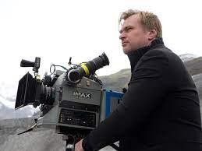

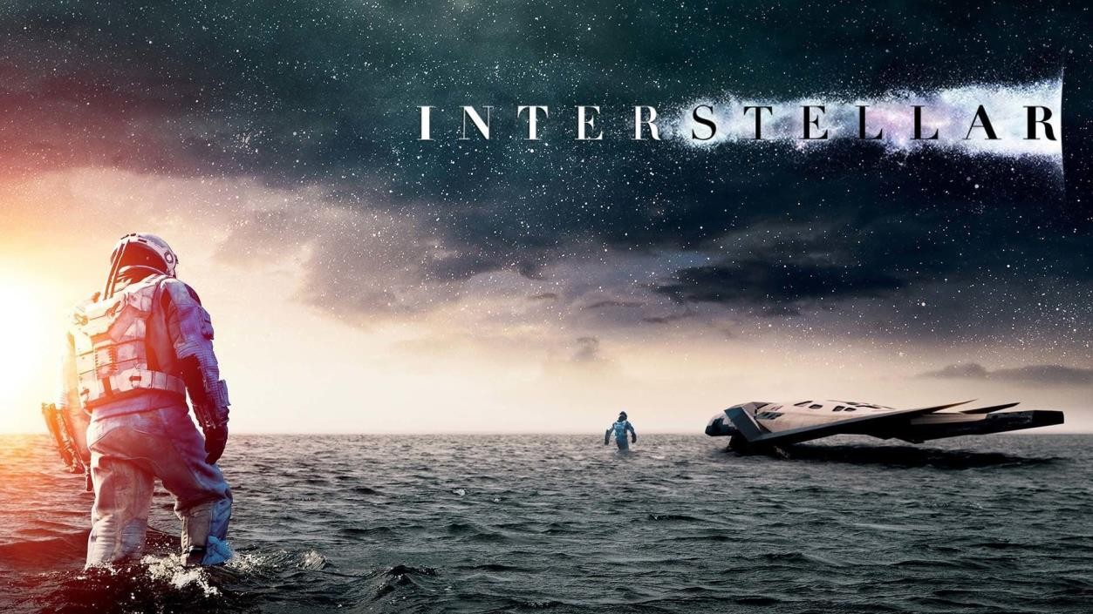

## RESULT

Thus, writing a final proposal involves strategic planning, creative thinking, and effective communication to pitch media production ideas successfully.

## Ex. No: 7 WRITE DOCUMENTARY & ANIMATION TREATMENT DATE:

**AIM**

To develop treatments for documentary and animation projects, including storytelling concepts, visual styles, and thematic elements.

## PROCEDURE

1. Choose a topic or theme for the documentary or animation project.
2. Develop a treatment that outlines the storytelling approach, visual style, and thematic elements.
3. Incorporate research, interviews, and narrative elements into the documentary treatment.
4. Define character designs, animation techniques, and visual aesthetics for the animation treatment.
5. Revise and refine the treatments based on feedback and creative insights.

## DOCUMENTARY TREATMENT

**Overview**

"Interstellar: Echoes of the Cosmos" is a documentary film that embarks on a captivating exploration of space, delving into the wonders of the cosmos and humanity's quest for understanding. Through a blend of expert interviews, archival footage, and stunning visual imagery, the documentary immerses viewers in the awe-inspiring beauty of the universe while unravelling the scientific mysteries that lie beyond.

## Narrative Structure

**Introduction:** The documentary opens with a mesmerizing overview of the cosmos, setting the stage for the journey ahead and introducing the key themes of space exploration and discovery.

**Expert Interviews:** Renowned scientists, astronomers, and astronauts share their insights and experiences, offering valuable perspectives on topics such as black holes, exoplanets, and the search for extraterrestrial life.

**Archival Footage:** Utilizing archival footage from historic space missions and scientific discoveries, the documentary provides a retrospective look at humanity's exploration of space and the advancements that have shaped our understanding of the universe.

**Visual Exploration**: Through stunning visual imagery captured by telescopes and spacecraft, the documentary showcases the breathtaking beauty of celestial phenomena such as nebulae, galaxies, and supernovae.

**Cutting-Edge Research:** The documentary highlights the latest advancements in space exploration and astrophysics, from groundbreaking discoveries to ambitious missions that push the boundaries of human knowledge and technology.

**Conclusion:** Reflecting on the journey through space, the documentary concludes with a sense of wonder and awe, inspiring viewers to continue exploring the mysteries of the cosmos and to embrace the spirit of curiosity and discovery.

## Visual Style

"Interstellar: Echoes of the Cosmos" will feature a visually stunning presentation that combines breathtaking footage of space with dynamic visual effects and immersive sound design. From sweeping vistas of distant galaxies to close-up views of celestial objects, the documentary will transport viewers on a cinematic journey through the cosmos, leaving them with a deeper appreciation for the wonders of the universe.

## Target Audience

The documentary is intended for a broad audience of science enthusiasts, space enthusiasts, and anyone curious about the mysteries of the universe. It will appeal to viewers of all ages who are fascinated by space exploration and the quest to unravel the secrets of the cosmos.

## ANIMATION TREATMENT

**Overview**

"Interstellar: Echoes of the Cosmos" is an animated film that invites audiences on a magical journey through space and time, blending elements of fantasy, adventure, and cosmic exploration. Set in a fantastical universe where stars twinkle like jewels and planets dance in orbit, the film follows the epic quest of a young hero who embarks on a daring adventure to save the galaxy from a dark and ancient evil.

## Visual Style

The animation will feature a rich and vibrant visual style that combines traditional hand-drawn animation with cutting-edge computer-generated imagery (CGI). From lush alien landscapes to towering space stations, the film will transport viewers to a visually stunning world filled with wonder and imagination. The use of dynamic camera angles, expressive character designs, and stunning visual effects will bring the story to life in a way that is both captivating and immersive.

## Narrative Structure

**Introduction:** The film opens with a glimpse into the protagonist's ordinary life on a distant planet, hinting at the adventure that lies ahead.

**Call to Adventure:** When an unexpected threat arises, the protagonist is called upon to embark on a quest to save the galaxy from destruction, setting the stage for an epic journey across the cosmos.

**Journey Through Space**: Joined by a colourful cast of characters, including wise mentors, plucky sidekicks, and fearsome villains, the protagonist sets out on a perilous adventure through space, encountering alien worlds, cosmic phenomena, and ancient mysteries along the way.

**Confrontation:** As the journey unfolds, the protagonist faces increasingly difficult challenges and obstacles, testing their courage, strength, and determination.

**Final Showdown:** In a climactic battle against the forces of darkness, the protagonist must summon all their skills and courage to defeat the villain and save the galaxy from destruction.

**Resolution:** With the galaxy saved and peace restored, the protagonist returns home a hero, forever changed by their epic adventure through the cosmos.

## Target Audience

"Interstellar: Echoes of the Cosmos" is intended for audiences of all ages who enjoy epic storytelling, richly detailed animation, and themes of courage, friendship, and cosmic adventure. It will appeal to fans of animated films, science fiction, and fantasy, as well as anyone who dreams of exploring the wonders of the universe.

# OUTPUT

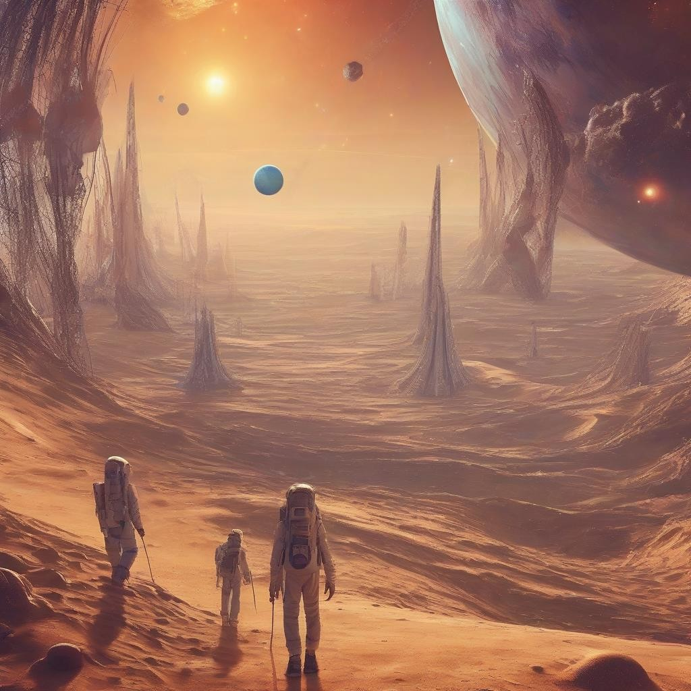



## RESULT

Thus, creating documentary and animation treatments involves conceptualizing ideas, defining visual styles, and crafting engaging narratives for media projects.

## Ex. No: 8 POST-PRODUCTION: EDITING, SOUND DESIGN, FINISHING

**Date:**

## AIM

To learn the post-production processes involved in media production, including editing, sound design, and finishing touches.

## PROCEDURE

1. Import and organize video footage, audio recordings, and graphics into the editing software.
2. Edit the footage to create a cohesive narrative, incorporating transitions, effects, and titles.
3. Enhance the audio with sound design, mixing, and adding music tracks.
4. Apply visual effects, graphics, and colour grading to enhance visual aesthetics.
5. Review and refine the final edit, ensuring quality and coherence.

## POST-PRODUCTION ELEMENTS

**Editing**

**Assembly Edit:** The editor compiles all raw footage into a preliminary cut of "Interstellar: Echoes of the Cosmos," aligning with the script and storyboard.

**Fine Cut:** Refinement of pacing, timing, and scene continuity occurs, ensuring a seamless narrative flow.

**Narrative Structure:** Collaborating closely with the director, the editor balances the non- linear narrative elements, optimizing flashbacks, hallucinations, and present-day scenes for maximum impact.

**Visual Effects:** Visual effects artists enhance atmospheric lighting, create dream sequences and incorporate subtle CGI elements to enrich the storytelling.

**Colour Grading:** The colourist adjusts the film's colour palette, enhancing mood and atmosphere to evoke the cosmic wonders explored.

**Title Sequences and Credits:** Finalization of opening, closing title sequences, and end credits ensures alignment with the film's tone and style.

## Sound Design

**Dialogue Editing:** Clearing up dialogue tracks, removing background noise, and ensuring consistent volume levels for optimal clarity.

**Sound Effects:** Adding layered sound effects such as footsteps, creaking doors, and ambient sounds to enrich the film's atmosphere.

**Foley:** Recording additional sound effects like footsteps and cloth movements to enhance realism and depth in the audio.

**Music Composition:** Creating an original musical score to complement the film's mood and heighten emotional moments, utilizing a mix of instruments and electronic elements.

**Mixing:** Balancing all audio elements—including dialogue, sound effects, music, and ambient noise—to craft a dynamic and immersive sound mix.

## Finishing

**Mastering:** Finalizing the film for distribution by creating various deliverables such as digital files, DCPs for theatrical screenings, and DVD/Blu-ray discs.

**Quality Control:** Thorough quality control checks ensure technical specifications are met, and there are no errors or glitches in the final product.

**Distribution:** Ready for distribution across multiple platforms including film festivals, streaming services, theatrical releases, and home media, "Interstellar: Echoes of the Cosmos" is prepared to captivate audiences worldwide with its cosmic journey.

# OUTPUT

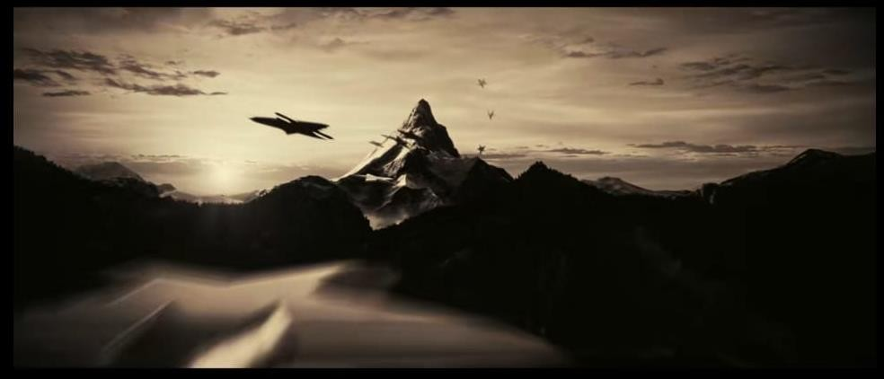

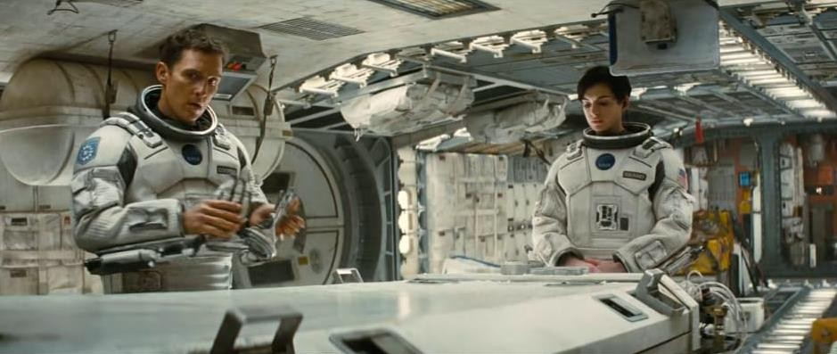

## RESULT

Thus, post-production is a crucial phase in media production, where editing, sound design, and finishing touches come together to create a polished and impactful final product.