Title: Git-HOL 3 – Branching and Merging

Objective: To understand Git branching and merging by creating a new branch, making changes in the branch, comparing it with the main branch, merging the changes, and deleting the branch after a successful merge.

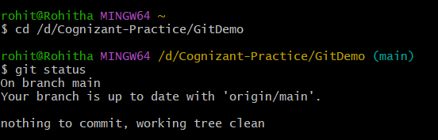

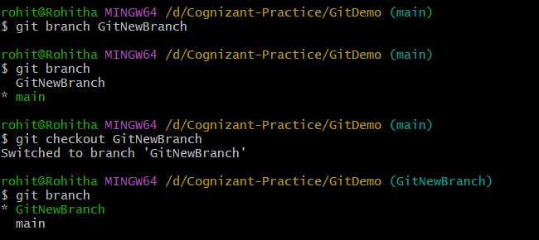

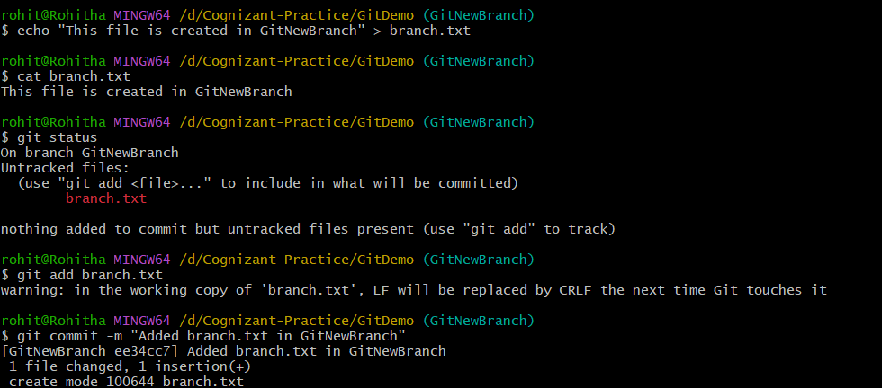

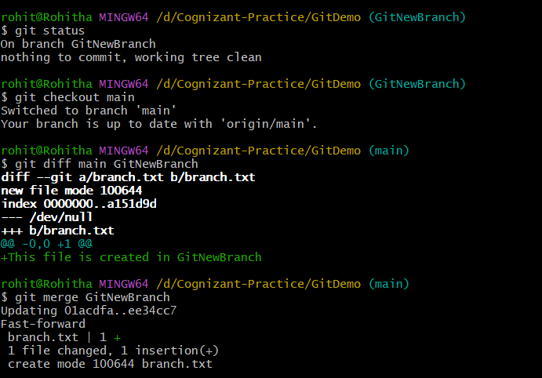

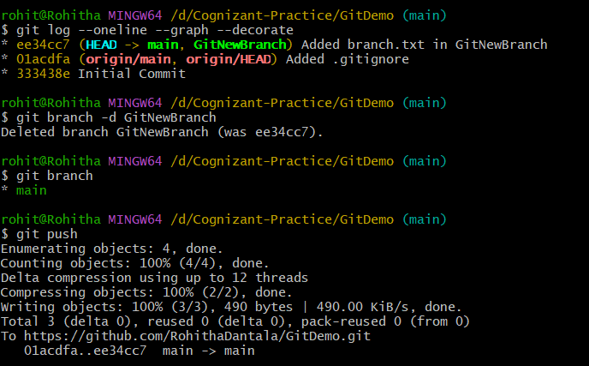

Title: Git-HOL 4 – Merge Conflict Resolution

Objective: To understand and resolve merge conflicts by creating conflicting changes in different branches, resolving them manually, and completing the merge successfully.

