

CS2403 COMPUTER NETWORKS

Mini Project Report

From Flat to Micro-Segmented: A Simulation-Based Evaluation of Lateral-Movement Containment for Compromised IoMT Devices in a Smart-Hospital Network

Submitted
By
Student Name 1 (USN)
Student Name 2 (USN)
Student Name 3 (optional) (USN)
Under the guidance of:
Dr./Prof. Faculty Name
School of Computer Science and Engineering
RV University, Bangalore

School of Computer Science and Engineering

CERTIFICATE
Certified that the CS2403 Computer Networks Mini Project work titled “From Flat to Micro-Segmented: A Simulation-Based Evaluation of Lateral-Movement Containment for Compromised IoMT Devices in a Smart-Hospital Network” is carried out by Student Name 1 (USN), Student Name 2 (USN), Student Name 3 (USN), who are bonafide students of the School of Computer Science and Engineering, RV University, Bengaluru, during the year 2025–26. It is certified that all corrections/ suggestions from all the continuous internal evaluations have been incorporated into the project and in this report.

Dr./ Prof. ________________
Faculty Guide | Program Director

1 Problem statement
Hospitals now connect large numbers of medical Internet-of-Things (IoMT) devices, such as patient monitors and infusion pumps, to the same network as staff computers, clinical servers and building systems. These devices often run old, unpatchable firmware, so one of them can be taken over. In a flat network the attacker can then move sideways (lateral movement) to the electronic health record (EHR) server, to other medical devices and to the switches and routers themselves. This project builds a smart-hospital network in Cisco Packet Tracer and measures how well four levels of network segmentation contain a compromised medical IoT device. The four levels are a flat network (D0), VLANs only (D1), VLANs with zone ACLs (D2) and full micro-segmentation with a stateful firewall and Layer-2 hardening (D3). Each design is tested with the same seven attacks and nine legitimate-traffic checks. We then compare the attack surface left open, whether clinical functions still work, and the configuration effort each level costs.

2. Introduction
A modern “smart hospital” depends on its network: nurses read patient records from the EHR, bedside monitors stream vital signs, infusion pumps receive drug libraries, and doors, fire detectors, ventilation and CCTV are all networked. Healthcare is one of the sectors most often hit by ransomware, and attackers usually get in through the weakest device, then move sideways towards valuable data. Medical IoT devices are a common weak device. They run embedded operating systems that often cannot be patched or run security software, so the network itself has to contain them. Network segmentation, and its finest-grained form micro-segmentation, is the control recommended by the Zero Trust model (NIST SP 800-207). The question for a network designer is how much segmentation is enough, and what it costs.
Our network models a small hospital campus with a collapsed-core design. A Cisco 2911 edge router connects the hospital to a simulated ISP using PAT and exchanges routes with the core over OSPF. A Catalyst 3560 multilayer switch is the core and routes between VLANs. Three Catalyst 2960 access switches serve Ward A, Ward B and the admin block. A server switch holds four servers: the EHR web server, the DNS/DHCP server, the IoT registration server and a Syslog/NTP server. End devices include staff PCs, a network-admin PC, eight IoT devices (four standing in for medical devices, four for building devices) and a WPA2 guest Wi-Fi network with a phone and a tablet. In the final design an ASA 5506-X firewall guards the server zone. A laptop placed in a medical-IoT VLAN acts as the “compromised device”, because Packet Tracer IoT devices cannot generate attack traffic.
The same physical network is saved as four Packet Tracer files, and only the security policy changes between them. D0 is a single flat VLAN. D1 separates devices into role-based VLANs but routes freely between them. D2 adds coarse zone ACLs on the core switch. D3 applies least-privilege micro-segmentation: each device class gets its own VLAN and may reach only the exact server and port it needs. D3 also adds a stateful firewall, port security, DHCP snooping, BPDU Guard, hardened trunks and SSH-only management. Keeping everything else fixed makes the comparison a controlled experiment. It answers three research questions: (RQ1) how much does each level shrink the attack surface; (RQ2) does tighter segmentation break legitimate clinical and IoT traffic; and (RQ3) what does each level cost in configuration complexity?
Several Layer-2 and Layer-3 technologies are used. VLANs (IEEE 802.1Q) split one switched network into separate broadcast domains, and 802.1Q trunks carry several VLANs over one link using a 4-byte tag. Inter-VLAN routing is done by Switched Virtual Interfaces (SVIs) on the multilayer switch, which act as each VLAN’s default gateway. OSPF, a link-state routing protocol, exchanges routes between the core and the edge router, and the edge router injects a default route. Floating static routes (administrative distance 250) on both the core and the edge act as a backup that is used only if OSPF fails. DHCP (RFC 2131) hands out addresses from a central server. The core switch relays the DHCP broadcasts to that server with ip helper-address, which also tells the server which pool to use. DNS resolves names such as ehr.hospital.local. PAT (NAT overload, RFC 3022) lets all private 10.10.x.x hosts share one public address. Extended ACLs filter traffic by source, destination, protocol and port. The ASA is a stateful firewall: it allows traffic from a higher to a lower security level, blocks the reverse unless an ACL permits it, and tracks connections so that replies get back in.
At the access edge, port security limits each switch port to its learned (sticky) MAC address and shuts the port if another device is plugged in. DHCP snooping lets only the trusted uplink send DHCP offers, which defeats rogue DHCP servers. PortFast with BPDU Guard protects the Spanning Tree Protocol, and an unused native VLAN, allowed-VLAN lists and disabled DTP reduce VLAN-hopping risk. Management uses SSH version 2 with local accounts and VTY access-class filters instead of plaintext Telnet, and every network device sends logs to a Syslog server and takes its time from NTP so events can be correlated. Our contribution is a reproducible, openly documented Packet Tracer testbed. It measures how lateral movement is contained at each level of segmentation, and it reports both the security gained and the configuration cost.

3 Network Diagram
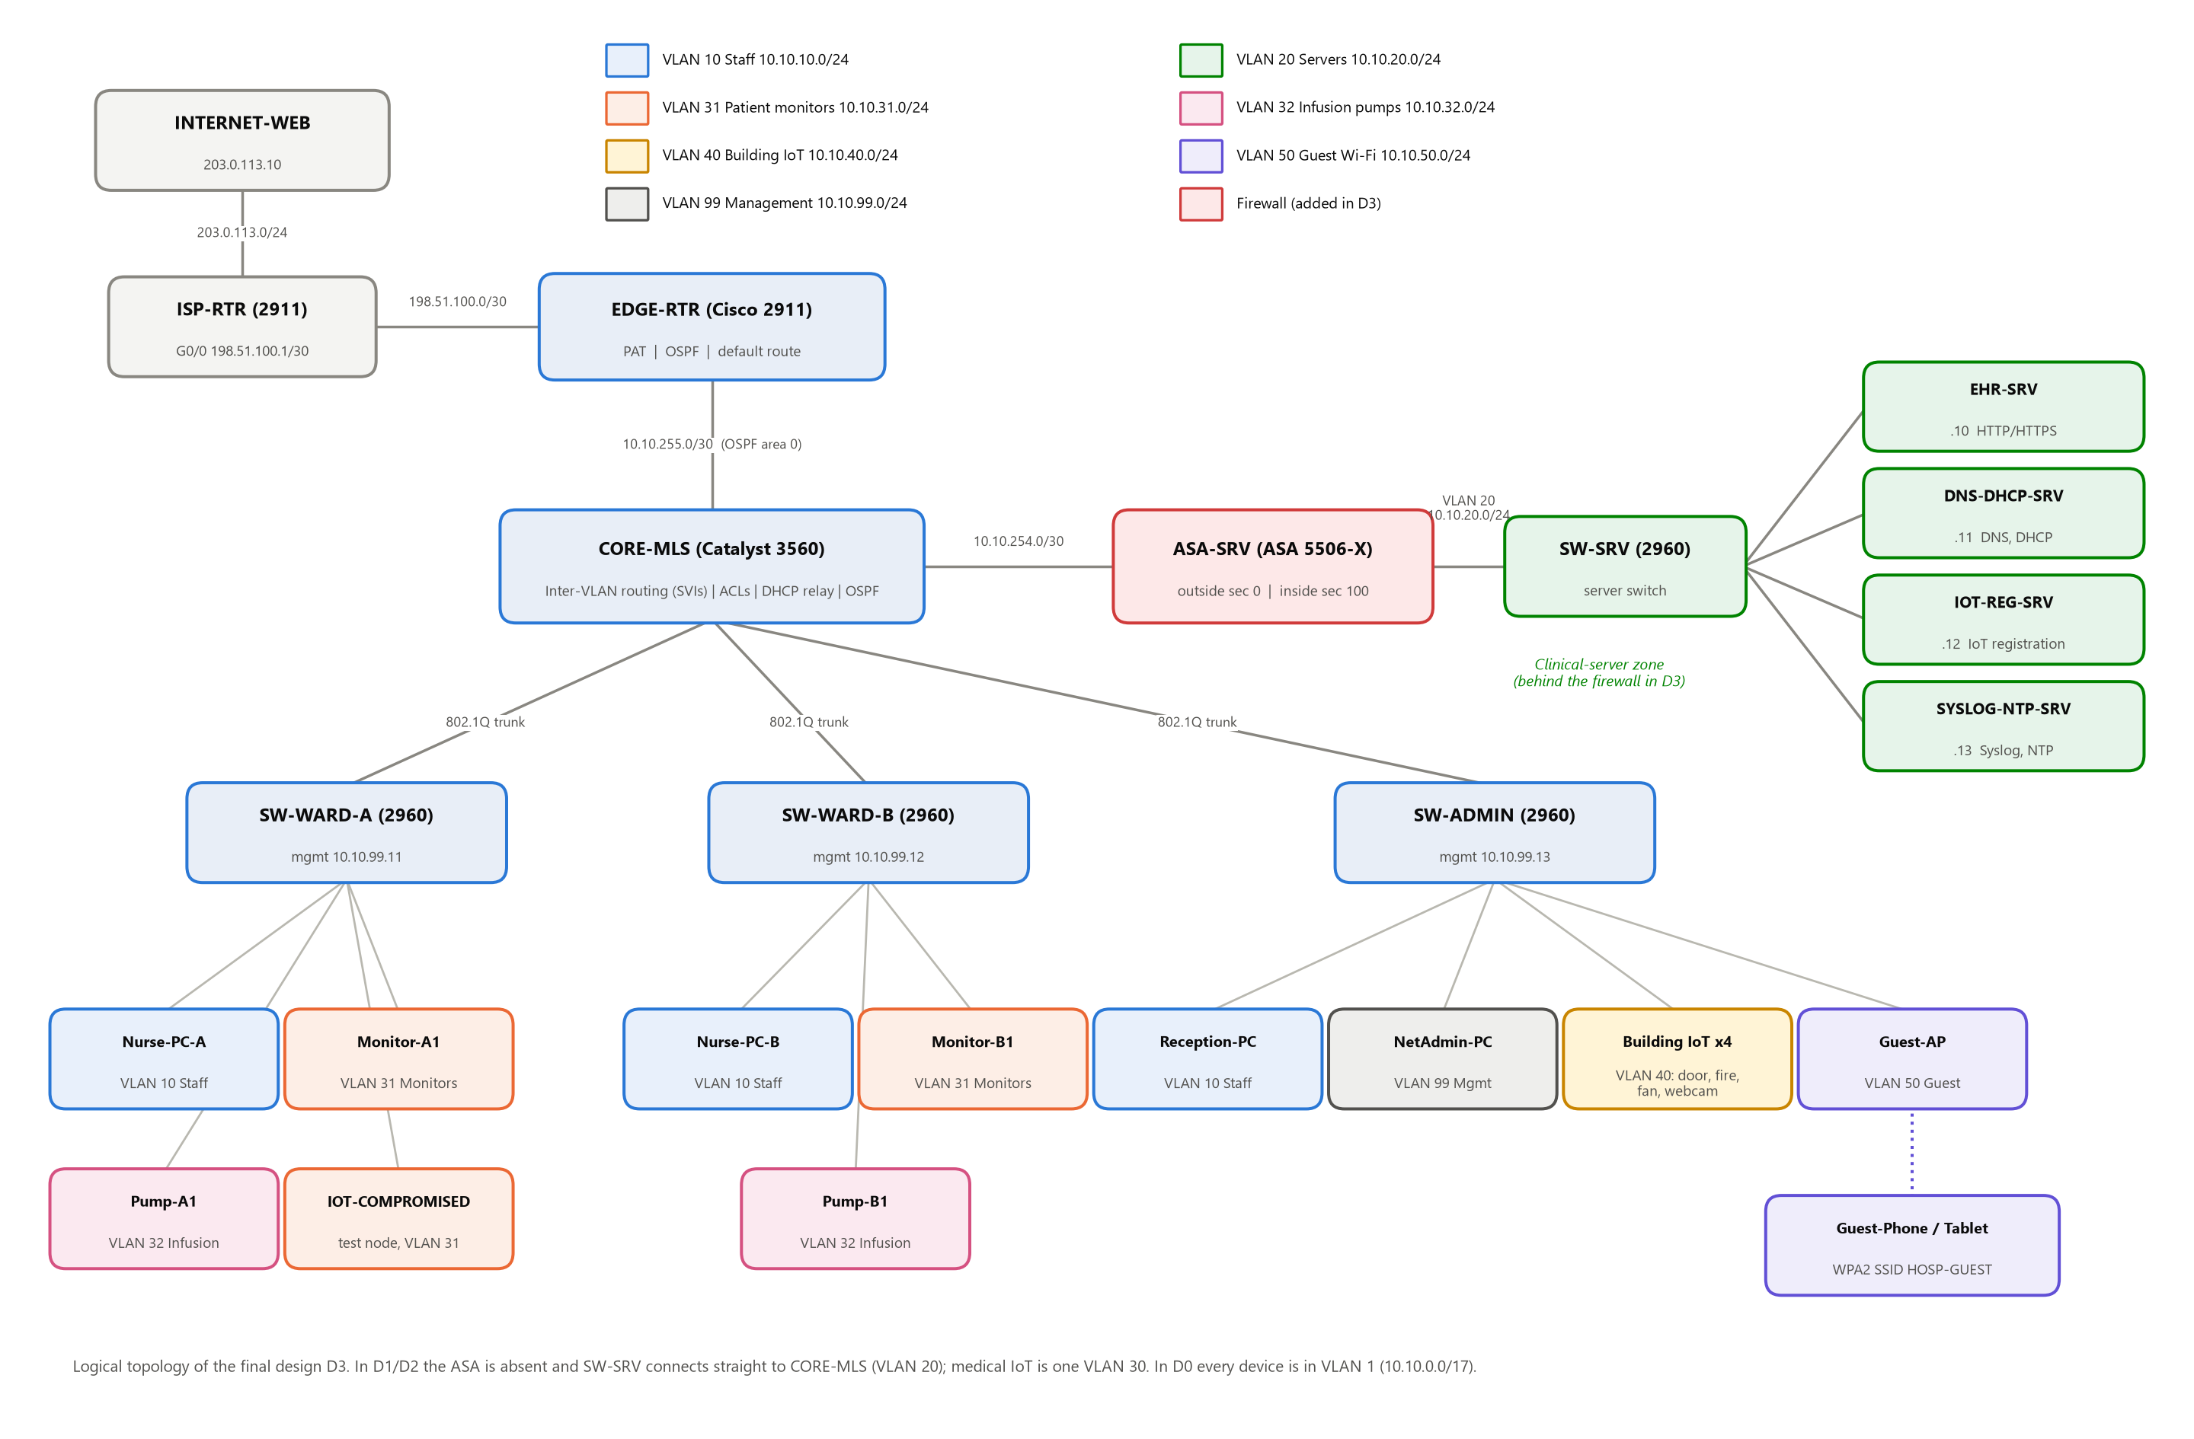
Figure 1: Logical topology of the final micro-segmented design (D3), colour-coded by VLAN/zone
Note: Also paste the Packet Tracer workspace screenshot (Logical view) of D3 below this figure.
Table 3.1: VLAN and IP addressing plan
VLAN | Name | Subnet | Gateway | Used in | Members
1 | Flat (D0) | 10.10.0.0/17 | 10.10.0.1 (core SVI 1) | D0 | Every device
10 | STAFF | 10.10.10.0/24 | 10.10.10.1 | D1–D3 | Nurse PCs, reception PC
20 | SERVERS | 10.10.20.0/24 | .1 core SVI (D1–D2) / ASA inside (D3) | D1–D3 | EHR, DNS/DHCP, IoT reg., Syslog/NTP
30 | MED-IOT | 10.10.30.0/24 | 10.10.30.1 | D1–D2 | All medical IoT
31 | MED-MONITORS | 10.10.31.0/24 | 10.10.31.1 | D3 | Patient monitors
32 | MED-INFUSION | 10.10.32.0/24 | 10.10.32.1 | D3 | Infusion pumps
40 | BLDG-IOT | 10.10.40.0/24 | 10.10.40.1 | D1–D3 | Door, fire monitor, fan, webcam
50 | GUEST | 10.10.50.0/24 | 10.10.50.1 | D1–D3 | Guest Wi-Fi clients
99 | MGMT | 10.10.99.0/24 | 10.10.99.1 | D1–D3 | Switch management, NetAdmin-PC
998 / 999 | NATIVE / BLACKHOLE | – | – | D3 | Unused native VLAN / parked ports
– | Core–Edge link | 10.10.255.0/30 | – | All | OSPF area 0
– | Core–ASA link | 10.10.254.0/30 | – | D3 | Routed transit to firewall
– | WAN / Internet | 198.51.100.0/30, 203.0.113.0/24 | – | All | ISP link, public web server

Table 3.2: Devices and physical connections
Device (PT model) | Port | Connects to | Cable
ISP-RTR (2911) | G0/0 / G0/1 | EDGE-RTR G0/0 / INTERNET-WEB | Copper cross-over
EDGE-RTR (2911) | G0/1 | CORE-MLS G0/1 (routed port) | Copper straight
CORE-MLS (3560-24PS) | Fa0/1, 2, 3 | SW-WARD-A, SW-WARD-B, SW-ADMIN (G0/1), 802.1Q trunks | Copper cross-over
CORE-MLS | G0/2 | SW-SRV G0/1 (D0–D2) / ASA-SRV G1/1 (D3) | Cross-over / straight
ASA-SRV (5506-X), D3 only | G1/2 | SW-SRV G0/1 | Copper straight
SW-SRV (2960) | Fa0/1–4 | EHR-SRV, DNS-DHCP-SRV, IOT-REG-SRV, SYSLOG-NTP-SRV | Copper straight
SW-WARD-A / B (2960) | Fa0/1–5 | Nurse PC, monitor, pump, test-node port, staff wall jack | Copper straight
SW-ADMIN (2960) | Fa0/1–8 | Reception PC, NetAdmin PC, 4 building IoT, test-node port, Guest-AP | Copper straight
Guest-AP (AccessPoint-PT) | Wireless | Guest-Phone, Guest-Tablet (WPA2-PSK) | Wireless

Table 3.3: The four designs compared (only the security policy changes)
Design | Segmentation | Filtering | Extra controls
D0 Flat | One VLAN, one /17 subnet | None | Telnet with shared password
D1 VLAN-only | 6 role VLANs + 802.1Q trunks | None (free inter-VLAN routing) | Telnet
D2 Zone ACLs | Same as D1 | Coarse zone ACLs on SVIs (IoT → server zone only; guests → Internet only) | Telnet
D3 Micro-seg | 8 VLANs, IoT split per device class | Least-privilege ACLs (host + port) + ASA stateful firewall | Port security, DHCP snooping, BPDU Guard, trunk hardening, SSH-only mgmt, unused ports shut

4. Configuration setup
This section gives the configuration of every device in the final design (D3). End devices are set up through the Packet Tracer GUI. Network devices are configured from the CLI; the commands below can be pasted directly into each device’s CLI tab. Lines starting with “!” are comments that explain the purpose of each block. The full configuration files for all four designs are in the project’s configs/ folder, and Section 4.10 lists what differs in D0–D2. In our build, every router, switch and firewall configuration was pushed into Packet Tracer 9.0.1 from these same files, so the report and the .pkt files match line for line.

4.1 PCs and laptops
Device | Switch / port | VLAN (D3) | IP configuration
Nurse-PC-A | SW-WARD-A Fa0/1 | 10 STAFF | DHCP → 10.10.10.100+, GW 10.10.10.1, DNS 10.10.20.11
Nurse-PC-B | SW-WARD-B Fa0/1 | 10 STAFF | DHCP (same pool)
Reception-PC | SW-ADMIN Fa0/1 | 10 STAFF | DHCP (same pool)
NetAdmin-PC | SW-ADMIN Fa0/2 | 99 MGMT | Static 10.10.99.50/24, GW 10.10.99.1, DNS 10.10.20.11
IOT-COMPROMISED (Laptop) | SW-WARD-A Fa0/4 (also Ward-B Fa0/4, Admin Fa0/7) | 31 / 40 | DHCP: simulates a hijacked medical device
ROGUE-LAPTOP | SW-WARD-A Fa0/2 (attack A6 only) | 31 | DHCP: unauthorised device
Guest-Phone, Guest-Tablet | Wireless via Guest-AP | 50 GUEST | SSID HOSP-GUEST, WPA2-PSK, DHCP

4.2 Servers
Server | IP / mask / gateway | Services enabled
EHR-SRV | 10.10.20.10 /24, GW 10.10.20.1 | HTTP, HTTPS (index.html: “Hospital EHR – Patient Records (CONFIDENTIAL)”)
DNS-DHCP-SRV | 10.10.20.11 /24, GW 10.10.20.1 | DNS: ehr.hospital.local→.10, iot.hospital.local→.12, web.isp.test→203.0.113.10; DHCP pools (Table 4.2)
IOT-REG-SRV | 10.10.20.12 /24, GW 10.10.20.1 | IoT registration server (account iotadmin)
SYSLOG-NTP-SRV | 10.10.20.13 /24, GW 10.10.20.1 | Syslog, NTP
INTERNET-WEB | 203.0.113.10 /24, GW 203.0.113.1 | HTTP (“Public Internet web server”)
ROGUE-DHCP (attack A5 only) | 10.10.10.66 /24 | DHCP pool handing out gateway/DNS 10.10.10.66 (man-in-the-middle)
Table 4.2: DHCP pools on DNS-DHCP-SRV (D3); the relay agent’s giaddr selects the pool
Pool | Default gateway | DNS | Start IP | Mask | Max users
serverPool | 10.10.20.1 | 10.10.20.11 | 10.10.20.200 | 255.255.255.0 | 20
STAFF | 10.10.10.1 | 10.10.20.11 | 10.10.10.100 | 255.255.255.0 | 100
MED-MONITORS | 10.10.31.1 | 10.10.20.11 | 10.10.31.100 | 255.255.255.0 | 100
MED-INFUSION | 10.10.32.1 | 10.10.20.11 | 10.10.32.100 | 255.255.255.0 | 100
BLDG-IOT | 10.10.40.1 | 10.10.20.11 | 10.10.40.100 | 255.255.255.0 | 100
GUEST | 10.10.50.1 | 10.10.20.11 | 10.10.50.100 | 255.255.255.0 | 100

4.3 IoT devices
Device | Represents | Port | VLAN (D3) | Settings
Monitor-A1, Monitor-B1 | Patient vital-signs monitor | Ward-A/B Fa0/2 | 31 | Wired NIC (PT-IOT-NM-1CFE), DHCP, IoT server 10.10.20.12
Pump-A1, Pump-B1 | Infusion pump | Ward-A/B Fa0/3 | 32 | Same as above
Smart-Door | Access-controlled door | Admin Fa0/3 | 40 | Same as above
Fire-Monitor | Smoke / fire detector | Admin Fa0/4 | 40 | Same; rule: smoke → HVAC-Fan high
HVAC-Fan | Ventilation | Admin Fa0/5 | 40 | Same as above
Webcam | CCTV camera | Admin Fa0/6 | 40 | Same as above

4.4 Wireless access point
Guest-AP (AccessPoint-PT): Port 0 is cabled to SW-ADMIN Fa0/8 (VLAN 50). Port 1 uses SSID HOSP-GUEST with WPA2-PSK authentication and the passphrase GuestWiFi@2026. Wireless clients get addresses from the GUEST DHCP pool through the core’s DHCP relay.

4.5 ISP-RTR (Cisco 2911)
! =====================================================================
! ISP-RTR (Cisco 2911) - simulated Internet Service Provider
! Same configuration in ALL designs (D0, D1, D2, D3)
! Paste in CLI tab after the "Router>" prompt.
! =====================================================================
enable
configure terminal
hostname ISP-RTR
no ip domain-lookup
!
interface GigabitEthernet0/0
description WAN link to hospital EDGE-RTR G0/0
ip address 198.51.100.1 255.255.255.252
no shutdown
!
interface GigabitEthernet0/1
description "Internet" LAN with public web server
ip address 203.0.113.1 255.255.255.0
no shutdown
!
! No route back to 10.10.0.0/16 is needed: the hospital is hidden
! behind PAT (NAT overload) on EDGE-RTR, so every reply goes to
! 198.51.100.2, which is directly connected.
end
write memory

4.6 EDGE-RTR (Cisco 2911)
! =====================================================================
! EDGE-RTR (Cisco 2911) - D3 MICRO-SEGMENTATION
! Same routing/NAT as D0-D2. Added: SSH-only management, local user,
! VTY limited to the management VLAN, encrypted passwords, banner.
! =====================================================================
enable
configure terminal
hostname EDGE-RTR
no ip domain-lookup
enable secret Edge@2026
service password-encryption
service timestamps log datetime msec
banner motd ^Authorised access only. Activity is logged.^
!
! ---- SSH prerequisites: hostname + domain + RSA key + local user ----
ip domain-name hospital.local
username netadmin privilege 15 secret Adm1n@2026
crypto key generate rsa general-keys modulus 1024
ip ssh version 2
ip ssh time-out 60
ip ssh authentication-retries 3
!
interface GigabitEthernet0/0
description WAN to ISP-RTR G0/0
ip address 198.51.100.2 255.255.255.252
ip nat outside
no shutdown
!
interface GigabitEthernet0/1
description Routed link to CORE-MLS G0/1
ip address 10.10.255.1 255.255.255.252
ip nat inside
no shutdown
!
interface GigabitEthernet0/2
shutdown
!
ip route 0.0.0.0 0.0.0.0 198.51.100.1
! ---- Floating static backup (AD 250): used only if OSPF is down ----
ip route 10.10.0.0 255.255.0.0 10.10.255.2 250
!
!
access-list 1 remark Hospital private range allowed to use NAT
access-list 1 permit 10.10.0.0 0.0.255.255
ip nat inside source list 1 interface GigabitEthernet0/0 overload
!
! ---- Only the management VLAN may open a VTY session ----
access-list 10 remark Management VLAN only
access-list 10 permit 10.10.99.0 0.0.0.255
!
router ospf 1
router-id 1.1.1.1
network 10.10.255.0 0.0.0.3 area 0
default-information originate
!
ntp server 10.10.20.13
logging host 10.10.20.13
!
line console 0
login local
exec-timeout 5 0
line vty 0 4
access-class 10 in
login local
transport input ssh
exec-timeout 5 0
end
write memory

4.7 CORE-MLS (Cisco Catalyst 3560-24PS)
! =====================================================================
! CORE-MLS (Cisco Catalyst 3560-24PS) - D3 MICRO-SEGMENTATION
! Changes from D2:
! * Medical IoT split by device class: VLAN 31 monitors, VLAN 32 pumps
! * Server VLAN 20 removed from the core: servers now sit behind the
! ASA firewall (G0/2 becomes a routed /30 link to the ASA)
! * Least-privilege ACLs: each class may reach only the exact server
! and port it needs (e.g. monitors -> IoT server TCP 80, nothing else)
! * Trunks: unused native VLAN 998, allowed-VLAN lists, DTP off
! * Unused ports shut down and parked in black-hole VLAN 999
! * SSH-only management from VLAN 99
!
! =====================================================================
enable
configure terminal
hostname CORE-MLS
no ip domain-lookup
enable secret Core@2026
service password-encryption
service timestamps log datetime msec
banner motd ^Authorised access only. Activity is logged.^
ip routing
!
ip domain-name hospital.local
username netadmin privilege 15 secret Adm1n@2026
crypto key generate rsa general-keys modulus 1024
ip ssh version 2
ip ssh time-out 60
ip ssh authentication-retries 3
!
vlan 10
name STAFF
vlan 31
name MED-MONITORS
vlan 32
name MED-INFUSION
vlan 40
name BLDG-IOT
vlan 50
name GUEST
vlan 99
name MGMT
vlan 998
name NATIVE-UNUSED
vlan 999
name BLACKHOLE
!
interface GigabitEthernet0/1
description Routed link to EDGE-RTR G0/1
no switchport
ip address 10.10.255.2 255.255.255.252
no shutdown
!
! ---- Trunks: explicit native VLAN + only the VLANs each closet needs ----
interface range FastEthernet0/1 - 2
description 802.1Q trunk to ward switch
switchport trunk encapsulation dot1q
switchport mode trunk
switchport trunk native vlan 998
switchport trunk allowed vlan 10,31,32,99
switchport nonegotiate
interface FastEthernet0/3
description 802.1Q trunk to SW-ADMIN
switchport trunk encapsulation dot1q
switchport mode trunk
switchport trunk native vlan 998
switchport trunk allowed vlan 10,40,50,99
switchport nonegotiate
!
! ---- Routed link to the firewall that guards the clinical servers ----
interface GigabitEthernet0/2
description Routed link to ASA-SRV G1/1 (outside)
no switchport
ip address 10.10.254.1 255.255.255.252
no shutdown
!
! ---- Park every unused port ----
interface range FastEthernet0/4 - 24
switchport mode access
switchport access vlan 999
shutdown
!
! =====================================================================
! LEAST-PRIVILEGE ACLs (inbound on each SVI)
! 10.10.20.10 EHR-SRV | .11 DNS-DHCP-SRV | .12 IOT-REG-SRV | .13 SYSLOG-NTP
! "echo-reply to 10.10.99.0" lets the admin ping devices for
! troubleshooting while the devices themselves cannot start a ping.
! =====================================================================
ip access-list extended STAFF-IN
remark Staff: DHCP, DNS, EHR web, IoT dashboard, ping servers, Internet
permit udp any any eq 67
permit udp 10.10.10.0 0.0.0.255 host 10.10.20.11 eq 53
permit tcp 10.10.10.0 0.0.0.255 host 10.10.20.10 eq 80
permit tcp 10.10.10.0 0.0.0.255 host 10.10.20.10 eq 443
permit tcp 10.10.10.0 0.0.0.255 host 10.10.20.12 eq 80
permit icmp 10.10.10.0 0.0.0.255 10.10.20.0 0.0.0.255 echo
permit icmp 10.10.10.0 0.0.0.255 10.10.99.0 0.0.0.255 echo-reply
deny ip any 10.0.0.0 0.255.255.255
permit ip 10.10.10.0 0.0.0.255 any
!
ip access-list extended MONITORS-IN
remark Patient monitors: DHCP + IoT registration server only
permit udp any any eq 67
permit tcp 10.10.31.0 0.0.0.255 host 10.10.20.12 eq 80
permit icmp 10.10.31.0 0.0.0.255 10.10.99.0 0.0.0.255 echo-reply
deny ip any any
!
ip access-list extended INFUSION-IN
remark Infusion pumps: DHCP + IoT registration server only
permit udp any any eq 67
permit tcp 10.10.32.0 0.0.0.255 host 10.10.20.12 eq 80
permit icmp 10.10.32.0 0.0.0.255 10.10.99.0 0.0.0.255 echo-reply
deny ip any any
!
ip access-list extended BLDGIOT-IN
remark Building IoT: DHCP + IoT registration server only
permit udp any any eq 67
permit tcp 10.10.40.0 0.0.0.255 host 10.10.20.12 eq 80
permit icmp 10.10.40.0 0.0.0.255 10.10.99.0 0.0.0.255 echo-reply
deny ip any any
!
ip access-list extended GUEST-IN
remark Guests: DHCP, DNS, Internet. Never internal subnets
permit udp any any eq 67
permit udp 10.10.50.0 0.0.0.255 host 10.10.20.11 eq 53
deny ip any 10.0.0.0 0.255.255.255
permit ip 10.10.50.0 0.0.0.255 any
!
! ---- Only the management VLAN may open a VTY session ----
access-list 10 remark Management VLAN only
access-list 10 permit 10.10.99.0 0.0.0.255
!
interface Vlan1
no ip address
shutdown
interface Vlan10
description STAFF gateway
ip address 10.10.10.1 255.255.255.0
ip helper-address 10.10.20.11
ip access-group STAFF-IN in
no shutdown
interface Vlan31
description MED-MONITORS gateway
ip address 10.10.31.1 255.255.255.0
ip helper-address 10.10.20.11
ip access-group MONITORS-IN in
no shutdown
interface Vlan32
description MED-INFUSION gateway
ip address 10.10.32.1 255.255.255.0
ip helper-address 10.10.20.11
ip access-group INFUSION-IN in
no shutdown
interface Vlan40
description BUILDING IoT gateway
ip address 10.10.40.1 255.255.255.0
ip helper-address 10.10.20.11
ip access-group BLDGIOT-IN in
no shutdown
interface Vlan50
description GUEST Wi-Fi gateway
ip address 10.10.50.1 255.255.255.0
ip helper-address 10.10.20.11
ip access-group GUEST-IN in
no shutdown
interface Vlan99
description MANAGEMENT gateway (trusted)
ip address 10.10.99.1 255.255.255.0
no shutdown
!
! ---- Server zone is behind the ASA ----
ip route 10.10.20.0 255.255.255.0 10.10.254.2
!
! ---- Floating static backup (AD 250): used only if OSPF is down ----
ip route 0.0.0.0 0.0.0.0 10.10.255.1 250
!
router ospf 1
router-id 2.2.2.2
passive-interface default
no passive-interface GigabitEthernet0/1
network 10.10.0.0 0.0.255.255 area 0
redistribute static subnets
!
ntp server 10.10.20.13
logging host 10.10.20.13
!
line console 0
login local
exec-timeout 5 0
line vty 0 15
access-class 10 in
login local
transport input ssh
exec-timeout 5 0
end
write memory

4.8 ASA-SRV (Cisco ASA 5506-X)
! =====================================================================
! ASA-SRV (Cisco ASA 5506-X) - D3 only
! Stateful firewall in front of the clinical-server zone.
! G1/1 "outside" security-level 0 10.10.254.2/30 -> CORE-MLS G0/2
! G1/2 "inside" security-level 100 10.10.20.1/24 -> SW-SRV G0/1
! Rules of the ASA:
! * higher -> lower security level is allowed by default (servers can
! answer and the replies are tracked statefully)
! * lower -> higher is DENIED unless an access-list permits it
! (that is what OUTSIDE-IN below does, one line per real need)
!
! PT NOTE: the ASA ships with a default DHCP pool on "inside"
! (192.168.1.x). Remove it first, or the new inside IP is rejected.
! In PT the ASA prompt is "ciscoasa>"; the default enable password is
! empty (just press Enter).
! =====================================================================
enable
configure terminal
hostname ASA-SRV
enable password Asa@2026
!
! ---- remove the factory DHCP server on inside ----
no dhcpd enable inside
no dhcpd address 192.168.1.5-192.168.1.36 inside
!
interface GigabitEthernet1/1
nameif outside
security-level 0
ip address 10.10.254.2 255.255.255.252
no shutdown
!
interface GigabitEthernet1/2
nameif inside
security-level 100
ip address 10.10.20.1 255.255.255.0
no shutdown
!
! ---- everything not in the server zone is reached via the core ----
route outside 0.0.0.0 0.0.0.0 10.10.254.1
!
! =====================================================================
! OUTSIDE-IN: what the campus may open towards the servers
! (second layer of defence behind the core ACLs = defence in depth)
! ASA ACLs use SUBNET MASKS, not wildcard masks like IOS.
! =====================================================================
access-list OUTSIDE-IN extended permit tcp 10.10.10.0 255.255.255.0 host 10.10.20.10 eq 80
access-list OUTSIDE-IN extended permit tcp 10.10.10.0 255.255.255.0 host 10.10.20.10 eq 443
access-list OUTSIDE-IN extended permit tcp 10.10.10.0 255.255.255.0 host 10.10.20.12 eq 80
access-list OUTSIDE-IN extended permit tcp 10.10.31.0 255.255.255.0 host 10.10.20.12 eq 80
access-list OUTSIDE-IN extended permit tcp 10.10.32.0 255.255.255.0 host 10.10.20.12 eq 80
access-list OUTSIDE-IN extended permit tcp 10.10.40.0 255.255.255.0 host 10.10.20.12 eq 80
access-list OUTSIDE-IN extended permit udp 10.10.0.0 255.255.0.0 host 10.10.20.11 eq 67
access-list OUTSIDE-IN extended permit udp 10.10.10.0 255.255.255.0 host 10.10.20.11 eq 53
access-list OUTSIDE-IN extended permit udp 10.10.50.0 255.255.255.0 host 10.10.20.11 eq 53
access-list OUTSIDE-IN extended permit udp 10.10.254.0 255.255.255.252 host 10.10.20.13 eq 514
access-list OUTSIDE-IN extended permit udp 10.10.255.0 255.255.255.252 host 10.10.20.13 eq 514
access-list OUTSIDE-IN extended permit udp 10.10.254.0 255.255.255.252 host 10.10.20.13 eq 123
access-list OUTSIDE-IN extended permit udp 10.10.255.0 255.255.255.252 host 10.10.20.13 eq 123
access-list OUTSIDE-IN extended permit icmp 10.10.10.0 255.255.255.0 10.10.20.0 255.255.255.0 echo
access-list OUTSIDE-IN extended permit ip 10.10.99.0 255.255.255.0 10.10.20.0 255.255.255.0
access-list OUTSIDE-IN extended deny ip any any
access-group OUTSIDE-IN in interface outside
!
! ---- Stateful ICMP: let echo-replies back in for permitted pings ----
class-map inspection_default
match default-inspection-traffic
policy-map global_policy
class inspection_default
inspect icmp
service-policy global_policy global
!
end
write memory

4.9 Access and server switches (Cisco 2960-24TT)

SW-WARD-A
! =====================================================================
! SW-WARD-A (Cisco 2960-24TT) - D3 MICRO-SEGMENTATION
! Added vs D1/D2:
! * medical IoT split: monitors VLAN 31, infusion pumps VLAN 32
! * port security (sticky MAC, shutdown on violation)
! * DHCP snooping (only the uplink may send DHCP offers)
! * PortFast + BPDU Guard on edge ports
! * hardened trunk (native 998, allowed list, DTP off)
! * unused ports shut and parked in VLAN 999
! * SSH-only management from VLAN 99
! =====================================================================
enable
configure terminal
hostname SW-WARD-A
no ip domain-lookup
enable secret WardA@2026
service password-encryption
banner motd ^Authorised access only. Activity is logged.^
!
ip domain-name hospital.local
username netadmin privilege 15 secret Adm1n@2026
crypto key generate rsa general-keys modulus 1024
ip ssh version 2
!
vlan 10
name STAFF
vlan 31
name MED-MONITORS
vlan 32
name MED-INFUSION
vlan 99
name MGMT
vlan 998
name NATIVE-UNUSED
vlan 999
name BLACKHOLE
!
! ---- DHCP snooping: offers are only accepted from trusted ports ----
ip dhcp snooping
ip dhcp snooping vlan 10,31,32
no ip dhcp snooping information option
!
interface FastEthernet0/1
description Nurse-PC-A (staff)
switchport mode access
switchport access vlan 10
switchport port-security
switchport port-security maximum 1
switchport port-security mac-address sticky
switchport port-security violation shutdown
spanning-tree portfast
spanning-tree bpduguard enable
interface FastEthernet0/2
description Monitor-A1 (patient monitor)
switchport mode access
switchport access vlan 31
switchport port-security
switchport port-security maximum 1
switchport port-security mac-address sticky
switchport port-security violation shutdown
spanning-tree portfast
spanning-tree bpduguard enable
interface FastEthernet0/3
description Pump-A1 (infusion pump)
switchport mode access
switchport access vlan 32
switchport port-security
switchport port-security maximum 1
switchport port-security mac-address sticky
switchport port-security violation shutdown
spanning-tree portfast
spanning-tree bpduguard enable
interface FastEthernet0/4
description IOT-COMPROMISED test node - location 1 (Ward A monitors)
switchport mode access
switchport access vlan 31
switchport port-security
switchport port-security maximum 1
switchport port-security mac-address sticky
switchport port-security violation shutdown
spanning-tree portfast
spanning-tree bpduguard enable
interface FastEthernet0/5
description Staff wall jack (rogue-DHCP test)
switchport mode access
switchport access vlan 10
switchport port-security
switchport port-security maximum 2
switchport port-security mac-address sticky
switchport port-security violation shutdown
spanning-tree portfast
spanning-tree bpduguard enable
!
interface range FastEthernet0/6 - 24, GigabitEthernet0/2
description UNUSED - parked
switchport mode access
switchport access vlan 999
shutdown
!
interface GigabitEthernet0/1
description 802.1Q trunk to CORE-MLS Fa0/1
switchport mode trunk
switchport trunk native vlan 998
switchport trunk allowed vlan 10,31,32,99
switchport nonegotiate
ip dhcp snooping trust
!
interface Vlan1
no ip address
shutdown
interface Vlan99
description Management
ip address 10.10.99.11 255.255.255.0
no shutdown
ip default-gateway 10.10.99.1
!
access-list 10 remark Management VLAN only
access-list 10 permit 10.10.99.0 0.0.0.255
!
line console 0
login local
exec-timeout 5 0
line vty 0 15
access-class 10 in
login local
transport input ssh
exec-timeout 5 0
end
write memory

SW-WARD-B
Same as SW-WARD-A with these changes: hostname SW-WARD-B, enable secret WardB@2026, port descriptions naming Nurse-PC-B, Monitor-B1 and Pump-B1, uplink to CORE-MLS Fa0/2, and management IP 10.10.99.12/24. The full file is configs/D3-microseg/SW-WARD-B.txt.

SW-ADMIN
! =====================================================================
! SW-ADMIN (Cisco 2960-24TT) - D3 MICRO-SEGMENTATION
! Same hardening as the ward switches. The guest AP port allows up to
! 10 MAC addresses because every wireless client behind the AP shows
! up on this one switch port.
! =====================================================================
enable
configure terminal
hostname SW-ADMIN
no ip domain-lookup
enable secret Admin@2026
service password-encryption
banner motd ^Authorised access only. Activity is logged.^
!
ip domain-name hospital.local
username netadmin privilege 15 secret Adm1n@2026
crypto key generate rsa general-keys modulus 1024
ip ssh version 2
!
vlan 10
name STAFF
vlan 40
name BLDG-IOT
vlan 50
name GUEST
vlan 99
name MGMT
vlan 998
name NATIVE-UNUSED
vlan 999
name BLACKHOLE
!
ip dhcp snooping
ip dhcp snooping vlan 10,40,50
no ip dhcp snooping information option
!
interface FastEthernet0/1
description Reception-PC (staff)
switchport mode access
switchport access vlan 10
switchport port-security
switchport port-security maximum 1
switchport port-security mac-address sticky
switchport port-security violation shutdown
spanning-tree portfast
spanning-tree bpduguard enable
interface FastEthernet0/2
description NetAdmin-PC (management)
switchport mode access
switchport access vlan 99
switchport port-security
switchport port-security maximum 1
switchport port-security mac-address sticky
switchport port-security violation shutdown
spanning-tree portfast
spanning-tree bpduguard enable
interface range FastEthernet0/3 - 7
description Building IoT (door, fire, HVAC, webcam) + test node location 3
switchport mode access
switchport access vlan 40
switchport port-security
switchport port-security maximum 1
switchport port-security mac-address sticky
switchport port-security violation shutdown
spanning-tree portfast
spanning-tree bpduguard enable
interface FastEthernet0/8
description Guest-AP (guest Wi-Fi)
switchport mode access
switchport access vlan 50
switchport port-security
switchport port-security maximum 10
switchport port-security violation restrict
spanning-tree portfast
spanning-tree bpduguard enable
!
interface range FastEthernet0/9 - 24, GigabitEthernet0/2
description UNUSED - parked
switchport mode access
switchport access vlan 999
shutdown
!
interface GigabitEthernet0/1
description 802.1Q trunk to CORE-MLS Fa0/3
switchport mode trunk
switchport trunk native vlan 998
switchport trunk allowed vlan 10,40,50,99
switchport nonegotiate
ip dhcp snooping trust
!
interface Vlan1
no ip address
shutdown
interface Vlan99
description Management
ip address 10.10.99.13 255.255.255.0
no shutdown
ip default-gateway 10.10.99.1
!
access-list 10 remark Management VLAN only
access-list 10 permit 10.10.99.0 0.0.0.255
!
line console 0
login local
exec-timeout 5 0
line vty 0 15
access-class 10 in
login local
transport input ssh
exec-timeout 5 0
end
write memory

SW-SRV
! =====================================================================
! SW-SRV (Cisco 2960-24TT) - server-room switch
! Same configuration in ALL designs. It is a plain Layer-2 switch with
! every port in VLAN 1; the device on the other end of G0/1 decides
! which network the servers are in:
! D0 -> CORE-MLS G0/2, access VLAN 1 (flat)
! D1, D2 -> CORE-MLS G0/2, access VLAN 20 (server VLAN)
! D3 -> ASA-SRV G1/2 (inside interface of the firewall)
! =====================================================================
enable
configure terminal
hostname SW-SRV
no ip domain-lookup
enable secret cisco
!
interface FastEthernet0/1
description EHR-SRV 10.10.20.10
interface FastEthernet0/2
description DNS-DHCP-SRV 10.10.20.11
interface FastEthernet0/3
description IOT-REG-SRV 10.10.20.12
interface FastEthernet0/4
description SYSLOG-NTP-SRV 10.10.20.13
interface GigabitEthernet0/1
description Uplink (CORE-MLS G0/2 in D0-D2, ASA-SRV G1/2 in D3)
!
line console 0
password cisco
login
end
write memory

4.10 Baseline designs D0, D1 and D2: what is different
ISP-RTR and SW-SRV are identical in all designs. EDGE-RTR keeps the same routing and NAT but uses Telnet with a shared password instead of SSH. Key differences:
- D0 Flat: there are no VLANs. The core has a single SVI (VLAN 1, 10.10.0.1/17), every host uses a /17 mask (255.255.128.0, chosen so it cannot overlap the 10.10.255.0/30 core–edge link), and one DHCP pool serves everyone.
- D1 VLAN-only: VLANs 10/20/30/40/50/99, trunks to the access switches, an SVI and ip helper-address per VLAN, no ACLs, and SW-SRV in access VLAN 20 on the core.
- D2 Zone ACLs: D1 plus three coarse ACLs on the core SVIs:
! =====================================================================
! CORE-MLS (Cisco Catalyst 3560-24PS) - D2 ZONE ACLs
! = D1 + coarse extended ACLs applied INBOUND on the SVIs.
! * Medical IoT and building IoT may talk to the server ZONE (any port)
! and nothing else internal or external.
! * Guests may use DHCP/DNS and the Internet, never internal subnets.
! * Staff and management are unfiltered.
! Coarse = whole zone to whole zone; it does NOT say which server or
! which port, so a compromised IoT device can still reach the EHR.
!
! =====================================================================
enable
configure terminal
hostname CORE-MLS
no ip domain-lookup
enable secret cisco
service timestamps log datetime msec
ip routing
!
vlan 10
name STAFF
vlan 20
name SERVERS
vlan 30
name MED-IOT
vlan 40
name BLDG-IOT
vlan 50
name GUEST
vlan 99
name MGMT
!
interface GigabitEthernet0/1
description Routed link to EDGE-RTR G0/1
no switchport
ip address 10.10.255.2 255.255.255.252
no shutdown
!
interface range FastEthernet0/1 - 3
description 802.1Q trunk to access switch
switchport trunk encapsulation dot1q
switchport mode trunk
!
interface GigabitEthernet0/2
description To SW-SRV G0/1 (server VLAN 20)
switchport mode access
switchport access vlan 20
!
! ---------------------------------------------------------------------
! Zone ACLs (extended, named). Order matters: first match wins and
! every ACL ends with an invisible "deny ip any any".
! UDP 67 = DHCP (bootps). The DHCP DISCOVER is a broadcast from 0.0.0.0,
! so it must be permitted before anything else or no host gets an IP.
! ---------------------------------------------------------------------
ip access-list extended MEDIOT-IN
remark Medical IoT -> server zone only
permit udp any any eq 67
permit ip 10.10.30.0 0.0.0.255 10.10.20.0 0.0.0.255
deny ip any any
!
ip access-list extended BLDGIOT-IN
remark Building IoT -> server zone only
permit udp any any eq 67
permit ip 10.10.40.0 0.0.0.255 10.10.20.0 0.0.0.255
deny ip any any
!
ip access-list extended GUEST-IN
remark Guests -> DHCP, DNS, Internet. Never internal subnets
permit udp any any eq 67
permit udp 10.10.50.0 0.0.0.255 host 10.10.20.11 eq 53
deny ip any 10.0.0.0 0.255.255.255
permit ip 10.10.50.0 0.0.0.255 any
!

5. Results

5.1 Test method
Every design was put through the same test plan. A laptop (IOT-COMPROMISED) plays a hijacked medical device and is placed at three locations: Ward A medical IoT, Ward B medical IoT and building IoT. Each attack is repeated three times at each location, and the outcome is confirmed in Packet Tracer’s Simulation mode, where the PDU details show the exact ACL or firewall rule that dropped a packet. Nine functional tests check that legitimate traffic still works. All observations are logged in results/attack-matrix.csv, attack-surface.csv and functional.csv, and the graphs are generated from these files.
ID | Attack scenario | How it is performed
A1 | Reconnaissance sweep | From IOT-COMPROMISED, ping all 23 target hosts and gateways; count replies
A2 | Unauthorised data access | Browser on IOT-COMPROMISED → http://10.10.20.10 (EHR)
A3 | Device / IoT-server hijack | Browse to the IoT server login (10.10.20.12) and ping a device of another class (e.g. a pump)
A4 | Infrastructure takeover | telnet / ssh to 10.10.99.11–13, the core gateway and EDGE-RTR
A5 | Rogue DHCP server | Connect ROGUE-DHCP to SW-WARD-A Fa0/5; renew Nurse-PC-A’s lease
A6 | Unauthorised device / MAC spoof | Unplug Monitor-A1, plug ROGUE-LAPTOP into SW-WARD-A Fa0/2
A7 | Guest → clinical pivot | Guest-Phone browser → http://10.10.20.10

5.2 Proof of communication (screenshots)
[Paste screenshot 2 here]
How to capture: Nurse-PC-A → Desktop → Command Prompt → ping 10.10.20.10; then Web Browser → ehr.hospital.local.
Figure 2: Nurse-PC-A successfully pings EHR-SRV and opens http://ehr.hospital.local (D3)
[Paste screenshot 3 here]
How to capture: Any staff PC → Web Browser → 10.10.20.12 → log in as iotadmin.
Figure 3: All IoT devices registered on the IoT server dashboard
[Paste screenshot 4 here]
How to capture: Guest-Phone opens http://web.isp.test, then run the command on EDGE-RTR.
Figure 4: Internet access through PAT: output of show ip nat translations on EDGE-RTR
[Paste screenshot 5 here]
How to capture: Simulation mode, filter HTTP/TCP, browse to 10.10.20.10 from IOT-COMPROMISED, click the red X PDU at CORE-MLS.
Figure 5: D3: IoT → EHR request dropped by ACL MONITORS-IN (Simulation mode, PDU details)
[Paste screenshot 6 here]
How to capture: After attack A6 run show port-security interface fa0/2 and show interfaces status err-disabled.
Figure 6: D3: port security shuts SW-WARD-A Fa0/2 when ROGUE-LAPTOP is connected
[Paste screenshot 7 here]
How to capture: Run show ip dhcp snooping on SW-WARD-A and ipconfig on Nurse-PC-A.
Figure 7: D3: DHCP snooping drops the rogue server’s offers; Nurse-PC-A keeps a legitimate lease
[Paste screenshot 8 here]
How to capture: show access-lists on CORE-MLS; show access-list OUTSIDE-IN on ASA-SRV.
Figure 8: D3: ACL hit counters on CORE-MLS and ASA-SRV after the attack runs
[Paste screenshot 9 here]
How to capture: Open the D0 file and repeat the browser test from IOT-COMPROMISED.
Figure 9: D0/D1 contrast: the same IoT → EHR request succeeds in the flat network

5.3 Functional preservation (legitimate traffic)
Expected result for every design is PASS. Fill the observed column from results/functional.csv. [Update after testing]
ID | Legitimate flow | D0 | D1 | D2 | D3
F1 | Staff PC opens EHR web page by name (DNS + HTTP) | [ ] | [ ] | [ ] | [ ]
F2 | Staff PC pings EHR-SRV | [ ] | [ ] | [ ] | [ ]
F3 | All 8 IoT devices registered on IoT server | [ ] | [ ] | [ ] | [ ]
F4 | DHCP: every client gets an address in its own subnet | [ ] | [ ] | [ ] | [ ]
F5 | Guest phone reaches Internet web server | [ ] | [ ] | [ ] | [ ]
F6 | Staff reaches Internet; NAT entries on EDGE-RTR | [ ] | [ ] | [ ] | [ ]
F7 | NetAdmin manages switches (Telnet D0–D2, SSH D3) | [ ] | [ ] | [ ] | [ ]
F8 | IoT rule fires (smoke → HVAC fan) | [ ] | [ ] | [ ] | [ ]
F9 | Syslog server receives device logs | [ ] | [ ] | [ ] | [ ]

5.4 Attack success matrix
Table 5.2 gives the outcome predicted by analysing each design’s configuration. Every cell must be confirmed in Packet Tracer and recorded in results/attack-matrix.csv; then re-run python tools/make_graphs.py to redraw Figure 10 from the observed data. [Replace “expected” with observed after testing]
Table 5.2: Expected attack outcome per design, and the control responsible in D3
Attack | D0 | D1 | D2 | D3 | D3 control that stops it
A1 Recon sweep | Succeeded | Succeeded | Partial | Partial | SVI ACLs drop all ICMP; only same-class peers (same VLAN) still answer
A2 EHR access | Succeeded | Succeeded | Succeeded | Blocked | MONITORS-IN + ASA OUTSIDE-IN permit EHR only from staff
A3 IoT server / device hijack | Succeeded | Succeeded | Succeeded | Partial | Cross-class device blocked; IoT server port 80 stays open by necessity
A4 Telnet/SSH to infra | Succeeded | Succeeded | Blocked | Blocked | SVI ACLs, VTY access-class 10, SSH-only
A5 Rogue DHCP | Succeeded | Succeeded | Succeeded | Blocked | DHCP snooping (untrusted access ports)
A6 Unauthorised device | Succeeded | Succeeded | Succeeded | Blocked | Port security sticky MAC, violation shutdown
A7 Guest → EHR | Succeeded | Succeeded | Blocked | Blocked | GUEST-IN denies 10.0.0.0/8; ASA has no guest → EHR rule
S = attack succeeded, P = partial (limited reach), B = blocked.
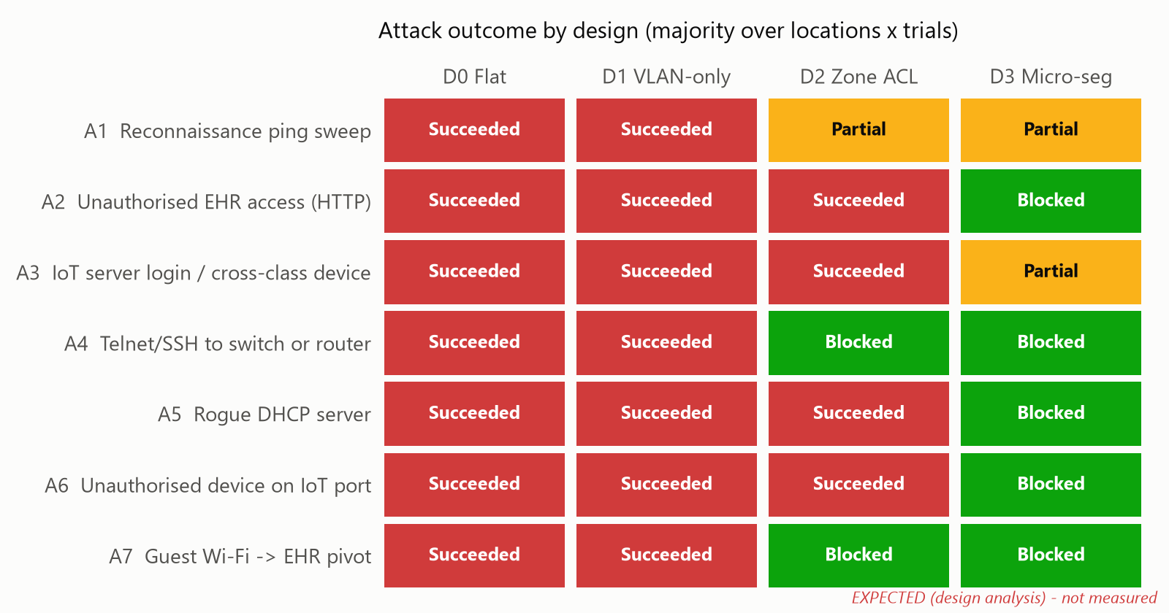
Figure 10: Attack outcome matrix (currently the expected values; regenerate from observed data)

5.5 Attack surface (RQ1)
The attack surface is the share of 23 target hosts (staff PCs, servers, IoT devices, guest clients and network devices) that answer a ping from the compromised node, together with the share of 10 target services (EHR HTTP/HTTPS, IoT server web page, DNS, the Internet web server as an exfiltration path, and Telnet/SSH on five network devices) that accept a connection.
Design | Hosts reachable (of 23) | Services reachable (of 10) | Why
D0 | 23 (100%) | 10 (100%) | One broadcast domain, no filtering
D1 | 23 (100%) | 10 (100%) | VLANs are routed freely by the core SVIs
D2 | 8 (35%) | 4 (40%) | IoT may reach the whole server zone; management, other VLANs and Internet denied
D3 | 2–4 (9–17%) | 1 (10%) | Only same-class peers in the same VLAN; only IoT-server TCP 80
[Expected values from design analysis; replace with the observed means]
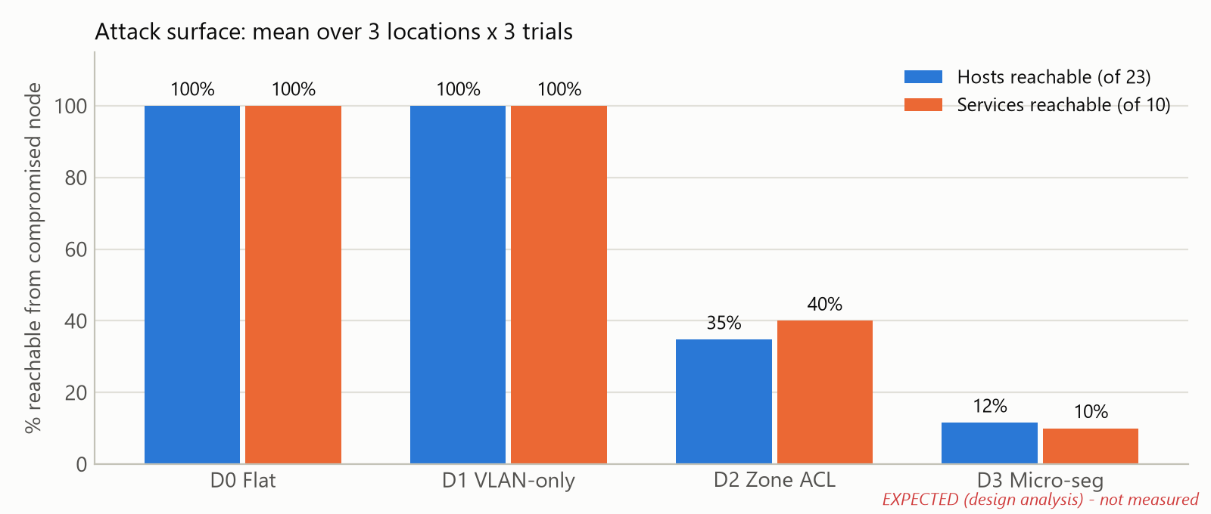
Figure 11: Attack surface reachable from the compromised node

5.6 Configuration complexity (RQ3)
These numbers are counted directly from the configuration files by tools/config_stats.py. They are exact for the configurations in Section 4.
Design | Devices configured | Config lines | ACEs | Security features
D0 | 7 | 189 | 1 | 0
D1 | 7 | 274 | 1 | 1
D2 | 7 | 293 | 11 | 2
D3 | 8 | 559 | 47 | 12
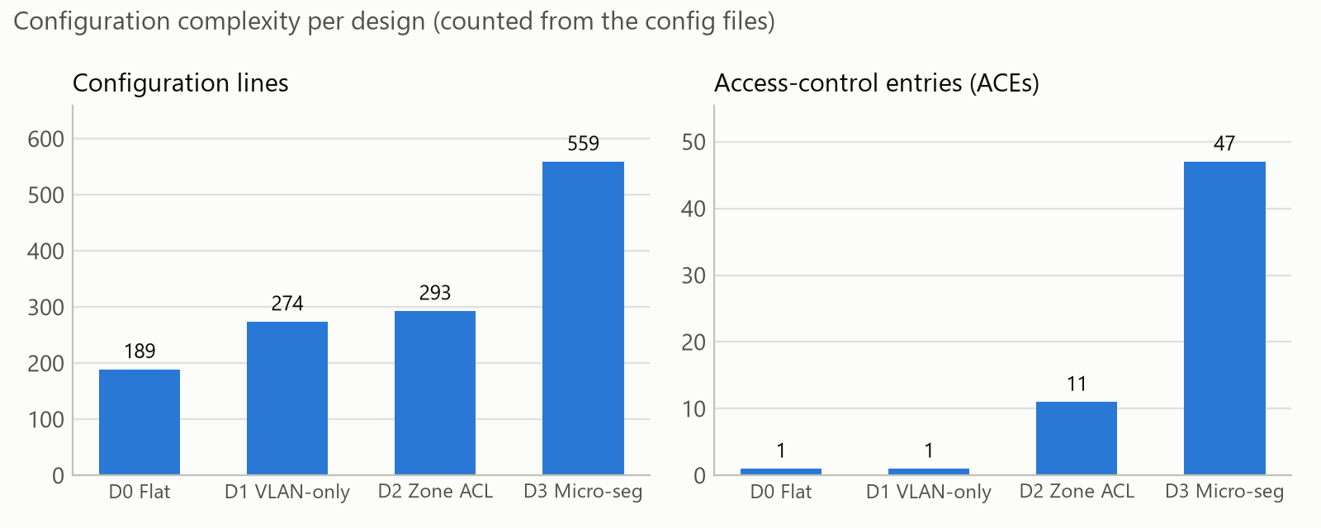
Figure 12: Configuration lines and access-control entries per design
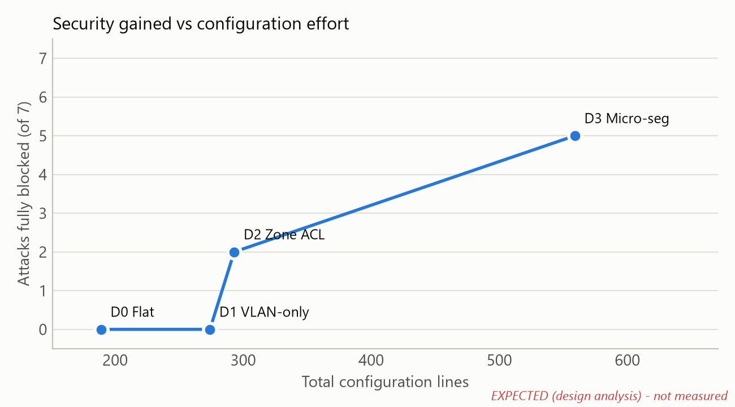
Figure 13: Security gained versus configuration effort (expected attack outcomes)

5.7 Overhead on legitimate traffic (RQ2)
Flow | D0 | D1 | D2 | D3
Nurse-PC → EHR: Layer-3 devices in path | 0 (same subnet) | 1 (core) | 1 (core) | 2 (core + ASA)
Nurse-PC → EHR: policy checks | 0 | 0 | 0 | 2 (STAFF-IN, OUTSIDE-IN)
Monitor → IoT server: policy checks | 0 | 0 | 1 (MEDIOT-IN) | 2 (MONITORS-IN, OUTSIDE-IN)
Verify with tracert from Nurse-PC-A and by counting events in Simulation mode. By default the ASA does not decrement TTL, so it does not appear in tracert output even though it is in the path. [Add observed event counts]

5.8 Discussion
- VLANs alone give no containment. D1 needs 85 more configuration lines than D0, but the expected attack surface stays at 100%, because the core routes freely between VLANs. VLANs separate broadcast domains; they are not a security boundary unless filtering is added.
- Coarse zone ACLs are the cheapest large gain. D2 adds only 10 ACEs and is expected to block management takeover (A4) and the guest pivot (A7). It still lets a compromised IoT device reach the EHR, because it permits the whole server zone.
- Least privilege closes data access, but costs effort. D3 roughly triples the configuration size of D0 (559 lines, 47 ACEs). It is expected to block five of seven attacks fully and leave two partial.
- Residual risk is structural. Devices in the same VLAN still reach each other at Layer 2, and the IoT server must stay reachable. Private VLANs, 802.1X/NAC or per-device SDN policies would be needed to close these gaps.
- Minimum viable segmentation. For small hospitals, D2-style zone ACLs, plus a least-privilege rule protecting the EHR and Layer-2 hardening on IoT ports, give most of D3’s protection for a fraction of its configuration effort. [Confirm against the observed results]
- Limitations. Packet Tracer is a simulator: there are no real exploits, timing is approximate, and a laptop stands in for a compromised IoT device. Packet Tracer’s implementation of some features (e.g. ASA inspection) is simplified.

6. Conclusion
We designed and simulated a smart-hospital network in Cisco Packet Tracer and evaluated four levels of segmentation, from a flat LAN to full micro-segmentation, against the same set of lateral-movement attacks launched from a compromised medical IoT device. The network combines 802.1Q VLANs, inter-VLAN routing on a multilayer switch, OSPF, DHCP relay, DNS, PAT, extended ACLs, a stateful ASA firewall, port security, DHCP snooping, BPDU Guard, SSH-only management, Syslog/NTP and WPA2 guest Wi-Fi. By changing only the security policy between designs, we could measure the attack surface, functional impact and configuration cost of each level. The analysis shows that VLANs by themselves do not contain an attacker, that coarse zone ACLs remove the biggest risks cheaply, and that least-privilege micro-segmentation keeps a compromised device away from patient records while clinical services keep working. This gives hospital IT teams a practical, evidence-based path to protect patient data and safety-critical devices. Future work includes private VLANs or per-port ACLs to stop same-VLAN movement, 802.1X with RADIUS-based network access control for device identity, and controller-based (SDN) segmentation that isolates a device automatically when an intrusion detection system flags it.

References
[1] S. Rose, O. Borchert, S. Mitchell and S. Connelly, “Zero Trust Architecture,” NIST Special Publication 800-207, 2020.
[2] IEEE Std 802.1Q, “IEEE Standard for Local and Metropolitan Area Networks—Bridges and Bridged Networks.”
[3] R. Droms, “Dynamic Host Configuration Protocol,” RFC 2131, IETF, 1997.
[4] M. Patrick, “DHCP Relay Agent Information Option,” RFC 3046, IETF, 2001.
[5] J. Moy, “OSPF Version 2,” RFC 2328, IETF, 1998.
[6] P. Srisuresh and K. Egevang, “Traditional IP Network Address Translator (Traditional NAT),” RFC 3022, IETF, 2001.
[7] Y. Rekhter et al., “Address Allocation for Private Internets,” RFC 1918, IETF, 1996.
[8] T. Ylonen and C. Lonvick, “The Secure Shell (SSH) Transport Layer Protocol,” RFC 4253, IETF, 2006.
[9] R. Gerhards, “The Syslog Protocol,” RFC 5424, IETF, 2009.
[10] D. Mills, J. Martin, J. Burbank and W. Kasch, “Network Time Protocol Version 4,” RFC 5905, IETF, 2010.

