Blockchain in the Electronics Industry for Supply Chain Management: A Survey
In this paper author is giving huge survey on utilizing Blockchain technology in supply chain management as all existing supply chain systems are dependent on Centralized servers where all orders, manufacturing and supply details will be recorded. Different manufacturers or retailers may use different servers and may not have transparency of all orders coming and going which will lead to inaccurate order supply and inventory management. In centralized servers there is no direct or possible way to trace about product supply chain as malicious admin or employee can easily alter centralized server data with fake products supply.
To fight against above disadvantages author of this paper suggesting to employ Blockchain technology in supply chain management as this Blockchain provides following advantages
- Transparency: Blockchain provides a decentralised and immutable ledger that records all transactions and activities within the supply chain. This transparency enables participants to view and verify the authenticity and integrity of data, ensuring trust among stakeholders.
- Traceability: With Blockchain, every step of the supply chain can be recorded in a tamper-proof and decentralized manner and any user can trace all steps of supply.
- Enhanced security: all data stored in Blockchain in encrypted format so it will have more security
- Supply chain visibility: Blockchain enables real-time visibility into the supply chain by providing a single source of truth for all stakeholders. Participants can access relevant information, such as the origin of products, their journey through the supply chain, and associated certifications or compliance data.
- Efficiency and cost savings: By providing a transparent and secure platform, Blockchain fosters trust and collaboration among supply chain participants. It facilitates direct peer-to-peer interactions, eliminating the need for intermediaries. Smart contracts also enable automated, trust-based interactions between parties, improving efficiency and reducing disputes.
In propose paper to manage supply chain author describing different users such as Supplier, Producer, Distributor, Retailer and consumer.
Extension 1: in above para we can see author describe about different users exists in Supply Chain but who will manage all those different users that information is not provided by author. So as exetnsion1 we are suggesting to define extra module as SUPER ADMIN who will login to system and then manage details of all different users and those different users are called as Stakeholders of the supply chain system.
Extension 2: in propose paper author has not suggested any information about locating the product location which is traversing through various steps like Raw material to manufacturing, supplying, selling and retailer. So as extension 2 we are providing another option to add location while updating product tracing details at different steps so consumer can see what all locations product has traverse to reach to him.
With propose paper and extension concepts we have designed following modules
Admin Login: admin can login to system using username and password as admin and admin. After login admin can add various stakeholders like ‘Raw material supplier, Manufacturer, Distributor and Retailers’. Admin can view all available stakeholders and can generate orders and this order details go to Raw Material Supplier so he will ship raw material to supplier and admin can view tracing of each order on Google Map.
Raw Material suppliers: this user can login to system using username and password given by admin. Raw material suppliers can view all newly generated orders and then update tracing to manufacturer by sending raw material supplied.
Manufacturer: manufacturer can view all records supplied by raw material and once manufacture done then update tracing to distributor
Distributor: distributor will get all records submitted by manufacturer and then update tracing or send all manufactured units to retailers
Retailers: will receive stock and sold to customers
Consumer Tracing: consumer can use this module to enter Product ID and then can view all tracing details
Blockchain Ethereum can be used to store records as Transaction/block and associate each block with unique hash code for future verification. All records can be manage using Smart Contract which will be designed using Solidity programming. In below screen we are showing smart contract code used for Product tracing
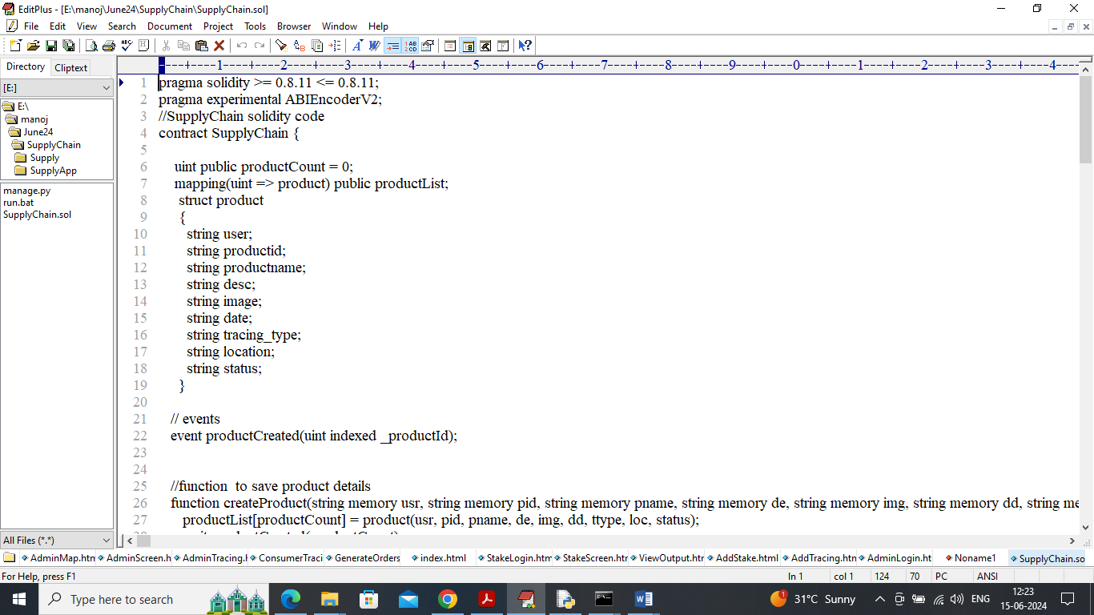
In above contract we will define all functions which can be called from any programming language to manage data in Blockchain. Above contract need to deployed in Blockchain Ethereum using below steps
- First go inside hello-eth/node-modules/bin folder and then double click on ‘runBlockchain.bat’ file to get below screen
- 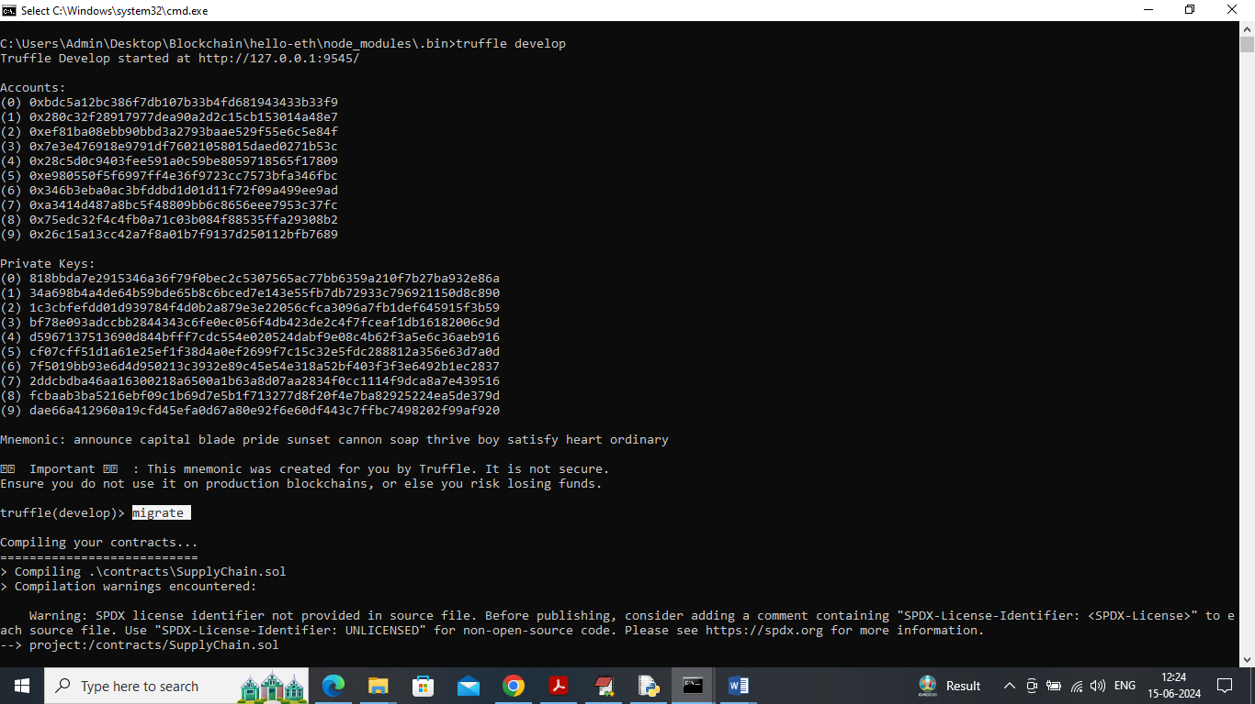
- In above screen Ethereum started with default accounts and private keys and now type command as ‘migrate’ and press enter key to deployed contract and get below page
- 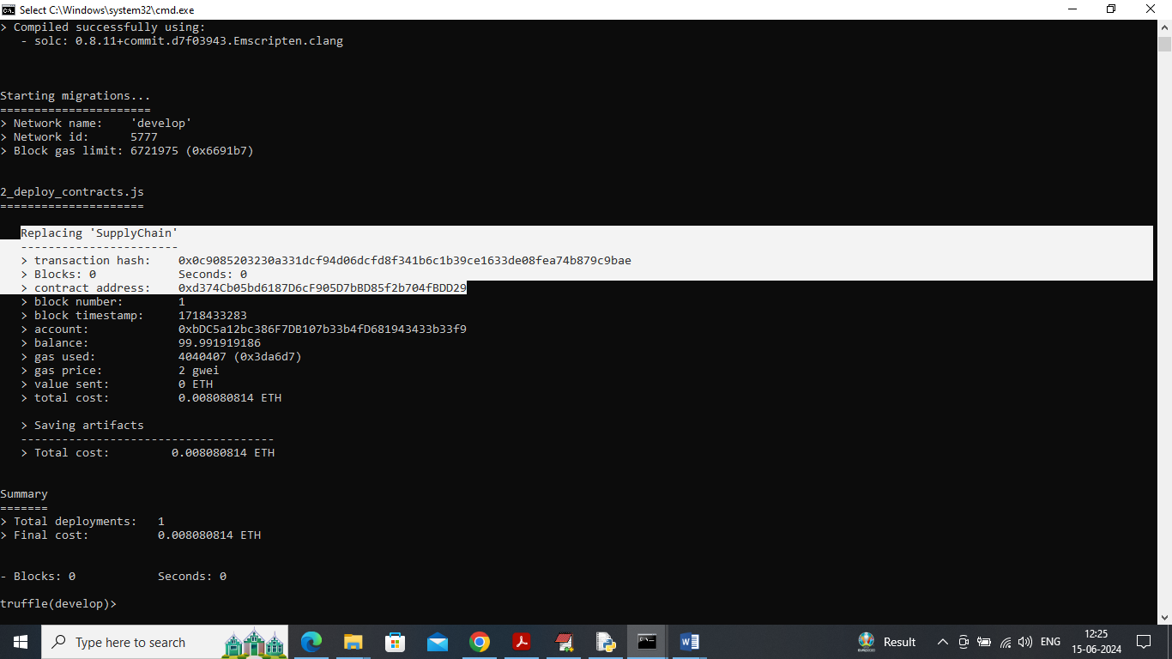
- In above screen in white colour text can see ‘Supply Chain’ contract deployed and got contract address also and this address need to specify in python code to call above contract
- 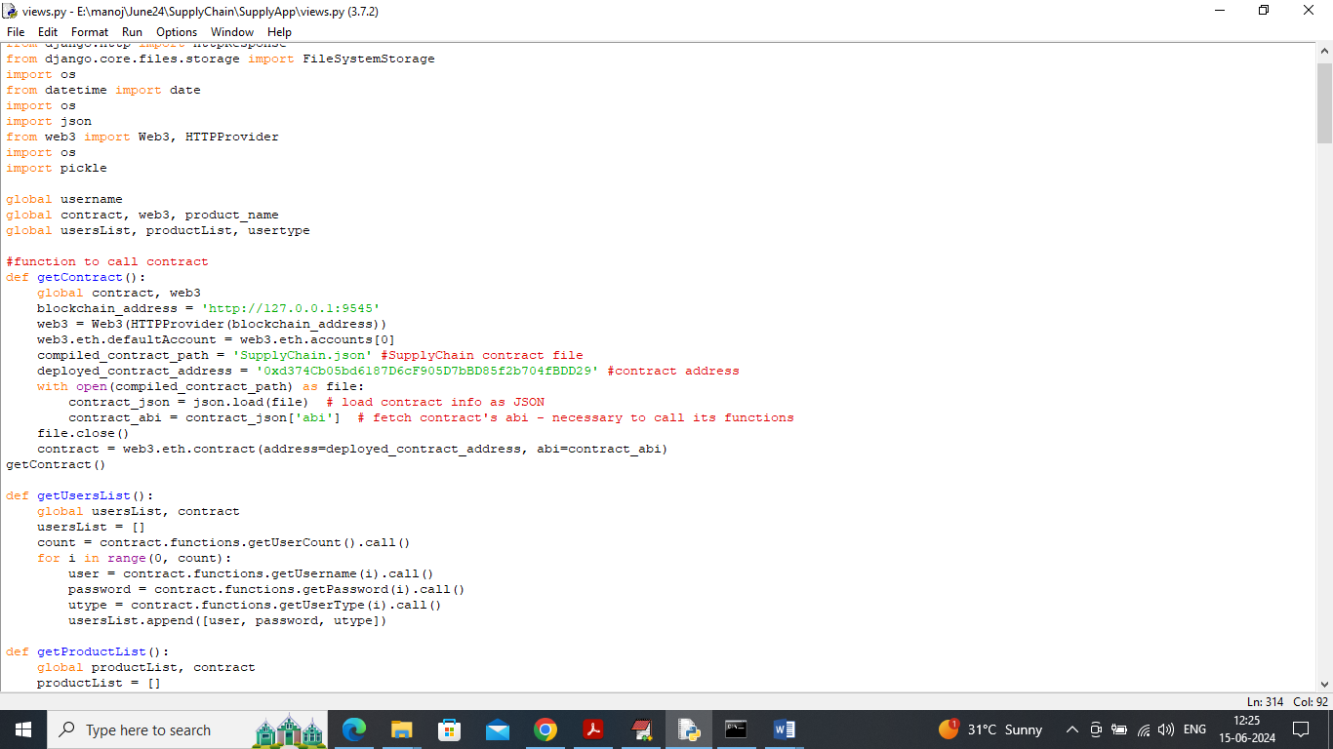
- In above screen read red colour comments to know about contract calling and in black console and can see contract deployed and running and let it run.
Now double click on ‘run.bat’ file to start python and get below page
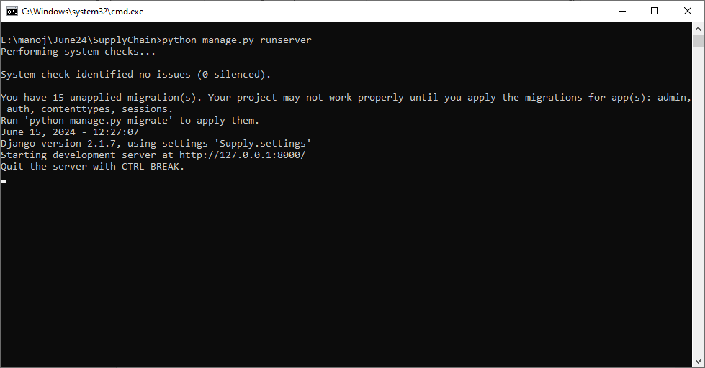
In above screen python server started and now open browser and enter URL as http://127.0.0.1:8000/index.html and press enter key to get below page
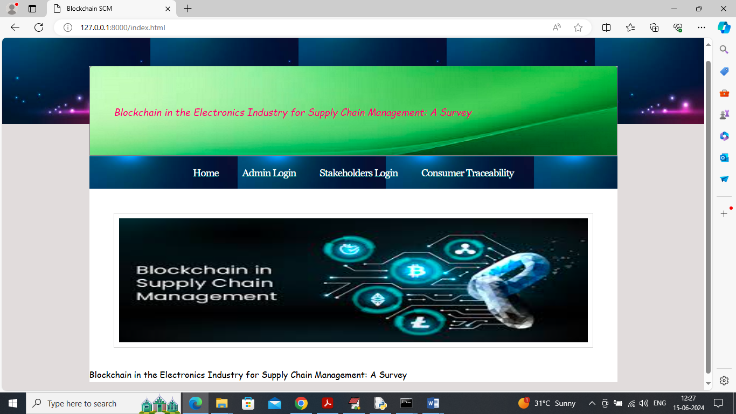
In above screen click on ‘Admin Login’ link to get below page
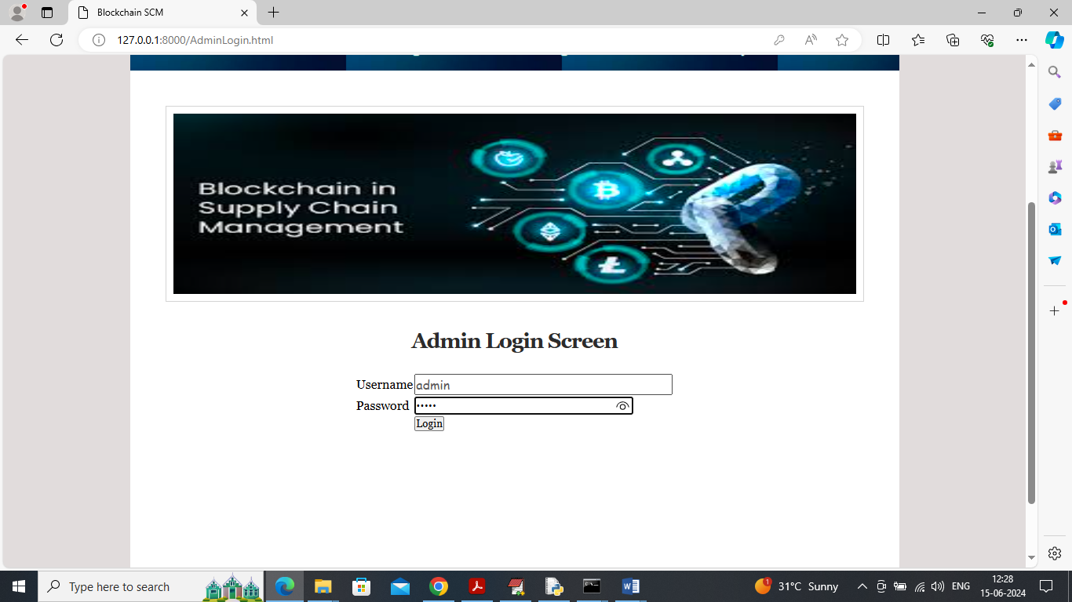
In above screen admin is login and after login will get below page
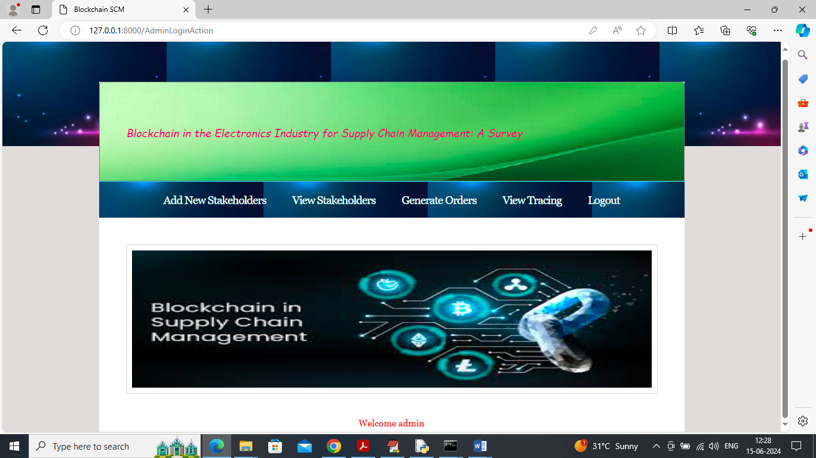
In above screen admin can click on ‘Add New Stakeholder’ link to add stake holders and get below page
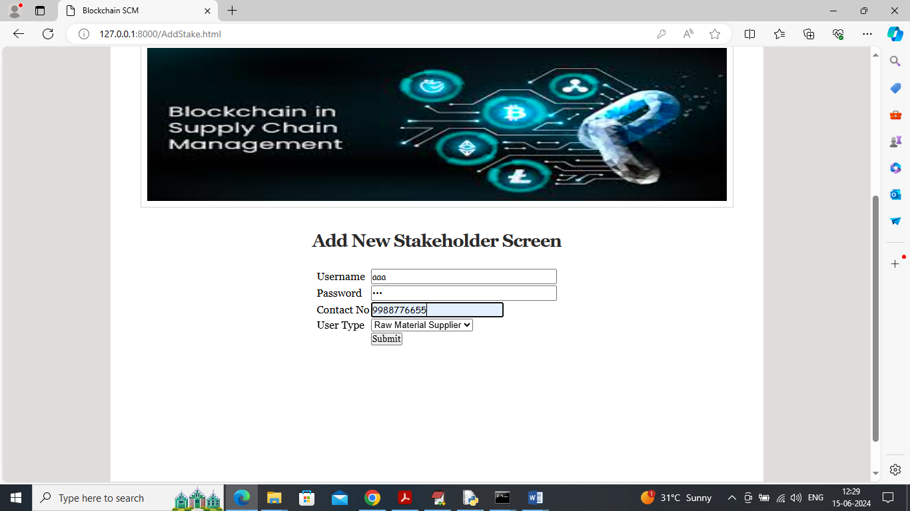
In above screen adding stake holder as ‘raw material supplier’ and then press button to get below page
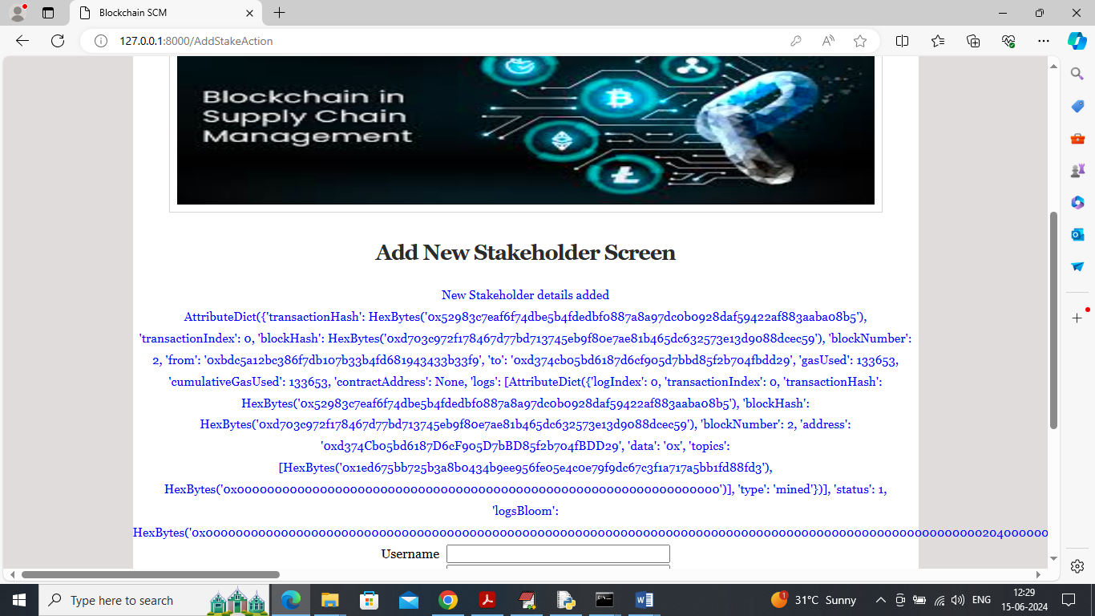
In above screen raw material supplier details added and for your understanding purpose I am printing all log output received from Blockchain as Block No, Transaction address etc. Similarly add all stake holders like distributor, retailers etc.
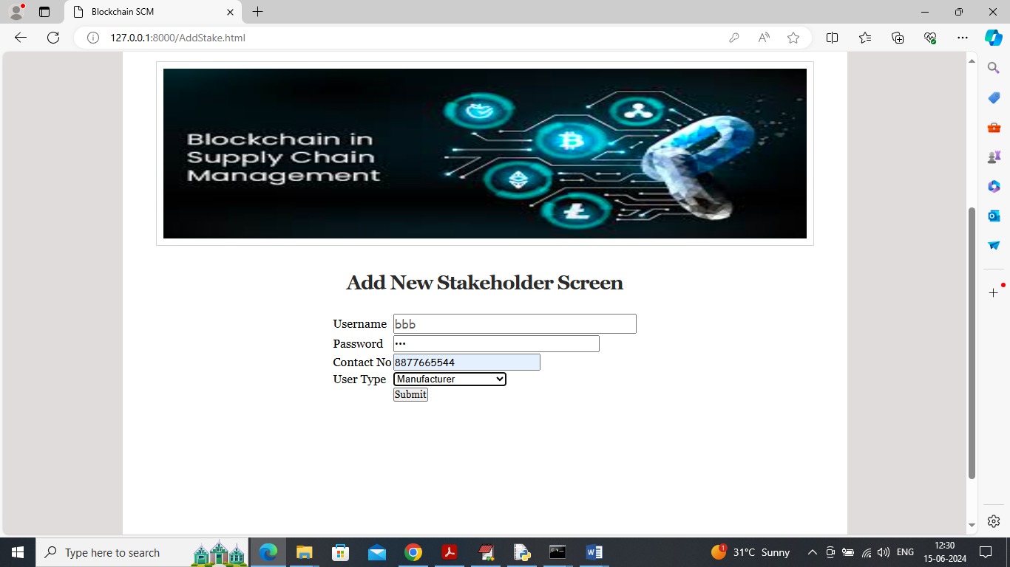
In above screen adding manufacturer details and similarly add all stakeholders
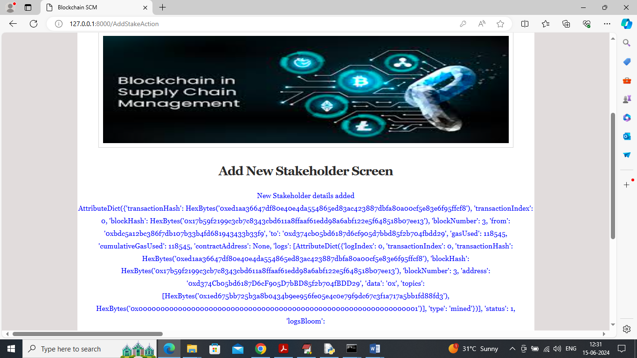
In above screen manufacturer details added and now click on ‘View Stakeholders’ link to view all stake holders like below page
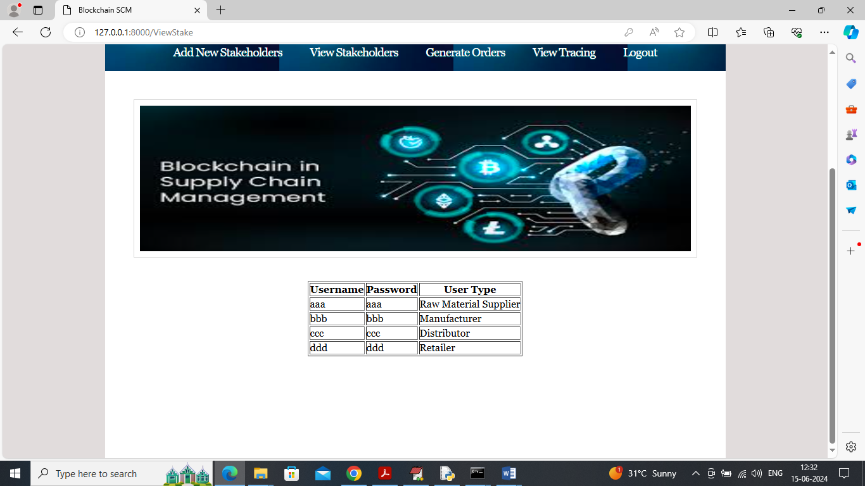
In above screen can view details of all available stake holders and with login details and now click on ‘Generate Orders’ link to generate new order by admin and this order will receive and process by supplier by sending raw material to manufacturer
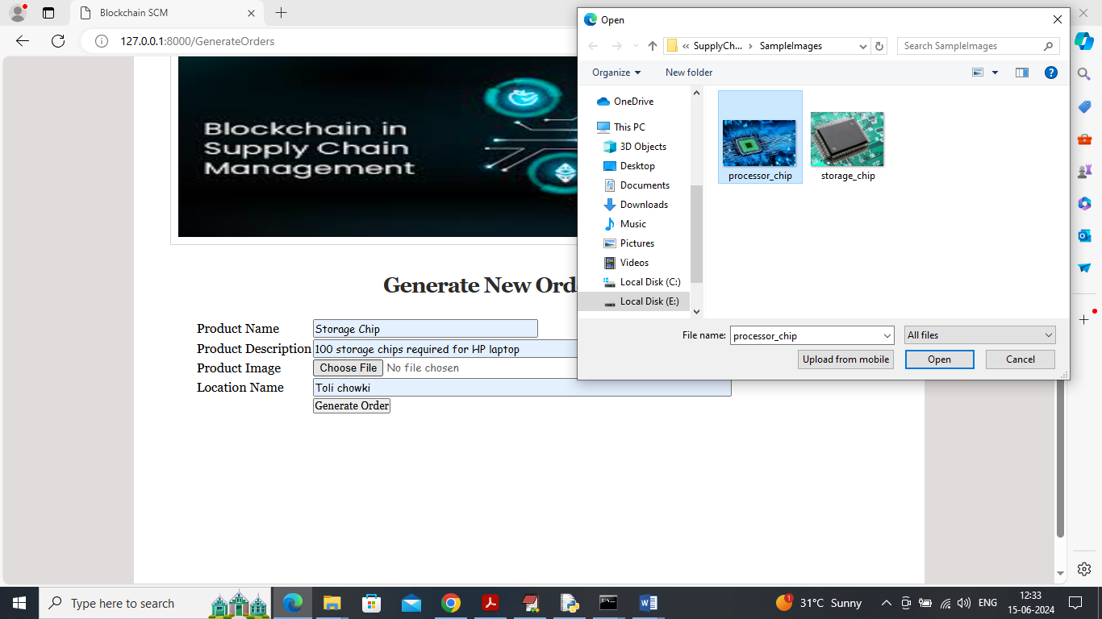
In above screen admin generating new product order and uploading related image and then enter its order location name so user can view on map while tracing for order generation and then press button to get below page
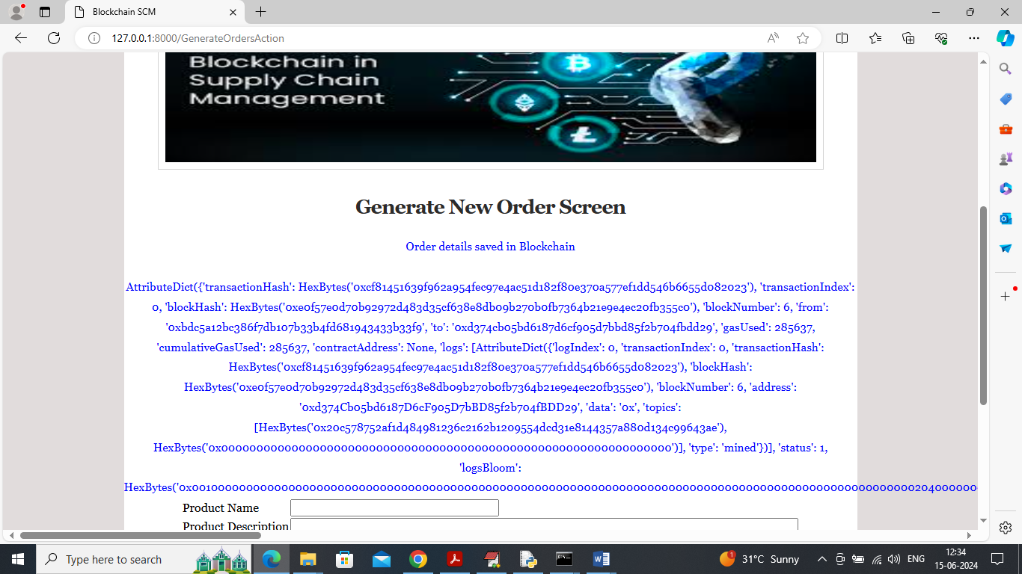
In above screen order generated in Blockchain and now admin can click on ‘View Tracing’ link to get below tracing details
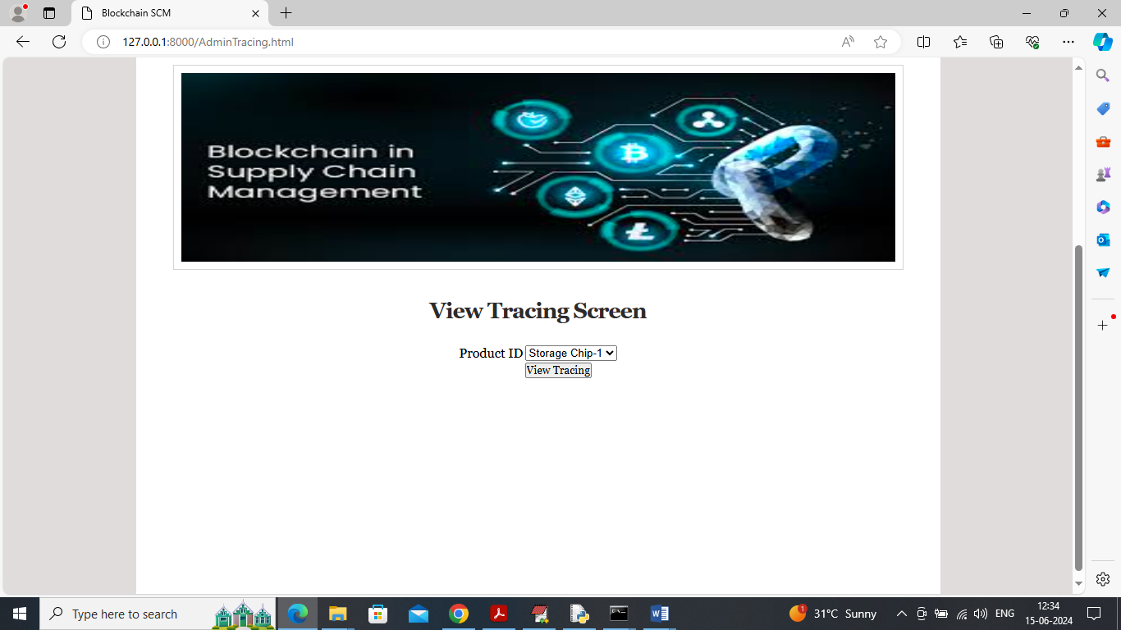
In above screen admin will select desired product id to view tracing like below screen
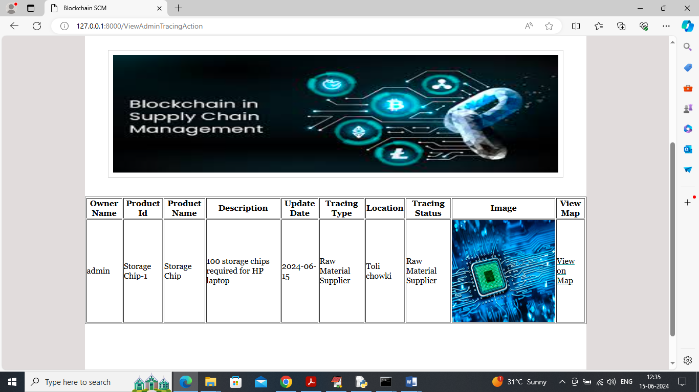
In above screen admin can view order details and can see tracing status as order received by ‘Raw Material supplier’ and once raw material supplier complete this order then he will update tracing to manufacturer and admin can click on ‘View On Map’ link to view current location of order
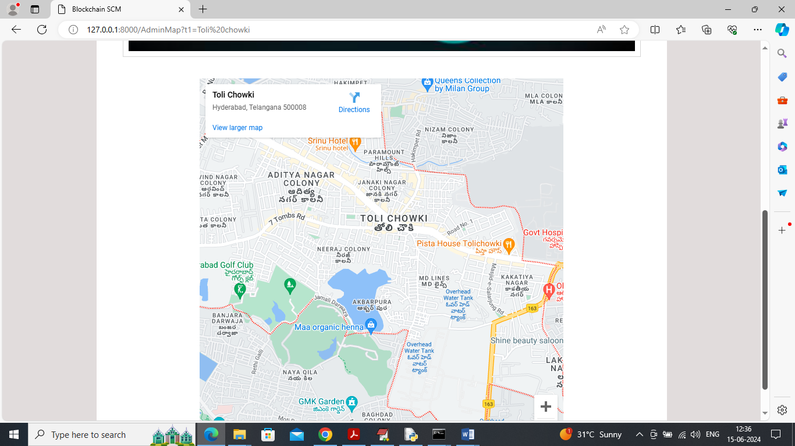
In above screen admin can view order generated from ‘Toli chowki’ Area and similarly he can view all tracing and location from raw material till sold to customers and now logout and login as Raw Material supplier to complete order
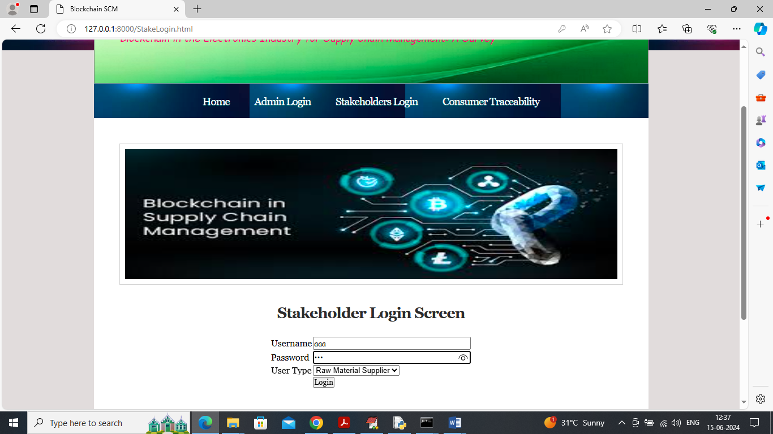
In above screen raw material supplier is login and after login will get below page
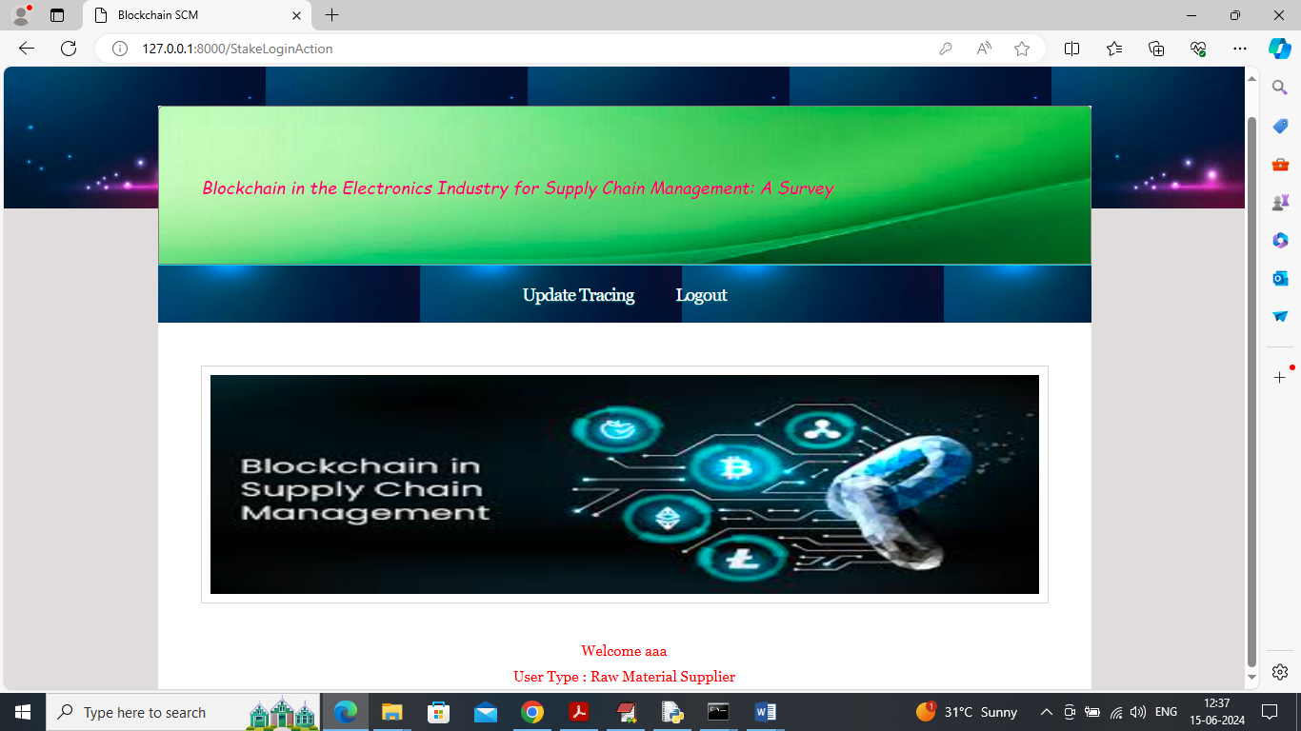
In above screen click on ‘Update Tracing’ link to view orders from admin and once raw material ready then he will send raw material to manufacturer
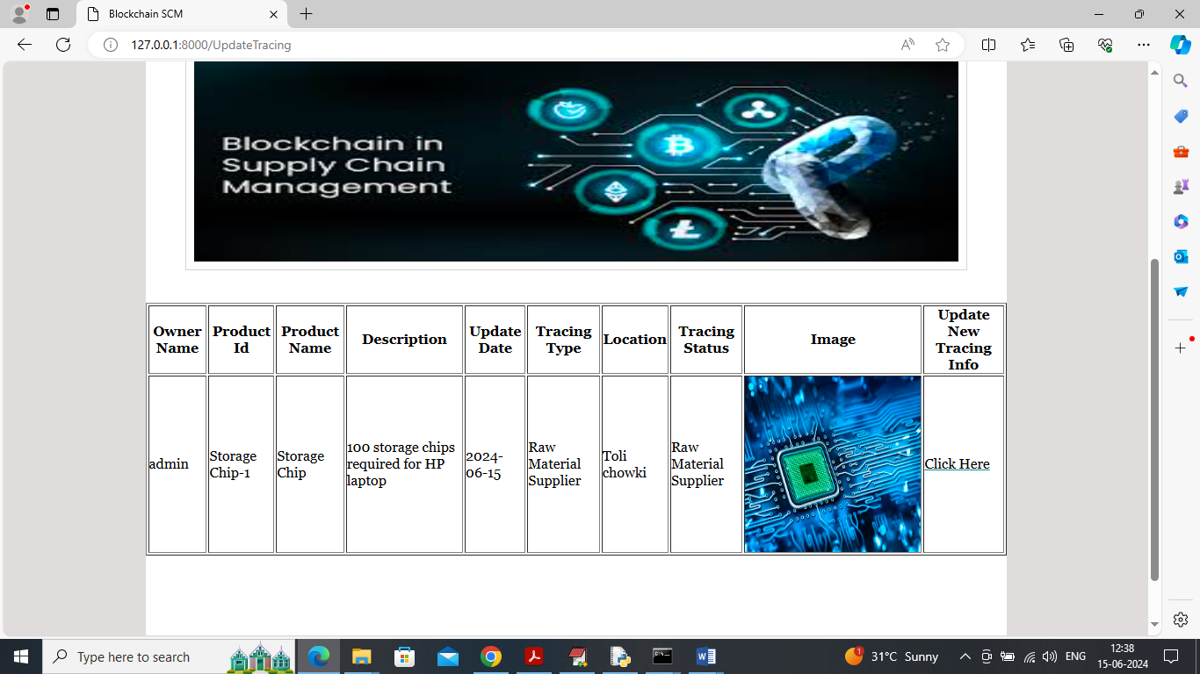
In above screen ‘Raw Material Supplier click on Click Here link to send updates to manufacture and get below tracing updates
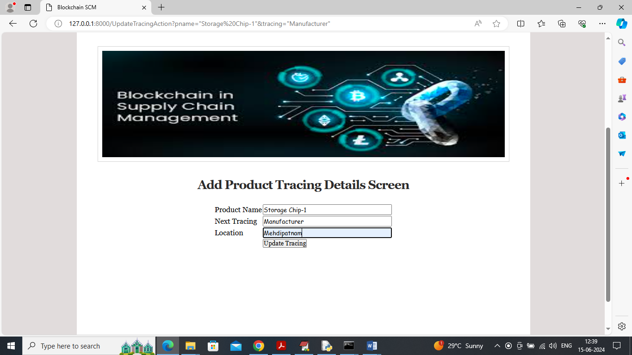
In above screen we can see Next tracing is reported to manufacturer from current location so manufacture can use raw material to manufacture product and ship to distributor
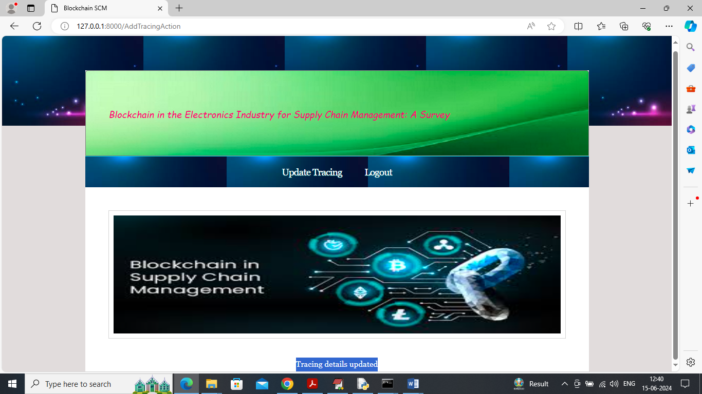
In above screen in blue colour text can see trace updated and now logout and login as manufacture to update trace to distributor once manufacturing completed
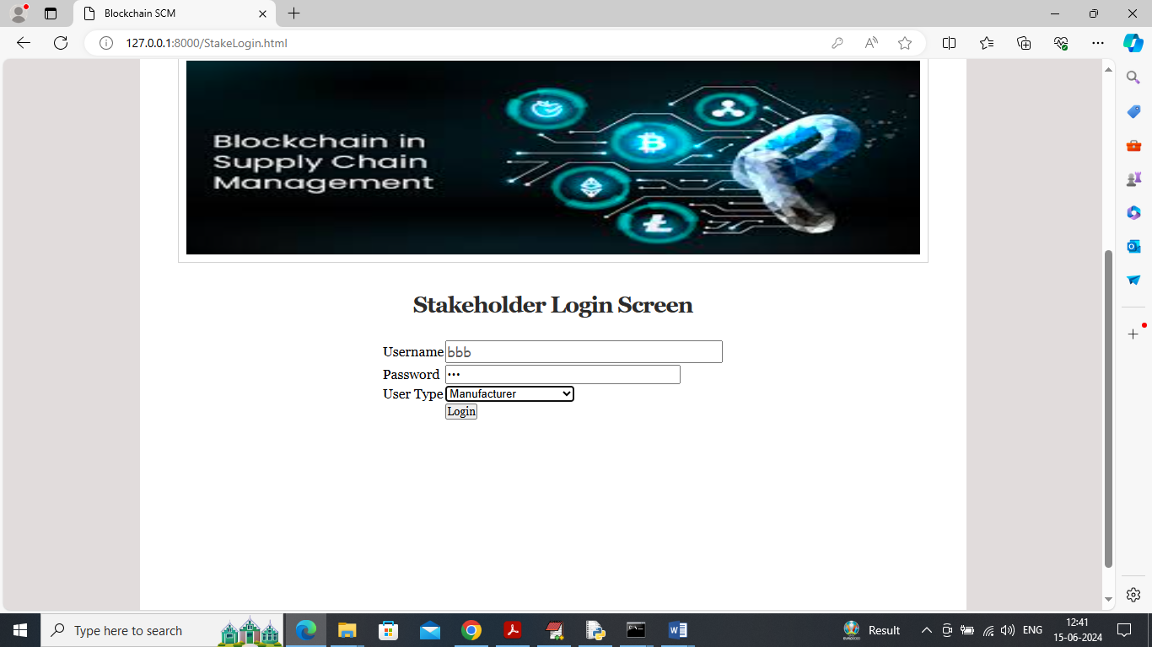
In above screen manufacturer is login and after login will get below page
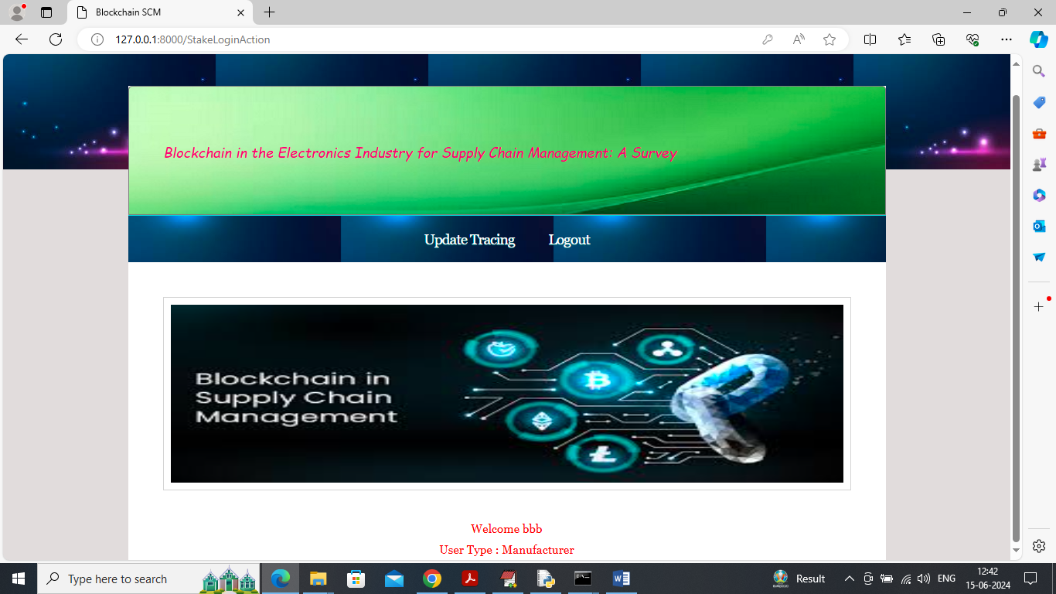
In above screen manufacturer can click on ‘Update Tracing’ link to get order from raw material user
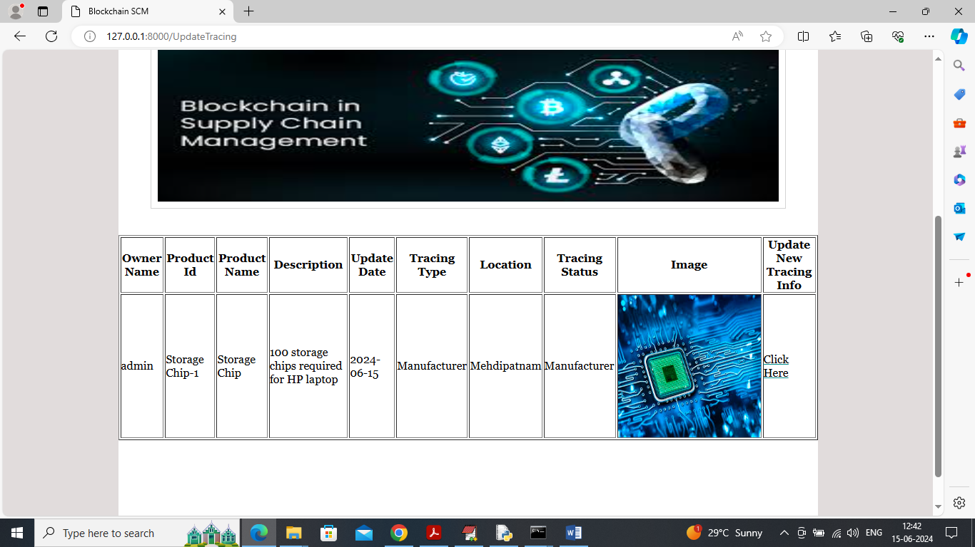
In above screen manufacturer will view order by receiving raw material and then shipped manufactured products to distributor by clicking on ‘Click Here’ link to get below page
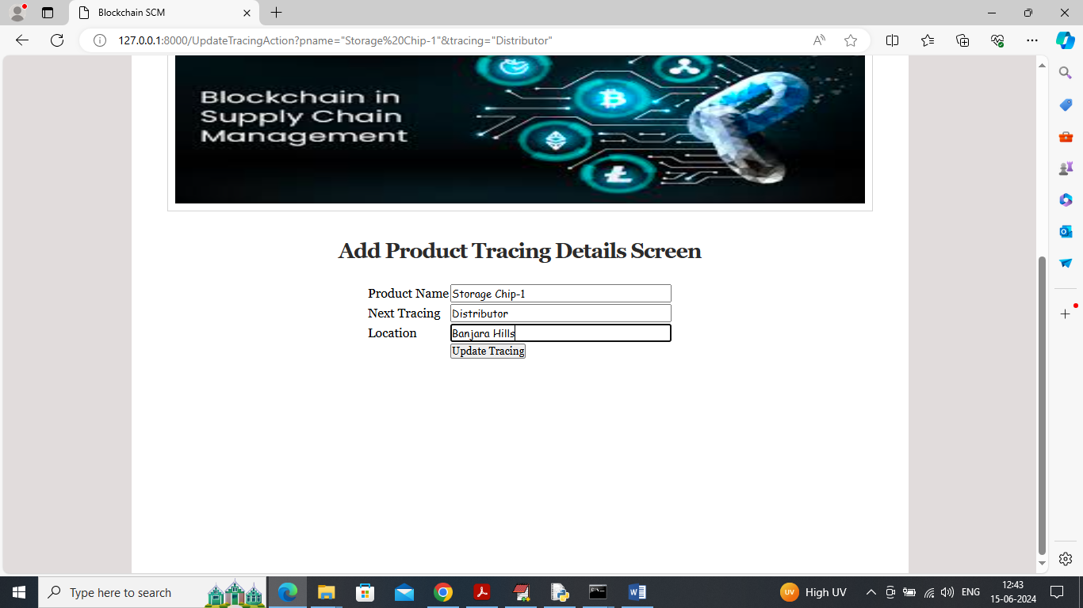
In above screen next stage proceeding to distributor so he will receive order and send to retailer and now logout and login as Distributor
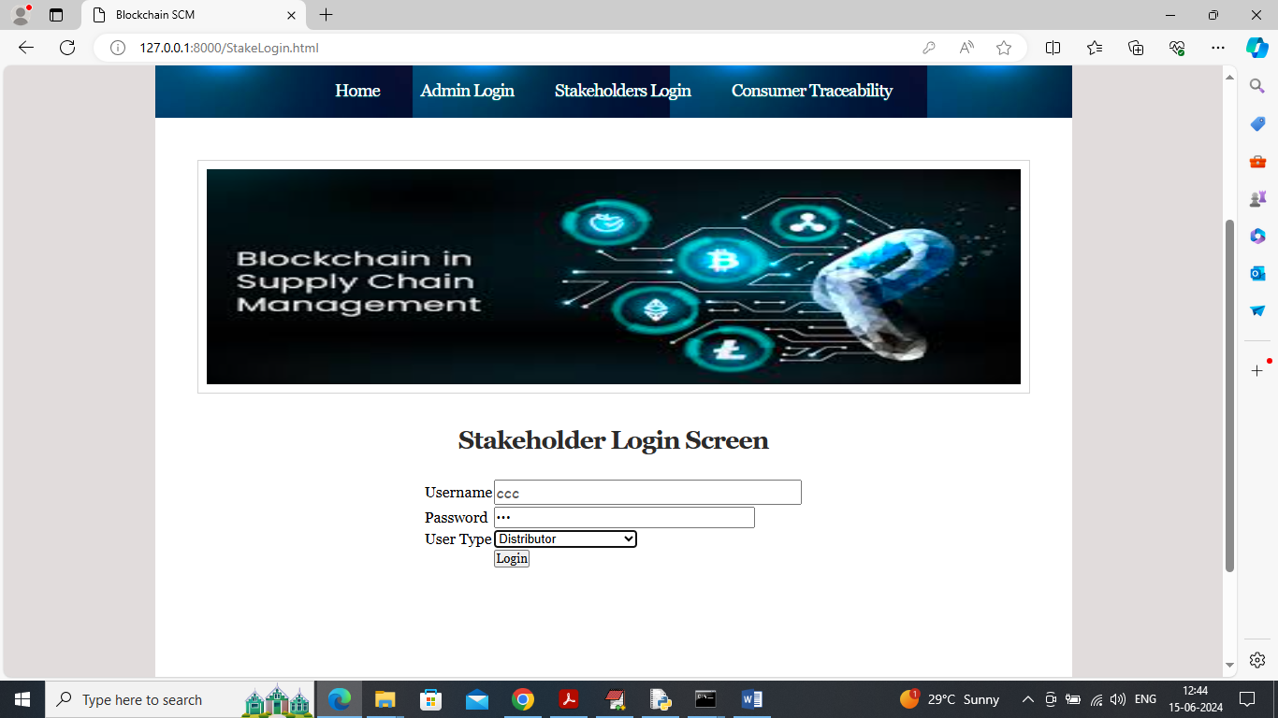
In above screen distributor is login and then report received order to retailer
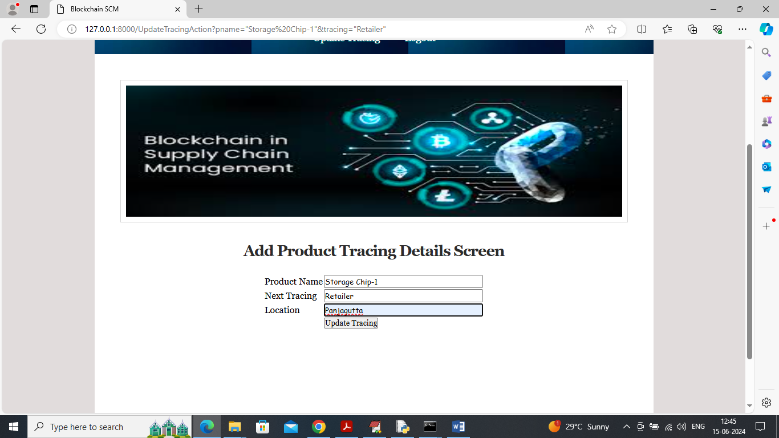
In above screen Distributor sending all products to Retailer and now retailer will login and sale to customer by login to system.
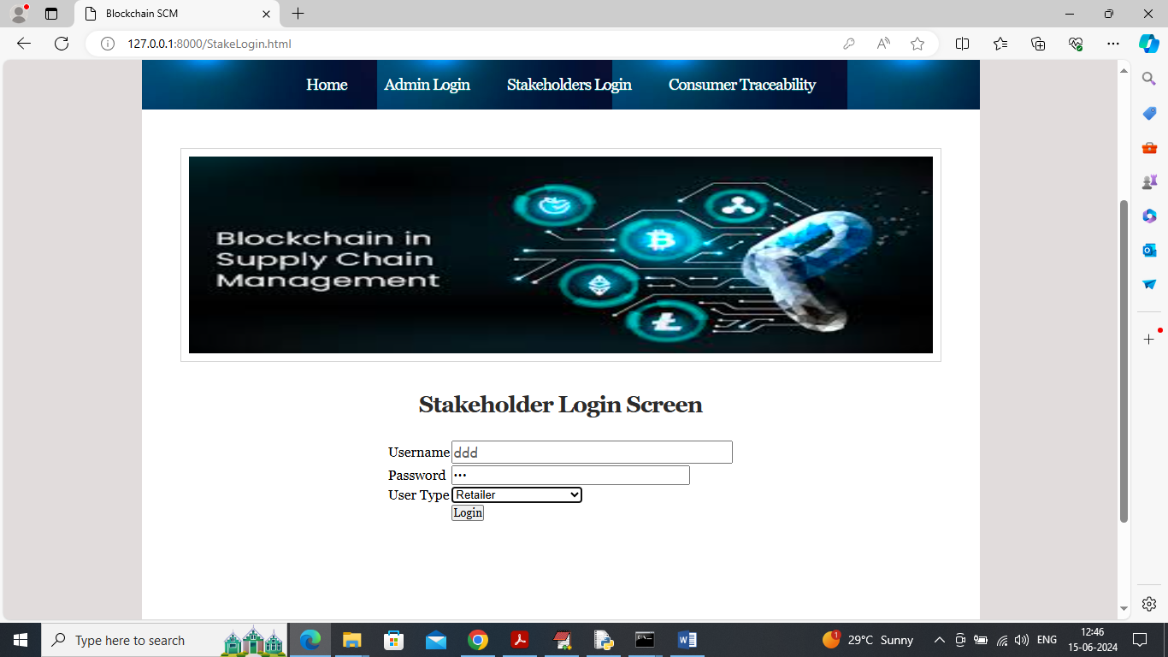
In above screen retailer is login and can see all available product list by clicking on ‘Update Tracing’ and get below page
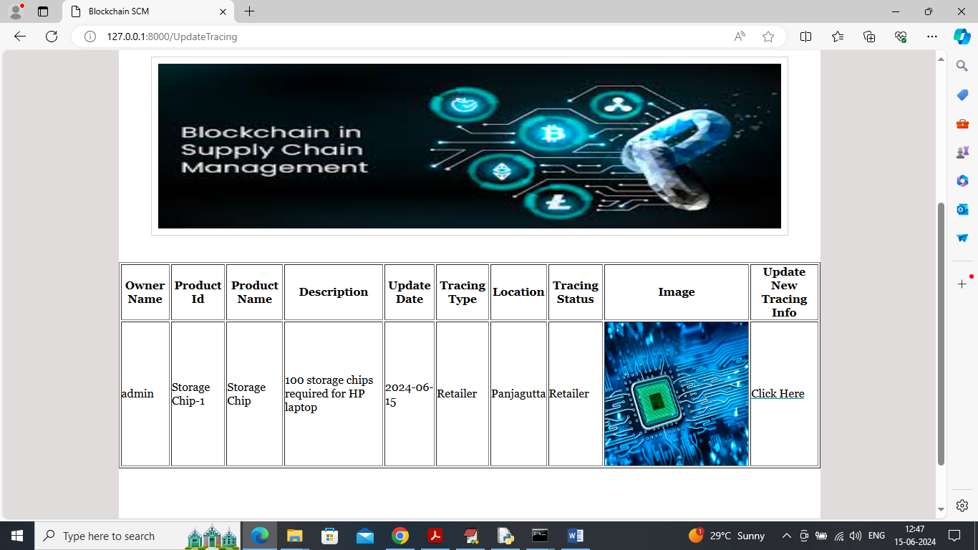
In above screen retailer can view all available product list and if any customer come for purchase then he will click on ‘Click Here’ link to sale to customer from his current location
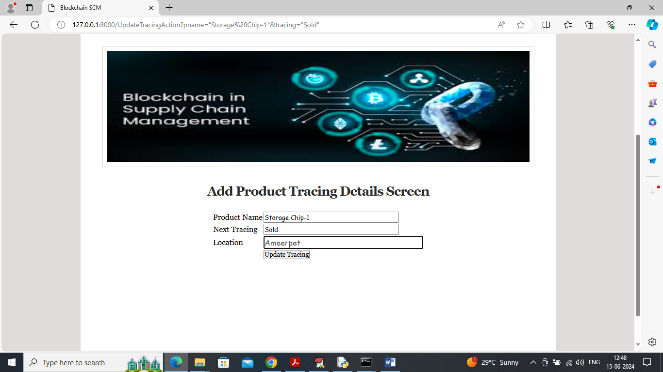
In above screen Retailer updating trace next state as ‘Sold’ to customer from current location and then press button to get below page
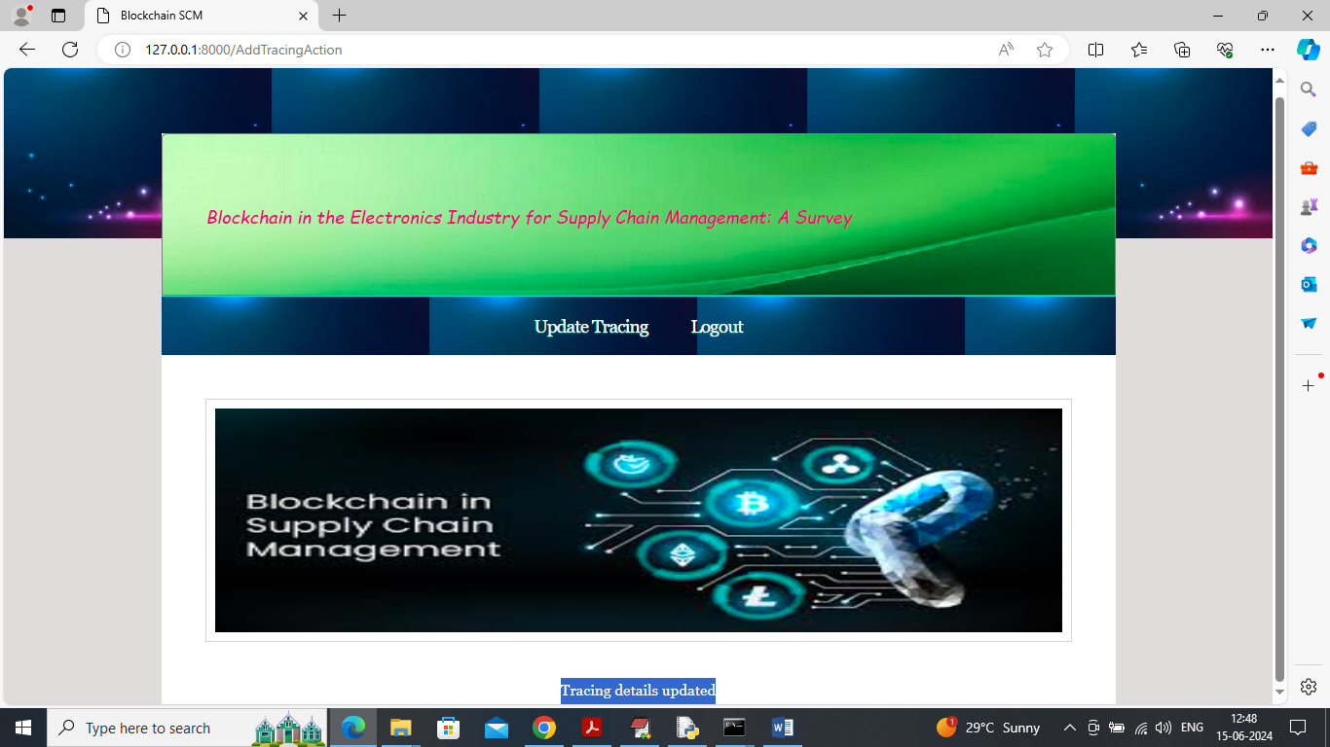
In above screen can see selling trace details also updated and now logout and then customer or admin can view all steps product traverse to reach him
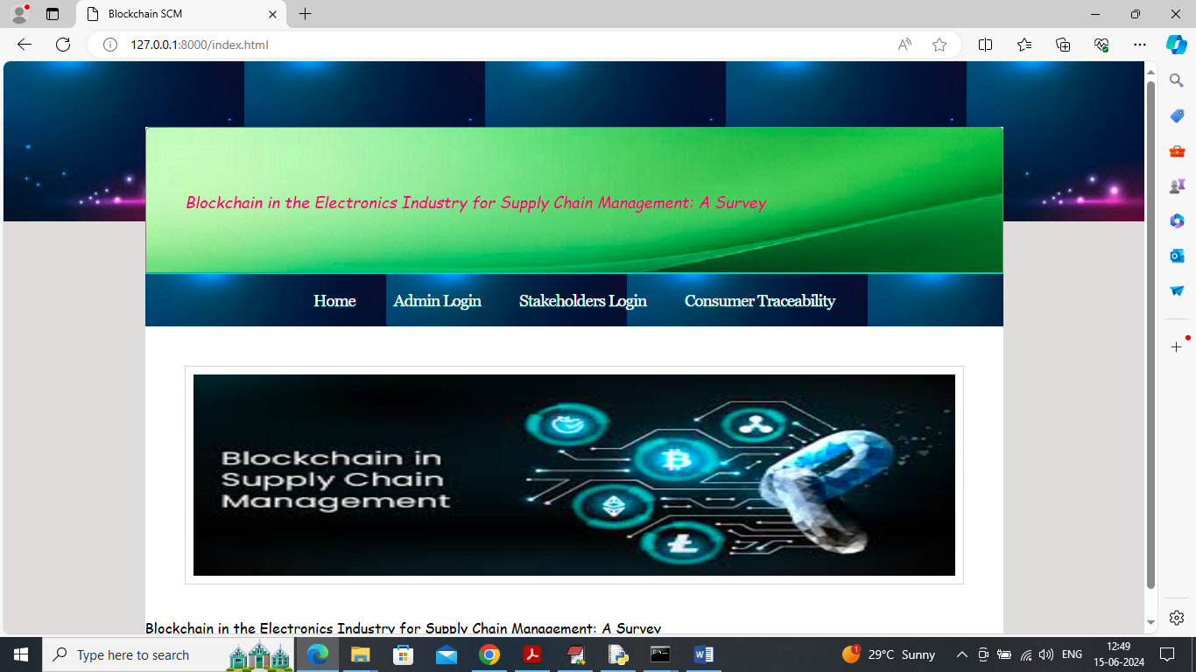
In above screen customer can click on ‘Customer Traceability’ link to get below page
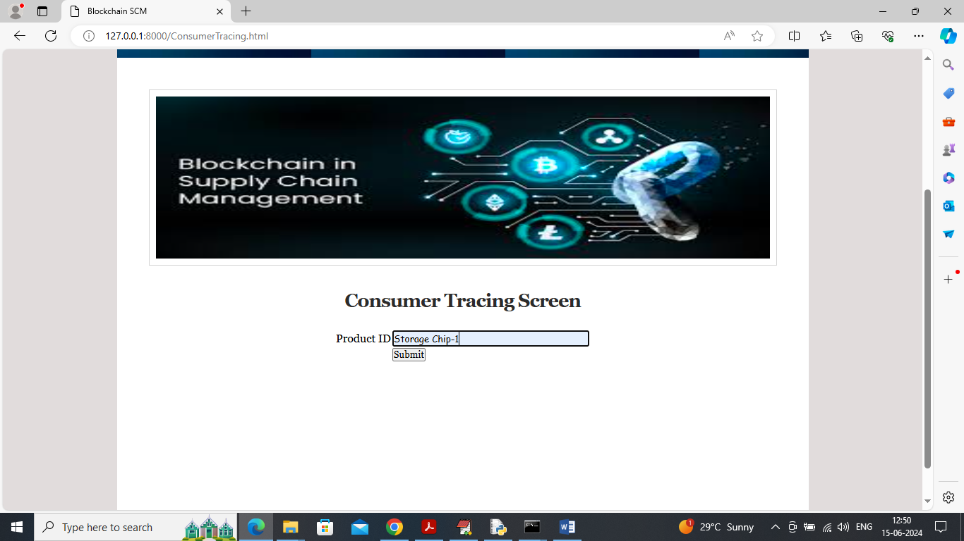
In above screen customer can enter product ID which he received and then press button to view all steps and location like below screen
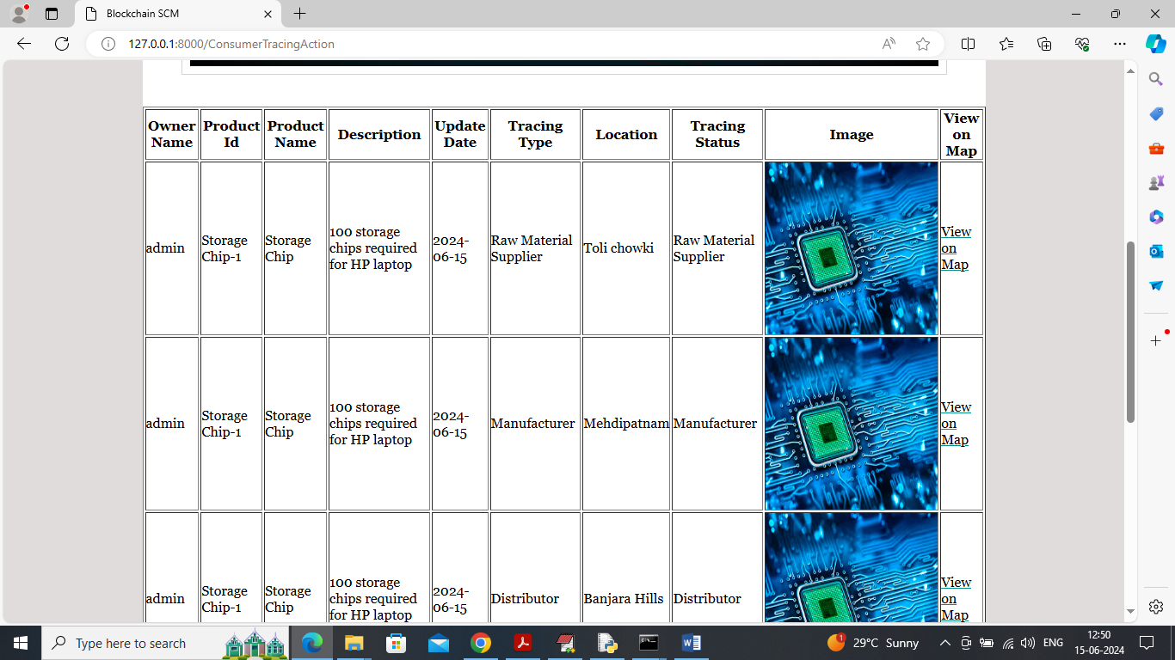
In above screen customer can view when and where first order generated and then received and reported by raw material supplier to manufacturer to distributor
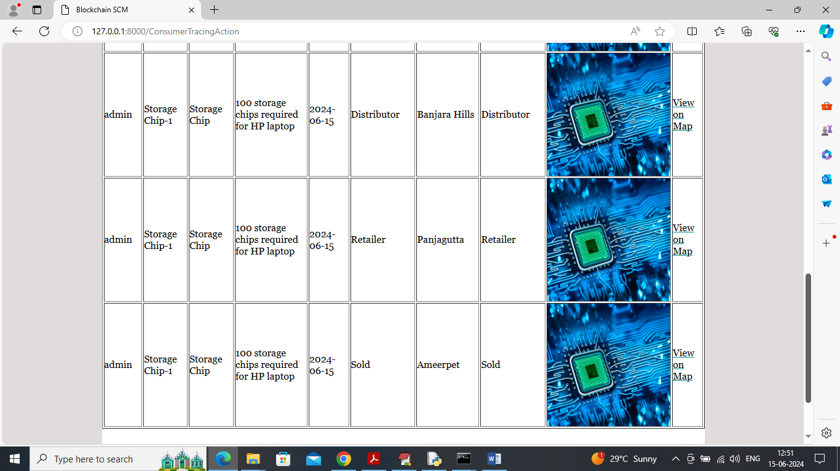
In above screen can see further tracing like distributor to retailer to customer sale and each step user can click on ‘View on Map’ link to view different locations product was processed.
So by employing above technique supply chain system can manage all orders in secured, transparent, traceability and with reliability.

