**Continuous integration**

To implement CI we use NGrok as a server

Ngrok http 8080

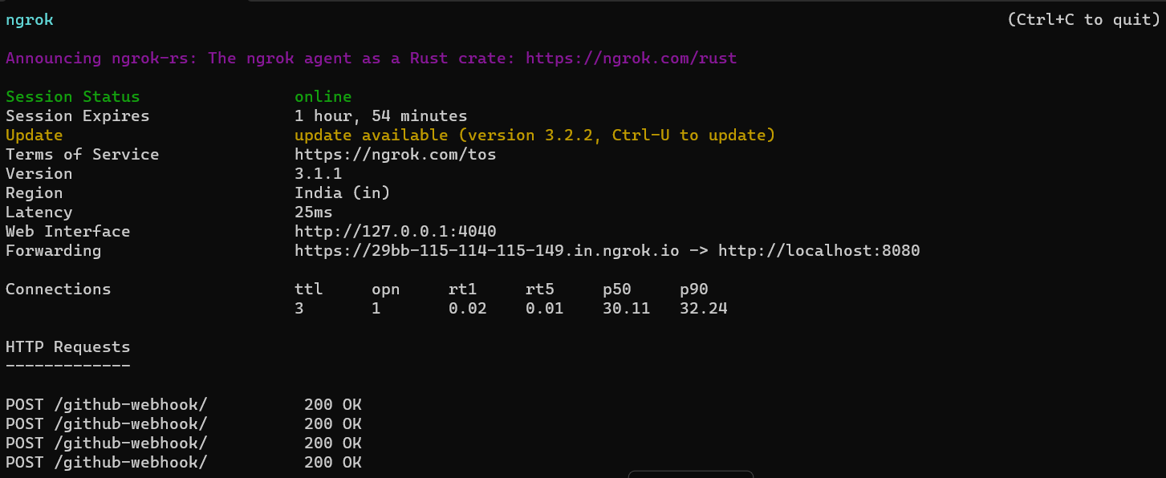

Add Forwarding URL to Github repo => webhook Settings

Add this repo into Jenkins to implement continuous integration

