To create an instance using terraform: YAML files

Terraform Apply : to apply Yaml and create Instances

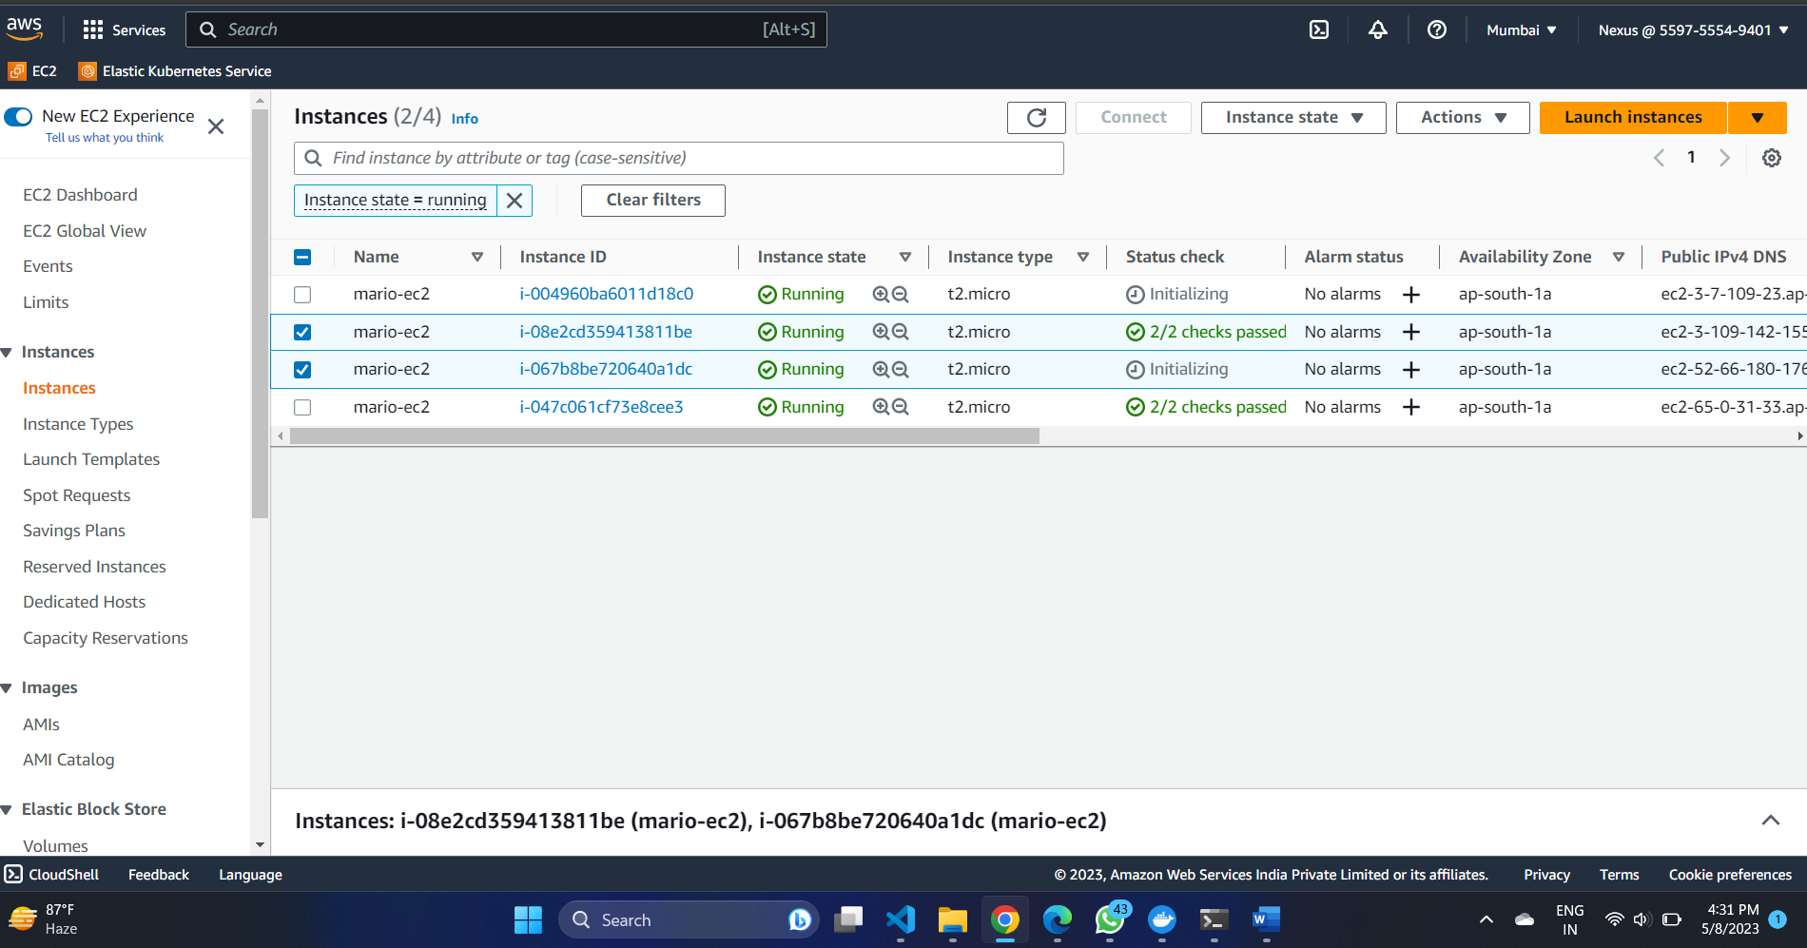

**Ec2 Insctance Created Succesfully**

To Destroy

Terraform Destroy : to destroy Instances Which got created

