**Creating Microservices app into k8s cluster:**

Necessary Yaml files with Required Configurations and Images:

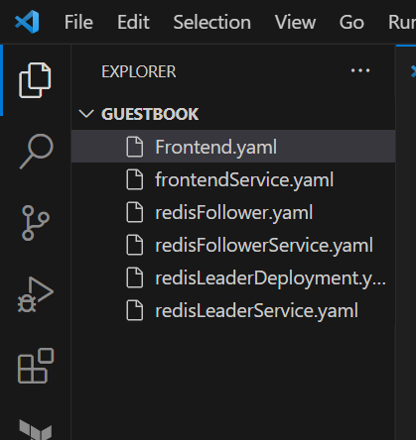

* Create a Namspace with any name\

Kubectl create namespace <name>

Kubectl apply -n <namespace> -f <file name> (or)

Kubectl apply .

(.) dot refers to all files in the folder

