JAVA PROGRAM-10(21/11/2018)

1)Write a java program to find rate od intrest of ICIC,Sbi,Andra,City bank using the concept of Run time polymorphisum?

CODE:

class Bank
{
void givingLoan()
{
System.out.println("Bank has Rate of interest ");
}
}
class ICIC extends Bank
{
void givingLoan()
{
System.out.println(" Rate of interest of Bank is 18%");
}
}
class Sbi extends Bank
{
void givingLoan()
{
System.out.println(" Rate of interest of Bank is 15%");
}
}
class Andra extends Bank
{
void givingLoan()
{
System.out.println(" Rate of interest of Bank is 12%");
}
}
class City extends Bank
{
void givingLoan()
{
System.out.println(" Rate of interest of Bank is 10%");
}
}
public class TestRoi {

public static void main(String[] args) {
Bank obj=new ICIC();
obj.givingLoan();

System.out.println();
System.out.println();

Bank obj1=new Sbi();
obj1.givingLoan();

System.out.println();
System.out.println();

Bank obj2=new Andra();
obj2.givingLoan();

System.out.println();
System.out.println();

Bank obj3=new City();
obj3.givingLoan();
}

}

OUTPUT:

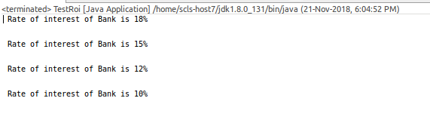

2)Write a java program to find the area of squarae,rectangle using method overloading?

CODE:

class Calu
{
int a,b,total;

void area(int a, int b)
{
total=a*b;
System.out.println("Area Of a Rectangle is:"+total);
}
void area(int a)
{
total=a*a;
System.out.println("Area Of a Square is:"+total);
}
}

public class AreaLod {

public static void main(String[] args) {
Calu obj=new Calu();
obj.area(10,50);
obj.area(544);

}

}

OUTPUT:

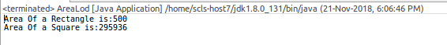

3)Write a java program to check overloading of main method?

CODE:

class Count
{
int count=0;
int count1=0;
String s1="JAVA IS A OBJECT ORIENTED PROGRAMMING LANGUAGE DEVELOPED BY JAMES GOSING";
String s2[]=s1.split(" ");
String s3[]=s1.split("");
String s4[]=s1.split(" ");
void getData()
{
for (int i = 0; i < s2.length; i++)
{
count++;

}
System.out.println("No of Words present in string are:"+count);
for (int i = 0; i < s3.length; i++)
{

count1++;
}
System.out.println("No of characters present in string are:"+count1);

System.out.println("No of void spaces present in string are:"+(count-1));
}
}
public class CountStr {

public static void main(String[] args) {
Count obj=new Count();
obj.getData();
}

}

OUTPUT:

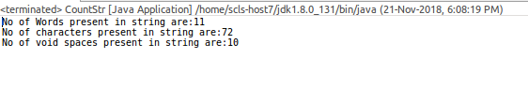

4)Write a java program to calculate number of character, no of void spaces and no of words of the following statement,
Stirng=”JAVA IS A OBJECT ORIENTED PROGRAMMING LANGUAGE DEVELOPED BY JAMES GOSLING”

CODE:

public class OverLod {

public static void main(String[] args) {
System.out.println("Rohith will be the one");
main(null,null);
}
public static void main(String[] args,String[] arg) {
System.out.println("Always will be one");

}
}

OUTPUT:

