JAVA PROGRAM-10(20/11/2018)

1)Write a java program to peferform the following

A(int)

B(char,double)

CODE:

class A
{
A(int a)
{
System.out.println("A is constructor:"+a);
}
}
class B extends A
{
B(double d,char c,int a)
{
super(a);
System.out.println("B is constructor:"+d);
System.out.println("C is constructor:"+c);
}
}
public class TestSumCon {

public static void main(String[] args) {
B obj=new B(21.2,'f',1515);

}

}

OUTPUT:

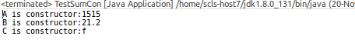

2)

A (char)

B(String)

C(int)

CODE:

class Sum
{
Sum(char c)
{
System.out.println("C is a constructor:"+c);
}
}
class Add extends Sum
{
Add(String s,char c)
{
super(c);
System.out.println("B is a constructor:"+s);
}
}
class Mul extends Add
{
Mul(int a,String s ,char c)
{
super(s,c);
System.out.println("C is a constructor:"+a);
}
}
public class TestMuCon {

public static void main(String[] args) {
Mul obj=new Mul(121,"asfd",'c');

}
}

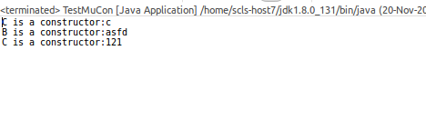
OUTPUT:

3)

A(String)

B

C(int) D(double)

CODE:

class Oper
{
Oper(String s)
{
System.out.println("Oper is a constructor:"+s);
}
}
class Mul1 extends Oper
{
Mul1(String s)
{
super(s);
System.out.println("Mul1 is a constructor:");
}
}
class Add1 extends Mul1
{
Add1(int a,String s)
{
super(s);
System.out.println("Add1 is a constructor:"+a);
}
}
class Divi extends Mul1
{
Divi(double d,String s)
{
super(s);
System.out.println("Divi is a constructor:"+d);
}
}
public class TestHieCon {

public static void main(String[] args) {
Divi obj=new Divi(12.21253,"t");
Add1 obj1=new Add1(10,"h");

}

}

OUTPUT:

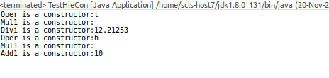

4)Write a java program to comapare the following string character by character amd print the calculation and the character which has matched?

CODE:

class Comp{
int count=0;
String s="Rohith";
String d="Rakesh";
char ch[]=s.toCharArray();
char ch1[]=d.toCharArray();
void run(){
for(int i=0;i<ch.length;i++)
{
for (int j = 0; j < ch1.length; j++)
{
if(ch1[j]==ch[i])
{
count++;
System.out.println(ch1[j] +"is common character at :"+j);

}

}
}
}
}
public class TestCompString {

public static void main(String[] args)
{
Comp obj=new Comp();
obj.run();
}
}

OUTPUT:

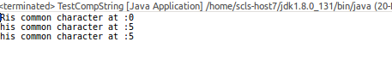
5)Write a java program to find the string “THERE IS A WAY,THERE IS A WILL”,with location?

CODE:

class Same
{
String s="WHEN THERE IS WILL THERE IS A WAY";
String ch[]=s.split(" ");
int count=0;
void rum()
{
for (int i = 0; i < ch.length; i++)
{
if(ch[i].equals("THERE"))
{
count++;

}

}
System.out.println(count +"is the count of there");
}
}
public class TestCompareStr {

public static void main(String[] args)
{
Same obj=new Same();
obj.rum();

}

}

OUTPUT:

