JAVA PROGRAM-7(14/10/2018)

1)Write a program to find the average to the sum with array values?

CODE:

class Test1545
{
public static void main(String args[])
{
float c;
int a[]={10,20,30,54,50};
int b=0;
for(int i=0;i<5;i++)
{
b=a[i]+b;
}
c=(float)b/(a.length);
System.out.println("PRINT AVERAGE VALUE:"+ c);
}
}

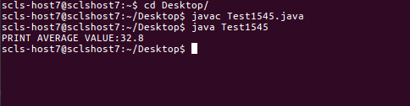
OUTPUT:

2)Write a java program to find the 5 arthematic operations for array values?

CODE:

class OperationsTest
{
public static void main(String args[])
{
double c=0;
int b=0;
int a[]={12,54,65,57};
for(int i=0;i<a.length;i++)
{
if(a[i]==a[a.length-1])
{
break;
}
b=a[i]+a[i+1];
System.out.println("Sum of Numbers is:"+ b);
b=a[i]-a[i+1];
System.out.println("SUB of Numbers is:"+ b);
b=a[i]*a[i+1];
System.out.println("MUL of Numbers is:"+ b);
c=(double)a[i]/a[i+1];
System.out.println("DIV of Numbers is:"+ c);
c=(double)a[i]%a[i+1];
System.out.println("MOD of Numbers is:"+ c);
}

}
}

OUTPUT:

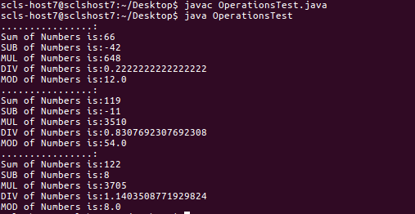

3)Write a java program to find the vowels and consonamts in the given array?

CODE:

class TestVowles
{
public static void main(String args[])
{
char ch[]={'a','b','h','o','k'};
for(int i=0;i<ch.length;i++)
{
if(ch[i]=='a'||ch[i]=='e'||ch[i]=='i'||ch[i]=='o'||ch[i]=='u')
{
System.out.println(ch[i] +" is VOWEL");
}
else
{
System.out.println(ch[i] +" is CONSONENT");
}
}
}
}

OUTPUT:

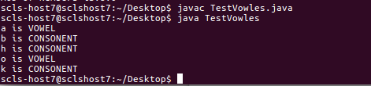

4)Write a java program to find the even and odd numbers for the given a set of array?

CODE:

class EvenTest
{
public static void main(String args[])
{
int b=0;
int a[]={124,54,21,5465,546545,177,87487};
for(int i=0;i<a.length;i++)
{
if(a[i]%2==0)
{
b=a[i];
System.out.println("PRINT NUMBER IS EVEN:"+b);
}
else
{
b=a[i];
System.out.println("PRINT NUMBER IS ODD:"+b);
}
}
}
}

CODE:

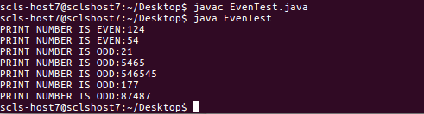

4)Write a program to do a= sum of first two arrays and note the output of array must be next b= sub of first two arrays.
Next first values of c=mul array and now e=div of whole array?

CODE:

class TestElement
{
public static void main(String args[])
{
float e=0;
int k=0;
int d=0;
int j=0;
int a[]={1,2,3,4,5,6,7,8};
int b[]=new int[a.length/2];
int c[]=new int[a.length/4];
for(int i=0;i<a.length;i++)
{
b[j]=a[i]+a[++i];
System.out.println("PRINT THE SUM:"+b[j]);
j++;
}
System.out.println("..........");
for(j=0;j<b.length;j++)
{
c[k]=b[j]-b[++j];
System.out.println("PRINT THE SUBSTRACTION:"+c[k]);
k++;
}
System.out.println("..........");
for(k=0;k<c.length;k++)
{
d=c[k]*c[++k];
System.out.println("PRINT THE SUBSTRACTION:"+d);
}
System.out.println("..........");
e=(float)d/a.length;
System.out.println("PRINT THE AVG"+e);
}
}

OUTPUT:
