## 

## P.E.S COLLEGE OF ENGINEERING, MANDYA,571401

(An Autonomous & GOVT. Aided Institution, Affiliated to VTU, Belagavi)

### An Internship-I Report On

**SOULSYNC – Stress relieve application**

### In partial fulfillment of the requirement of project work Internship-I as specified for 4th semester in

## COMPUTER SCIENCE AND ENGINEERING

**Submitted by:-** Nayana T P (4PS22CS109) Rohan S M (4PS22CS139)

RohithGowda V (4PS22CS140) Samhitha M C (4PS22CS143)

Under the guidance of

## Mrs.SHWETHA M K

Assistant professor, Dept of CS&E P.E.S.C.E, Mandya.

## DEPARTMENT OF COMPUTER SCIENCE AND ENGINEERING

## 2023-24

## 



**P.E.S COLLEGE OF ENGINEERING, MANDYA,571401**

(An Autonomous & GOVT. Aided institution, Affiliated to VTU, Belagavi)

## D DEPARTMENT OF COMPUTER SCIENCE AND ENGINEERING

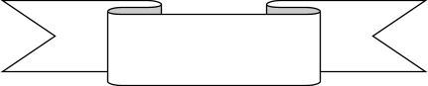

This is to certify that **Nayana T P(4PS22CS109), Rohan S M(4PS22CS139), RohithGowda V(4PS22CS140), Samhitha M C(4PS22CS143)** are the students of 4th semester B.E in Computer Science and engineering from P.E.S college of Engineering, Mandya, Has satisfactorily completed the internship-I report on **SOULSYNC – Stress relieve application** during the year 2023-2024.

The internship-I report has been approved as it satisfies the academic requirements in respect of internship-I work prescribed for 4th semester of B.E computer science and engineering discipline.

##### Signature of guide Shwetha M K

Assistant professor

Dept. of CS&E, PESCE, Mandya.

**Name of Examiners 1.**

**2.**

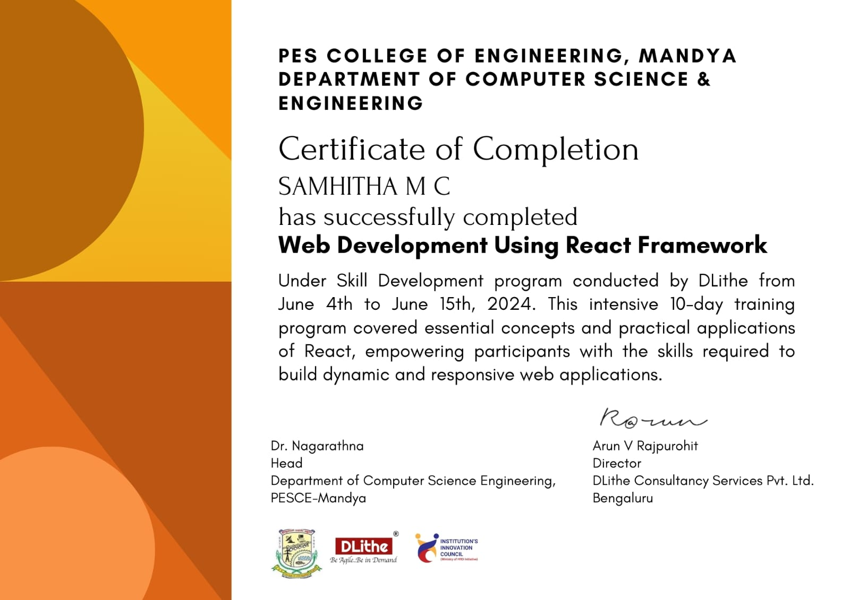

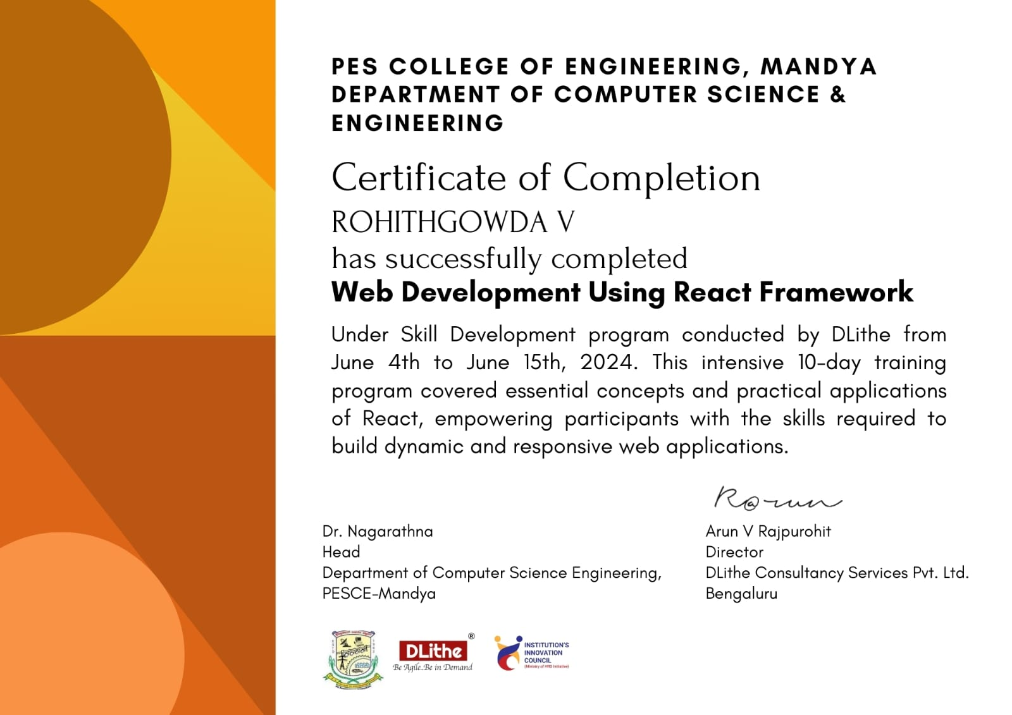

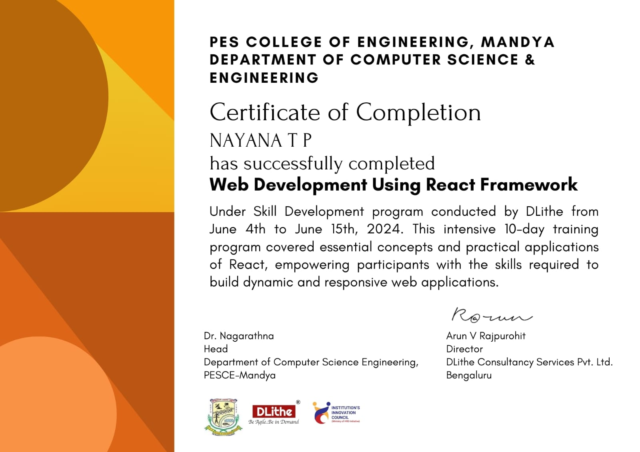

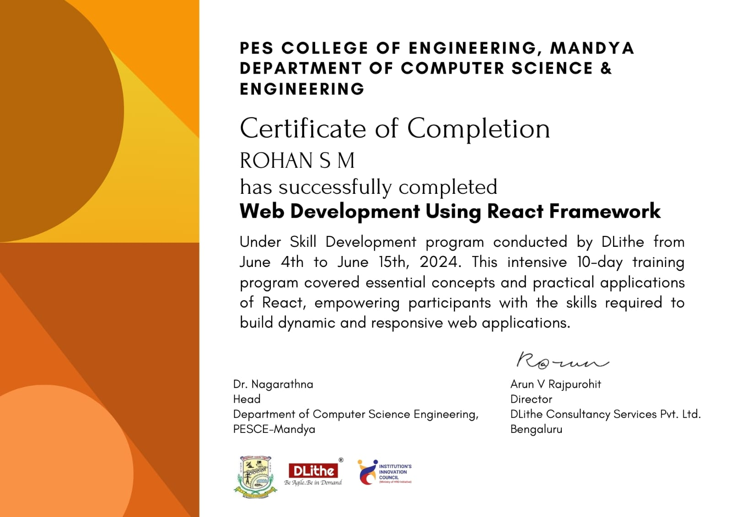

**ACKNOWLEDGEMENT**

The satisfaction and euphoria that accompany successful completion of any task would be incomplete without the mention of people who made it possible. We take this opportunity to express my sincere gratitude to all those who have helped me in this Internship-I.

We have immense pleasure in expressing our thanks to **DR. H M NANJUNDASWAMY**, Principal, PESCE, Mandya for providing all the facilities for the successful Completion of the internship-I.

It is our great privilege to express sincere and heartfelt thanks to **DR. NAGARATHNA**, Professor and Head, Department of Computer science and engineering, for her Constant encouragement, valuable suggestions and support in bringing out the This dissertation successfully

We would like to express heartfelt gratitude to our guide **Mrs. SHWETHA M K,** Assistant Professor, Department of Computer science and Engineering for his Encouragement and help through the tenure of the Internship-I.

Also, we would like to express our heartfelt gratitude to all the teaching and non-teaching Staff for their kind cooperation and support during the course of our Internship-I Work. Finally, we would like to thank our parents and all our friends for their Constant support

**ABSTRACT**

**HTML, CSS** and **JavaScript** collectively for the cornerstone of modern web development. **HTML** provides the structure by defining the content and layout of web pages, arranging text and multimedia elements, and creating the foundation for the user interface. **CSS**, the style sheet language, controls the visual presentation, enabling designers and developers to customize the look and feel of the webpages to ensure they are visually appealing and user-friendly. **JAVASCRIPT,** a versatile and powerful scripting language, facilitates interactivity and dynamic behavior in web applications. It enables features such as client-side form validation, real-time updates, and responsive user interfaces. By manipulating the Document Object Model (DOM), JavaScript allows developers to alter the page content and respond to user actions, resulting in rich, interactive web experiences. Together, HTML, CSS, and JavaScript are essential tools for web developers, working in harmony to create engaging and functional web applications and empowering developers to craft compelling user interfaces and interactive experiences on the web. Understanding these technologies is fundamental for anyone in web development.

# Table of Contents

ACKNOWLEDGEMENT i

ABSTRACT ii

CHAPTER 1 1

INTRODUCTION 1

* 1. Problem definition 1
  2. Motivation 2
  3. Objectives 3

Chapter 2 4

SYSTEM ANALYSIS 4

* 1. Proposed System 4

Chapter 3 7

REQUIREMENT SPECIFICATION 7

3.1 Introduction 7

Chapter 4 9

SYSTEM IMPLEMENTATION 9

4.1 Technologies used 9

HTML Code Snippets 10

CSS Code Snippets 12

**JAVASCRIPT Code Snippet** 13

Chapter 5 14

Snapshots 14

CONCLUSION 18

Bibliography 19

CHAPTER 1:

## INTRODUCTION

Welcome to SoulSync, your ultimate destination for cultivating mental peace and harmony within yourself. At SoulSync, we understand the importance of inner balance and well-being in today's fast-paced world. Our platform is dedicated to providing you with the tools, resources, and guidance to help you achieve tranquility and serenity in your daily life.

Through a blend of mindfulness practices, meditation techniques, and personalized guidance, SoulSync aims to empower individuals to connect with their inner selves and foster a sense of inner peace. Whether you are seeking to reduce stress, improve focus, or simply enhance your overall well-being, SoulSync offers a holistic approach to mental wellness.

At SoulSync, we believe that mental peace and harmony are essential components of a fulfilling and enriching life. Our mission is to support you on your journey towards self-discovery and inner balance. Join us on this transformative path towards a more peaceful and harmonious existence. Let SoulSync be your companion in nurturing your mind, body, and soul for a more balanced and harmonious life.

* 1. Problem definition

The problem we aim to address at SoulSync revolves around the challenge many individuals face in finding inner peace and harmony in their lives amidst the chaos and stress of modern-day living. This problem is characterized by feelings of anxiety, overwhelm, and a lack of connection with oneself**.**

1. **High Stress Levels:** Many people experience high levels of stress due to work, relationships, or other life pressures, leading to mental unrest.
2. **Physical Health Impact**: Mental unrest can take a toll on physical health, leading to symptoms like muscle tension, fatigue, and compromised immune function. The mind-body connection is profound, and unresolved mental stress can manifest physically. Recognizing the impact of mental well-being on physical health is essential in prioritizing holistic wellness and achieving a state of inner peace.
3. **Difficulty in Relaxation:** Some individuals may struggle to unwind and relax due to a busy lifestyle, racing thoughts, or an inability to disconnect from technology. Finding

activities that promote relaxation, such as meditation, yoga, or spending time in nature, can help quiet the mind and restore a sense of calm. Learning to prioritize self-care and relaxation is essential in nurturing mental peace and well-being.

1. **Lack of Mindfulness:** Individuals often struggle to be present in the moment and practice mindfulness, which is crucial for inner peace
2. **Disconnect from Self:** In the hustle and bustle of daily life, people may lose touch with their inner selves, resulting in a sense of disconnection and unease.
3. **Perfectionism:** Striving for perfection can create constant stress and dissatisfaction, hindering the ability to find peace in imperfection.
4. **Negative Thought Patterns:** Negative thought patterns, such as self-criticism and rumination, can significantly impact mental well-being by fueling feelings of anxiety and self-doubt. These patterns often create a cycle of negativity that hinders the ability to find peace within oneself. Addressing and challenging these negative thoughts is crucial in cultivating a more positive and harmonious mindset.
5. **External Influences:** External factors like constant exposure to social media, societal expectations, or environmental stressors can create a sense of dissonance and disrupt inner peace. The pressure to conform to external standards and comparisons with others can lead to feelings of inadequacy and unrest. Recognizing and setting boundaries with external influences is key to reclaiming mental harmony and authenticity**.**

### Motivation

"Embark on a transformative journey with SoulSync, where motivation meets purpose. Unleash your inner drive and passion as you explore a wealth of resources designed to fuel your motivation and empower your growth. With SoulSync as your companion, you'll find the inspiration and tools needed to conquer challenges and reach new heights of success.

Through SoulSync's platform, you'll discover a supportive community and valuable insights to keep your motivation burning bright. Dive into personalized content tailored to your aspirations, nurturing a mindset of resilience and determination. Let SoulSync's guidance and encouragement propel you forward on your path to realizing your dreams and aspirations.

With SoulSync, motivation becomes more than just a fleeting feeling—it becomes a sustainable force propelling you towards your goals. Embrace the power of motivation and self-discovery as you engage with SoulSync's empowering content and connect with like-minded individuals. Together, let's ignite the spark within and embark on a journey of growth, achievement, and fulfillment."

### Objectives:

"SoulSync's primary goal is to seamlessly integrate captivating design elements using HTML and CSS to create an engaging user experience. By leveraging the power of HTML for structuring content and CSS for styling, the website aims to provide a visually appealing platform that captivates and inspires visitors. Furthermore, JavaScript is employed to add interactive features and dynamic functionality, enhancing user engagement and personalization on SoulSync."

Through the harmonious blend of HTML, CSS, and JavaScript, SoulSync endeavors to not only offer motivational content but also deliver a visually stunning and interactive interface that resonates with users on a deeper level. By utilizing these web technologies effectively, the website strives to enhance the user experience, encourage exploration, and foster a sense of connection and empowerment among its audience.

Chapter 2

## SYSTEM ANALYSIS

#### Proposed System:

To enhance the **SOUL SYNC** Website, our project proposes a

streamlined approach that focuses on improving website and user experience.

#### 

#### The proposed system aims to:

* **Enhanced User Interface:** Implement a visually appealing and intuitive interface using HTML, CSS, and JavaScript to enhance customer engagement.
* **Responsive Design:** Optimize the website for seamless performance across various devices and screen sizes, ensuring accessibility.
* **Interactive Features:** Introduce dynamic animations and interactive elements to enrich the website.
* **Optimized Performance:** Revitalize your mind and elevate your performance with Soul Sync - where optimized mental harmony meets peak productivity for a balanced life.

#### Advantages of Proposed System:

* + **Accessibility**: Available on a wide range of devices and platforms, maximizing customer accessibility.
  + **Engaging Website play:** Provides a fun and interactive experience focused on improving memory skills.
  + **User-Friendly Interface:** Designed to be intuitive and easy to navigate, enhancing overall usability.
  + **Performance**: Optimized for smooth website performance, ensuring a seamless experience.

# Chapter 3

REQUIREMENT SPECIFICATION

#### Introduction:

The Website Requirements Specification (GRS) serves as a detailed

description of the behavior and functionalities of the proposed Soulsync Website. It outlines both the functional and non-functional requirements essential for developing the website. Functional requirements define what the website should do, while non-functional requirements encompass constraints on the design or implementation

#### Hardware Requirements

##### Server Infrastructure:

* + - * + No dedicated server infrastructure required; the website operates entirely on client-side within browsers.

##### Networking Equipments:

* + - * + Internet Connectivity: Stable internet connection for accessing development resources and testing online functionality.
        + Secure Communication**:** Ensure HTTPS support for secure data transmission during development

##### Backup Systems:

* + - * + Version Control: Use Git for version control to manage code changes and collaborate with team members.
        + Backup Strategy**:** Regularly push code to a remote repository (e.g., Github) for backup and collaboration purposes.

#### Software Requirements

##### Web Server:

* No dedicated web server required as the website runs entirely on client-side within browsers.

##### Database Management System (DBMS):

* No database management system needed; the website operates without backend data storage.

##### Programming Languages and Frameworks:

* **Client-side**: HTML, CSS, JavaScript for frontend development and interactivity.

##### Security Tools and Libraries:

* Basic security measures such as using HTTPS for secure communication (if deploying to a server).

##### Development and Testing Tools:

* **IDE**: Visual Studio Code for coding and testing website functionalities.

These simplified software requirements ensure a straight forward development environment using HTML, CSS, and JavaScript without the need of complex backend infrastructure or security and tools for the website development and front-end technology

# Chapter 4

## TECHNOLOGIES USED

In our internship-I showcases the synergy of HTML, CSS, and JavaScript in crafting a captivating SOUL SYNC. HTML forms the backbone by structuring the website's layout and content, ensuring clarity and user-friendly navigation. CSS enriches the visual aesthetics with customized styles, animations, and responsive design, enhancing the overall look and feel of the website. JavaScript, as the engine behind the interactivity, enables dynamic features, website logic, and user input handling, providing customers with an immersive and seamless experience. Together, these technologies not only demonstrate the capabilities of modern web development but also deliver an enjoyable and challenging website that engages customers

#### HTML (HyperText Markup Language)

* Purpose: HTML is the standard markup language used to create the structure of web pages. It defines the content and layout of a page by using elements like headings, paragraphs, images, links, and more.
* Key Features: HTML uses a system of tags (such as `<div>`, `<p>`, `<h1>`, etc.) to organize content. Each tag has an opening and closing version, and some tags can have attributes that provide additional information (e.g., `src` for images, `href` for links).

#### CSS (Cascading Style Sheets)

* Purpose: CSS is used to control the presentation and styling of HTML elements. It allows developers to apply styles such as colors, fonts, spacing, and layout.
* Key Features: CSS can be written inline within HTML, embedded in the `<style>` tags within the `<head>` section, or included in an external stylesheet. It uses selectors to target HTML elements and applies styles through properties and values (e.g., `color: red;`,

`font-size: 16px;`).

#### JavaScript

* Purpose: JavaScript is a programming language that adds interactivity and dynamic behavior to web pages. It can manipulate HTML and CSS, respond to user events, and handle data.
* Key Features: JavaScript can be embedded directly in HTML using the `<script>` tag or included as an external file. It can interact with the Document Object Model (DOM) to

change the content and style of web pages dynamically. JavaScript is also used for client-side validation, animations, and handling asynchronous operations through APIs and libraries.

Together, these technologies form the foundation of modern web development. HTML provides the structure, CSS defines the appearance, and JavaScript enables interactivity and functionality.

#### Here are some brief details about the technologies used in the SoulSync website:

1. HTML: Used to create the structure and layout of the website, including elements like headers, paragraphs, images, and forms.
2. CSS: Applied to style the website, including colors, fonts, layout design, and responsive elements to ensure a consistent look across devices.
3. JavaScript: Implemented for interactive features, such as form validation, dynamic content updates, animations, and user interactions.
4. Responsive Design: Utilized media queries in CSS to ensure the website is optimized for different screen sizes and devices, providing a seamless user experience across desktops, tablets, and smartphones.
5. Navigation: Implemented a navigation bar for easy access to different sections of the site, possibly using JavaScript for smooth scrolling or dropdown menus.
6. Animations and Transitions: Added visual enhancements such as animations or transitions using CSS and JavaScript to improve user engagement and make interactions more fluid.
7. Forms and Validation: Included forms for user input, such as contact forms or sign-ups, with JavaScript handling client-side validation to ensure data integrity before submission.

These elements contribute to a more engaging and functional user experience on the SoulSync website.

# CODE SNIPPET :-

# Devlopment Page-

# <!DOCTYPE html>

# <html lang="en">

# <head>

# <meta charset="UTF-8">

# <meta name="viewport" content="width=device-width, initial-scale=1.0">

# <title>SoulSync - Stress-Relieving Website</title>

# <style>

# body {

# font-family: Arial, sans-serif;

# background-color: #f0f0f0;

# text-align: center;

# }

# .container {

# padding: 20px;

# background-color: #fff;

# border-radius: 10px;

# box-shadow: 0 2px 4px rgba(0, 0, 0, 0.1);

# margin: 20px auto;

# max-width: 600px;

# }

# h1 {

# color: #333;

# }

# p {

# color: #777;

# }

# </style>

# </head>

# <body>

# <div class="container">

# <h1>Welcome to SoulSync!</h1>

# <p>Here, you'll find a variety of tools and resources to help you manage and reduce stress in your daily life. From carefully crafted playlists and relaxing podcasts to articles and tips on stress management techniques, our goal is to provide you with a one-stop-shop for all of your stress-relief needs.</p>

# <p>Whether you're looking for a quick break during a hectic workday or a longer practice to

# unwind at night, we've got you covered. Take a look around, try out some of our resources, and let us know if there's anything we can do to improve your experience.</p>

# <p>Remember, taking care of yourself is just as important as taking care of your work and projects, so don't hesitate to make time for stress relief in your busy schedule.</p>

# <p><em>The following part is under development.</em></p>

# </div>

# </body>

# </html>

# SERVICE PAGE:-

# const ham = document.getElementById("ham");

# const burger = document.querySelector(".burger");

# const cancel = document.querySelector(".cancel");

# const menu = document.getElementById("menu");

# const login = document.querySelector(".login-button");

# cancel.style.display = "none";

# const toggleMenu = () => {

# if (menu.classList.contains("open")) {

# menu.classList.remove("open");

# cancel.style.display = "none";

# login.style.display = "block";

# burger.style.display = "block";

# // menu.style.display = "block";

# console.log("open");

# } else {

# menu.classList.add("open");

# login.style.display = "none";

# burger.style.display = "none";

# cancel.style.display = "block";

# // menu.style.display = "none";

# console.log("close");

# }

# };

# // select all accordion items

# const accItems = document.querySelectorAll(".accordion__item");

# // add a click event for all items

# accItems.forEach((acc) => acc.addEventListener("click", toggleAcc));

# function toggleAcc() {

# // remove active class from all items exept the current item (this)

# accItems.forEach((item) => item != this ? item.classList.remove("accordion__item--active") : null

# );

# // toggle active class on current item

# if (this.classList != "accordion__item--active") {

# this.classList.toggle("accordion__item--active");

# }

# }

# const backTopElement = document.getElementById("back-top-div");

# const minScolledAmountToBackTop = 800;

# window.addEventListener("scroll", () => {

# if (window.scrollY < minScolledAmountToBackTop) {

# backTopElement.classList.add("hidden");

# } else {

# backTopElement.classList.remove("hidden");

# }

# });

# const backTop = () => {

# window.scrollTo(0, 0);

# };

# backTopElement.addEventListener("click", backTop);

# ham.addEventListener("click", toggleMenu);

# // Close the drawer when a link inside it is clicked

# document.querySelectorAll('.menu a').forEach(link => {

# link.addEventListener('click',toggleMenu);

# });

**CSS** **CODE** **SNIPPET**:-

* {

box-sizing: border-box;

}

*{

margin: 0%;

padding: 0%;

box-sizing: border-box;

}

body{

background-image: url("../images/coming_soon_bg.png");

background-color: black;

background-repeat: no-repeat;

background-size: cover;

background-position: center center;

height: 100vh;

font-family: "Poppins", sans-serif;

display: flex;

flex-direction: column;

align-items: center;

justify-content: center;

text-align: center;

margin: 0;

overflow: hidden;

}

p{

color: white;

display: flex;

align-items: center;

width: 100%;

font-size: 30px;

font-weight: bold;

margin: 30px 0;

}

h1{

color: white;

margin: 20px 0;

width: 100%;

font-size: 80px;

text-align: center;

font-weight: bold;

}

hr{

margin: 30px 0;

display:flex;

width: 700px;

}

#launch{

margin: 20px 0;

margin-left:20%;

font-size: 40px;

}

h1 {

font-family: 'Itim',cursive;

color: white;

font-weight: normal;

font-size: 60px;

text-shadow: 2px 2px 4px #011120;

-moz-transition: all 0.2s ease-in;

-o-transition: all 0.2s ease-in;

-webkit-transition: all 0.2s ease-in;

transition: all 0.2s ease-in;

margin: 20px 0;

width: 100%;

font-size: 80px;

text-align: center;

font-weight: bold;

}

h3{

color: white;

}

h3 a{

color: white;

text-decoration: none;

}

h3 a:hover{

color: lightcyan;

text-shadow:0px 0px 10px blueviolet;

-moz-transition: all 0.2s ease-in;

-o-transition: all 0.2s ease-in;

-webkit-transition: all 0.2s ease-in;

transition: all 0.2s ease-in;

}

h1:hover {

color: lightcyan;

text-shadow:0px 0px 20px blueviolet;

-moz-transition: all 0.2s ease-in;

-o-transition: all 0.2s ease-in;

-webkit-transition: all 0.2s ease-in;

transition: all 0.2s ease-in;

}

@keyframes typing {

from {

width: 0;

}

}

@media (max-width: 500px) {

h1 {

font-size: 45px;

}

.time {

margin: 5px;

padding: 0.1rem;

}

.time h2 {

font-size: 12px;

}

.text {

font-size: 10px;

box-shadow: 5px 5px 3px rgb(143, 143, 143);

padding: 0.1rem;

border-radius: 1px;

}

h3 {

color: white;

font-size: 1rem;

animation: typing 1s steps(12);

}

}

## 

## SNAPSHOT

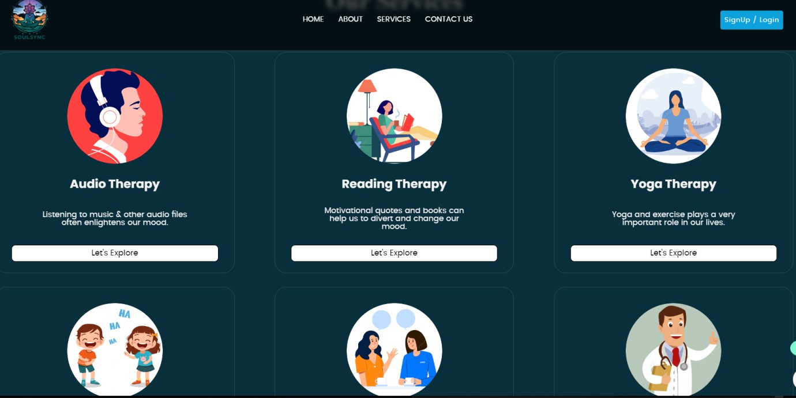

##### Fig 5.1: User interface of the Soul Sync Website.

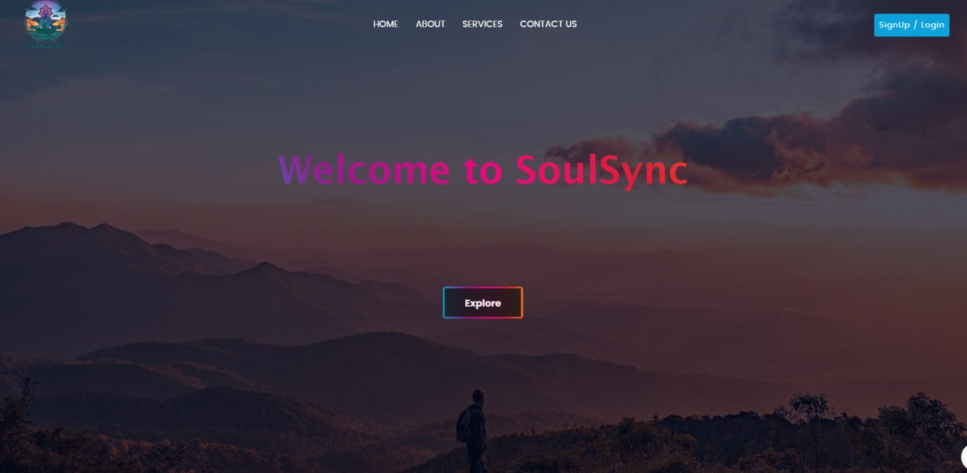

##### 

##### Fig 5.2: Home page of SOUL SYNC website

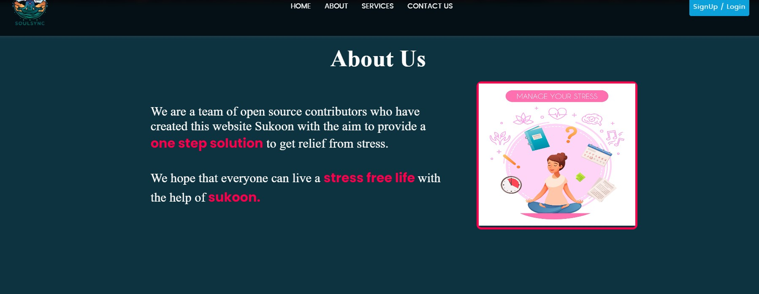

##### Fig 5.3: SOUL SYNC website

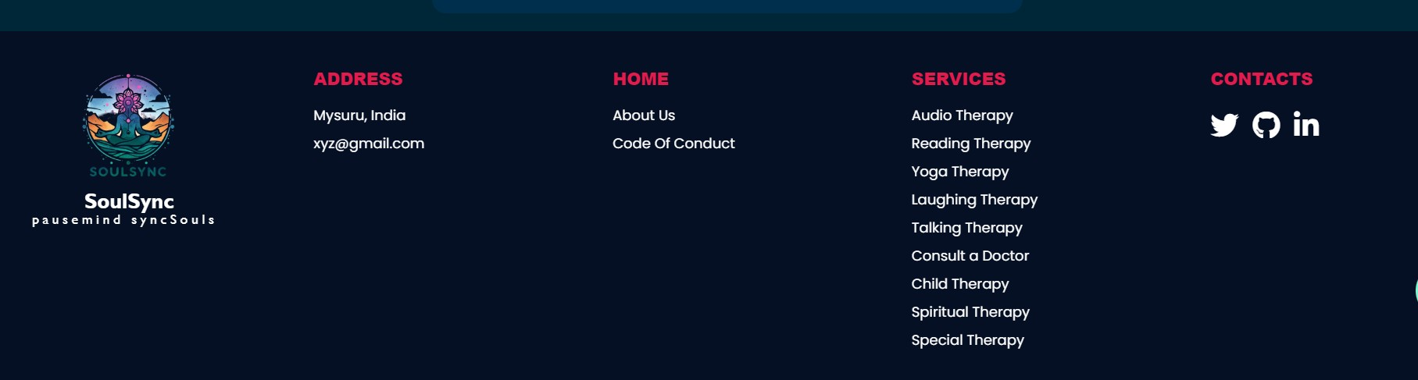

##### Fig 5.4: Soulsync website

## CONCLUSION

In conclusion, SoulSync stands as a beacon of motivation and empowerment, weaving together captivating design elements through HTML, CSS, and JavaScript to create an immersive user experience. With a commitment to inspiring personal growth and self-discovery, SoulSync not only provides valuable resources and a supportive community but also utilizes these web technologies to enhance user engagement and interaction. By embracing the power of technology and motivation, SoulSync invites individuals to embark on a journey of self-improvement, resilience, and fulfillment, making it a transformative platform for those seeking to unlock their full potential and thrive in all aspects of their lives.

In essence, SoulSync is a digital oasis where the synergy of HTML, CSS, and JavaScript converges to craft an immersive and dynamic online platform. By artfully blending these web technologies, the website transcends conventional boundaries, offering users a transformative experience that marries functionality with inspiration. Through its strategic use of HTML for content structure, CSS for aesthetic appeal, and JavaScript for interactive features, SoulSync not only informs and motivates but also fosters a sense of community and personal growth. This amalgamation of technology and purpose propels SoulSync beyond a mere website, elevating it to a virtual sanctuary where individuals can explore, learn, and evolve on their journey to self-discovery and empowerment.

Repository link : <https://github.com/ro-36/SoulSync>

**BIBLIOGRAPHY:-**

1) https://www.w3schools.com/html/

2) https://www.w3schools.com/css/

3) https://www.w3schools.com/js/