1. WAP to print

Program:

// Online Java Compiler

// Use this editor to write, compile and run your Java code online

import java.util.\*;

class Main {

public static void main(String []args){

Scanner s=new Scanner(System.in);

int a=s.nextInt();

int m=a/2;

int count=1,v=0,sp=1;

for(int i=0;i<a/2;i++)

{

if(i==0||i==a-1)

{

for(int n=0;n<a;n++)

{

System.out.print("\*");

}

System.out.println();

}

for(int j=1;j<=(a/2)-count;j++)

{

System.out.print("\*");

}

for(int l=sp;l>0;l--)

{

System.out.print(" ");

}

//v=v+count;

for(int k=(a/2)+count;k<=a;k++)

{

System.out.print("\*");

}

if(i>=a/2)

{

for(int z=0;z<a;z++)

{

if(z==0||z==a-1)

{

System.out.print("\*");

}

else{

System.out.print(" ");

}

}

}

System.out.println();

count=count+1;

sp=sp+2;

}

for(int i=(a/2)+1;i<a;i++)

{

if(i==(a/2)+1)

{

System.out.print("\*");

}

else{

for(int j=0;j<a;j++)

{

if(j==0||j==a-1)

{

System.out.print("\*");

}

else{

System.out.print(" ");

}

}

System.out.println();

}

}

for(int i=0;i<a;i++)

{

System.out.print("\*");

}

}

}

Output:-

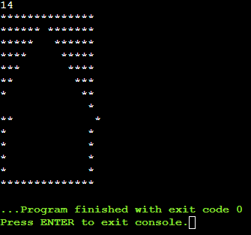

2. Write a program to print

1 1 1

2 2 2

3 3 3

4 4 4

Program:

import java.util.\*;

class Main {

public static void main(String []args){

Scanner s=new Scanner(System.in);

int a=s.nextInt();

for(int i=1;i<=a;i++)

{

for(int j=1;j<=a;j++)

{

System.out.print(i);

}

System.out.println();

}

}

}

Output:-

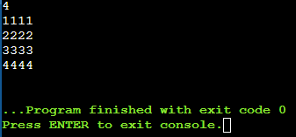

3.WAP to print

program:- import java.util.\*;

class Main {

public static void main(String []args){

Scanner s=new Scanner(System.in);

// int a=s.nextInt();

int t=14;

for(int i=0;i<8;i++)

{

if(i==7||i==8)

{

for(int m=0;m<14;m++)

{

System.out.print("\*");

}

}

else{

for(int j=0;j<=i;j++)

{

System.out.print("\*");

}

for(int l=i;l<t-i-2;l++)

{

System.out.print(" ");

}

// System.out.print("\*");

for(int k=i;k>=0;k--)

{

System.out.print("\*");

}

}

//if()

System.out.println();

//for(int k=7;k)

}

}

}

OUTPUT:-

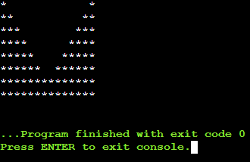

4. . WAP to print

Program:-

import java.util.\*;

class Main {

public static void main(String []args){

Scanner s=new Scanner(System.in);

int n=s.nextInt();

int c=2;

for(int i=0;i<n;i++)

{

if(i==0||i==n-1)

{

for(int k=0;k<n;k++)

{

System.out.print("\*");

}

}

else{

for(int j=0;j<n/2-i;j++)

{

System.out.print("\*");

}

}

if(i>=7&&i<n-1)

{

for(int l=0;l<c;l++)

{

System.out.print("\*");

}

c++;

}

System.out.println();

}

}

}OUTPUt:-

