20. Design DFA Using Simulator to Accept Strings Ending with ab
AIM
To design and simulate a Deterministic Finite Automaton (DFA) that accepts strings ending with ab over the alphabet {a, b}, for the given input string W = aaabab.
PROCEDURE
- Open the DFA simulator.
- Define the input alphabet as {a, b}.
- Create three states: q0, q1, and q2.
- Make q0 the initial state.
- Make q2 the final state.
- From q0, on a, move to q1.
- From q1, on b, move to q2.
- Add transitions to handle other occurrences of a and b.
- Enter the input string aaabab in the simulator.
- Run the DFA and check the final state.
- Since aaabab ends with ab, the string should be accepted.
ALGORITHM
- Start at q0.
- Read the input symbols from left to right.
- If a is encountered, move to the state representing a possible beginning of ab.
- If ab is found at the end of the string, move to final state q2.
- If the input ends in q2, accept the string.
- Otherwise, reject the string.
DFA TRANSITION TABLE
Current State | Input a | Input b
→ q0 | q1 | q0
q1 | q1 | *q2
*q2 | q1 | q0
q0 = Initial State
q2 = Final State
INPUT
W = aaabab
STATE TRANSITIONS
q0 --a--> q1
q1 --a--> q1
q1 --a--> q1
q1 --b--> q2
q2 --a--> q1
q1 --b--> q2
Final state:
q2
OUTPUT
Accepted
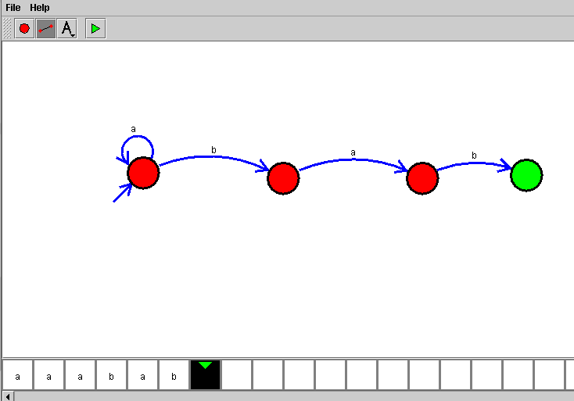
RESULT
Thus, the DFA for accepting strings ending with ab was successfully designed and simulated. The given string aaabab was accepted because it ends with ab.

