21. Design DFA Using Simulator to Accept Strings Having ‘ab’ as a Substring
AIM
To design and simulate a Deterministic Finite Automaton (DFA) that accepts strings containing ‘ab’ as a substring over the alphabet {a, b}, for the given input string W = aaabab.
PROCEDURE
- Open the DFA simulator.
- Define the input alphabet as {a, b}.
- Create three states: q0, q1, and q2.
- Make q0 the initial state.
- Make q2 the final state.
- From q0, on a, move to q1.
- From q0, on b, remain in q0.
- From q1, on a, remain in q1.
- From q1, on b, move to q2.
- From q2, on both a and b, remain in q2.
- Enter the input string aaabab in the simulator.
- Run the DFA and check the final state.
- Since aaabab contains ab as a substring, the string should be accepted.
ALGORITHM
- Start at q0.
- Read the input symbols from left to right.
- If a is encountered, move to q1.
- If b is encountered while in q1, move to final state q2.
- Once q2 is reached, remain in q2 for any remaining input.
- If the input ends in q2, accept the string.
- Otherwise, reject the string.
DFA TRANSITION TABLE
Current State | Input a | Input b
→ q0 | q1 | q0
q1 | q1 | ★ q2
★ q2 | q2 | q2
q0 = Initial State
q2 = Final State
INPUT
W = aaabab
STATE TRANSITIONS
q0 --a--> q1
q1 --a--> q1
q1 --a--> q1
q1 --b--> q2
q2 --a--> q2
q2 --b--> q2
Final State
q2
OUTPUT
Accepted
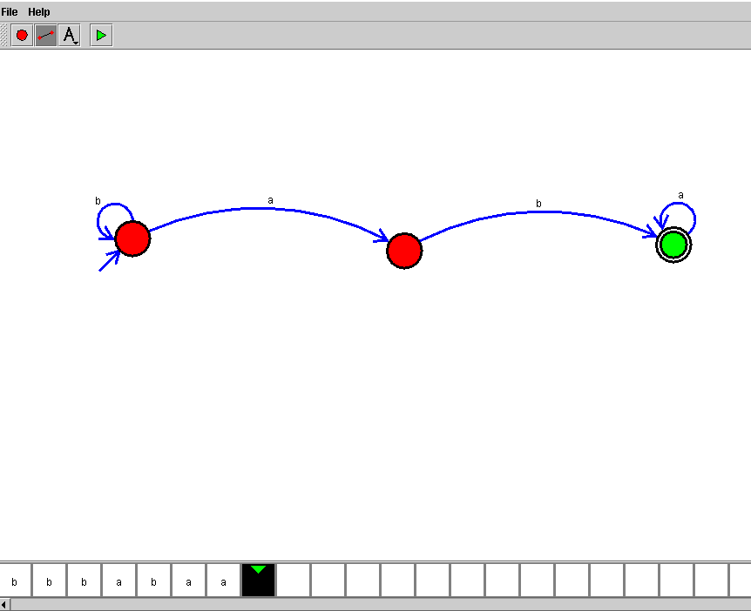
RESULT
Thus, the DFA for accepting strings having ab as a substring was successfully designed and simulated. The given string aaabab was accepted because it contains ab as a substring.

