22. Design DFA Using Simulator to Accept Strings Starting with a or b
AIM
To design and simulate a Deterministic Finite Automaton (DFA) that accepts strings starting with a or b over the alphabet {a, b}.
PROCEDURE
- Open the DFA simulator.
- Define the input alphabet as {a, b}.
- Create three states: q0, q1, and q2.
- Make q0 the initial state.
- Make q1 and q2 the final states.
- From q0, on a, move to q1.
- From q0, on b, move to q2.
- From q1, on a or b, remain in q1.
- From q2, on a or b, remain in q2.
- Enter the required input string in the simulator.
- Run the DFA and check the final state.
- If the string starts with a or b, it will be accepted.
ALGORITHM
- Start at q0.
- Read the first input symbol.
- If the first symbol is a, move to final state q1.
- If the first symbol is b, move to final state q2.
- Continue reading the remaining symbols while staying in the respective final state.
- If the input ends in q1 or q2, accept the string.
DFA TRANSITION TABLE
Current State | Input a | Input b
→ q0 | ★ q1 | ★ q2
★ q1 | q1 | q1
★ q2 | q2 | q2
q0 = Initial State
q1, q2 = Final States
INPUT
W = aaabab
STATE TRANSITIONS
q0 --a--> q1
q1 --a--> q1
q1 --a--> q1
q1 --b--> q1
q1 --a--> q1
q1 --b--> q1
Final State
q1
OUTPUT
Accepted
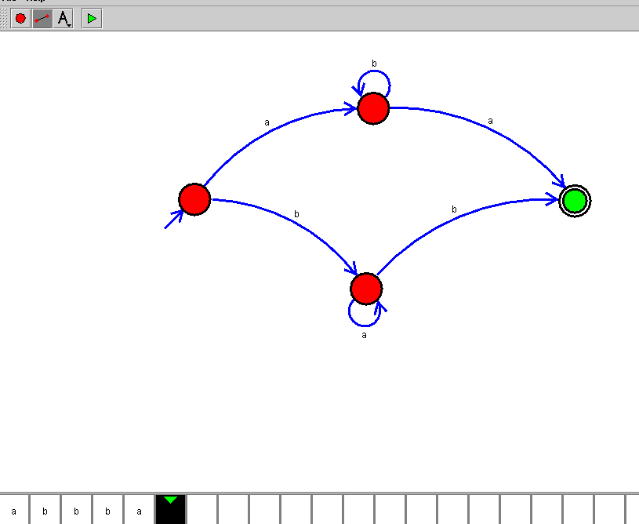

RESULT
Thus, the DFA for accepting strings starting with a or b was successfully designed and simulated. The given string aaabab was accepted because it starts with a.

