23. Design TM Using Simulator to Accept the Input String Palindrome bbabb
AIM
To design and simulate a Turing Machine (TM) that accepts a palindrome string over the alphabet {a, b}, for the given input string W = bbabb.
PROCEDURE
- Open the Turing Machine simulator.
- Define the input alphabet as {a, b}.
- Use X and Y as marked symbols for a and b.
- Create states to compare the first and last unmarked symbols.
- Mark the first symbol and move toward the right end.
- Compare it with the last unmarked symbol.
- If both symbols are equal, mark the last symbol and return to the left.
- Repeat the process until all symbols are marked.
- If all corresponding symbols match, move to the accept state.
- Enter the input string bbabb in the simulator.
- Run the TM and check the final state.
- Since bbabb reads the same from both directions, the string should be accepted.
ALGORITHM
- Start from the leftmost symbol.
- Read the first unmarked symbol.
- If it is b, mark it as Y and move right.
- Move to the rightmost unmarked symbol.
- Check whether the rightmost symbol is also b.
- If it matches, mark it as Y and return to the left.
- Repeat the same process for the remaining symbols.
- When the middle symbol is reached, mark it and continue.
- If all symbols match, enter the Accept state.
- Otherwise, enter the Reject state.
TM TRANSITION TABLE
Current State | Read | Write | Move | Next State
→ q0 | b | Y | R | q1
q0 | a | X | R | q2
q0 | Y | Y | R | q6
q0 | X | X | R | q6
q1 | b | b | R | q1
q1 | a | a | R | q1
q1 | Y | Y | R | q3
q1 | X | X | R | q3
q3 | b | Y | L | q4
q3 | a | a | L | q5
q4 | b | b | L | q4
q4 | a | a | L | q4
q4 | Y | Y | L | q0
q5 | b | b | L | q5
q5 | a | a | L | q5
q5 | X | X | L | q0
q6 | Y | Y | R | q6
q6 | X | X | R | q6
q6 | B | B | R | q_accept
q0 = Initial State
q_accept = Final/Accept State
X = Marked a
Y = Marked b
B = Blank
INPUT
W = bbabb
STATE TRANSITIONS
bbabb
Ybab b
YbabY
YYabY
YYaYY
YYXYY
The machine compares matching symbols from both ends:
b = b
b = b
a = a
Final State
q_accept
OUTPUT
Accepted
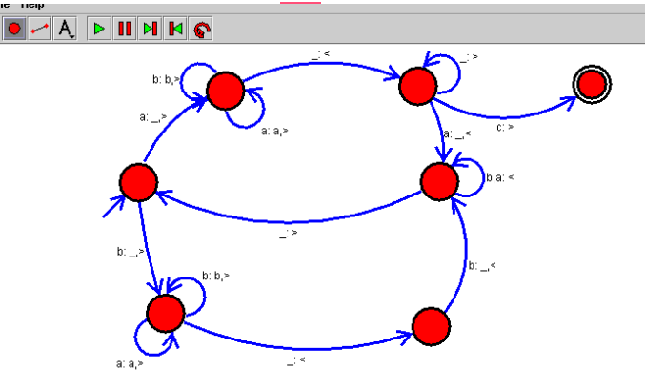

RESULT
Thus, the Turing Machine for accepting palindrome strings was successfully designed and simulated. The given input string bbabb was accepted because it reads the same from left to right and right to left.

