24. Design TM Using Simulator to Accept the Input String wcw
AIM
To design and simulate a Turing Machine (TM) that accepts strings of the form wcw over the alphabet {a, b, c}, where the same string w appears on both sides of c, for the given input string wcw.
PROCEDURE
- Open the Turing Machine simulator.
- Define the input alphabet as {a, b, c}.
- Use X to mark the symbols of the first part w.
- Create states to compare symbols before and after c.
- Find the first unmarked symbol before c and mark it.
- Move right across c to find the corresponding unmarked symbol.
- Compare the symbols on both sides.
- If they match, mark the corresponding symbol and return to the left.
- Repeat the process for all symbols in w.
- When all symbols are matched, move to the accept state.
- If any symbols do not match, move to the reject state.
ALGORITHM
- Start from the leftmost symbol.
- Select the first unmarked symbol before c.
- Mark the selected symbol and remember whether it is a or b.
- Move right until c is reached.
- Move to the corresponding unmarked symbol after c.
- If the symbol matches, mark it and return to the left.
- Repeat the process until all symbols before c are marked.
- If every symbol matches in the same order, accept the string.
- Otherwise, reject the string.
TM TRANSITION TABLE
For a simple example abcab, where w = ab:
Current State | Read | Write | Move | Next State
→ q0 | a | X | R | q1
q0 | b | Y | R | q2
q0 | c | c | R | q_accept
q1 | a/b | Same | R | q1
q1 | c | c | R | q3
q3 | a | X | L | q4
q3 | b | Y | L | q_reject
q2 | a/b | Same | R | q2
q2 | c | c | R | q5
q5 | b | Y | L | q4
q5 | a | X | L | q_reject
q4 | a/b/c/X/Y | Same | L | q4
q4 | B | B | R | q0
q0 = Initial State
q_accept = Final/Accept State
q_reject = Reject State
B = Blank
INPUT
W = abcab
Here, w = ab, so:
w c w = ab c ab = abcab
STATE TRANSITIONS
abcab
Xbcab
XbcXb
XbcXY
XbcXY
The machine compares:
a = a
b = b
Final State
q_accept
OUTPUT
Accepted
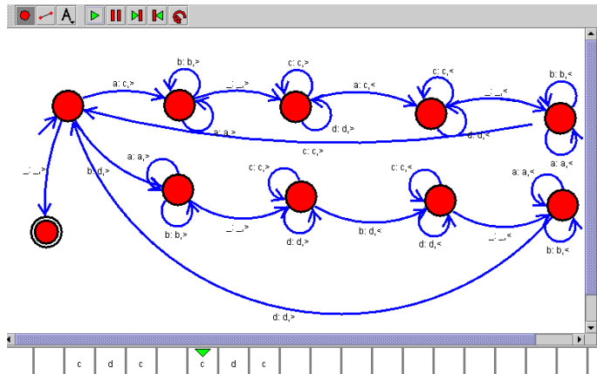

RESULT
Thus, the Turing Machine for accepting strings of the form wcw was successfully designed and simulated. The input string abcab was accepted because it has the form w c w, where w = ab.

