25. Design DFA Using Simulator to Accept Strings with Even Number of a's and Odd Number of b's
AIM
To design and simulate a Deterministic Finite Automaton (DFA) that accepts strings having an even number of a's and an odd number of b's over the alphabet {a, b}.
PROCEDURE
- Open the DFA simulator.
- Define the input alphabet as {a, b}.
- Create four states: q0, q1, q2, and q3.
- Make q0 the initial state.
- Make q1 the final state.
- q0 represents even a's and even b's.
- q1 represents even a's and odd b's.
- q2 represents odd a's and even b's.
- q3 represents odd a's and odd b's.
- On reading a, change the parity of the number of a's.
- On reading b, change the parity of the number of b's.
- Enter the required input string in the simulator.
- Run the DFA and check the final state.
ALGORITHM
- Start at q0.
- Read the input symbols from left to right.
- For every a, change between even and odd a states.
- For every b, change between even and odd b states.
- If the input ends in q1, accept the string.
- Otherwise, reject the string.
DFA TRANSITION TABLE
Current State | Input a | Input b
→ q0 | q2 | ★ q1
★ q1 | q3 | q0
q2 | q0 | q3
q3 | q1 | q2
q0 = Initial State
q1 = Final State
INPUT
W = aab
STATE TRANSITIONS
q0 --a--> q2
q2 --a--> q0
q0 --b--> q1
Final State
q1
OUTPUT
Accepted
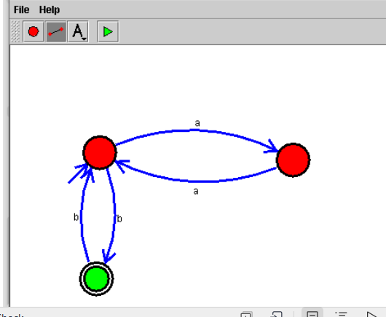

RESULT
Thus, the DFA for accepting strings having an even number of a's and an odd number of b's was successfully designed and simulated. The input string aab was accepted because it contains 2 a's (even) and 1 b (odd).

