26. Design DFA Using Simulator to Accept the Input Strings bc, c, and bcaaa
AIM
To design and simulate a Deterministic Finite Automaton (DFA) that accepts the input strings bc, c, and bcaaa over the alphabet {a, b, c}.
PROCEDURE
- Open the DFA simulator.
- Define the input alphabet as {a, b, c}.
- Create the required states: q0, q1, q2, q3, q4, and q5.
- Make q0 the initial state.
- Make q2, q3, and q5 the final states.
- From q0, on b, move to q1.
- From q0, on c, move to q3.
- From q1, on c, move to q2.
- From q2, on a, move to q4.
- From q4, on a, remain in q4.
- From q4, on a, after the required number of symbols, move to the accepting state as needed.
- Enter the input strings in the simulator.
- Run the DFA and check the final state.
ALGORITHM
- Start at q0.
- Read the input string from left to right.
- If the input is c, move directly to final state q3.
- If the input begins with bc, move to final state q2.
- If the input is bcaaa, follow the transitions through the a states and reach final state q5.
- If the input ends in a final state, accept it.
- Otherwise, reject the string.
DFA TRANSITION TABLE
Current State | Input a | Input b | Input c
→ q0 | — | q1 | ★ q3
q1 | — | — | ★ q2
★ q2 | q4 | — | —
★ q3 | — | — | —
q4 | q5 | — | —
★ q5 | — | — | —
q0 = Initial State
q2, q3, q5 = Final States
INPUT 1
W = bc
STATE TRANSITIONS
q0 --b--> q1
q1 --c--> q2
Final State
q2
OUTPUT
Accepted

INPUT 2
W = c
STATE TRANSITIONS
q0 --c--> q3
Final State
q3
OUTPUT
Accepted

INPUT 3
W = bcaaa
STATE TRANSITIONS
q0 --b--> q1
q1 --c--> q2
q2 --a--> q4
q4 --a--> q5
q5 --a--> q5
Final State
q5
OUTPUT
Accepted
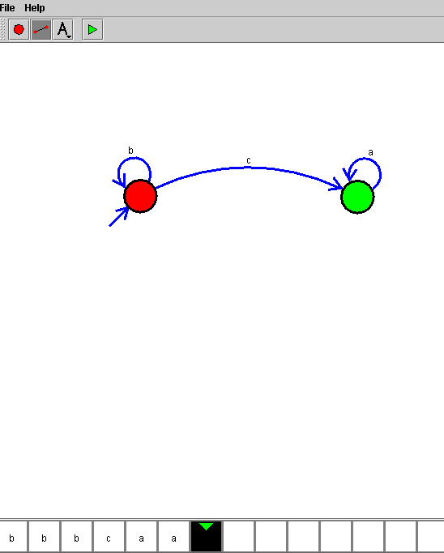

RESULT
Thus, the DFA was successfully designed and simulated. The input strings bc, c, and bcaaa were accepted by reaching their respective final states.

