27. Design NFA Using Simulator to Accept Any Number of a's Where Input = {a,b}
AIM
To design and simulate a Nondeterministic Finite Automaton (NFA) that accepts strings containing any number of a's over the input alphabet {a, b}.
PROCEDURE
- Open the NFA simulator.
- Define the input alphabet as {a, b}.
- Create two states: q0 and q1.
- Make q0 the initial state.
- Make q0 the final state.
- From q0, on input a, remain in q0.
- Since only a's are accepted, there is no transition for b.
- Enter the input string in the simulator.
- Run the NFA and check the final state.
- If the input contains only a's, the string is accepted.
ALGORITHM
- Start at q0.
- Read the input symbols from left to right.
- For every a, remain in q0.
- If b is encountered, there is no valid transition.
- If the input ends in q0, accept the string.
- Otherwise, reject the string.
NFA TRANSITION TABLE
Current State | Input a | Input b
→ ★ q0 | q0 | —
q0 = Initial State and Final State
INPUT
W = aaaa
STATE TRANSITIONS
q0 --a--> q0
q0 --a--> q0
q0 --a--> q0
q0 --a--> q0
Final State
q0
OUTPUT
Accepted
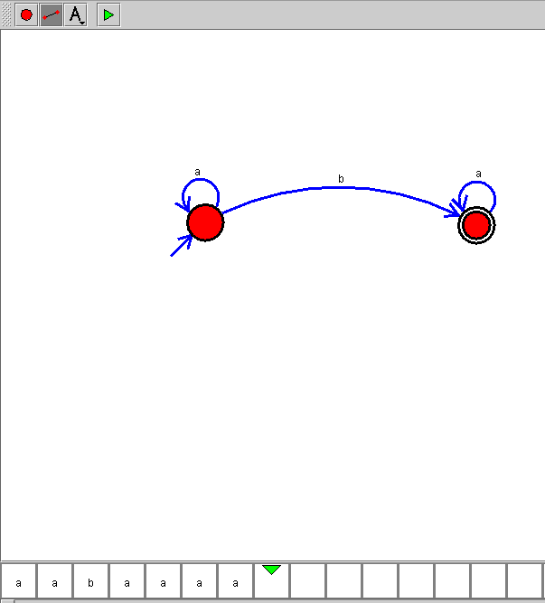

RESULT
Thus, the NFA for accepting any number of a's was successfully designed and simulated. The input string aaaa was accepted because it contains only a's.
Accepted examples: ε, a, aa, aaa, aaaa
Rejected examples: b, ab, ba, aab

