28. Design PDA Using Simulator to Accept the Input String aⁿbⁿ
AIM
To design and simulate a Pushdown Automaton (PDA) that accepts strings of the form aⁿbⁿ, where the number of a's is equal to the number of b's, over the alphabet {a, b}.
PROCEDURE
- Open the PDA simulator.
- Define the input alphabet as {a, b}.
- Define the stack alphabet as {A, Z₀}.
- Create three states: q0, q1, and q2.
- Make q0 the initial state.
- Make q2 the final state.
- In q0, read each a and push A onto the stack.
- When b is encountered, move to q1.
- In q1, read each b and pop one A from the stack.
- When all A symbols are popped and the input is completely read, move to q2.
- Enter the input string aaabbb in the simulator.
- Run the PDA and check the final state.
- Since the number of a's and b's is equal, the string should be accepted.
ALGORITHM
- Start at q0 with stack symbol Z₀.
- For every input a, push A onto the stack.
- When the first b is read, move to q1.
- For every b, pop one A from the stack.
- Continue until all A symbols are removed.
- If the input is completely read and the stack reaches Z₀, move to the final state.
- Accept the string if the final state is reached.
- Otherwise, reject the string.
PDA TRANSITION TABLE
Current State | Input | Stack Top | Stack Operation | Next State
→ q0 | a | Z₀ | AZ₀ | q0
q0 | a | A | AA | q0
q0 | b | A | ε | q1
q1 | b | A | ε | q1
q1 | ε | Z₀ | Z₀ | ★ q2
q0 = Initial State
q2 = Final State
Z₀ = Initial Stack Symbol
A = Stack Symbol
INPUT
W = aaabbb
Here,
n = 3
Number of a's = 3
Number of b's = 3
STATE TRANSITIONS
q0 --a, Z₀/AZ₀--> q0
q0 --a, A/AA----> q0
q0 --b, A/ε-----> q1
q1 --b, A/ε-----> q1
q1 --ε, Z₀/Z₀--> q2
STACK OPERATION
Input: a a a b b b

Stack: Z₀
AZ₀
AAZ₀
AAAZ₀
AAZ₀
AZ₀
Z₀
Final State
q2
OUTPUT
Accepted
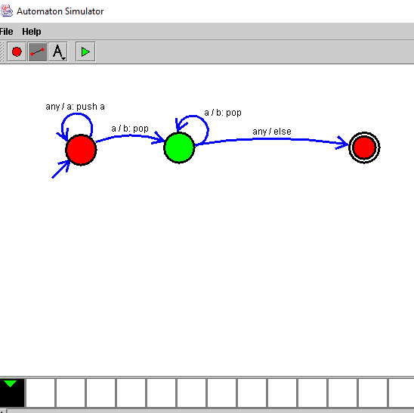

RESULT
Thus, the PDA for accepting strings of the form aⁿbⁿ was successfully designed and simulated. The input string aaabbb was accepted because it contains an equal number of a's and b's.

