29. Design TM Using Simulator to Perform String Comparison Where w = {aba aba}
AIM
To design and simulate a Turing Machine (TM) that performs string comparison for the given input w = abaaba, by comparing the two strings aba and aba.
PROCEDURE
- Open the Turing Machine simulator.
- Enter the input string abaaba.
- Divide the input into two parts: aba and aba.
- Compare the first symbol of the first string with the corresponding symbol of the second string.
- Mark the compared symbols.
- Repeat the comparison for the remaining symbols.
- If all corresponding symbols are equal, move to the accept state.
- If any corresponding symbols are different, move to the reject state.
- Run the TM and check the final state.
ALGORITHM
- Start at the first symbol of the input.
- Compare the first a with the first a of the second string.
- Compare the first b with the second b.
- Compare the second a with the second a.
- If all corresponding symbols match, accept the input.
- If any symbols do not match, reject the input.
TM TRANSITION TABLE
Current State | Read | Write | Move | Next State
→ q0 | a | X | R | q1
q1 | b | Y | R | q2
q2 | a | X | R | q3
q3 | a | X | R | q4
q4 | b | Y | R | q5
q5 | a | X | R | q_accept
q_accept | B | B | R | q_accept
q0 = Initial State
q_accept = Final/Accept State
X, Y = Marked symbols
B = Blank
INPUT
W = abaaba
The two strings are:
First string = aba
Second string = aba
STATE TRANSITIONS
q0 --a--> q1
q1 --b--> q2
q2 --a--> q3
q3 --a--> q4
q4 --b--> q5
q5 --a--> q_accept
COMPARISON
First String : a b a
↓ ↓ ↓
Second String: a b a

Comparison : = = =
All corresponding symbols are equal.
Final State
q_accept
OUTPUT
Accepted
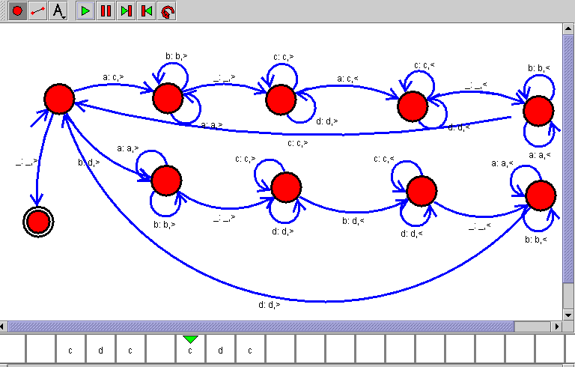

RESULT
Thus, the Turing Machine for string comparison was successfully designed and simulated. The strings aba and aba are equal, so the input abaaba was accepted.

