30. Design DFA Using Simulator to Accept the String Having abc as Substring
AIM
To design and simulate a Deterministic Finite Automaton (DFA) that accepts strings having abc as a substring over the alphabet {a, b, c}.
PROCEDURE
- Open the DFA simulator.
- Define the input alphabet as {a, b, c}.
- Create four states: q0, q1, q2, and q3.
- Make q0 the initial state.
- Make q3 the final state.
- From q0, on a, move to q1.
- From q1, on b, move to q2.
- From q2, on c, move to q3.
- Add transitions to handle other occurrences of a, b, and c.
- Once q3 is reached, remain in q3 for all input symbols.
- Enter the required input string in the simulator.
- Run the DFA and check the final state.
- If abc occurs anywhere in the string, the string is accepted.
ALGORITHM
- Start at q0.
- Read the input symbols from left to right.
- When a is found, move to q1.
- When b follows a, move to q2.
- When c follows ab, move to final state q3.
- Once q3 is reached, remain in q3.
- If the input ends in q3, accept the string.
- Otherwise, reject the string.
DFA TRANSITION TABLE
Current State | Input a | Input b | Input c
→ q0 | q1 | q0 | q0
q1 | q1 | q2 | q0
q2 | q1 | q0 | ★ q3
★ q3 | q3 | q3 | q3
q0 = Initial State
q3 = Final State
INPUT
W = aabc
STATE TRANSITIONS
q0 --a--> q1
q1 --a--> q1
q1 --b--> q2
q2 --c--> q3
Final State
q3
OUTPUT
Accepted
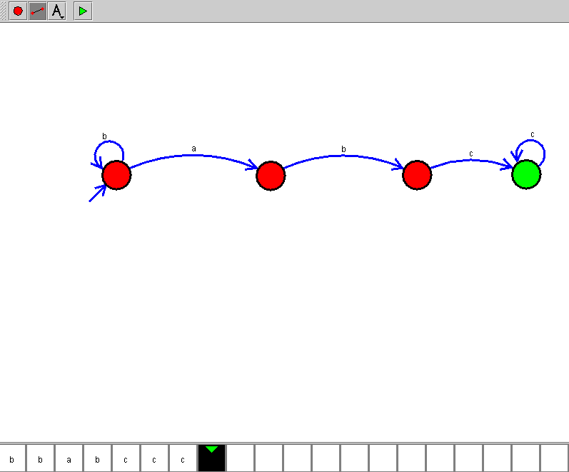

RESULT
Thus, the DFA for accepting strings having abc as a substring was successfully designed and simulated. The given input string aabc was accepted because it contains abc as a substring.

