31. Design DFA Using Simulator to Accept Strings Having Even Number of c's
AIM
To design and simulate a Deterministic Finite Automaton (DFA) that accepts strings having an even number of c's over the alphabet {a, b, c}.
PROCEDURE
- Open the DFA simulator.
- Define the input alphabet as {a, b, c}.
- Create two states: q0 and q1.
- Make q0 the initial state.
- Make q0 the final state.
- From q0, on a or b, remain in q0.
- From q0, on c, move to q1.
- From q1, on a or b, remain in q1.
- From q1, on c, move back to q0.
- Enter the required input string in the simulator.
- Run the DFA and check the final state.
- If the input ends in q0, the string is accepted.
- Otherwise, the string is rejected.
ALGORITHM
- Start at q0.
- Read the input symbols from left to right.
- For every c, change the state between q0 and q1.
- For a and b, remain in the same state.
- If the input ends in q0, accept the string.
- If the input ends in q1, reject the string.
DFA TRANSITION TABLE
Current State | Input a | Input b | Input c
→ ★ q0 | q0 | q0 | q1
q1 | q1 | q1 | ★ q0
q0 = Initial State and Final State
q1 = Odd number of c's
INPUT
W = abcc
STATE TRANSITIONS
q0 --a--> q0
q0 --b--> q0
q0 --c--> q1
q1 --c--> q0
Final State
q0
OUTPUT
Accepted
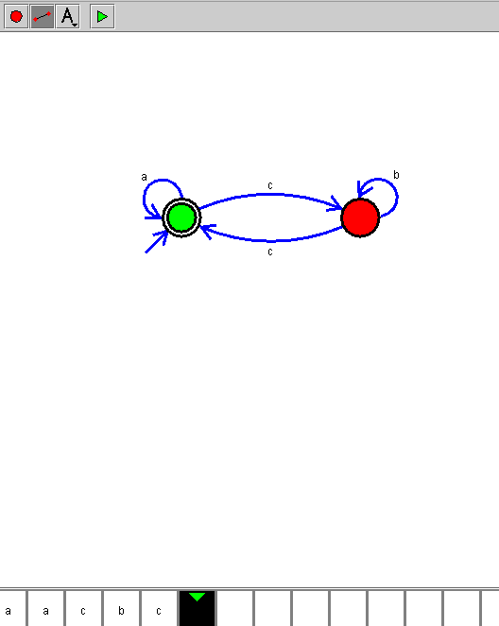
RESULT
Thus, the DFA for accepting strings having an even number of c's over the alphabet {a,b,c} was successfully designed and simulated.

