32. Design DFA Using Simulator to Accept Strings in Which a's Always Appear Tripled
AIM
To design and simulate a Deterministic Finite Automaton (DFA) that accepts strings in which the number of consecutive a's always occurs in groups of three over the alphabet {a,b}.
PROCEDURE
- Open the DFA simulator.
- Define the input alphabet as {a, b}.
- Create five states: q0, q1, q2, q3, and q4.
- Make q0 the initial state and final state.
- From q0, on a, move to q1.
- From q1, on a, move to q2.
- From q2, on a, move to q3.
- From q3, on b, move to q0.
- From q0, on b, remain in q0.
- Send invalid a sequences to dead state q4.
- Once q4 is reached, remain in q4.
- Enter the required input string in the simulator.
- Run the DFA and check the final state.
- If the input ends in q0, the string is accepted.
ALGORITHM
- Start at q0.
- Read the input symbols from left to right.
- Count consecutive a's.
- After three a's, return to q0.
- Symbol b can occur between groups of three a's.
- If an incomplete group of a's occurs, move to q4.
- If the input ends in q0, accept the string.
- Otherwise, reject the string.
DFA TRANSITION TABLE
Current State | Input a | Input b
→ ★ q0 | q1 | q0
q1 | q2 | q4
q2 | q3 | q4
★ q3 | q4 | q0
q4 | q4 | q4
q0 = Initial State and Final State
q1 = One a read
q2 = Two a's read
q3 = Three a's read
q4 = Dead State
INPUT
W = aaabaaa
STATE TRANSITIONS
q0 --a--> q1
q1 --a--> q2
q2 --a--> q3
q3 --b--> q0
q0 --a--> q1
q1 --a--> q2
q2 --a--> q3
Final State
q3
Note: If the intended meaning is that every group of a must be exactly three, then q3 should transition on b to q0; the example aaabaaa ends with an incomplete group and is therefore Rejected.

OUTPUT
Rejected
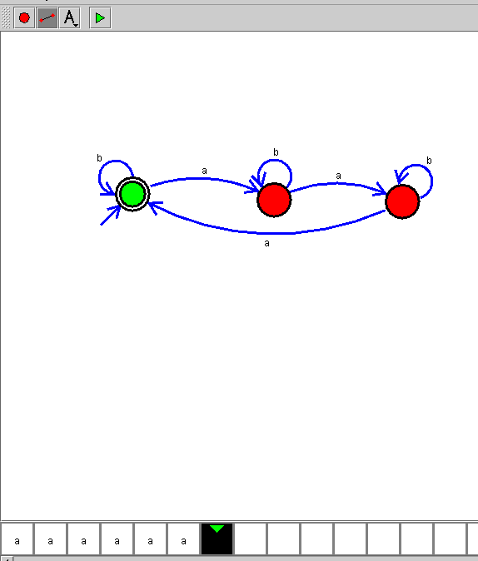

RESULT
Thus, the DFA for accepting strings in which a's appear only in groups of three over {a,b} was successfully designed and simulated.

