33. Design NFA Using Simulator to Accept Strings That Start with a and End with b
AIM
To design and simulate a Nondeterministic Finite Automaton (NFA) that accepts strings which start with a and end with b over the alphabet {a,b}, and to check whether W = abaab is accepted.
PROCEDURE
- Open the NFA simulator.
- Define the input alphabet as {a,b}.
- Create three states: q0, q1, and q2.
- Make q0 the initial state.
- Make q2 the final state.
- From q0, on a, move to q1.
- From q1, on a or b, remain in q1.
- From q1, on b, also move to q2.
- From q2, no further transition is required for this input.
- Enter W = abaab in the simulator.
- Run the NFA and check the final state.
- If the input reaches q2, the string is accepted.
ALGORITHM
- Start at q0.
- The first symbol must be a.
- Move from q0 to q1 on a.
- Read the remaining symbols.
- Nondeterministically choose the last b to move to q2.
- If the input ends in q2, accept the string.
- Otherwise, reject the string.
NFA TRANSITION TABLE
Current State | Input a | Input b
→ q0 | q1 | —
q1 | q1 | q1, q2
★ q2 | — | —
q0 = Initial State
q2 = Final State
INPUT
W = abaab
STATE TRANSITIONS
q0 --a--> q1
q1 --b--> q1
q1 --a--> q1
q1 --a--> q1
q1 --b--> q2
Final State
q2
OUTPUT
Accepted
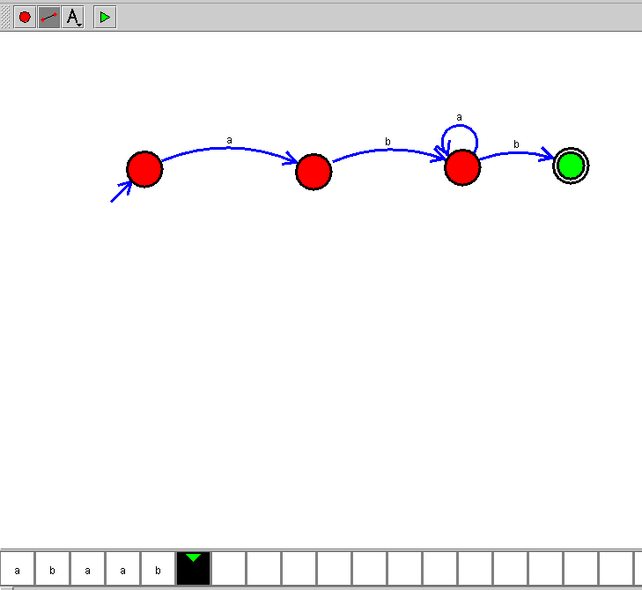

RESULT
Thus, the NFA for accepting strings that start with a and end with b was successfully designed and simulated. The input string W = abaab is Accepted.

