34. Design NFA Using Simulator to Accept Strings That Start and End with Different Symbols
AIM
To design and simulate a Nondeterministic Finite Automaton (NFA) that accepts strings whose first and last symbols are different over the alphabet {a,b}.
PROCEDURE
- Open the NFA simulator.
- Define the input alphabet as {a,b}.
- Create five states: q0, q1, q2, q3, and q4.
- Make q0 the initial state.
- Make q3 and q4 the final states.
- From q0, on a, move to q1.
- From q0, on b, move to q2.
- From q1, on a or b, remain in q1.
- From q1, on b, move to q3.
- From q2, on a or b, remain in q2.
- From q2, on a, move to q4.
- Enter the required input string in the simulator.
- Run the NFA and check the final state.
- If the string ends in a final state, it is accepted.
ALGORITHM
- Start at q0.
- If the first symbol is a, move to q1.
- If the first symbol is b, move to q2.
- For a string starting with a, accept if the last symbol is b.
- For a string starting with b, accept if the last symbol is a.
- If the first and last symbols are the same, reject the string.
NFA TRANSITION TABLE
Current State | Input a | Input b
→ q0 | q1 | q2
q1 | q1 | q1, ★q3
q2 | q2, ★q4 | q2
★q3 | — | —
★q4 | — | —
q0 = Initial State
q3, q4 = Final States
INPUT
W = aab
STATE TRANSITIONS
q0 --a--> q1
q1 --a--> q1
q1 --b--> q3
Final State
q3
OUTPUT
Accepted
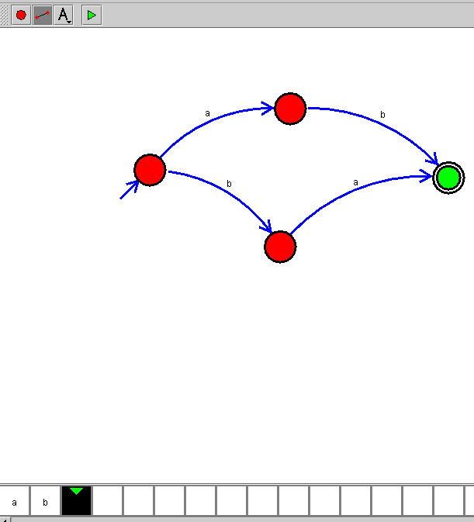
RESULT
Thus, the NFA for accepting strings whose first and last symbols are different over {a,b} was successfully designed and simulated. The input string W = aab is Accepted.

