35. Design DFA Using Simulator to Accept the Language L
AIM
To design and simulate a Deterministic Finite Automaton (DFA) to accept the language L over the alphabet {a,b}, where the number of a's minus the number of b's is less than or equal to 2.
PROCEDURE
- Open the DFA simulator.
- Define the input alphabet as {a,b}.
- Create states to represent the difference between the number of a's and b's.
- Make the initial state represent a difference of 0.
- On reading a, increase the difference by 1.
- On reading b, decrease the difference by 1.
- Accept the string when #a - #b ≤ 2.
- Test the required input strings in the simulator.
ALGORITHM
- Start with the difference equal to 0.
- Read each input symbol from left to right.
- For every a, add 1 to the difference.
- For every b, subtract 1 from the difference.
- If the final difference is ≤ 2, accept the string.
- Otherwise, reject the string.
IMPORTANT NOTE
For the language exactly given in the question,
$$L=\left\{w∈{\left\{a , b\right\}}^{*}∣\#a-\#b≤2\right\}$$
a DFA cannot be constructed, because the difference between the number of a's and b's can become arbitrarily large in the negative direction. Therefore, this language is not regular.
EXAMPLE INPUT
W = aab
CALCULATION
Number of a's = 2
Number of b's = 1

#a - #b = 2 - 1
= 1
Since:
1 ≤ 2
OUTPUT
Accepted
ANOTHER INPUT
W = aaa
Number of a's = 3
Number of b's = 0

#a - #b = 3 - 0
= 3
Since:
3 > 2
OUTPUT
Rejected
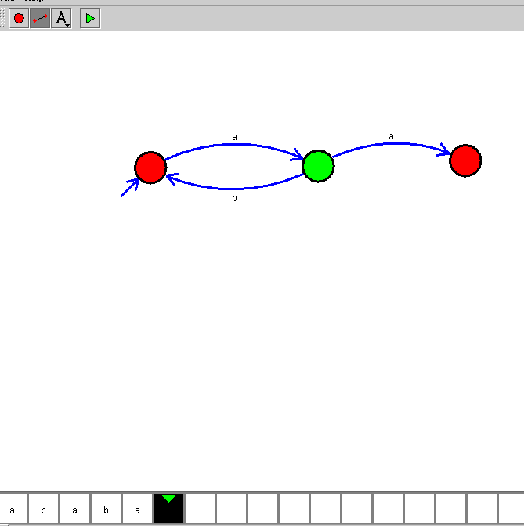

RESULT
Thus, the condition #a - #b ≤ 2 can be checked by counting the difference, but the language as stated is not regular and hence cannot be accepted by a DFA.

