CERTEX: A Complexity-Certifying Compiler for Regular Expressions with Static ReDoS Analysis and Runtime Enforcement

Voturi Aditya
Vellore Institute of Technology
Vellore, Tamil Nadu, India.
voturi.aditya2024@vitstudent.ac.in

Thamminaina Chandana Priya
Vellore Institute of Technology
Vellore, Tamil Nadu, India.
thamminaina.chanda2024@vitstudent.ac.in

Rohith Pranov V
Vellore Institute of Technology
Vellore, Tamil Nadu, India.
rohithpranov.v2024@vitstudent.ac.in
Abstract
Regular-expression denial of service (ReDoS) occurs when adversarial inputs cause regular-expression engines to exhibit exponential or high-polynomial matching times. Existing detection approaches based on execution-time measurements and structural heuristics can produce false negatives and false positives, while static detection alone does not enforce safe execution at runtime.
This paper presents CERTEX, a complexity-certifying compiler for regular expressions that combines static analysis with runtime enforcement. Within its supported syntax, CERTEX analyzes patterns using fine-grained complexity classification, ambiguity analysis for detecting potentially exploitable exponential and polynomial behavior, and a tractability check for backreferences. It also incorporates engine-specific pattern rewriting, selects an appropriate non-backtracking matching kernel, and generates an HMAC-SHA256-signed certificate containing the complexity classification, selected kernel, and execution-step budget. A runtime governor verifies the certificate and enforces the budget during matching.
Evaluation on 43 labelled ReDoS patterns achieved 100% accuracy under the CPython profile, compared with 44.2% for a timing-based baseline and 65.1% for a star-height heuristic. Fine-grained type inference correctly classified all 252 generated patterns, while differential testing across 64,800 cases reported no disagreements with Python's re module. On six selected attack patterns, CERTEX completed matching in approximately 12 microseconds, compared with 0.5–1.3 seconds for CPython. Evaluation on a public corpus of 63,352 PyPI patterns identified 6,448 potentially vulnerable patterns among 50,567 analyzed patterns; 295 of 300 sampled flagged patterns were confirmed slow on CPython. Results also reveal limitations in syntax coverage and cross-engine attack reproduction, particularly for Java. These findings demonstrate the potential of combining static complexity analysis with certificate-based runtime enforcement to mitigate ReDoS within the supported syntax and execution model.
Keywords— Regular-expression denial of service, ReDoS, static analysis, ambiguity analysis, fine-grained complexity, complexity certification, runtime enforcement, non-backtracking matching.

I. INTRODUCTION
1.1 Background
Regular expressions are widely used in input validation, web routing, log processing, parsing, and security filtering. However, regular-expression engines that rely on backtracking can exhibit excessive matching times when processing specially crafted inputs. This vulnerability, known as regular-expression denial of service (ReDoS), can allow an attacker to consume substantial computational resources through a single input.
For example, the pattern (a+)+$ can trigger exponential matching behavior when presented with a long sequence of a characters followed by a character that prevents a match. The engine repeatedly explores alternative matching paths before determining that the input is invalid. Consequently, even relatively short inputs can cause significant delays, potentially affecting the availability of applications that process untrusted input.
Empirical studies have demonstrated the prevalence of ReDoS vulnerabilities in software ecosystems, including npm and PyPI packages, as well as their impact on web servers [2], [14]. These findings highlight the need for techniques that can identify vulnerable patterns and prevent excessive matching costs during execution.
1.2 Motivation and Research Gap
Existing approaches to ReDoS mitigation include execution-time testing, structural heuristics, static analysis, and runtime protection. Timing-based approaches attempt to identify vulnerabilities by measuring matching time on selected inputs. However, their effectiveness depends on the tested inputs, the execution environment, and the behavior of the target regular-expression engine. For example, GNU grep -E uses automata-based matching behavior that does not reproduce the backtracking-related performance problems being investigated, making it unsuitable as a direct timing proxy for such vulnerabilities.
Structural heuristics, such as star-height-based classification, provide another means of identifying potentially problematic patterns. However, these approaches may miss vulnerable patterns or flag patterns that do not exhibit exploitable slow matching. Static analyses based on automata ambiguity can provide stronger evidence of potential complexity problems, but identifying a vulnerability does not, by itself, guarantee that matching will execute within a controlled computational budget.
These limitations motivate an approach that combines pattern analysis with runtime enforcement. Such an approach must account for the target engine's pattern transformations, distinguish potentially exploitable matching behavior from ambiguity that does not lead to an exploitable failure, and ensure that matching is performed under a controlled execution budget.
1.3 Objectives and Contributions
This work presents CERTEX, a complexity-certifying compiler for regular expressions that combines static complexity analysis, engine-aware processing, and runtime enforcement. Its objective is to classify patterns before matching, generate a verifiable certificate describing the selected execution strategy, and enforce a step budget during execution.
The main contributions are as follows:
- Fine-grained complexity classification: The system applies complexity classification based on the results of Backurs and Indyk [3] and Bringmann, Grønlund, and Larsen [4] to distinguish different classes of regular-expression matching behavior.
- Exploitability-aware ambiguity analysis: The system analyzes automata ambiguity to identify potential exponential and polynomial matching behavior and synthesizes attack witnesses. A rejecting-suffix analysis further distinguishes exploitable ambiguity from cases that can be classified as linear under the supported model, building on established ambiguity-based analyses [10]–[12], [17].
- Engine-aware pattern processing: The system incorporates engine-specific pattern transformations before analysis to account for differences between the original pattern and the form processed by the target engine.
- Complexity certification and runtime enforcement: The compiler generates an HMAC-SHA256-signed certificate containing the complexity classification, selected matching kernel, and execution-step budget. A runtime governor verifies the certificate and enforces the budget while executing matches using non-backtracking kernels, with fallback or rejection handling as appropriate.
- Experimental evaluation: The system is evaluated using labelled ReDoS patterns, generated patterns for complexity classification, differential tests against Python's re module, attack-string benchmarks, cross-engine replay experiments, and a public PyPI pattern corpus. The evaluation examines detection accuracy, semantic agreement, runtime performance, and limitations across engines.
1.4 Scope and Assumptions
CERTEX targets a defined subset of regular-expression syntax and focuses on matching semantics compatible with Python's re module for ASCII text. Its analysis and runtime guarantees apply within the supported syntax and execution model; unsupported constructs are rejected rather than treated as verified safe patterns. The system includes a tractability check for backreferences and uses non-backtracking matching kernels to enforce controlled execution.
The analysis pipeline applies engine-specific processing before subsequent transformations and static analyses. It constructs automata for ambiguity analysis, subject to configured state and time limits. If an analysis exceeds its limits, the result is classified as unknown rather than being treated as safe.
The evaluation considers CPython, PCRE2, and Java to examine how engine-specific behavior affects attack reproduction and the effectiveness of the analysis. However, the implementation does not provide equally comprehensive engine-specific rewriting for all three engines. The results are therefore interpreted in the context of the supported syntax, implemented engine profiles, and experimental conditions.

II. LITERATURE REVIEW
2.1 Empirical Studies of ReDoS
Empirical studies have established regular-expression denial of service (ReDoS) as a practical security concern in software ecosystems. Research on npm and PyPI packages has identified vulnerable regular expressions in real-world software and highlighted the difficulty of ensuring that such vulnerabilities are addressed [2]. Studies of JavaScript web servers have also demonstrated the potential for exploitable ReDoS vulnerabilities to affect application availability [14]. These findings motivate the need for reliable techniques to identify vulnerable patterns before they can be exploited.
Although empirical studies establish the prevalence and practical impact of ReDoS, they do not necessarily provide a formal complexity classification for each pattern or guarantee bounded execution during matching. CERTEX addresses these limitations by combining static pattern analysis with a runtime mechanism that enforces a configured execution-step budget.
2.2 Static Detection Based on Automata Ambiguity
Automata-based static analysis provides a theoretical foundation for examining the computational cost of regular-expression matching. Previous work has investigated the relationship between ambiguity in nondeterministic finite automata (NFAs) and the number of execution paths explored by backtracking matchers [10]–[12], [17]. In particular, exponential-degree ambiguity (EDA) is associated with exponential matching behavior, while infinite-degree ambiguity (IDA) is associated with polynomial matching behavior under the relevant analysis model [10]. Related approaches have also explored automated vulnerability detection and attack generation based on ambiguity analysis [11].
These techniques provide stronger theoretical foundations than approaches based exclusively on syntactic features. However, identifying ambiguity does not necessarily establish that a particular input can exploit it to produce costly matching behavior under a target engine's execution semantics.
CERTEX builds on ambiguity-based analysis by incorporating engine-specific pattern processing and a rejecting-suffix search. The search is intended to distinguish potentially exploitable ambiguity from patterns that can be classified as linear under the supported analysis model. When the analysis cannot establish a result within its configured limits, the system reports an unknown result rather than treating the pattern as verified safe.
2.3 Dynamic Detection and Fuzzing Approaches
Dynamic detection approaches attempt to demonstrate ReDoS by generating inputs that cause unusually long matching times. Search-based techniques such as ReScue [13] generate candidate attack strings and evaluate them through execution. Such approaches can provide concrete evidence of vulnerability for a particular pattern and engine. However, failure to discover a slow input does not prove that no such input exists, since the outcome depends on the search strategy, input space, engine implementation, and experimental conditions.
CERTEX uses dynamic testing to supplement static analysis, including validation of selected linear-time classifications in experiment E1b. These tests serve as empirical checks rather than a substitute for static reasoning and do not establish correctness for every possible input.
Runtime mitigation provides a complementary direction. Selective memoization has been investigated as a means of reducing repeated work during regular-expression matching [18]. This approach mitigates excessive computation by changing the matcher's execution behavior. In contrast, CERTEX focuses on analyzing the pattern, selecting an eligible matching kernel, generating a certificate, and enforcing a configured step budget during execution.
2.4 Fine-Grained Complexity of Regular-Expression Matching
Fine-grained complexity theory provides a basis for distinguishing regular-expression patterns according to their theoretical matching costs. Conditional lower-bound results based on the Strong Exponential Time Hypothesis (SETH) identify important distinctions among classes of regular-expression matching problems [3]. Further work developed this complexity classification into a dichotomy for the pattern classes considered in the theoretical model [4].
These results help distinguish patterns with different theoretical complexity characteristics. Nevertheless, a theoretical classification does not by itself implement a compiler, account for every target engine's preprocessing behavior, or enforce a runtime resource limit.
CERTEX incorporates this line of research into its fine-grained type-inference module (M2). The module classifies patterns within the supported model and uses the resulting classification as an input to subsequent analysis and certificate generation. This integration connects theoretical complexity results to practical decisions in the compiler pipeline while retaining the assumptions and limitations of the underlying model.
2.5 Non-Backtracking Matching and Backreferences
Non-backtracking matching provides an alternative to exploring potentially large numbers of execution paths. Thompson's NFA simulation [5] provides a foundational approach whose matching time is proportional to the product of the input length and automaton size. Further discussion of practical automata-based matching has highlighted its advantages over backtracking implementations for suitable pattern classes [9].
Other established techniques support efficient matching for specific representations and workloads. Glushkov-automaton simulation [6], bit-parallel matching methods such as Shift-And [7], and multi-pattern matching algorithms such as Aho–Corasick [8] illustrate different approaches to efficient pattern processing. Their applicability depends on the pattern representation, supported operations, and required matching semantics; they are not interchangeable for every regular-expression construct.
Backreferences introduce additional complexity because a pattern can refer to text captured by an earlier group. Regular-expression matching with backreferences is NP-hard in general [15], [16]. Consequently, a non-backtracking kernel cannot be assumed to preserve the behavior of every pattern containing backreferences without additional analysis or restrictions.
CERTEX addresses this issue through a backreference tractability gate (M4a), which evaluates supported backreference usage against configured limits. Its kernel-selection module (M4b) then selects an eligible non-backtracking matching strategy. Constructs outside the supported model, or cases that exceed configured limits, are rejected or reported as unsupported rather than being granted an unconditional safety guarantee.
2.6 Research Gap and Positioning
The reviewed literature addresses complementary aspects of ReDoS mitigation. Empirical studies establish the prevalence and practical impact of vulnerable patterns [2], [14]. Ambiguity-based analyses provide a theoretical foundation for static detection [10]–[12], [17], while dynamic search approaches attempt to discover concrete attack inputs [13]. Fine-grained complexity results distinguish classes of regular-expression matching problems [3], [4], and non-backtracking algorithms provide alternative execution strategies [5]–[9]. Runtime memoization offers another direction for mitigating excessive matching costs [18].
These approaches provide important foundations, but detection, complexity classification, and runtime protection address different parts of the problem. Static analysis alone does not enforce a runtime bound, while the use of an alternative matching kernel requires attention to supported syntax and matching semantics.
CERTEX integrates engine-aware pattern processing, fine-grained complexity classification, ambiguity and exploitability analysis, backreference tractability checks, non-backtracking kernel selection, and certificate-based runtime enforcement into a single pipeline. Its intended contribution is this integration: the compiler generates a certificate describing the selected execution strategy and configured step budget, and the runtime governor verifies the certificate and enforces the budget for supported patterns.
The contribution should therefore be understood as a system-level integration rather than a claim that each underlying technique is new. Its guarantees are limited to the implemented syntax, engine profiles, and analysis bounds. The following sections evaluate the system's detection performance, matching behavior, and limitations under these conditions.

Table 1. Summary of Reviewed Prior Art and Point of Departure of CERTEX
Prior art / related work | Point of departure of CERTEX
Base-paper `grep -E` timing classifier | Linear-time automata-based matching in `grep -E` cannot directly represent the backtracking cost of the target engine. CERTEX performs static analysis and uses target-engine execution for empirical confirmation where appropriate.
Star-height and syntactic heuristics | Syntactic heuristics may miss vulnerable patterns or produce false positives. CERTEX uses ambiguity analysis and additional exploitability checks.
Ambiguity analyses [10]–[12], [17] | Existing work provides ambiguity-based analysis. CERTEX adds engine profiles, rejecting-suffix analysis, kernel selection, and an enforced runtime budget.
Dynamic attack search (ReScue [13]) | Search-based testing can discover concrete attacks, but failure to find one does not prove that attacks are absent. CERTEX supplements static analysis with dynamic validation.
Runtime memoization [18] | Memoization mitigates repeated work by changing matcher execution. CERTEX combines pattern analysis and certification with selected kernels and runtime-budget enforcement.
SETH-based fine-grained complexity results [3], [4] | Theoretical results classify pattern families. CERTEX incorporates this classification into its M2 module and certification pipeline.
Non-backtracking algorithms [5]–[9] | Existing algorithms provide efficient matching strategies for suitable representations. CERTEX integrates kernel selection with syntax checks and runtime governance.
The table summarizes the distinction between the reviewed approaches and the integration targeted by CERTEX. It does not imply that every prior system lacks all related capabilities.

3. PROPOSED SYSTEM
CERTEX is a complexity-certifying compiler for regular expressions designed to identify potentially exploitable matching behavior and enforce controlled execution. The proposed system integrates static analysis, engine-specific pattern processing, matching-kernel selection, certificate generation, and runtime enforcement into a single pipeline.
The system analyzes a regular expression before matching, selects an eligible non-backtracking matching kernel, and generates a signed certificate containing the analysis results, selected kernel, and execution-step budget. During matching, a runtime governor verifies the certificate and monitors execution against the configured budget.
The proposed system is organized into four modules: (1) front-end processing and engine profiles, (2) fine-grained complexity classification, (3) ambiguity analysis and attack synthesis, and (4) backreference handling, kernel selection, certificate generation, and runtime enforcement.
System Architecture
CERTEX follows a compile-time and runtime architecture. During compile time, the input regular expression is parsed into an intermediate representation (IR), processed using the selected engine profile, and normalized for subsequent analysis. The normalized pattern is passed to the complexity-classification, ambiguity-analysis, and backreference-checking components. Their outputs are used to select an eligible matching kernel and generate a signed certificate.
During runtime, the governor verifies the certificate, executes the selected kernel, and tracks the execution steps against the configured budget. If certificate verification fails, execution is rejected. If the execution budget is exceeded, the governor follows the implemented fallback or rejection policy.
Architecture diagram:
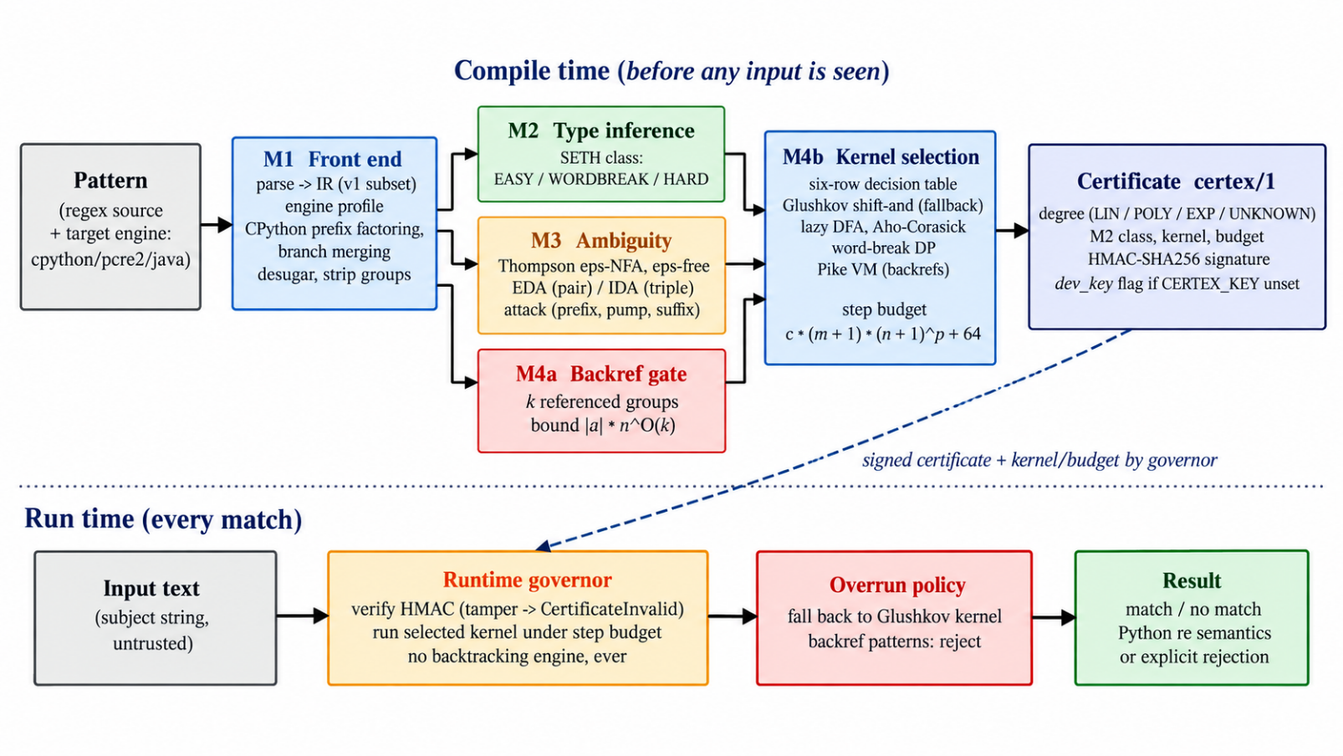

The overall workflow is:
Input Regular Expression → Front-End Processing and Engine Profiles → Fine-Grained Complexity Classification and Ambiguity Analysis → Backreference Tractability Check → Kernel Selection → Certificate Generation → Certificate Verification → Governed Matching.
3.1 Module 1: Front End and Engine Profiles
The front end parses the input regular expression, validates its syntax, and converts it into an intermediate representation suitable for static analysis. CERTEX supports a defined subset of regular-expression syntax and rejects unsupported constructs rather than treating them as verified safe patterns.
The engine-profile component applies supported transformations associated with the selected regular-expression engine. This step is important because an engine may simplify or combine pattern alternatives before matching, potentially changing the performance characteristics relevant to static analysis.
The implemented CPython profile reproduces selected parsing-time transformations, including factoring common prefixes and merging suitable single-character and character-class alternatives. For example, the pattern (0|[0-9])+$ can be simplified under the CPython profile because the alternatives can be represented by a common character class. The current PCRE2 and Java profiles are identity profiles and do not implement equivalent engine-specific rewriting.
After profile processing, the pattern undergoes desugaring and group handling to produce a normalized representation. This representation is supplied to the subsequent analysis components.
3.2 Module 2: Fine-Grained Complexity Classification
This module classifies the structure of a regular expression according to the fine-grained complexity model incorporated into CERTEX, based on established theoretical results [3], [4]. The resulting classification contributes to the selection of a suitable matching kernel.
The module converts the pattern into an operator-type string over the alphabet ({o, |, , +}), where (o) represents concatenation, (|) represents alternation, and () and (+) represent repetition operators. It simplifies this representation using predefined normalization rules and assigns a class according to the implemented classification procedure.
The supported classification includes EASY, WORDBREAK, HARD, and GENERAL categories. The simplified operator structure and resulting class are recorded as part of the compiler's analysis output. Where applicable, a hard-core witness is also generated to support the classification.
The classification is not used in isolation. It is considered alongside the ambiguity-analysis result and backreference status during kernel selection. Its purpose is to provide structural complexity information before matching rather than relying exclusively on measured execution times.
3.3 Module 3: Ambiguity Analysis and Attack Synthesis
The ambiguity-analysis module examines the automaton corresponding to the normalized regular expression to identify alternative matching paths that may cause excessive computation in backtracking engines. It constructs a Thompson epsilon-NFA and converts it into a path-preserving epsilon-free NFA for subsequent analysis.
The module searches for exponential-degree ambiguity (EDA) and infinite-degree ambiguity (IDA). EDA is associated with potential exponential matching behavior, while IDA is associated with potential polynomial matching behavior under the analysis model [10]–[12], [17].
When relevant ambiguity is detected, the module attempts to synthesize an attack witness represented by a prefix, pump, and suffix. Repeating the pump can increase the number of matching paths explored, while the suffix completes the input needed to exercise the relevant behavior. The witness can subsequently be used to evaluate whether the predicted behavior is reproduced by a target engine.
Since ambiguity alone does not establish that an exploitable slow match exists, CERTEX also performs a rejecting-suffix search. If the analysis establishes that the ambiguity cannot be exploited under the supported model, the pattern may be classified as linear with an unexploitable-ambiguity indication. The implementation limits epsilon-path enumeration to 5,000 paths, the rejecting-suffix search to 20,000 states, and the analysis deadline to two seconds. If an analysis exceeds its limits, the result is reported as unknown rather than being treated as safe.
Pseudocode 1: Ambiguity Analysis and Attack Synthesis
Algorithm: AnalyzeAmbiguity(pattern)
Input: Normalized regular expression
Output: Degree, attack witness, and analysis status
1. Construct a Thompson epsilon-NFA from pattern.
2. Convert it into a path-preserving epsilon-free NFA,
subject to the configured path limit.
3. If conversion exceeds the limit:
return UNKNOWN.
4. Search the automaton's pair product for EDA.
5. If EDA is detected:
attempt to synthesize (prefix, pump, suffix).
return EXP with the witness, if available.
6. Search the automaton's triple product for IDA.
7. If IDA is detected:
attempt to synthesize (prefix, pump, suffix).
return POLY with the witness, if available.
8. Search for a rejecting suffix that can expose the relevant ambiguity.
9. If the analysis establishes that the ambiguity is unexploitable
under the supported model:
return LIN with unexploitable = true.
10. If a required search exceeds its state or time limit:
return UNKNOWN.
11. Return the classification established by the implemented analysis
and its corresponding status.
End Algorithm
The pseudocode summarizes the principal analysis stages. The actual classification and witness-generation behavior is determined by the implemented search procedures and their resource limits.
3.4 Module 4: Backreference Handling, Kernel Selection and Runtime Enforcement
This module connects the analysis results to the execution strategy. It combines backreference tractability checking, matching-kernel selection, certificate generation, and runtime enforcement.
Backreference tractability checking: Backreferences allow a pattern to refer to text previously captured by a group. Matching regular expressions with backreferences is NP-hard in general [15], [16]. CERTEX identifies the distinct referenced groups and evaluates the pattern against its supported tractability criteria. The implementation uses a conservative syntactic candidate test as an approximation of the full memory-determinism condition. Patterns outside the supported conditions are restricted or rejected according to the implemented policy.
Kernel selection: The system selects a matching kernel using the complexity degree, fine-grained complexity class, and backreference status. The available strategies include bit-parallel Glushkov Shift-And matching, lazy DFA matching, Aho–Corasick matching, a word-break dynamic programming algorithm, and a Pike virtual machine with backreference support. The Glushkov-based kernel also serves as a fallback strategy. Kernel eligibility depends on the supported pattern features and the compiler's selection rules.
Certificate generation: After selecting the kernel, CERTEX calculates an execution-step budget using its configured budget model:
[
B(m,n)=8(m+1)(n+1)^p+64
]
where (m) denotes the pattern size, (n) denotes the subject-input length, and (p) is the polynomial degree used in the budget calculation.
The compiler generates a certificate using the certex/1 schema. It records the complexity degree, classification, selected kernel, budget information, and an attack witness when one is available. The certificate fields are signed using HMAC-SHA256 [21]. The signing key must be configured appropriately; the development-key mode indicated by the implementation is not a production security configuration.
Runtime enforcement: Before matching, the runtime governor recomputes and verifies the certificate signature. If verification fails, it rejects the request. Otherwise, it runs the selected kernel while counting execution steps. If the budget is exceeded, the governor attempts the implemented Glushkov-based fallback or rejects the request. Backreference-containing patterns are rejected on budget overrun.
This design makes the certificate an input to runtime policy enforcement rather than merely a report of a static warning. Its guarantees depend on the correctness of the analysis, the integrity of certificate verification, and the behavior of the selected and fallback kernels.
Pseudocode 2: Certificate-Based Kernel Selection and Governed Matching
Algorithm: CompileAndMatch(pattern, input, profile)
Input: Regular expression, subject input, engine profile
Output: Match result or explicit rejection
COMPILE-TIME PHASE
1 Parse pattern and validate supported syntax.
2 Apply the selected engine profile.
3 Normalize the pattern.
4 Compute its fine-grained complexity classification.
5 Perform ambiguity analysis and obtain a witness
when one can be established.
6 Check backreference tractability.
7 Select an eligible kernel using the analysis results.
8 Calculate the configured execution-step budget.
9 Generate the certificate containing the analysis
results, kernel, budget, and optional witness.
10 Sign the certificate fields using HMAC-SHA256.
RUNTIME PHASE
11 Verify the certificate signature.
12 If verification fails:
reject the request.
13 Execute the selected kernel while counting steps.
14 If matching completes within the budget:
return the match result.
15 If the budget is exceeded:
if the pattern contains backreferences:
reject the request.
otherwise, attempt the implemented
Glushkov-based fallback or reject.
End Algorithm
The proposed system integrates static analysis and runtime control into a single workflow. Its contribution is the combination of complexity classification, ambiguity analysis, engine-aware processing, kernel selection, signed certification, and execution-budget enforcement for patterns within the supported syntax and execution model.

4. RESULTS AND IMPLEMENTATION
This section presents the implementation and experimental evaluation of CERTEX. The evaluation examines supported input patterns, fine-grained complexity classification, ambiguity-based vulnerability detection, matching-kernel selection, and runtime enforcement. The experiments use generated patterns, labelled ReDoS examples, a public PyPI pattern corpus, and differential tests against Python's re module.
4.1 Dataset Description
CERTEX was evaluated using multiple datasets designed to test different aspects of the proposed system. These include labelled patterns for vulnerability detection, generated patterns for complexity classification, patterns from the baseline study, a public corpus of regular expressions, and test cases for checking matching-semantic compatibility.
Table 2. Summary of Evaluation Datasets
Dataset | Description | Size | Evaluation purpose
D1 | Labelled regular expressions categorized as EXP, POLY, or LIN | 43 patterns | ReDoS detection and baseline comparison
D2 | Generated regular expressions with expected complexity classes | 252 patterns | Fine-grained complexity classification
D5 | Regular expressions selected from the base paper | 9 patterns | Examination of baseline patterns under CERTEX
Public PyPI corpus | Unique regular-expression patterns collected from PyPI packages | 63,352 patterns | Large-scale analysis and validation of flagged patterns
Differential test set | Inputs evaluated against Python's re module through the CERTEX governor | 64,800 cases | Checking matching-semantic agreement
Dataset D1 contains 14 EXP, 10 POLY, and 19 LIN patterns. D2 contains 201 EASY, 45 HARD, and 6 WORDBREAK patterns. The public corpus includes patterns outside the supported syntax; these are classified as unsupported and are not counted as successful classifications. Additional experiments include attack-string replay on six selected patterns and cross-engine replay using CPython, PCRE2, and Java.
4.2 Module 1: Front End and Engine Profiles
The front end parses regular expressions into an intermediate representation, validates supported syntax, and applies the selected engine profile before static analysis. The implementation supports a defined syntax subset and rejects unsupported constructs. The CPython profile applies selected pattern transformations, including prefix factoring and suitable alternative merging. The effect of these transformations was evaluated using the labelled D1 dataset.
Table 3. Effect of Engine Profiles on D1 Detection
Configuration | True positives | False positives | False negatives | True negatives | Accuracy
CERTEX without engine profile | 24 | 1 | 0 | 18 | 97.67%
CERTEX with CPython profile | 24 | 0 | 0 | 19 | 100%
Inference. Without engine-specific transformations, CERTEX identified all 24 vulnerable patterns but incorrectly flagged one pattern, (0|[0-9])+$, which CPython simplifies into a linear single-character-class loop. With the CPython profile enabled, the false positive disappeared and all 43 patterns were classified consistently with the dataset labels. This result demonstrates the importance of accounting for target-engine transformations before analyzing pattern complexity.
4.3 Module 2: Fine-Grained Complexity Classification
The fine-grained complexity-classification component assigns a class to each supported pattern using the implemented operator-type simplification and classification rules. Its performance was evaluated on D2, a generated dataset with known expected classes.
Table 4. Fine-Grained Complexity Classification Results
Complexity class | Patterns | Correct classifications | Recall
EASY | 201 | 201 | 100%
HARD | 45 | 45 | 100%
WORDBREAK | 6 | 6 | 100%
Total | 252 | 252 | 100%
Inference. The classifier correctly assigned all 252 generated patterns to their expected classes. This indicates that the implemented simplification and classification rules were consistent with the generator's labelling procedure. However, D2 was generated using the same grammar and rules that informed the implementation. The result therefore validates the implementation against its defined test model; it does not independently prove the theoretical classification or establish perfect accuracy on arbitrary real-world patterns.
4.4 Module 3: Ambiguity Analysis and Attack Synthesis
The ambiguity-analysis component examines automata to identify exponential-degree and infinite-degree ambiguity and attempts to synthesize attack witnesses. Detection performance was evaluated on D1, and synthesized attacks were replayed against CPython. The table below reports six selected attack cases; timings are machine-dependent.
Table 5. Attack-String Runtime Comparison
Pattern | Input length | CPython time | CERTEX time | CERTEX steps
(a+)+$ | 25 | 0.538 s | 13.13 µs | 25
(a|a)*$ | 24 | 0.531 s | 12.04 µs | 24
(\w+\s?)*$ | 25 | 0.986 s | 11.63 µs | 25
(x+x+)+y | 25 | 0.725 s | 11.71 µs | 25
^([a-z0-9]+[-_.?])*[a-z0-9]+@ | 23 | 0.508 s | 12.25 µs | 23
(a|aa)+$ | 36 | 1.278 s | 12.33 µs | 36
Inference. The selected attack inputs caused CPython to take approximately 0.5–1.3 seconds despite their relatively short lengths. CERTEX completed the corresponding matches in approximately 12 microseconds, with the recorded step count equal to the input length in each case. These results demonstrate the benefit of the selected non-backtracking kernels for the evaluated inputs. The six patterns form a selected sample, however, and the measured speed ratios should not be generalized to all regular expressions.
Standalone ambiguity-analysis metrics (for example, EDA/IDA precision and recall on an independently labelled ambiguity dataset): N/A — requires an additional experiment and should be filled in after running that evaluation.
4.5 Module 4: Backreference Handling, Kernel Selection and Runtime Enforcement
This module integrates backreference tractability checking, kernel selection, certificate generation, and runtime enforcement. The available results cover differential testing, automated tests, cross-engine attack replay, and large-scale corpus analysis. The report does not provide an independent accuracy metric for the backreference gate alone.
Table 6. Runtime and Large-Scale Evaluation Results
Evaluation | Result | Inference
Differential testing against Python re | 64,800 cases; 0 disagreements | No semantic differences were observed in the tested cases.
Automated test suite | 197 tests passed: 165 fast and 32 slow | The reported local test suite passed.
CPython attack replay | 24/24 attacks confirmed | All evaluated attacks reproduced on CPython.
PCRE2 attack replay | 15/24 as synthesized; 24/24 with required final literal retained | Replay depended on the attack suffix and engine pre-check behavior.
Java attack replay | 2/24 attacks confirmed | The engine's failed-start-position optimization reduced attack reproduction.
Public PyPI corpus | 63,352 total; 50,567 analyzed; 6,448 flagged | The system analyzed the supported subset and flagged patterns for further attention.
Replay of flagged PyPI patterns | 295/300 confirmed slow; estimated precision 98.33% | Precision is an estimate from the sampled flagged patterns.

Inference. The differential test compared the CERTEX governor with Python's re module across full-match, match, and search operations, with 21,600 cases per operation. No disagreements were observed in the 64,800 cases. The public-corpus experiment analyzed 50,567 supported patterns, of which 6,448 were flagged as EXP or POLY. Of a sample of 300 flagged patterns replayed on CPython, 295 were confirmed slow, giving an estimated precision of approximately 98.33%. A separate fuzzing sample of 500 patterns classified as LIN did not produce a slow input, but this does not prove that every LIN pattern is safe.
Cross-engine replay confirms that attack reproduction depends on the target engine. All 24 attacks reproduced on CPython. PCRE2 reproduced 15 of 24 synthesized attacks, increasing to 24 of 24 when the required final literal was retained. Java reproduced 2 of 24 attacks, below the intended 95% calibration target; the report attributes this to the JDK's optimization of failed start positions. This result is reported as a limitation rather than a successful calibration.
The N/A entries identify measurements that are not established by the current report. They should remain marked N/A until the corresponding experiments are run; do not replace them with assumed values. For the certificate and fallback tests, report both the number of cases tested and the number that passed the expected behavior checks.

5. PERFORMANCE AND METRICS
This section compares CERTEX with the existing detection approaches and summarizes the measured runtime and validation results. The comparisons use the reported D1 labelled dataset, D2 generated dataset, selected attack-string benchmarks, and public-corpus replay results. All reported timings are specific to the experimental environment and should not be interpreted as universal performance guarantees.
5.1 ReDoS Detection Accuracy: Existing and Proposed Methods
Detection accuracy was measured on D1, which contains 43 patterns: 24 vulnerable patterns labelled EXP or POLY and 19 LIN patterns. The base-paper timing classifier, star-height heuristic, and two CERTEX configurations were compared using the same labelled set.
Table 7. ReDoS Detection Performance on D1
Method | TP | FP | FN | TN | Accuracy | F1-score
Base-paper timing classifier (grep -E) | 0 | 0 | 24 | 19 | 44.19% | 0.0000
Star-height heuristic (≥ 2) | 11 | 2 | 13 | 17 | 65.12% | 0.5946
CERTEX without engine profile | 24 | 1 | 0 | 18 | 97.67% | 0.9796
CERTEX with CPython profile | 24 | 0 | 0 | 19 | 100.00% | 1.0000

Figure 1. ReDoS Detection Accuracy on D1
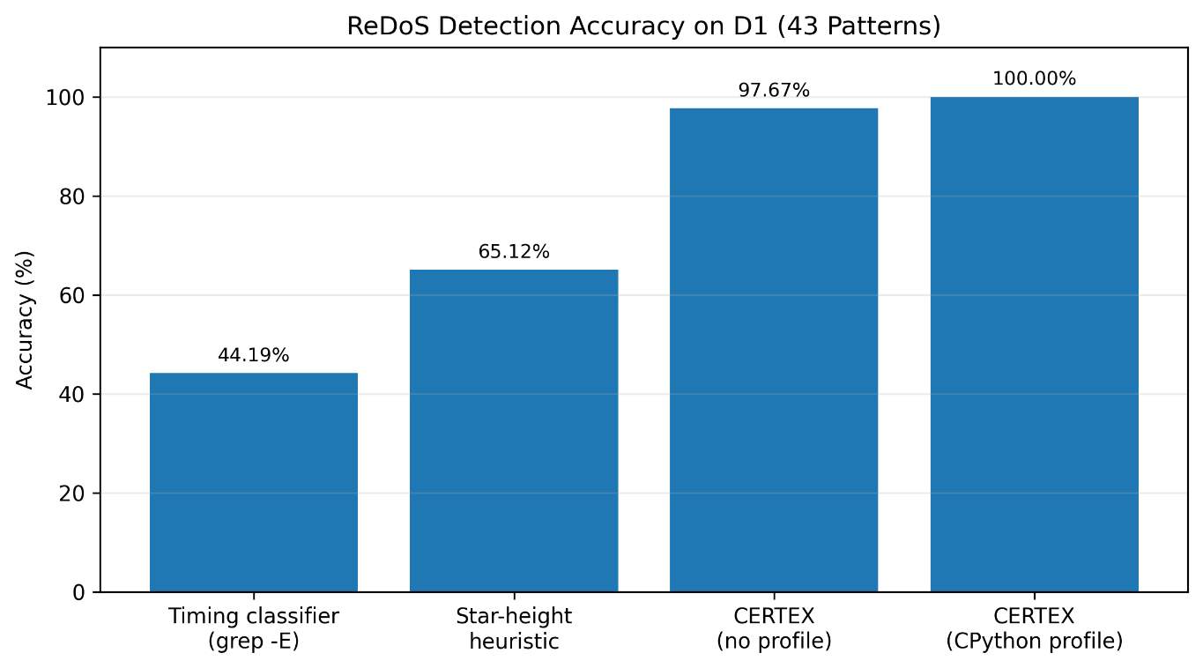
Inference. CERTEX with the CPython profile achieved 100% accuracy, identifying all 24 vulnerable patterns without false positives in D1. Without engine-specific rewriting, accuracy was 97.67%, with one false positive. The star-height heuristic achieved 65.12%, while the timing classifier achieved 44.19%. The timing baseline's low accuracy is consistent with the report's explanation that grep -E uses linear-time matching and therefore does not reproduce the backtracking costs being measured. The D1 result is strong evidence for this labelled set, but D1 was labelled by replay on CPython and is therefore not an independent proof of generalization to every engine.
5.2 Complexity Classification Performance
On D2, CERTEX classified all 252 generated patterns correctly: 201 EASY, 45 HARD, and 6 WORDBREAK. The observed accuracy and recall were 100% for the generated set. This supports consistency between the implemented rules and the dataset generator. Because the patterns were generated from the same grammar as the classification rules, the result should be interpreted as implementation validation, not as an independent proof of the theoretical classification.
5.3 Matching Runtime on Selected Attack Inputs
The six selected attack-string experiments compared CPython matching with the selected CERTEX kernel. CPython times ranged from approximately 0.508 to 1.278 seconds, whereas CERTEX times were approximately 11.63–13.13 microseconds.
Figure 2. Matching Time on Six Selected Attack Inputs (Logarithmic Scale)
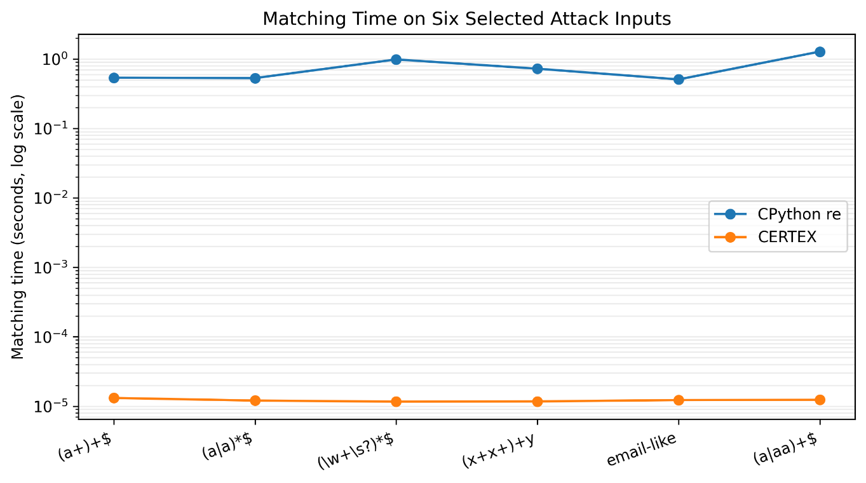
Inference. For these selected inputs, CERTEX completed matching substantially faster than CPython's backtracking engine. The reported speedups are machine-dependent and the patterns were selected from D1, so they should be presented as illustrative attack-case results rather than a general benchmark of benign workloads. The implementation report also notes that the pure-Python kernels can be slower than CPython's C engine on benign inputs; CERTEX targets controlled worst-case execution rather than maximum throughput.
5.4 Runtime Compatibility and Public-Corpus Evaluation
Table 8. Additional Performance and Validation Metrics
Metric | Measured result | Interpretation
Differential compatibility with Python re | 64,800 cases; 0 disagreements | No semantic disagreement in the tested ASCII/supported-syntax cases.
Public PyPI corpus analyzed | 50,567 of 63,352 patterns | 12,722 patterns were unsupported; unsupported syntax is not counted as a pass.
Patterns flagged EXP or POLY | 6,448 | Patterns identified for further attention under the CERTEX analysis.
Flagged-pattern replay sample | 295/300 confirmed slow; estimated precision 98.33% | Sample-based precision estimate, not a full-corpus measurement.
Cross-engine attack replay: CPython | 24/24 | All selected attacks reproduced.
Cross-engine attack replay: PCRE2 | 15/24 as synthesized; 24/24 with final literal retained | Attack reproduction depended on the required suffix.
Cross-engine attack replay: Java | 2/24 | Below the 95% calibration target; report attributes this to JDK optimization.

Inference. The differential test supports semantic compatibility for the tested cases, while the public-corpus evaluation demonstrates that CERTEX can analyze a large collection of patterns. The replay sample suggests high precision among flagged patterns, but the estimate is based on 300 sampled patterns. The cross-engine results reveal a limitation: attack witnesses do not reproduce uniformly across engines, especially Java. These results support the need for richer engine profiles and broader syntax coverage.
5.5 Overall Performance Assessment
Across the reported experiments, CERTEX combines high detection accuracy on D1, correct classification of the generated D2 patterns, zero disagreements in the differential test, and strong performance on the selected attack strings. These results support the proposed combination of static analysis and runtime enforcement within the implemented syntax subset and execution model. The principal limitations are the unsupported syntax share in the public corpus, incomplete engine-specific rewriting outside CPython, the low Java attack-replay rate, and the throughput cost of pure-Python kernels on benign inputs.
6. CONCLUSION
This paper presented CERTEX, a complexity-certifying compiler for regular expressions that combines engine-aware pattern processing, fine-grained complexity classification, ambiguity analysis, backreference tractability checking, matching-kernel selection, signed certificate generation, and runtime step-budget enforcement. The system is designed to identify potentially exploitable matching behavior before execution and to control matching through eligible non-backtracking kernels under a configured execution policy.
The experimental results show that CERTEX achieved 100% detection accuracy on the 43-pattern D1 dataset when the CPython profile was enabled, compared with 44.19% for the base-paper timing classifier and 65.12% for the star-height heuristic. It correctly classified all 252 generated D2 patterns, reported no disagreements across 64,800 differential cases against Python's re module, and confirmed 295 of 300 sampled flagged PyPI patterns as slow on CPython. In the selected attack-string experiments, CERTEX completed matching in roughly 12 microseconds, while CPython took approximately 0.5–1.3 seconds.
These findings must be interpreted within the system's limits. Approximately 20% of the public-corpus patterns used syntax outside the supported subset. The CPython profile includes selected rewrites, whereas the PCRE2 and Java profiles are identity profiles. Attack reproduction was also lower on Java than on CPython, and the pure-Python kernels prioritize controlled worst-case execution over throughput on benign inputs. The evaluation therefore supports CERTEX for the tested syntax and execution model rather than establishing universal guarantees for every regular-expression engine.
Future work includes extending syntax coverage, implementing more complete rewriting profiles for PCRE2 and Java, improving handling of negated character-class alternatives, replacing the conservative backreference candidate test with a full memory-determinism analysis, and porting performance-critical kernels to a compiled language. These improvements would broaden applicability and strengthen cross-engine validation.

REFERENCES
[1] P. Schepper, “Fine-Grained Complexity of Regular Expression Pattern Matching and Membership,” arXiv preprint arXiv:2008.02769v2, Sep. 2020. [Online]. Available: https://arxiv.org/abs/2008.02769v2.
[2] J. C. Davis, C. A. Coghlan, F. Servant, and D. Lee, “The impact of regular expression denial of service (ReDoS) in practice: An empirical study at the ecosystem scale,” in Proc. ESEC/FSE, 2018, pp. 246–256.
[3] A. Backurs and P. Indyk, “Which regular expression patterns are hard to match?” in Proc. IEEE FOCS, 2016, pp. 457–466.
[4] K. Bringmann, A. Grønlund, and K. G. Larsen, “A dichotomy for regular expression membership testing,” in Proc. IEEE FOCS, 2017, pp. 307–318.
[5] K. Thompson, “Regular expression search algorithm,” Communications of the ACM, vol. 11, no. 6, pp. 419–422, 1968.
[6] V. M. Glushkov, “The abstract theory of automata,” Russian Mathematical Surveys, vol. 16, no. 5, pp. 1–53, 1961.
[7] R. Baeza-Yates and G. H. Gonnet, “A new approach to text searching,” Communications of the ACM, vol. 35, no. 10, pp. 74–82, 1992.
[8] A. V. Aho and M. J. Corasick, “Efficient string matching: An aid to bibliographic search,” Communications of the ACM, vol. 18, no. 6, pp. 333–340, 1975.
[9] R. Cox, “Regular expression matching can be simple and fast,” 2007. [Online]. Available: https://swtch.com/~rsc/regexp/regexp1.html
[10] N. Weideman, B. van der Merwe, M. Berglund, and B. Watson, “Analyzing matching time behavior of backtracking regular expression matchers by using ambiguity of NFA,” in Proc. CIAA, Lecture Notes in Computer Science, vol. 9705, 2016, pp. 322–334.
[11] V. Wüstholz, O. Olivo, M. J. H. Heule, and I. Dillig, “Static detection of DoS vulnerabilities in programs that use regular expressions,” in Proc. TACAS, Lecture Notes in Computer Science, vol. 10206, 2017, pp. 3–20.
[12] A. Rathnayake and H. Thielecke, “Static analysis for regular expression exponential runtime via substructural logics,” arXiv preprint arXiv:1405.7058, 2014.
[13] Y. Shen, Y. Jiang, C. Xu, P. Yu, X. Ma, and J. Lu, “ReScue: Crafting regular expression DoS attacks,” in Proc. ASE, 2018, pp. 225–235.
[14] C.-A. Staicu and M. Pradel, “Freezing the web: A study of ReDoS vulnerabilities in JavaScript-based web servers,” in Proc. USENIX Security Symposium, 2018, pp. 361–376.
[15] C. Câmpeanu, K. Salomaa, and S. Yu, “A formal study of practical regular expressions,” International Journal of Foundations of Computer Science, vol. 14, no. 6, pp. 1007–1018, 2003.
[16] M. L. Schmid, “Characterising REGEX languages by regular languages equipped with factor-referencing,” Information and Computation, vol. 249, pp. 1–17, 2016.
[17] J. Kirrage, A. Rathnayake, and H. Thielecke, “Static analysis for regular expression denial-of-service attacks,” in Proc. NSS, Lecture Notes in Computer Science, vol. 7873, 2013, pp. 135–148.
[18] J. C. Davis, F. Servant, and D. Lee, “Using selective memoization to defeat regular expression denial of service (ReDoS),” in Proc. IEEE Symposium on Security and Privacy, 2021, pp. 1–17.
[19] J. E. Hopcroft, R. Motwani, and J. D. Ullman, Introduction to Automata Theory, Languages, and Computation, 3rd ed. Pearson, 2006.
[20] G. Navarro and M. Raffinot, Flexible Pattern Matching in Strings. Cambridge University Press, 2002.
[21] H. Krawczyk, M. Bellare, and R. Canetti, “HMAC: Keyed-hashing for message authentication,” RFC 2104, 1997.
[22] J. C. Davis et al., “PyPI and npm regular-expression corpus,” Zenodo, record 1294301.
[23] Python Software Foundation, “re module documentation and re._parser source,” CPython.
[24] PCRE2 Library and the pcre2 Python binding, version 0.7.1.
[25] D. R. MacIver, D. Hatfield-Dodds, and contributors, “Hypothesis: A new approach to property-based testing,” Journal of Open Source Software, vol. 4, no. 43, Art. no. 1891, 2019.

