A
Project Report
On
Understanding the Performance of AI Algorithms in Text-Based Emotion Detection for Conversational Agents
submitted in partial fulfillment of the requirements for the award of the degree of
Bachelor of Technology
In
Computer Science and Engineering
Submitted By
B Snehitha Reddy(22EG105G08)
CH Satwik Reddy (22EG105G11)
G Rohith Reddy (22EG105G18)
P Varshitha (22EG105G45)



Under the guidance of
Mrs. K. Rashmi
Assistant Professor
Department of CSE

DEPARTMENT OF COMPUTER SCIENCE AND ENGINEERING
ANURAG UNIVERSITY
VENKATAPUR-500088
TELANGANA
Year 2025-26



CERTIFICATE

This is to certify that the Report entitled “Understanding the Performance of AI Algorithms in Text-Based Emotion Detection for Conversational Agents” is being submitted by B Snehitha Reddy , CH Satwik Reddy, G Rohith Reddy and P Varshitha bearing the Hall Ticket numbers 22EG105G08, 22EG105G11, 22EG105G18 and 22EG105G48 in partial fulfillment for the award of Bachelor of Technology in Computer Science and Engineering to the Anurag University is a record of bonafide work carried out by them under my guidance and supervision for the academic year 2025 to 2026.
The results presented in this report have been verified and found to be satisfactory. The results embodied in this report have not been submitted to any other University or Institute for the award of any other degree or diploma.

Signature of Supervisor Signature of Dean
Mrs. K. Rashmi Dr.G.Vishnu Murthy
Assistant Professor Dean,CSE
Department of CSE

I

ACKNOWLEDGEMENT

We would like to express our sincere thanks and deep sense of gratitude to project supervisor Mrs. K. Rashmi for her constant encouragement and inspiring guidance without which this project could not have been completed. His/her critical reviews and constructive comments improved our grasp of the subject and steered to the fruitful completion of the work. His/her patience, guidance and encouragement made this project possible.

We would like to express our sincere gratitude to Dr.Archana Mantri, Vice Chancellor, Anurag University for their encouragement and support.

We would like to express our special thanks to Dr. V. Vijaya Kumar, Dean School of Engineering, Anurag University, for his encouragement and timely support in our B.Tech program.

We would like to acknowledge our sincere gratitude for the support extended by Dr. G. Vishnu Murthy, Dean, Department of Computer Science Engineering, Anurag University. We also express our deep sense of gratitude to Dr.V.Ramakrishna, academic coordinator. Dr. G. Balram, PQMC Chair, Dr. P. Nagaraj, Project Coordinator, Project Review and Quality & Monitoring Committee members, whose research expertise and commitment to the highest standards continuously motivated us during the crucial stage of our project work.

II

DECLARATION

We hereby declare that the Report entitled “Understanding the Performance of AI Algorithms in Text-Based Emotion Detection for Conversational Agents” submitted for the award of Bachelor of Technology Degree is my original work. It has not been submitted to any other University or Institution for the award of any degree or diploma.
PLACE:
DATE:

B SNEHITHA REDDY(22EG105G08)
CH SATWIK REDDY (22EG105G11)
G ROHITH REDDY (22EG105G18)
P VARSHITHA (22EG105G45)

III

ABSTRACT

Human–computer interaction has significantly evolved with the development of conversational artificial intelligence systems such as chatbots and virtual assistants. However, many traditional chatbots focus primarily on generating grammatically correct responses without considering the emotional state of the user. As a result, these systems often fail to provide empathetic and contextually appropriate interactions, which are essential for meaningful communication. To address this limitation, this project proposes an Emotion-Aware Conversational Chatbot, an intelligent system designed to detect user emotions from textual input and generate responses that are both context-aware and emotionally supportive.

The proposed system integrates Natural Language Processing (NLP) techniques with advanced deep learning models to analyze user messages and determine the underlying emotional state. The system uses a pre-trained transformer-based emotion classification model to categorize user inputs into emotions such as joy, sadness, anger, fear, surprise, disgust, and neutral. Based on the detected emotion and its confidence score, the system dynamically adjusts its response generation strategy to ensure that the chatbot replies in a manner that aligns with the user’s emotional context.

The application is implemented as a full-stack web platform consisting of a FastAPI-based backend and a React-based frontend interface. The backend handles emotion detection, conversation memory management, and integration with a Large Language Model through the Groq API for response generation. The frontend provides an interactive chat interface that displays messages, detected emotions, and conversation history in a clean and user-friendly environment. By combining emotion recognition, large language models, and modern web technologies, the proposed system enables more empathetic and intelligent conversational interactions, demonstrating the potential of emotion-aware AI systems in enhancing human–computer communication.

CONTENTS

1. INTRODUCTION 1
1.1. Overview 1
1.2. Problem Definition 3
1.3. Objectives of the Project 4
1.4. Scope of the Project 5
2. LITERATURE SURVEY 7
3. ANALYSIS 12
3.1. Existing System 12
3.3. System Requirement Specification 15
Hardware Requirements 16
3.3.1. Purpose 16
3.3.3. Overall Description 17
4. DESIGN 19
4.1. Uml Diagrams 19
5. IMPLEMENTATION 29
5.1. System Architecture 29
5.2. Design Phase 31
5.3. Development Phase 32
5.3.1. Frontend Development 32
5.3.2. Backend Development 33
5.3.3. AI Model Development 34
5.3.4. Dataset Description 34
5.4 API Design 35
5.4.1. Testing and Integration 36
6.EXPERIMENTAL RESULTS 41
7.CONCLUSION 43
8.FUTURE SCOPE 44
9. REFERENCES 45

LIST OF FIGURES

Figure Number | Name of Figure | Page No
4.1(a) | Class Diagram | 20
4.1(b) | Object Diagram | 21
4.1(c) | Use Case Diagram | 22
4.1(d) | Sequence Diagram | 23
4.1(e) | Activity Diagram | 24
4.1(f) | Collaboration | 25
4.1(g) | State Chart Diagram | 26
4.1(h) | Component Diagram | 27
4.1(i) | Deployment Diagram | 28
5.1(a) | System Architecture | 31

1. INTRODUCTION

1.1. Overview
The rapid growth of artificial intelligence and natural language processing technologies has significantly improved the way humans interact with computers. Conversational agents such as chatbots and virtual assistants are now widely used in various domains including customer service, education, healthcare, and online support systems. These systems are designed to simulate human conversation and provide users with quick access to information or assistance through text-based interaction. However, many conventional chatbots focus primarily on generating accurate responses without considering the emotional context of the user’s message. As a result, the interaction often lacks empathy and may fail to provide appropriate support when users express emotions such as sadness, frustration, or excitement.
Human communication naturally involves emotional cues that influence the tone and intent of conversations. When a person communicates with another individual, the listener often adjusts their response depending on the speaker’s emotional state. Traditional rule-based or retrieval-based chatbots do not possess this capability, which limits their effectiveness in providing meaningful conversational experiences. With the advancement of deep learning and transformer-based language models, it has become possible to design intelligent systems capable of understanding emotional context and generating more empathetic responses.
The Emotion-Aware Conversational Chatbot proposed in this project aims to improve human–computer interaction by incorporating emotion recognition into the chatbot communication process. The system analyzes the user’s text input and identifies the dominant emotion present in the message using a transformer-based emotion classification model. The detected emotion is then used to guide the response generation process of a Large Language Model (LLM), allowing the chatbot to respond in a tone that aligns with the user’s emotional state.
The system is implemented as a full-stack web application consisting of a FastAPI-based backend and a React-based frontend interface. The backend performs emotion detection using a pre-trained NLP model and generates responses using a Large Language Model accessed through the Groq API. A memory module manages the conversation history and ensures that responses remain contextually relevant throughout the dialogue. The frontend provides a user-friendly chat interface that displays messages, conversation history, and emotion indicators to enhance the overall user experience.
Human communication is not limited to the exchange of information but also involves the expression of emotions and feelings. In natural conversations, individuals interpret the emotional tone of messages and adjust their responses accordingly. However, many digital communication systems and automated assistants lack this capability, resulting in interactions that may appear mechanical or impersonal. Incorporating emotional intelligence into conversational agents is therefore essential to improve the quality of human–computer interaction.
Recent advancements in artificial intelligence have enabled the development of models capable of understanding contextual meaning and emotional tone in text. Transformer-based language models have demonstrated significant improvements in tasks such as sentiment analysis, emotion detection, and conversational response generation. These models use attention mechanisms to analyze relationships between words in a sentence, allowing them to capture deeper semantic and contextual information.
Emotion-aware conversational systems have the potential to transform various industries. In customer support systems, chatbots capable of detecting user frustration can respond with more empathetic solutions. In educational platforms, emotion-aware tutors can identify when students are confused or stressed and provide supportive guidance. Similarly, in mental health support systems, conversational agents can assist users by providing comforting responses and suggesting helpful resources.
By integrating emotion detection, contextual reasoning, and conversational AI, the Emotion-Aware Conversational Chatbot demonstrates how modern AI technologies can be used to create more natural, empathetic, and intelligent conversational systems.

1.2. Problem Definition
Traditional chatbot systems are widely used for automated communication and information retrieval. These systems typically rely on predefined rules, keyword matching, or basic natural language processing techniques to generate responses. Although such approaches can handle simple queries effectively, they often fail to capture the emotional context of user messages. As a result, the responses generated by these systems may appear mechanical, insensitive, or inappropriate when users express strong emotions.
One of the major challenges in conversational AI is the ability to recognize and interpret human emotions from textual communication. In real-life conversations, emotions play an important role in determining how responses should be delivered. For example, a user expressing sadness may require a supportive or comforting response, while a user expressing anger may require a calm and de-escalating reply. Traditional chatbot systems lack the capability to detect these emotional cues and therefore cannot adapt their responses accordingly.
Another limitation of many existing chatbot systems is the absence of contextual memory. Conversations often involve multiple messages that build upon previous interactions. Without maintaining a memory of the conversation history, a chatbot may generate responses that are inconsistent or disconnected from the ongoing discussion.
Additionally, many chatbot systems generate responses based solely on text understanding without integrating advanced reasoning capabilities provided by modern large language models. This limits the ability of the chatbot to produce natural, meaningful, and context-aware replies that closely resemble human communication.
Therefore, there is a need for an intelligent conversational system capable of:
- Detecting emotions from user input using advanced natural language processing techniques.
- Generating responses that align with the emotional context of the conversation.
- Maintaining conversation memory to ensure contextual continuity.
- Leveraging large language models to produce natural and coherent responses.
- Providing a user-friendly interface that enhances the interaction experience.
Another challenge faced by traditional chatbot systems is the difficulty of handling ambiguous language and implicit emotional expressions. Human language often contains subtle cues that indicate emotional states, such as sarcasm, indirect expressions, or contextual hints. Detecting these nuances requires advanced language models capable of understanding the deeper meaning of text.
Furthermore, traditional systems often lack adaptability in conversations. When users express different emotions throughout a conversation, the chatbot must adjust its responses dynamically. Without emotion detection capabilities, the chatbot may continue responding in a neutral tone even when the user expresses distress or excitement.
Scalability is another limitation of earlier chatbot systems. Rule-based systems require extensive manual configuration and maintenance, making them difficult to scale across different domains and conversational scenarios. Machine learning-based systems provide better scalability, but many of them still struggle to incorporate emotional awareness effectively.
Therefore, developing an intelligent chatbot system capable of understanding both the semantic meaning and emotional context of user messages is essential for creating more natural and effective conversational experiences.
The Emotion-Aware Conversational Chatbot addresses these challenges by combining transformer-based emotion detection models, large language models for response generation, and a full-stack architecture that supports real-time conversational interaction.

1.3. Objectives of the Project
The primary objective of this project is to design and develop an intelligent chatbot system capable of detecting user emotions and generating empathetic conversational responses using modern artificial intelligence techniques.
The specific objectives of the project include:
- To develop an emotion detection module capable of analyzing textual input and identifying the dominant emotion expressed by the user.
- To integrate a transformer-based natural language processing model for accurate emotion classification.
- To implement a conversational response generation system using a large language model that adapts its tone based on the detected emotion.
- To design a memory management system that stores conversation history and maintains contextual continuity during interactions.
- To develop a backend API using FastAPI that manages emotion detection, response generation, and chat session management.
- To create an interactive web-based user interface using React that allows users to communicate with the chatbot easily.
- To display detected emotions and confidence scores through visual indicators in the chat interface.
- To demonstrate how emotion-aware conversational systems can enhance the quality of human–computer interaction.

1.4. Scope of the Project
The scope of the Emotion-Aware Conversational Chatbot project focuses on developing an intelligent conversational system that can understand user emotions and generate contextually appropriate responses. The system is designed as a web-based application that allows users to interact with the chatbot through a text-based chat interface.
The project includes the implementation of an emotion detection module using a transformer-based model capable of classifying user messages into multiple emotional categories. The detected emotion is used to guide the behavior of a large language model responsible for generating conversational responses. This approach enables the chatbot to respond empathetically and adapt its tone depending on the user’s emotional state.
The system architecture consists of several components including an emotion detection service, a conversational response generation module, a memory service for managing chat history, and a frontend user interface. The backend is implemented using the FastAPI framework, which provides REST API endpoints for communication between the frontend and backend components. The frontend is developed using React and provides a clean, interactive interface for managing chat sessions and displaying responses.
The current implementation focuses on text-based conversational interaction and does not include additional input modalities such as voice or image processing. Furthermore, the system stores conversation data in memory for demonstration purposes rather than using a persistent database. Despite these limitations, the architecture is designed in a modular manner so that additional features such as database integration, authentication systems, or multimodal interaction capabilities can be added in future extensions.
By implementing this system, the project demonstrates how emotion recognition and large language models can be combined to create more intelligent and empathetic conversational agents capable of improving the overall user interaction experience.

2. LITERATURE SURVEY
Poria, S., Cambria, E., Hazarika, D., & Vij, P. (2017) – “Context-Dependent Sentiment Analysis in User-Generated Videos.”
Methodology:
This research explores the use of deep learning techniques for understanding sentiment and emotions in human communication. The study focuses on contextual sentiment analysis, where the meaning and emotional tone of a message depend on surrounding context rather than isolated words. The authors propose neural network architectures capable of analyzing sequential data and contextual cues to determine emotional polarity in conversations. Their approach demonstrates that deep learning models can capture subtle emotional expressions by learning patterns from large datasets. The research highlights the importance of contextual information in improving emotion recognition accuracy in conversational systems.
Challenges:
One of the major challenges identified in the study is the difficulty of accurately detecting emotions in short textual inputs. Emotional expressions can be ambiguous, and the same words may represent different emotions depending on context. The study also highlights limitations related to data availability and the complexity of training deep neural networks on multimodal emotional data.

1. Hazarika, D., Poria, S., Mihalcea, R., Cambria, E., & Zimmermann, R. (2018) – “ICON: Interactive Conversational Memory Network for Multimodal Emotion Detection.”
Methodology:
This research introduces the Interactive Conversational Memory Network (ICON), a deep learning architecture designed to detect emotions in conversations by maintaining contextual memory across dialogue sequences. The proposed system uses recurrent neural networks and memory mechanisms to track emotional patterns throughout a conversation. By storing contextual information from previous dialogue turns, the model can more accurately determine the emotional state of a speaker. The study demonstrates that memory-based architectures significantly improve emotion detection performance compared to models that analyze messages independently.
Challenges:
The authors emphasize that maintaining conversational context requires efficient memory management and increased computational resources. Additionally, training such models requires large datasets containing annotated emotional dialogue, which are often limited in availability.

2. Devlin, J., Chang, M. W., Lee, K., & Toutanova, K. (2019) – “BERT: Pre-training of Deep Bidirectional Transformers for Language Understanding.”
Methodology:
This research introduces BERT (Bidirectional Encoder Representations from Transformers), a transformer-based language model that revolutionized natural language processing tasks. BERT uses a bidirectional attention mechanism to understand the context of words within a sentence by analyzing relationships between tokens in both directions. The model is pre-trained on large corpora and can be fine-tuned for specific tasks such as sentiment analysis, emotion detection, and question answering. BERT and its variants have significantly improved the performance of NLP systems in tasks involving contextual language understanding.
Challenges:
Despite its strong performance, BERT-based models require significant computational resources during training and inference. Deploying such models in real-time applications may require optimization techniques such as model distillation or lightweight architectures.

3. Brown, T., Mann, B., Ryder, N., et al. (2020) – “Language Models are Few-Shot Learners.”
Methodology:
This study introduces GPT-3, a large-scale transformer-based language model capable of generating human-like text responses across a wide range of tasks. The model demonstrates strong performance in conversational AI, text generation, and question answering. The research highlights the ability of large language models to perform tasks using few-shot or zero-shot learning, meaning they can generate meaningful responses without extensive task-specific training. This capability makes LLMs highly suitable for building intelligent conversational agents.
Challenges:
The authors note that large language models require extensive computational resources and large datasets for training. Additionally, ensuring that generated responses are safe, unbiased, and contextually appropriate remains an ongoing challenge in conversational AI development.

4. Zhou, L., Gao, J., Li, D., & Shum, H. Y. (2020) – “The Design and Implementation of XiaoIce, an Empathetic Social Chatbot.”
Methodology:
This research presents the architecture of Microsoft XiaoIce, one of the earliest large-scale empathetic conversational agents. The chatbot integrates emotional computing, dialogue management, and deep learning-based response generation to simulate human-like interactions. XiaoIce uses emotion detection models to understand the emotional state of users and adjusts its responses accordingly. The system also maintains long-term conversation memory to sustain engaging dialogues. The research demonstrates that emotion-aware conversational systems can significantly improve user engagement and satisfaction.
Challenges:
The development of empathetic chatbots requires balancing emotional intelligence with response accuracy and safety. The system must ensure that generated responses remain appropriate and supportive while avoiding misleading or harmful content.

5. Wolf, T., Debut, L., Sanh, V., et al. (2020) – “Transformers: State-of-the-Art Natural Language Processing.”
Methodology:
This study introduces the HuggingFace Transformers library, which provides open-source implementations of transformer-based models for various NLP tasks. The framework supports models such as BERT, RoBERTa, GPT, and DistilBERT, enabling researchers and developers to easily integrate advanced NLP models into real-world applications. The library simplifies tasks such as sentiment analysis, emotion classification, text generation, and conversational AI development.
Challenges:
While transformer models provide powerful language understanding capabilities, they often require optimization to run efficiently in production systems. Memory consumption and inference speed are important considerations when deploying these models in real-time applications.

The studies discussed above demonstrate the rapid progress made in the fields of natural language processing and conversational AI. Transformer-based models and large language models have significantly improved the ability of machines to understand human language and generate meaningful responses. These technologies provide a strong foundation for developing advanced conversational systems capable of handling complex interactions.
However, despite these advancements, many conversational systems still lack the ability to recognize and respond appropriately to human emotions. Integrating emotion detection mechanisms with conversational AI models can bridge this gap and enable the development of more empathetic and intelligent chatbots. The Emotion-Aware Conversational Chatbot proposed in this project builds upon the ideas presented in the literature and combines emotion detection with large language models to create a more responsive and emotionally aware conversational system.
The literature reviewed above highlights the rapid advancements in natural language processing, emotion recognition, and conversational AI systems. These studies demonstrate that transformer-based language models and memory-enhanced architectures significantly improve the ability of machines to understand human language and emotional context. Inspired by these developments, the Emotion-Aware Conversational Chatbot integrates transformer-based emotion detection with large language models to generate empathetic and context-aware responses, thereby enhancing the overall quality of human–computer interaction.

3. ANALYSIS

3.1. Existing System
Conversational chatbots have become an important component of modern digital platforms, providing automated interaction for customer service, technical support, education, and entertainment. Traditional chatbot systems typically rely on rule-based mechanisms, keyword matching techniques, or retrieval-based approaches to generate responses. These systems follow predefined conversation patterns where user inputs are matched with a set of stored responses. Although such systems can handle simple queries efficiently, they often lack the flexibility and intelligence required for complex human-like conversations.
One of the major limitations of traditional chatbot systems is their inability to understand emotional context. Human communication is inherently emotional, and responses often depend on the speaker’s emotional state. Conventional chatbots analyze text primarily at a syntactic or semantic level without interpreting the emotional tone of the message. As a result, these systems may produce responses that are technically correct but emotionally inappropriate. For example, when a user expresses sadness or frustration, a traditional chatbot may respond with a neutral or generic reply that does not acknowledge the user’s emotional condition.
Another limitation of many existing chatbot systems is the lack of contextual memory. Conversations typically consist of multiple messages exchanged between the user and the system. Without maintaining a history of previous messages, a chatbot may fail to understand the context of the conversation and generate responses that appear disconnected or repetitive. This limitation reduces the quality of interaction and affects user engagement.
Furthermore, many early chatbot systems rely on simple machine learning models or rule-based logic, which restricts their ability to generate dynamic and natural language responses. Although recent developments in conversational AI have introduced more advanced models, some systems still struggle to integrate emotion recognition with response generation effectively.
Another limitation of many traditional chatbot systems is their inability to maintain long-term conversational context. In real-world interactions, conversations often involve multiple topics and references to previous messages. Without the ability to remember earlier parts of a conversation, a chatbot may produce responses that appear repetitive or unrelated to the ongoing discussion.
Additionally, traditional chatbots often rely on limited datasets or handcrafted rules, which restrict their ability to generalize across different conversation scenarios. This can lead to inaccurate responses when users express emotions in ways that were not anticipated during system design.
The absence of emotional intelligence in traditional chatbot systems can also negatively impact user experience. For example, when users express frustration or dissatisfaction, a chatbot that fails to recognize these emotions may continue providing generic responses that do not address the user's emotional needs.
These limitations highlight the need for advanced conversational systems that combine natural language understanding, emotion detection, and contextual memory to deliver more effective and empathetic interactions.
Due to these limitations, existing chatbot systems often fail to provide empathetic, context-aware interactions that resemble natural human conversations. This creates a need for intelligent conversational systems capable of understanding user emotions and adapting their responses accordingly.
3.2. Proposed System
To overcome the limitations of traditional chatbot systems, this project proposes an Emotion-Aware Conversational Chatbot, an intelligent conversational system designed to detect user emotions and generate empathetic responses using advanced artificial intelligence techniques.
The proposed system integrates emotion detection, conversational memory, and large language models to create a more natural and engaging user interaction experience. The system analyzes user messages using a transformer-based emotion classification model that identifies the dominant emotional state expressed in the text. The emotion detection module classifies messages into categories such as joy, sadness, anger, fear, surprise, disgust, and neutral, along with a confidence score indicating the reliability of the prediction.
After detecting the emotion, the system dynamically constructs a contextual prompt that instructs the large language model to generate a response that aligns with the detected emotional state. For example, if the user expresses sadness, the chatbot responds in a supportive and empathetic tone. If anger is detected, the system produces calm and respectful responses aimed at de-escalating the situation. This approach allows the chatbot to adapt its conversational style depending on the user’s emotional condition.
The proposed system also includes a memory module that maintains the history of messages exchanged during a conversation. This memory enables the chatbot to understand the context of the dialogue and produce responses that remain consistent with previous interactions.
The application is implemented as a full-stack web system consisting of a FastAPI backend and a React-based frontend interface. The backend performs emotion detection, manages conversation memory, and communicates with a Large Language Model through the Groq API for response generation. The frontend provides an interactive chat interface where users can send messages, view conversation history, and see visual indicators of detected emotions.
By combining emotion recognition, conversational memory, and advanced language models, the proposed system significantly improves the quality of chatbot interactions and provides a more empathetic and human-like conversational experience.
The proposed system addresses these limitations by integrating multiple advanced technologies into a unified architecture. The emotion detection component ensures that the chatbot understands the emotional tone of the user’s message before generating a response. By incorporating this emotional awareness into the response generation process, the chatbot can produce replies that are more supportive, empathetic, and contextually appropriate.

Another important feature of the proposed system is the use of conversational memory. By storing previous messages and emotional context, the chatbot can maintain continuity in conversations and provide responses that reflect the overall flow of the dialogue. This capability improves the coherence and naturalness of interactions.
The modular architecture of the system also allows for easy scalability and future enhancements. Additional features such as multilingual support, voice-based interaction, or persistent database storage can be integrated into the system without significantly modifying the core architecture.
Overall, the proposed system demonstrates how combining emotion detection, contextual memory, and large language models can create a more intelligent and emotionally responsive conversational agent.
3.3. System Requirement Specification
Software Requirements
Software Component | Specification
Operating System | Windows 10/11, Linux (Ubuntu 20.04 or above), or macOS
Programming Language | Python 3.11
Backend Framework | FastAPI
Frontend Framework | React (Vite)
NLP Library | HuggingFace Transformers
API Integration | Groq API for LLM communication
Frontend Libraries | React Markdown, Remark-GFM
HTTP Client | Axios / Fetch API
Version Control | Git

Hardware Requirements
Hardware Component | Specification
System | Intel Core i5 / i7 Processor or higher
RAM | 8 GB (Recommended: 16 GB)
Storage | 256 GB SSD (Recommended: 512 GB)
GPU | Optional (recommended for AI model processing)
Display | Monitor or Laptop Display (1080p recommended)
Network | Stable Internet Connection
Power Supply | Standard Laptop or Desktop Power Supply

3.3.1. Purpose

The purpose of the Emotion-Aware Conversational Chatbot is to develop an intelligent conversational platform capable of understanding user emotions and generating empathetic responses in real time. The system aims to enhance human–computer interaction by incorporating emotion recognition into the conversation process.

By analyzing the emotional tone of user messages and adapting responses accordingly, the chatbot provides more meaningful and supportive communication compared to traditional rule-based chatbot systems. The system demonstrates how modern natural language processing and large language models can be integrated to create emotionally intelligent conversational agents.
3.3.2. Scope

The scope of this project includes the design and development of a web-based chatbot capable of detecting user emotions from textual input and generating context-aware responses. The system focuses on text-based conversational interaction and integrates emotion detection models with large language models to enhance response quality.

The project includes the development of several key components such as the emotion detection module, conversation memory service, backend API services, and frontend chat interface. These components work together to provide a seamless conversational experience.
Although the current implementation focuses on text input, the system architecture can be extended in the future to support additional features such as voice-based interaction, multi-language support, persistent databases, and advanced personalization mechanisms..

3.3.3. Overall Description
The Emotion-Aware Conversational Chatbot is designed using a modular architecture consisting of multiple interconnected components responsible for different aspects of the system.
The emotion detection module processes user input and identifies the emotional category using a transformer-based NLP model. This module extracts meaningful emotional information from the text and produces a classification result along with a confidence score.
The conversation management module maintains the history of messages exchanged between the user and the chatbot. This memory allows the system to maintain context throughout the conversation and generate responses that remain consistent with previous interactions.
The response generation module integrates with a large language model through the Groq API. Based on the detected emotion and conversation context, the system constructs dynamic prompts that guide the LLM to produce emotionally appropriate responses.
The backend service layer is implemented using the FastAPI framework, which provides REST API endpoints for emotion detection, chat interaction, and chat history management.
The frontend interface is developed using React and provides a user-friendly chat environment where users can interact with the chatbot, view conversation history, and observe emotion indicators displayed alongside chatbot responses.
Overall, the system demonstrates how emotion recognition and conversational AI technologies can be combined to create intelligent and empathetic chatbots capable of improving the quality of human–computer communication.

4. DESIGN

4.1. Uml Diagrams
Unified Modeling Language (UML) diagrams are widely used to visually represent the structure, behavior, and interaction of components within a software system. UML diagrams help developers understand how different modules of a system are organized and how they communicate with each other during execution. They provide a graphical representation of the system architecture and workflow before the implementation phase begins.

For the Emotion-Aware Conversational Chatbot, UML diagrams are used to illustrate the interaction between the frontend interface, backend services, emotion detection module, conversational memory module, and the Large Language Model integration. These diagrams help explain how the chatbot processes user messages, detects emotions, generates responses, and maintains conversation history.

The following UML diagrams are used to represent the design of the proposed system.

1. Class Diagram
The class diagram represents the static structure of the Emotion-Aware Conversational Chatbot system. It illustrates the main classes involved in the application along with their attributes, methods, and relationships with other classes.

In the proposed system, several important classes are responsible for handling the chatbot functionality. The EmotionDetectionService class processes user input text and identifies the dominant emotion using a transformer-based model. The ChatService class manages the conversation flow and communicates with the large language model to generate responses. The MemoryService class maintains conversation history by storing messages, timestamps, and detected emotions. Additional classes include ChatThread, Message, EmotionResult, and APIController, which collectively handle data storage, communication, and system operations.

The class diagram also represents relationships such as associations and dependencies between these classes. This diagram helps developers understand how the system components interact and how responsibilities are distributed across different modules.

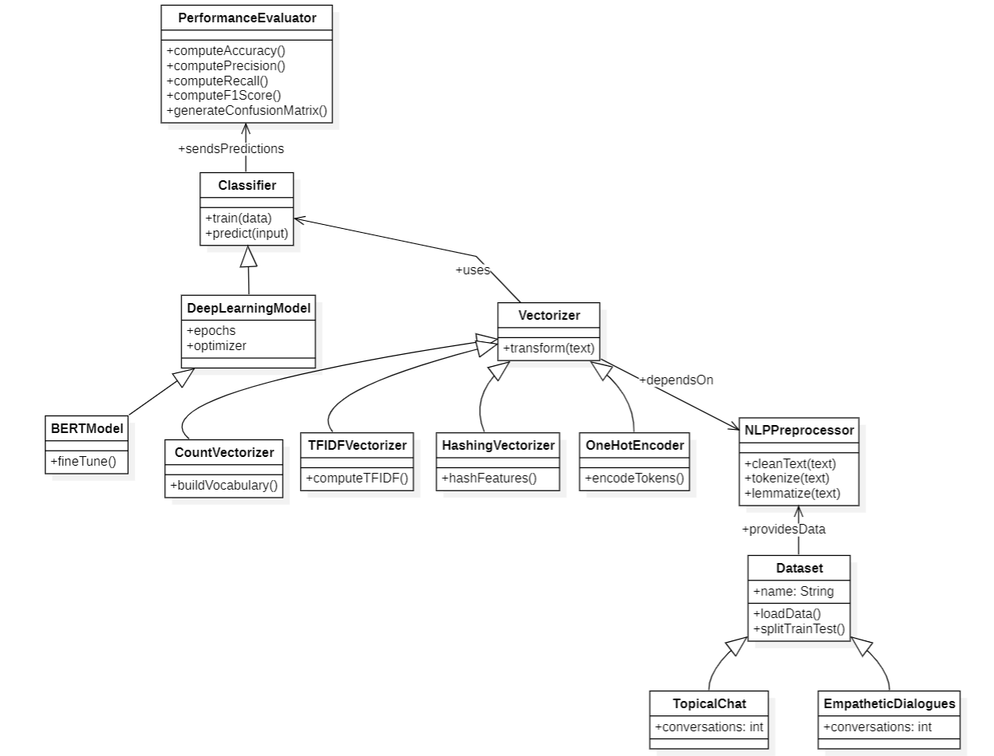
4.1(a). Class Diagram

2. Object Diagram
The object diagram represents instances of classes at a particular point in time during the execution of the chatbot system. While the class diagram defines the general structure of the system, the object diagram demonstrates how specific objects interact during runtime.
In the Emotion-Aware Conversational Chatbot, objects such as UserMessage, EmotionResult, ChatThreadInstance, and AssistantResponse are created when a user sends a message through the chat interface. The emotion detection object analyzes the user input and generates an emotion classification result. The chat service object then processes the message and interacts with the large language model to generate an appropriate response.
The object diagram provides a snapshot of how the chatbot processes messages during an active conversation and how different objects collaborate to produce the final output. 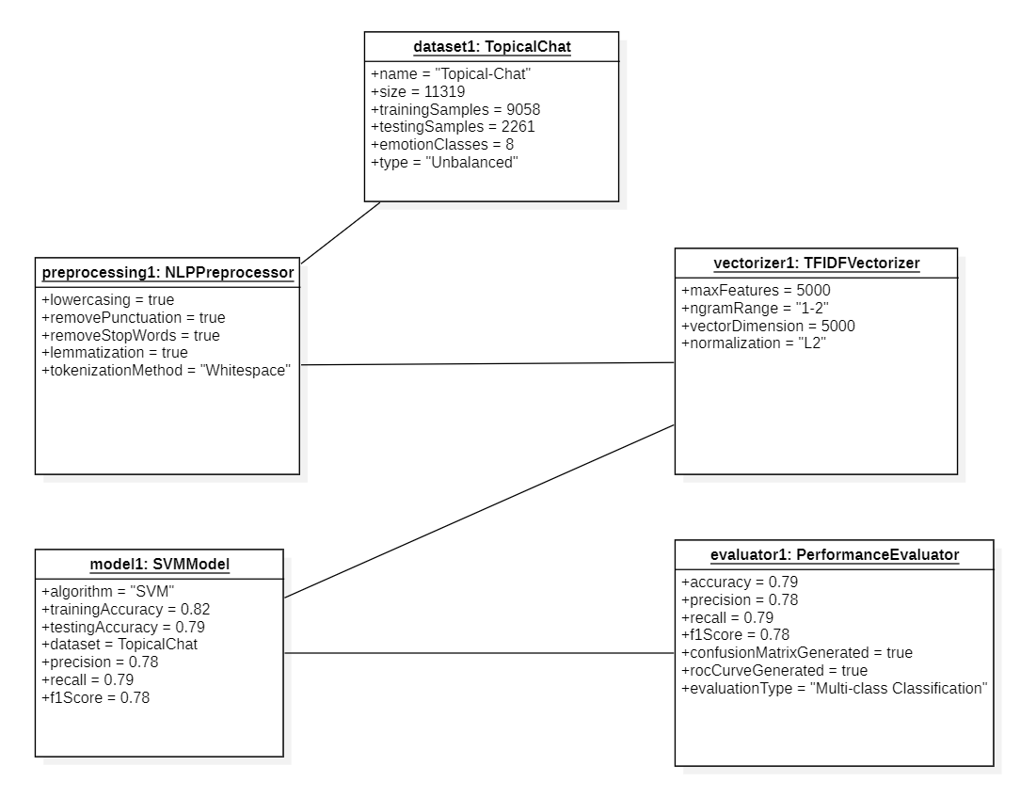
4.1(b). Object Diagram

3. Use Case Diagram
The use case diagram illustrates the interaction between the user and the chatbot system. It identifies the actors involved in the system and the functionalities available to them.
In the Emotion-Aware Conversational Chatbot, the primary actor is the User, who interacts with the chatbot through the web interface. The user can perform actions such as sending messages, viewing chatbot responses, starting a new conversation, and managing chat history. Another actor involved in the system is the System Administrator, who manages the deployment and maintenance of the application.

The use case diagram shows how the user interacts with the chatbot to initiate conversations, receive emotionally adaptive responses, and manage chat sessions. This diagram helps define the functional requirements of the system and provides a high-level overview of system interactions.
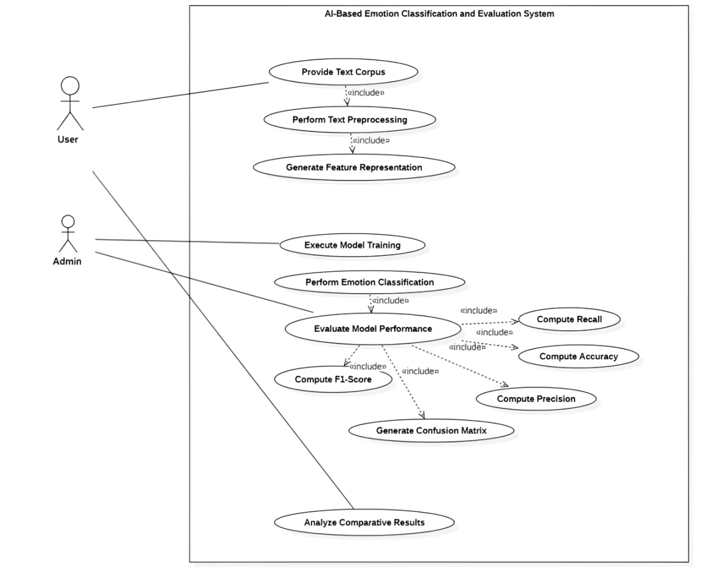
4.1(c). Use Case Diagram

4. Sequence Diagram
The sequence diagram represents the chronological order of interactions between different components of the chatbot system during message processing.
In the Emotion-Aware Conversational Chatbot, the sequence begins when the user sends a message through the frontend chat interface. The frontend sends a request to the FastAPI backend server through a REST API call. The backend then forwards the message to the emotion detection module, which analyzes the text and identifies the user’s emotional state.
After detecting the emotion, the backend retrieves the conversation history from the memory module and constructs a dynamic system prompt that includes emotional context. This prompt is sent to the large language model through the Groq API. The language model generates a response that aligns with the detected emotion and conversation context.
The generated response is returned to the backend, which stores the interaction in the conversation memory and sends the final response back to the frontend interface for display to the user.
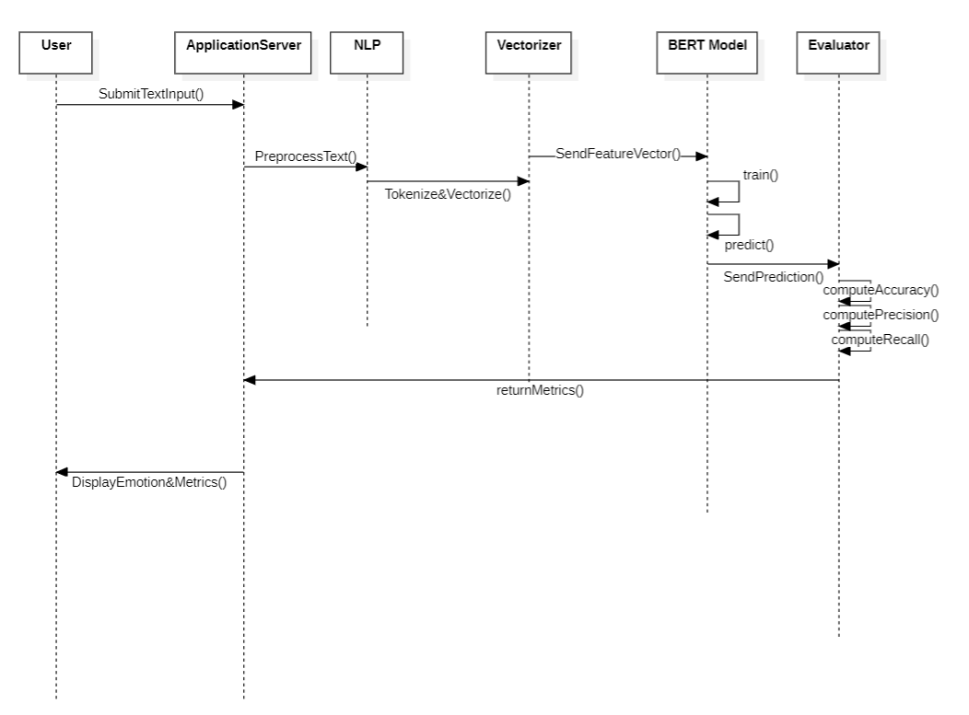
4.1(d). Sequence Diagram

5. Activity Diagram
The activity diagram represents the workflow of operations performed within the chatbot system. It describes the step-by-step process from receiving user input to generating a response.
The activity begins when the user enters a message in the chat interface. The system sends the message to the backend server, where the text is analyzed by the emotion detection model. After identifying the dominant emotion, the system retrieves the conversation history from memory and constructs an emotionally adaptive prompt.
The prompt is then sent to the large language model to generate a response. Once the response is generated, the system stores both the user message and assistant response in memory and sends the reply back to the user interface. The conversation continues until the user ends the chat session.
The activity diagram provides a clear visualization of the operational workflow of the chatbot system.

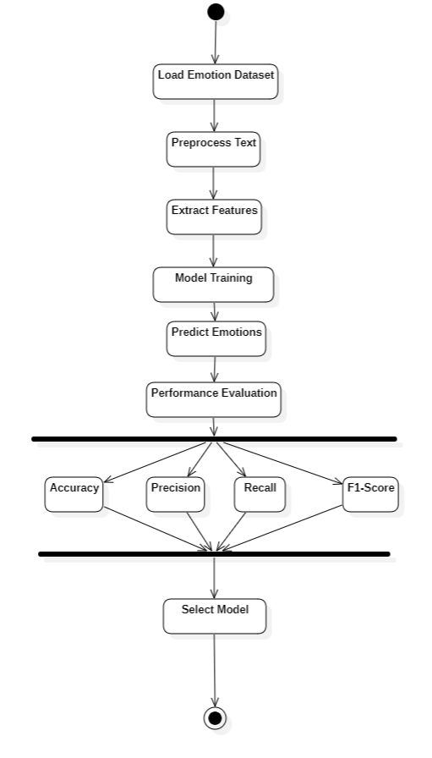
4.1(e). Activity Diagram
6. Collaboration Diagram
The collaboration diagram illustrates how different components of the chatbot system cooperate with each other to accomplish a specific task.

In the Emotion-Aware Conversational Chatbot, the collaboration diagram shows the interaction between the Frontend Interface, Backend API Server, Emotion Detection Module, Conversation Memory Module, and Large Language Model Service.

When a user sends a message, the frontend communicates with the backend through REST API calls. The backend coordinates with the emotion detection module to analyze the emotional content of the message. It then interacts with the memory module to retrieve the conversation context and communicates with the large language model to generate an appropriate response.

The collaboration diagram emphasizes the cooperative relationships between these components and illustrates how information flows between them. 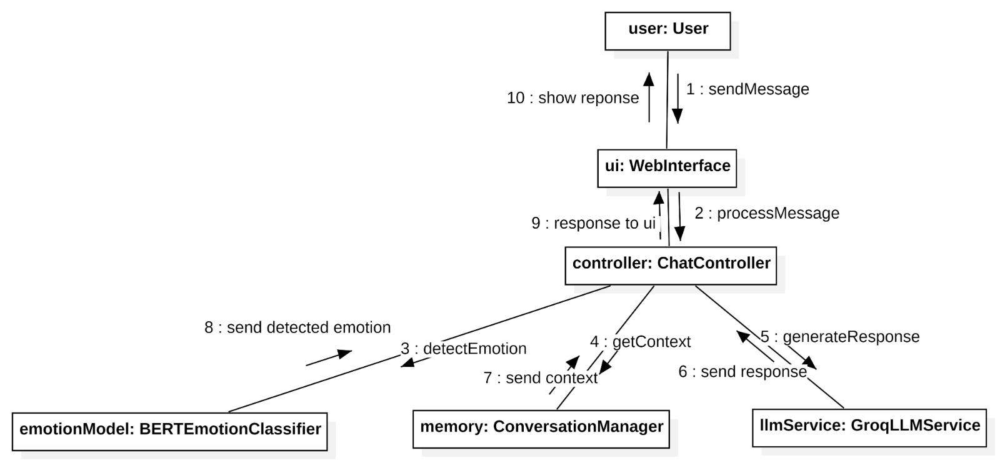
4.1(f). Collaboration Diagram
7. State Chart Diagram
The state chart diagram represents the different states that the chatbot system passes through during the conversation lifecycle.
Initially, the system remains in an Idle State, waiting for user input. When the user sends a message, the system transitions to the Message Processing State, where the message is analyzed for emotional content. The system then enters the Emotion Detection State, where the emotion classification model determines the dominant emotion.
After detecting the emotion, the system moves to the Response Generation State, where the large language model generates a context-aware and emotion-aware reply. Finally, the system transitions to the Response Display State, where the response is shown to the user in the chat interface.
This diagram helps visualize how the chatbot transitions between different operational states during a conversation.
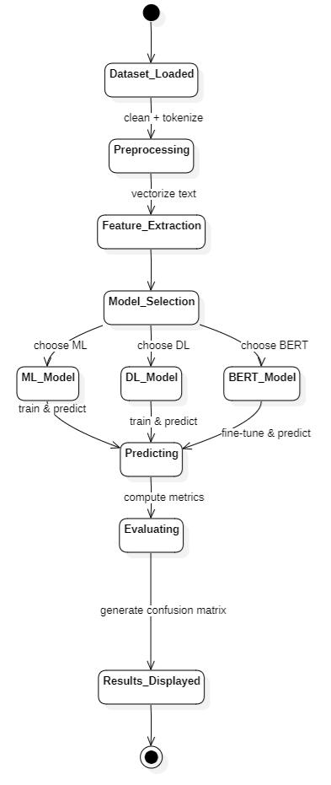
4.1(g). State Chart Diagram

8. Component Diagram
The component diagram illustrates the high-level organization of software modules within the chatbot system.
The major components include the React Frontend Interface, FastAPI Backend Server, Emotion Detection Service, Conversation Memory Service, and the Large Language Model Integration Module. The frontend component handles user interactions and displays messages in the chat interface. The backend server processes API requests and coordinates communication between system modules.
The emotion detection component analyzes user messages using a transformer-based NLP model. The memory component stores conversation history and manages chat sessions. The large language model component generates responses using the Groq API.
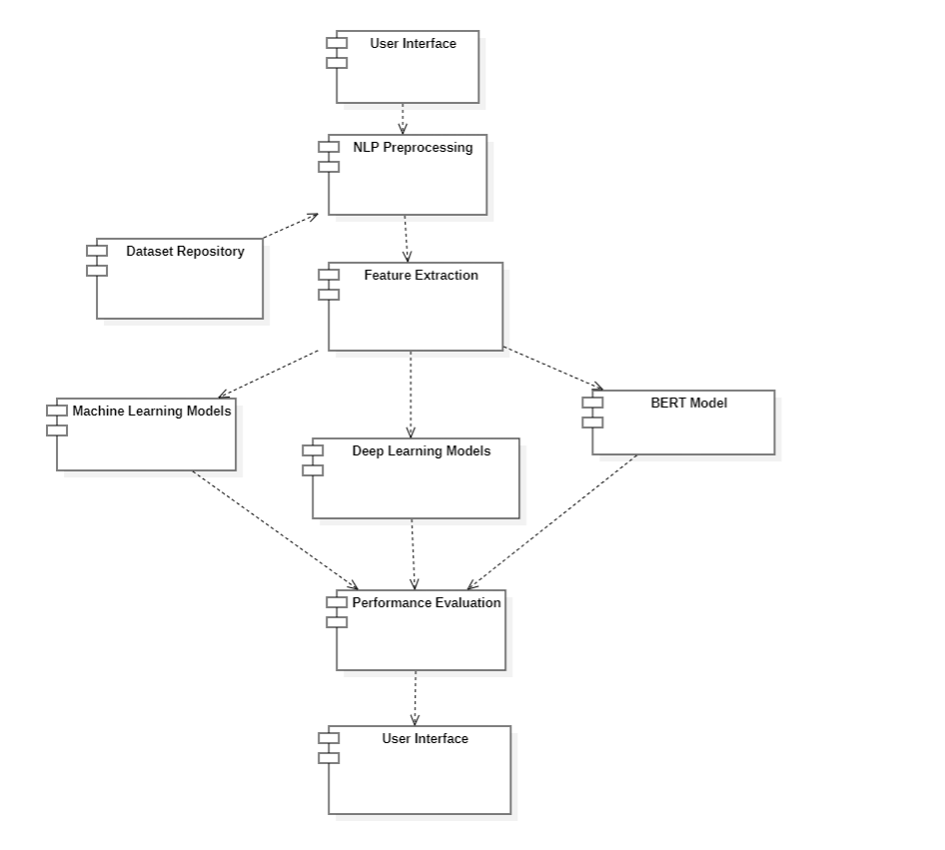 4.1(h). Component Diagram

9. Deployment Diagram
The deployment diagram represents the physical architecture of the Emotion-Aware Conversational Chatbot system and shows how software components are deployed across hardware environments.

In this system, the React frontend application runs in the user’s web browser on the client device. The FastAPI backend server runs on an application server that handles API requests and manages the chatbot services. The emotion detection model and conversation memory service operate within the backend environment.
The backend communicates with the Groq cloud service, which hosts the large language model responsible for generating chatbot responses. All components interact through network communication, enabling real-time conversational interaction between the user and the chatbot.

The deployment diagram helps visualize how the system components are distributed across hardware resources and how they interact in a real-world environment..
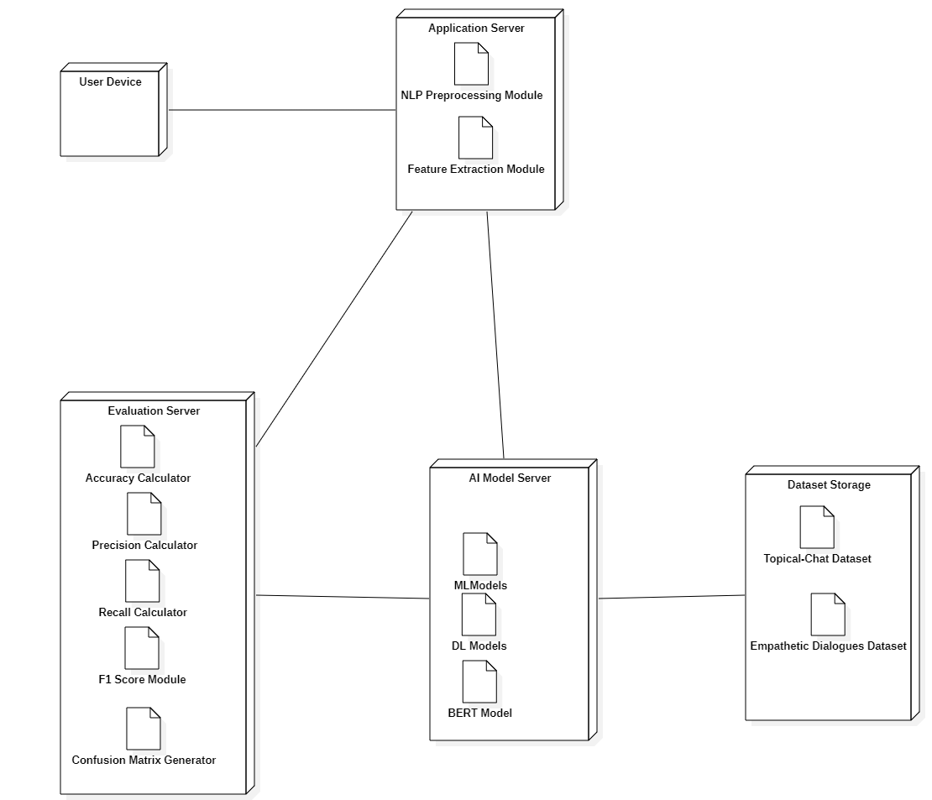
4.1(i). Deployment Diagram

5. IMPLEMENTATION

The implementation phase focuses on converting the system design and proposed architecture into a functional application. During this phase, the conceptual model of the Emotion-Aware Conversational Chatbot is transformed into a working system that integrates emotion detection, conversational reasoning, and a web-based interface. The implementation process involves multiple stages including system architecture development, user interface design, backend API development, emotion detection model integration, and system testing.
The proposed chatbot system is implemented as a full-stack web application consisting of a React-based frontend interface and a FastAPI-based backend server. The backend handles emotion detection, conversation memory management, and communication with a large language model through the Groq API. The frontend provides an interactive chat interface where users can communicate with the chatbot and view emotionally adaptive responses.

The integration of these components allows the system to analyze user messages, detect emotions, generate context-aware responses, and maintain conversation history in real time.

5.1. System Architecture
The system architecture of the Emotion-Aware Conversational Chatbot follows a modular design that separates the application into multiple functional layers. These layers include the frontend interface layer, backend service layer, emotion detection module, conversation memory module, and the large language model integration layer.
The frontend layer is responsible for providing the user interface through which users interact with the chatbot. It is developed using React with Vite and includes components such as the chat container, message bubbles, sidebar for chat management, and an emotion badge that displays the detected emotion for each response.
The backend service layer is implemented using the FastAPI framework. It provides REST API endpoints that allow the frontend to send user messages, retrieve chatbot responses, and manage chat sessions. The backend also coordinates the interaction between the emotion detection model, conversation memory service, and the large language model.
The emotion detection module uses a transformer-based NLP model from the HuggingFace Transformers library to analyze user messages and classify them into predefined emotional categories. The module returns both the detected emotion and a confidence score.
The conversation memory module stores the chat history for each conversation session. It maintains records of user messages, assistant responses, detected emotions, and timestamps. This memory allows the chatbot to maintain context throughout the conversation.
The response generation module communicates with a large language model using the Groq API. The backend constructs dynamic system prompts that include the detected emotion and conversation context, enabling the language model to generate responses that are both context-aware and emotionally appropriate.
The layered architecture of the system ensures a clear separation of responsibilities between different components. This separation improves system maintainability and allows developers to update individual modules without affecting other parts of the system. For example, improvements to the emotion detection model can be implemented independently without modifying the frontend interface.
Another important advantage of the modular architecture is scalability. As the number of users increases, backend services can be deployed across multiple servers or cloud environments to handle increased workloads. Similarly, the large language model service can be upgraded to more powerful models in the future without requiring major architectural changes.
The architecture also supports extensibility for additional AI features. Future versions of the system may include sentiment trend analysis, user personalization mechanisms, or integration with external knowledge sources to enhance chatbot responses.

By organizing system components into well-defined modules, the architecture ensures efficient communication between services while maintaining flexibility for future development.

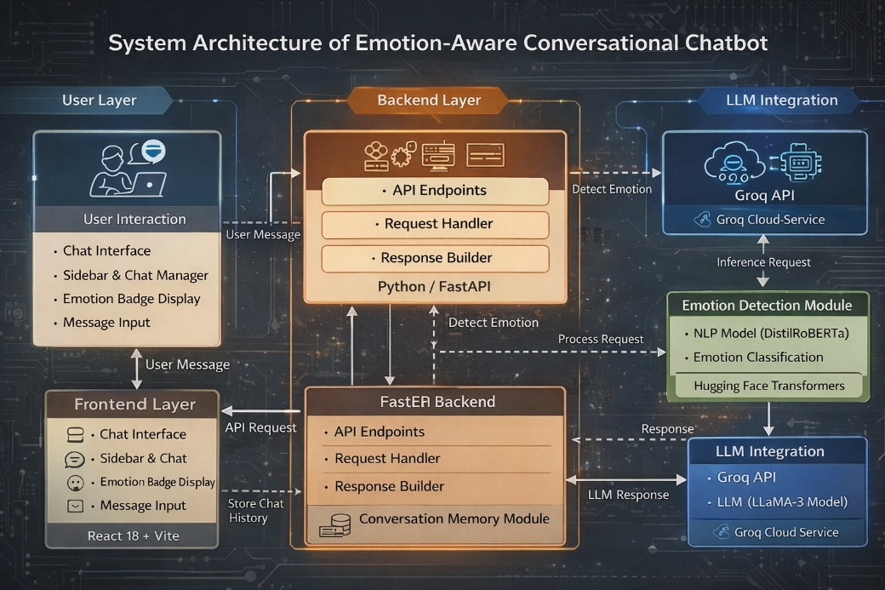
5.1(a). System Architecture

5.2. Design Phase

During the design phase, the structure and workflow of the chatbot system were carefully planned to ensure smooth interaction between system components. The design phase involved identifying the major modules of the system, defining the communication flow between modules, and selecting appropriate technologies for implementation.

The system workflow begins when the user sends a message through the chat interface. The frontend application sends the message to the backend server through a REST API request. The backend processes the message by first passing it to the emotion detection module, which identifies the emotional tone of the message.

After detecting the emotion, the system retrieves the conversation history from the memory service and constructs a dynamic prompt that includes both emotional context and previous conversation messages. This prompt is then sent to the large language model through the Groq API to generate a response.

The generated response is returned to the backend server, which stores the interaction in the conversation memory and sends the response back to the frontend interface for display. The chat interface updates the conversation thread and shows an emotion badge indicating the detected emotional state.

The design phase also focused on creating a clean and intuitive user interface that improves the overall conversational experience. The interface uses a minimalistic design with clear message alignment, smooth scrolling, and visual indicators for emotion detection.

5.3. Development Phase
The development phase involved implementing the system modules using modern programming frameworks and tools. The development process was divided into several stages including frontend development, backend development, AI model integration, and system testing.
The development environment included Python for backend development, FastAPI for API services, React with Vite for frontend development, and HuggingFace Transformers for emotion detection. The system also integrates with the Groq API to access a large language model for generating conversational responses.
Each module was developed independently and later integrated into the final system to ensure smooth interaction between all components.

5.3.1. Frontend Development

The frontend of the Emotion-Aware Conversational Chatbot was developed using React 18 with the Vite build tool. The frontend provides an interactive chat interface that allows users to communicate with the chatbot and view responses in real time.

The user interface includes several components that manage different aspects of the conversation. The ChatContainer component displays the conversation thread and automatically scrolls when new messages are added. The ChatBubble component displays individual messages with different styles for user and assistant messages. Assistant messages support Markdown formatting using the react-markdown and remark-gfm libraries.

The Sidebar component manages chat sessions and allows users to start new conversations or delete existing ones. A theme toggle feature enables switching between light and dark modes for improved usability.

Another important component is the EmotionBadge, which displays the emotion detected in the user’s message along with a confidence percentage. This visual indicator helps users understand how the system interprets their emotional state.

The frontend communicates with the backend server through HTTP requests using Axios or the Fetch API. These requests send user messages to the backend and retrieve chatbot responses.
5.3.2. Backend Development
The backend of the chatbot system was implemented using the FastAPI framework, which provides high-performance API services and asynchronous request handling. The backend server manages the core functionality of the chatbot including emotion detection, response generation, and conversation memory management.
Several API endpoints were created to support system functionality. The main endpoint handles chat interactions by receiving user messages, processing them through the emotion detection module, generating responses using the language model, and returning the final result to the frontend.
Additional endpoints allow the system to manage chat sessions, retrieve chat history, create new conversations, and delete existing chat threads.
During server initialization, the backend loads the emotion detection model from the HuggingFace Transformers library. The backend also establishes a connection with the Groq API to enable communication with the large language model responsible for generating chatbot responses.

5.3.3. AI Model Development
The emotion detection capability of the chatbot is implemented using a pre-trained transformer-based model available through the HuggingFace Transformers library. The model analyzes textual input and classifies it into one of several emotional categories.
When a user sends a message, the emotion detection service processes the text using the transformer model and returns the most probable emotion along with a confidence score. This emotional information is then used to influence the tone and style of the chatbot’s response.
For example, if the detected emotion is sadness, the system prompt instructs the language model to generate a supportive and empathetic response. If the detected emotion is anger, the system encourages calm and respectful replies aimed at reducing tension.

This emotion-guided prompting approach allows the chatbot to generate responses that feel more human-like and emotionally intelligent.
5.3.4. Dataset Description
The dataset used for emotion detection plays a crucial role in training and evaluating the performance of the chatbot’s emotion classification model. Emotion detection datasets typically consist of textual messages labeled with emotional categories. These datasets are used to train machine learning models to recognize emotional patterns in human language.
The emotion classification model used in this project is based on a pre-trained transformer model that has been trained on large-scale emotion-labeled datasets. These datasets include conversational texts, social media posts, and dialogue samples annotated with emotional labels.
The dataset used for emotion classification contains several emotion categories, including joy, sadness, anger, fear, surprise, disgust, and neutral. Each text sample in the dataset is associated with one of these emotional labels. During training, the model learns patterns in the text that correspond to specific emotional states.
Before training, the dataset undergoes several preprocessing steps to ensure consistency and quality. These preprocessing steps include text cleaning, tokenization, removal of unnecessary characters, and normalization of text. Tokenization converts sentences into smaller units called tokens, which represent individual words or subwords used by the model.
The dataset is also divided into different subsets, including training data and validation data. The training dataset is used to train the model, while the validation dataset is used to evaluate its performance and ensure that the model generalizes well to new data.
Using large and diverse emotion datasets allows the model to learn complex emotional patterns in language. As a result, the chatbot can accurately identify the emotional tone of user messages and generate appropriate responses.

5.4 API Design
The Emotion-Aware Conversational Chatbot uses a RESTful API architecture to enable communication between the frontend user interface and the backend processing services. The backend API is implemented using the FastAPI framework, which provides high performance, scalability, and asynchronous request handling.
The API design follows a modular approach where different endpoints handle specific operations related to emotion detection, conversation management, and chatbot responses. These endpoints allow the frontend application to send user messages, retrieve chatbot responses, and manage conversation sessions.
The primary endpoint of the system is the /chat endpoint, which processes user messages. When the user sends a message from the chat interface, the frontend sends an HTTP POST request to this endpoint. The backend receives the message, analyzes it using the emotion detection model, and generates a response using the large language model.
Another important endpoint is the /detect-emotion endpoint, which performs emotion classification independently of the chatbot response generation. This endpoint allows the system to analyze user text and determine the emotional state expressed in the message.
The API also includes endpoints for managing conversation sessions. For example, the /new-chat endpoint creates a new conversation thread, while the /chats endpoint retrieves existing chat sessions. The /chat/{chat_id} endpoint retrieves messages associated with a specific conversation, and the /chat/{chat_id} delete endpoint removes a conversation thread.
The use of RESTful APIs ensures efficient communication between system components and allows the chatbot system to be easily integrated with different frontend interfaces or external applications.

5.4.1. Testing and Integration
The final stage of implementation involved testing and integrating all system components to ensure proper functionality and performance. Multiple types of testing were performed during this phase.
Functional testing was conducted to verify that all system features operate correctly. This included testing chat interactions, verifying emotion detection results, checking conversation history storage, and validating the display of emotion badges in the user interface.
Integration testing ensured that the frontend interface, backend server, and external language model services communicate correctly with each other. API endpoints were tested to confirm that user messages are processed correctly and that responses are returned without errors.
Performance testing was performed to evaluate the responsiveness of the system. The chatbot demonstrated efficient response times due to the high-performance FastAPI backend and optimized communication with the Groq API.
Through successful testing and integration, the Emotion-Aware Conversational Chatbot was validated as a functional and interactive conversational platform capable of understanding user emotions and generating context-aware responses.
Code Snippets
1.Sample Code for Frontend development:
async function sendMessage() {
const messageInput =
document.getElementById("messageInput");
const userMessage = messageInput.value;
try {
const response = await fetch("http://localhost:8000/chat", {
method: "POST",
headers: {
"Content-Type": "application/json"
},
body: JSON.stringify({
message: userMessage
})
});
const data = await response.json();
document.getElementById("chatResponse").innerText = data.response;
document.getElementById("emotionLabel").innerText =
data.emotion + "(" + (data.confidence * 100).toFixed(2) + "%)";
}
catch (error)
{
console.error("Error sending message:", error);
}

Sample Code for Backend development:
from fastapi import FastAPI
from pydantic import BaseModel
from transformers import pipeline
from groq import Groq

app = FastAPI()

# Emotion detection model
emotion_classifier = pipeline(
"text-classification",
model="j-hartmann/emotion-english-distilroberta-base"
)

class ChatRequest(BaseModel):
message: str

@app.post("/chat")
def chat(request: ChatRequest):

# Detect emotion
emotion_result = emotion_classifier(request.message)[0]

emotion = emotion_result["label"]
confidence = emotion_result["score"]

# Simple response logic
response_text = f"I understand you're feeling {emotion}. How can I help you?"

return {
"response": response_text,
"emotion": emotion,
"confidence": confidence
}
Sample Code for Emotion Detection Model:
from transformers import pipeline

# Load emotion classification model
emotion_classifier = pipeline(
"text-classification",
model="j-hartmann/emotion-english-distilroberta-base"
)

def detect_emotion(text):

result = emotion_classifier(text)[0]

emotion = result["label"]
confidence = result["score"]

return emotion, confidence

# Example
emotion, confidence = detect_emotion("I feel really happy today!")
print(emotion, confidence)
Sample Code for Conversation Memory Management:
from datetime import datetime
chat_memory = {}

def add_message(chat_id, role, content, emotion=None):

if chat_id not in chat_memory:
chat_memory[chat_id] = []

chat_memory[chat_id].append({
"role": role,
"content": content,
"emotion": emotion,
"timestamp": datetime.now().isoformat()
})
def get_chat(chat_id):
return chat_memory.get(chat_id, [])

6.EXPERIMENTAL RESULTS
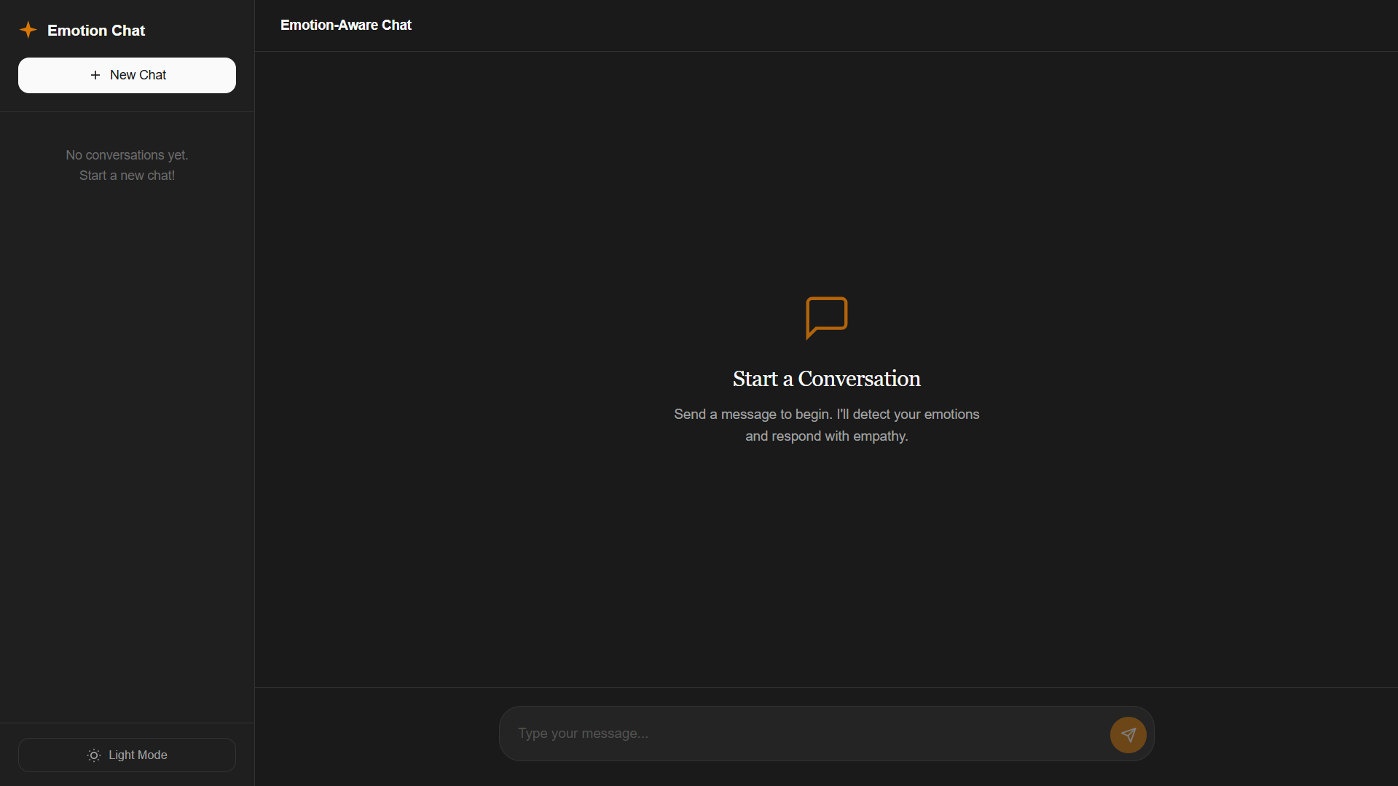
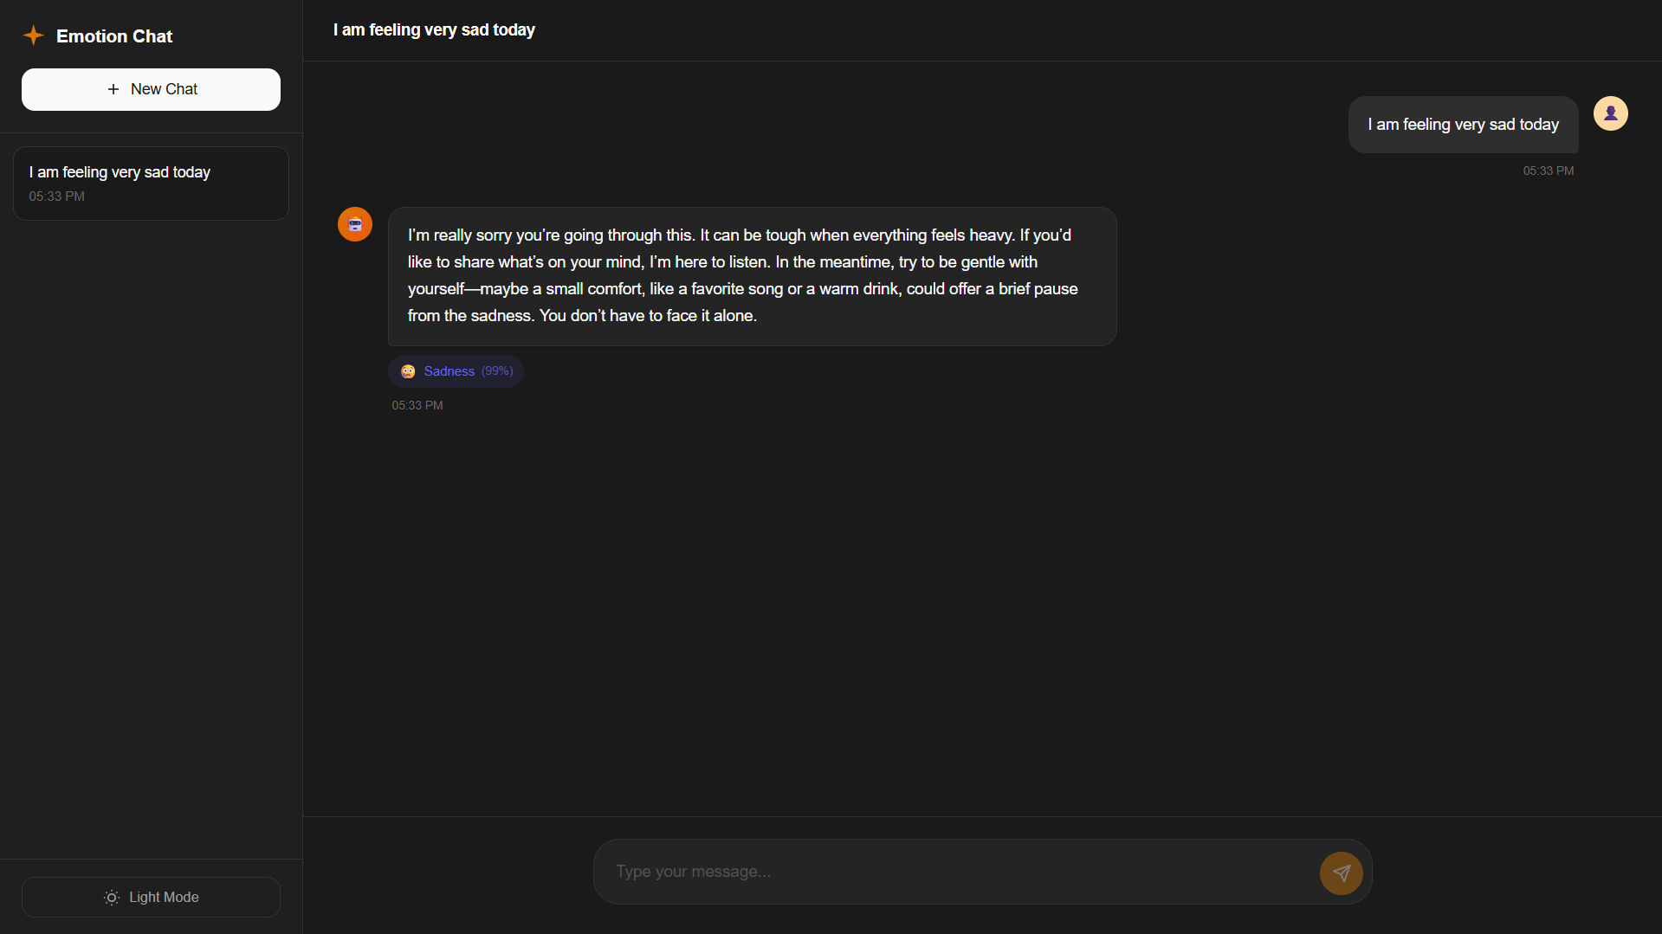

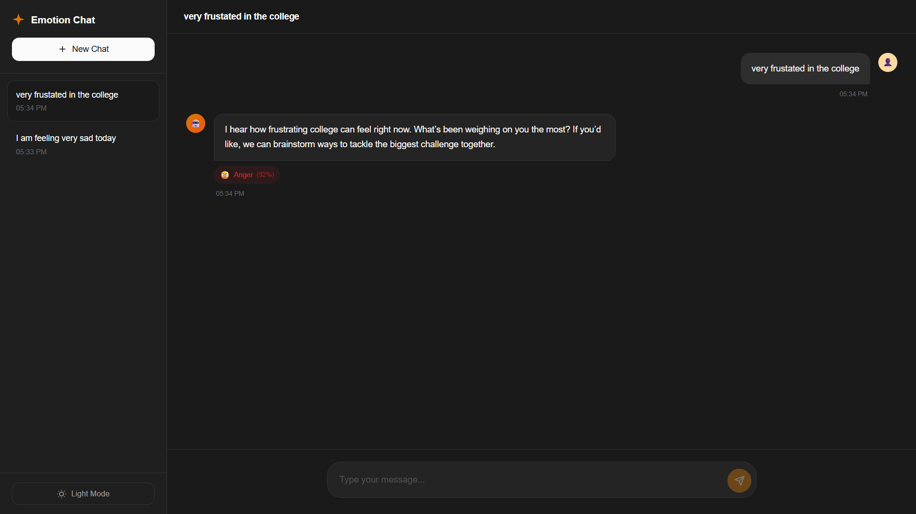
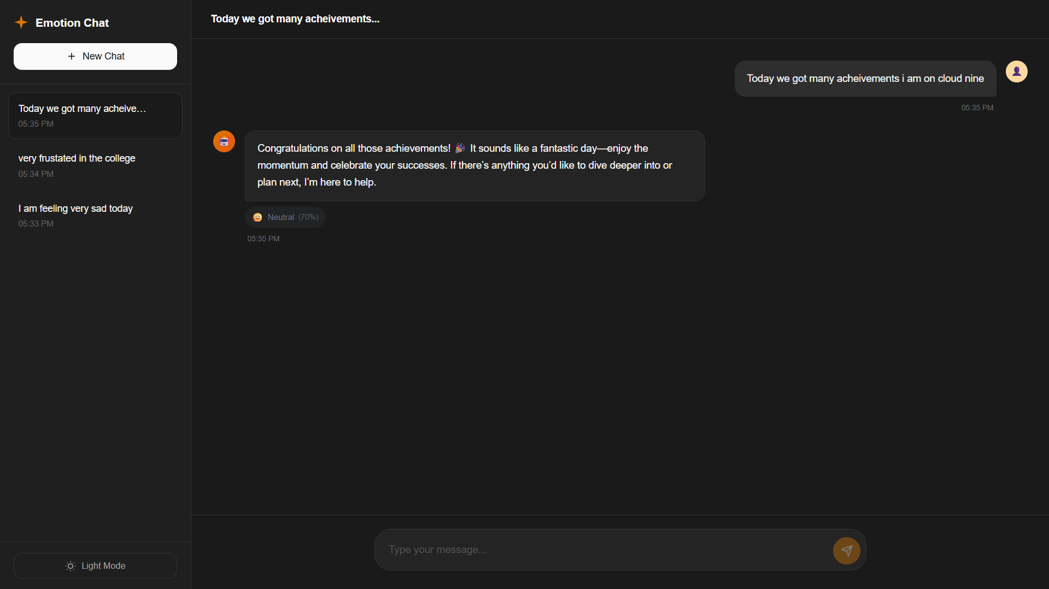

7.CONCLUSION
The Emotion-Aware Conversational Chatbot was developed to improve the quality of human–computer interaction by incorporating emotional intelligence into chatbot communication. Traditional chatbot systems often generate responses based solely on text understanding without considering the emotional context of user messages. This limitation reduces the effectiveness of conversational systems, especially when users express emotions such as sadness, frustration, or excitement.
The proposed system addresses this challenge by integrating emotion detection with conversational AI. The chatbot analyzes user messages using a transformer-based emotion classification model and identifies the emotional state expressed in the text. Based on the detected emotion, the system dynamically adjusts the response generation strategy of a large language model to produce replies that are empathetic, context-aware, and appropriate for the user’s emotional condition.
The system was implemented as a full-stack web application consisting of a React-based frontend interface and a FastAPI-based backend server. The backend performs emotion detection, manages conversation memory, and communicates with a large language model through the Groq API to generate responses. The frontend provides an interactive chat interface that allows users to communicate with the chatbot, view conversation history, and observe detected emotions through visual indicators.
Through successful integration of emotion detection, conversational memory, and advanced language models, the Emotion-Aware Conversational Chatbot demonstrates the potential of AI-driven systems to create more natural and empathetic conversational experiences. The system shows how modern natural language processing techniques can enhance chatbot interactions and improve user engagement.

8.FUTURE SCOPE
Although the Emotion-Aware Conversational Chatbot demonstrates effective emotion-aware interaction capabilities, several improvements and extensions can be implemented in future versions of the system.
One potential improvement is the integration of voice-based interaction. Currently, the chatbot supports only text-based communication. Future versions could incorporate speech recognition and speech synthesis technologies, enabling users to interact with the chatbot using voice commands and spoken responses.
Another area for improvement is multilingual support. The current implementation primarily focuses on English language input. Future development could include multilingual emotion detection models and translation systems to support conversations in multiple languages.
The system can also be enhanced by integrating a persistent database to store conversation history. Currently, the system maintains chat history in memory for demonstration purposes. A database such as PostgreSQL or MongoDB would allow conversations to be stored permanently and retrieved across sessions.
Another possible extension is the implementation of personalized chatbot responses. By analyzing previous conversations and user preferences, the chatbot could adapt its responses to provide a more personalized interaction experience.
The system could also benefit from incorporating advanced emotion analysis techniques, including multimodal emotion recognition that combines text, voice tone, and facial expressions to improve emotion detection accuracy.
Finally, the Emotion-Aware Conversational Chatbot architecture can be applied in various domains such as mental health support systems, customer service platforms, educational tutoring systems, and virtual personal assistants, where emotionally intelligent interaction plays a critical role.

9. REFERENCES
- Devlin, J., Chang, M. W., Lee, K., & Toutanova, K., “BERT: Pre-training of Deep Bidirectional Transformers for Language Understanding,” Proceedings of NAACL-HLT, 2019.
- Brown, T., Mann, B., Ryder, N., et al., “Language Models are Few-Shot Learners,” Advances in Neural Information Processing Systems, 2020.
- Zhou, L., Gao, J., Li, D., & Shum, H. Y., “The Design and Implementation of XiaoIce, an Empathetic Social Chatbot,” Computational Linguistics, 2020.
- Poria, S., Cambria, E., Hazarika, D., & Vij, P., “Context-Dependent Sentiment Analysis in User-Generated Videos,” Proceedings of ACL, 2017.
- Hazarika, D., Poria, S., Mihalcea, R., Cambria, E., & Zimmermann, R., “ICON: Interactive Conversational Memory Network for Multimodal Emotion Detection,” Proceedings of EMNLP, 2018.
- Vaswani, A., et al., “Attention Is All You Need,” Advances in Neural Information Processing Systems, 2017.
- Wolf, T., Debut, L., Sanh, V., et al., “Transformers: State-of-the-Art Natural Language Processing,” Proceedings of EMNLP, 2020.
- HuggingFace, “Transformers: State-of-the-Art Machine Learning for NLP,” HuggingFace Documentation.
- Groq Inc., “Groq API Documentation for LLM Integration.”

