Dash board Over View:

Date | 5 Feb 2026
Team ID | LTVIP2026TMIDS24922
Project Name | Toycraft Tales: Tableau's Vision into Toy Manufacturer Data
Marks | 2 Marks

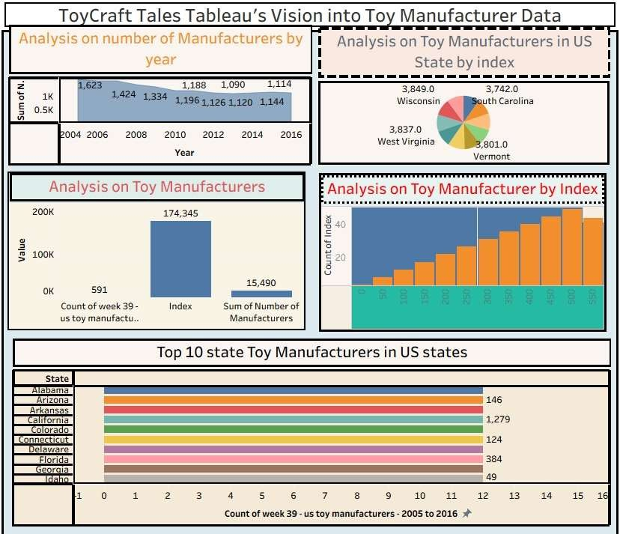
Link:
https://public.tableau.com/views/ToyCraftTales_17509161245270/ToyCraftTalesTableausVisionintoToyMan ufacturerData?:embed=y&:display_count=yes

