Project Design Phase-II
Technology Stack (Architecture & Stack)

Date | 1 Feb 2026
Team ID | LTVIP2026TMIDS24922
Project Name | Toycraft Tales: Tableau's Vision into Toy Manufacturer Data
Marks | 3 Marks

Technical Architecture:
The Deliverable shall include the architectural diagram as below and the information as per the table1 & table2

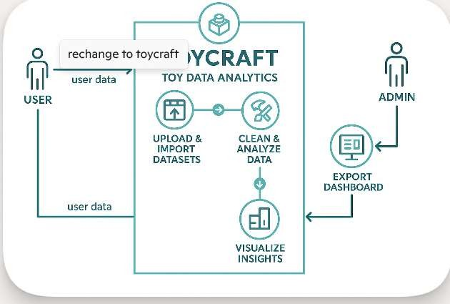
Guidelines:
Include all the processes (As an application logic / Technology Block)
Provide infrastructural demarcation (Local / Cloud) Indicate external interfaces (third party API’s etc.) Indicate Data Storage components / services Indicate interface to machine learning models (if applicable)

Table-1: Components & Technologies:

S.No | Component | Description | Technology
1. | User Interface | Interface to visualize Toy data insights (dashboards, graphs) | Tableau Public, HTML, CSS
2. | Data Preparation Logic | Scripts used to clean, filter, and prepare data for analysis | Python (Pandas, NumPy)
3. | Data Analysis Logic | Logic to compute KPIs and summaries (e.g., avg speed, efficiency) | Tableau Calculated Fields, Excel
4. | Data Source | Datasets used for Toy analysis . | CSV Files, Excel Sheets
5. | Database (optional) | Store dataset backups or Tableau extracts. | MySQL / SQLite (optional)
6. | Cloud Storage (optional) | Local storage for dashboards, data files, screenshots | Google Drive, IBM Cloud Object Storage
7. | File Storage | Local storage for dashboards, data files, screenshots | Local Filesystem
8. | External API-1 | Weather data for charging decision insights (optional) | OpenWeatherMap API / IBM Weather API
9. | External API-2 | EV Station Location / Map data (optional) | Google Maps API / NREL API
10. | Infrastructure | Platform used for development and visualization | Local System, Tableau Public Cloud

Table-2: Application Characteristics:

S.No | Characteristics | Description | Technology
1. | Open-Source Frameworks | Frameworks and tools used for data cleaning and visualization | Python (Pandas, NumPy), Tableau Public, Jupyter Notebook
2. | Security Implementations | Dataset stored and shared securely; minimal exposure to sensitive data | File-level protection, Google Drive Access Control, No login data used
3. | Scalable Architecture | Project can scale by integrating more datasets, APIs, or deploying via cloud BI tools | Tableau Public (scalable dashboard), Cloud-based deployment (optional)
4. | Availability | Tableau Public Cloud,Google Drive download offline | Tableau Public Cloud, Google Drive, Local System
5. | Performance | Lightweight dashboards with optimized data sources; performs well on local/cloud | CSV Optimization, Filtered Data in Tableau, Extract Mode

