HW4 Graph Queries

Query1:

g = TinkerGraph.open().traversal()

g.addV("course").property(id, "CS101").as("CS101")
.addV("course").property(id, "CS201").as("CS201")
.addV("course").property(id, "CS220").as("CS220")
.addV("course").property(id, "CS420").as("CS420")
.addV("course").property(id, "CS334").as("CS334")
.addV("course").property(id, "CS681").as("CS681")
.addV("course").property(id, "CS400").as("CS400")
.addV("course").property(id, "CS526").as("CS526")
.addE("prereq").from(g.V("CS201")).to(g.V("CS101")).property(id, "p1")
.addE("prereq").from(g.V("CS220")).to(g.V("CS201")).property(id, "p2")
.addE("prereq").from(g.V("CS420")).to(g.V("CS220")).property(id, "p3")
.addE("coreq").from(g.V("CS420")).to(g.V("CS220")).property(id, "c1")
.addE("prereq").from(g.V("CS334")).to(g.V("CS201")).property(id, "p4")
.addE("prereq").from(g.V("CS681")).to(g.V("CS334")).property(id, "p5")
.addE("prereq").from(g.V("CS400")).to(g.V("CS334")).property(id, "p6")
.addE("prereq").from(g.V("CS526")).to(g.V("CS400")).property(id, "p7")
.addE("coreq").from(g.V("CS526")).to(g.V("CS400")).property(id, "c2")

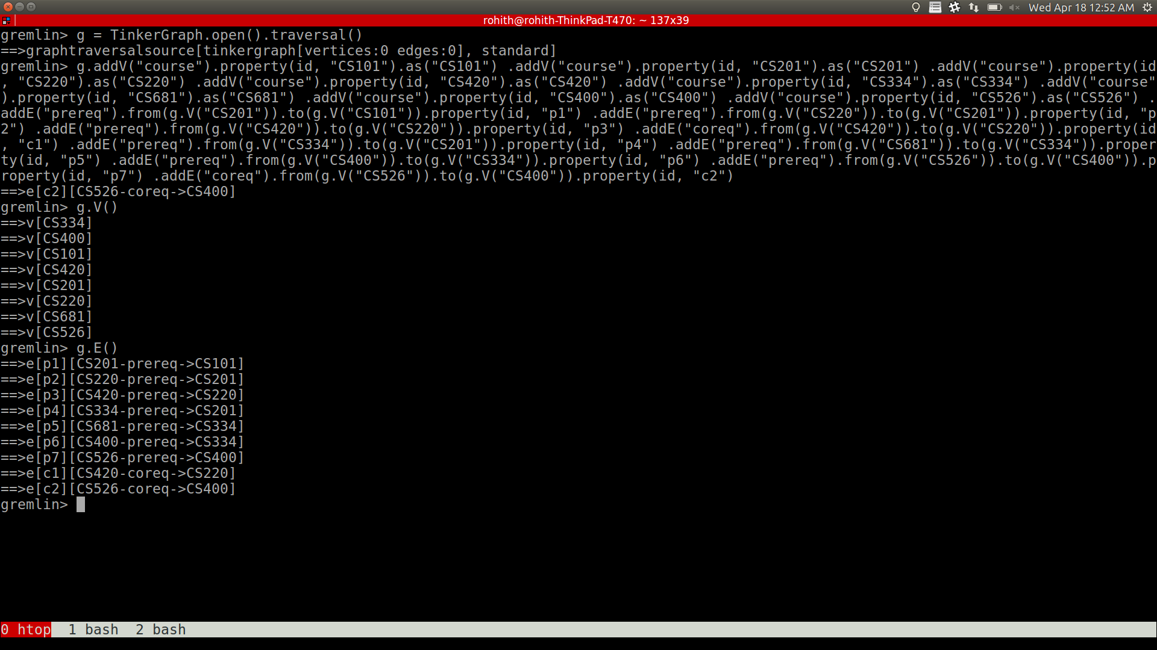

Explanation:

We initialize an in-memory tinker graph using “TinkerGraph.open()”, then we start a traversal pipeline using “TinkerGraph.open().traversal()”. We then add all the vertexes using “addV()” function, which takes name or type of the vertex as input. We can then set properties of the vertexes using “property” function, a create alias using “as” function. We then add edges using “addE()” function, which takes the type of edge as input, and set the edge from vertex v1 to v2 using the function “from()” and “to()”, we then set the property of the edge using “property()” function.

For all the queries below, “g” refers to traversal object initialized in this step

Query2:

query:

g.V().as("start").out().as("end").select("start","end").groupCount().unfold()
.filter(select(values).is(gt(1))).select(keys)

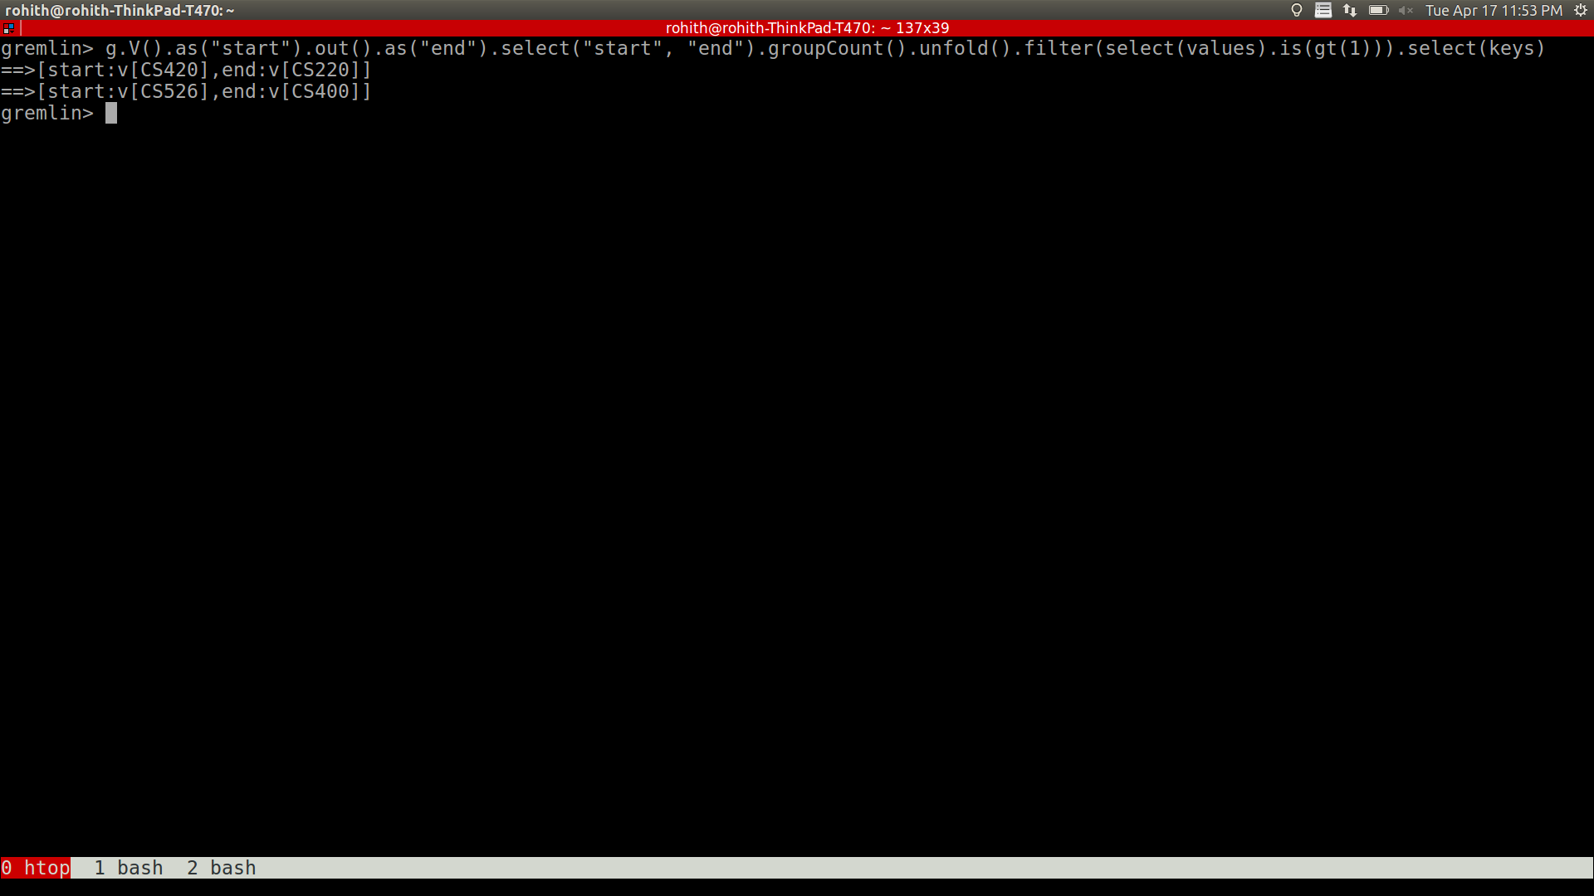

Explanation:

We take each edge as a tuple of vertexes (v1, v2), representing the edge from vertex v1 to vertex v2.
We then group by on the pairs of tuples, and filter the pairs whose count is greater than 1. This will contain the vertexes which are double connected.

Initially, we label each vertex as “start” using the function “as()”, now we compute new vertexes that have an edge from “start” vertex using the function “out”, we call them as “end”. We now select pairs of start and end vertexes, which actually represents edges as a tuple of vertexes, using the function “select()”. We then groupby on these pairs and get the count using “groupCount()” function, which basically computes the number of time an edge between a pair of vertexes has appeared, we flatten the data structure (flatmap) in order to apply filtering functions using “unfold” which is very similar to flatmap. We then filter the pairs, by iterating over each entity which is a tuple of vertexes and the count (the number of edges between them) using “filter()” function, with is(gt(1)) function, we get all the pairs which have doubly connected edges, finally we just output the keys (the tuple of vertexes) to stdout. These pairs contain two vertexes, which are double connected by edges.

Query3:

query:

g.V("CS526").repeat(out()).emit().dedup()

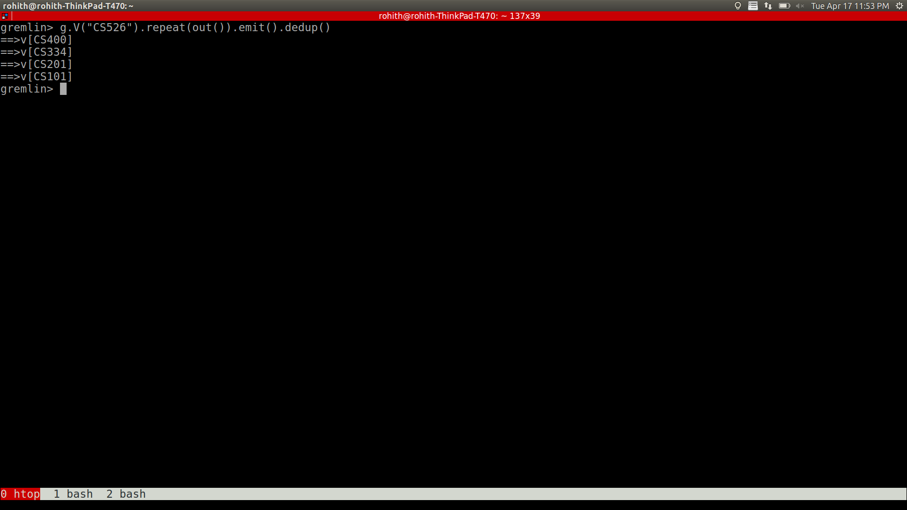
Explanation:

Starting from the vertex with id “CS526”, repeatedly compute the out edge vertexes, and emit them at each step. repeat and emit will act as while loop, which continuously computes the vertexes that are ancestors to the root node. In each loop, emit gets all the vertexes that are connected to vertexes from the previous loop, and repeat(out()) function computes the vertexes that are connected by an out edge from the vertexes from the current loop. Finally, there could be multiple times a vertex might appear due to multiple incoming edges, we remove duplicates using the dedup function.

Query 4:

g.V("CS101").emit().repeat(__.in()).path().count(local).max()

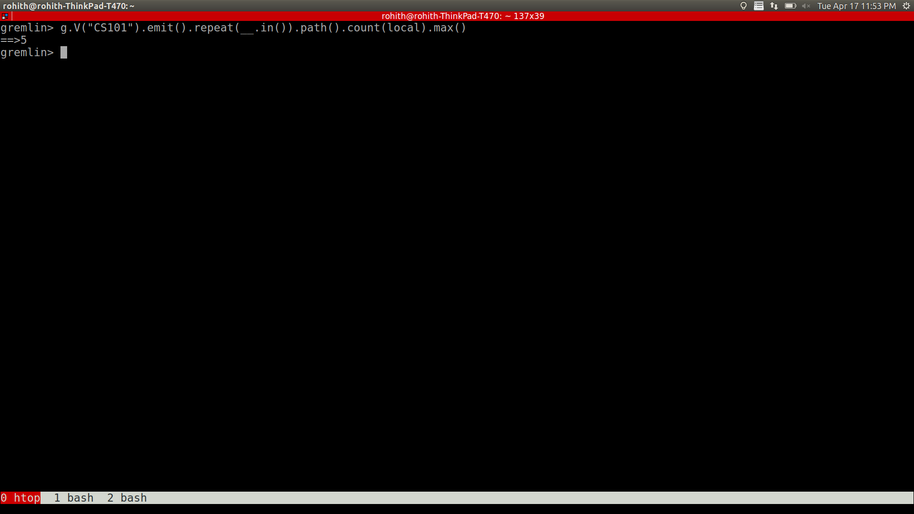
Explanation:

To get the longest sequence of courses that can be completed, we have to follow the link of incoming edges. We start out with finding the start node, in the above query it is “CS101”, now we go up the connections, following the incoming nodes. We can achieve this using emit and repeat loop similar to query3. We emit the vertexes at each step, we then compute the vertexes, which are the start nodes of the incoming edges to vertexes at this step, we repeat this until we reach the end. We get the path of our traversal using “path()” function. Now we have all paths, following up the incoming edges from the start node, we the compute the length of each path, we achieve this using “count(local)” function. Count function actually counts the size of a data structure, local function helps to compute for each entry of the traversal, which is it computes the length of each path in the entire traversal object. Finally, we take the max length of all the paths and return that number as the maximum number of courses that can be taken after having completed the prerequisite courses.

BONUS QUESTION

Q1, Q2, Q3, and Q4 are already expressed as single queries above.

