

S. B. JAIN INSTITUTE OF TECHNOLOGY, MANAGEMENT & RESEARCH, NAGPUR.
Session-2025-26 (Even)
TAE-I Project Based Learning

AI-Based Network Fault Prediction using Bayesian Networks
Submitted By
Rohit R Ubale(JAIN)-(CS23162)

AI Technique(s)  (2) | Problem  Representation  (4) | Tools Explored  (2) | Outcome  (2) | Total (10)
Sign of Student: |  |  | Sign of course  In-charge :

- Industry Problem Context
In modern IT infrastructure, network reliability is extremely important for maintaining digital services such as:
- Cloud computing platforms
- Web applications and online services
- Data center communication systems
- Enterprise networks
- Telecommunication systems
Network failures can lead to serious problems such as service downtime, slow network performance, loss of data packets, and financial losses. Traditional monitoring systems detect network faults only after they occur. However, modern AI-based systems focus on predicting faults before they happen so preventive actions can be taken. This project focuses on predicting possible network failures by analyzing important network parameters: CPU Usage, Latency, Packet Loss, and Bandwidth. Using these parameters, the system calculates the probability of network failure and provides useful insights for administrators.

2. Feasibility in IT Systems
In real-world IT systems, network monitoring tools continuously collect operational data from devices such as routers, switches, servers, and cloud infrastructure. These tools monitor several important metrics including:
- CPU utilization of network devices
- Network latency
- Packet loss rate
- Available bandwidth
This data can be analyzed using AI models to detect patterns that indicate possible system failures. Bayesian probabilistic models are particularly useful because they can work effectively with uncertain or incomplete information, which is very common in real-world network environments.

3. AI Techniques Used in Industry
This project uses a Bayesian Network, which is a probabilistic graphical model used to represent relationships between different variables. Bayesian Networks are commonly used in fault diagnosis systems, risk prediction systems, decision support systems, and network reliability analysis.
The model calculates the probability of a network fault based on the observed network parameters. Example knowledge rules used in the system include:
- IF CPU Usage is High AND Latency is High → Network Congestion Risk
- IF Packet Loss = 1 → Network Fault Likely
- IF Bandwidth is Low AND CPU Usage is High → Performance Issue
- IF Latency is High AND Packet Loss = 1 → High Fault Probability

4. Representation / Modeling in Industry Systems
The network monitoring problem is modeled using a probabilistic dependency graph. The main variables (nodes) used in the model are: CPU Usage, Latency, Packet Loss, Bandwidth, and Network Fault. Each parameter influences the probability of a network failure as shown below:
- CPU Usage → Network Fault
- Latency → Network Fault
- Packet Loss → Network Fault
- Bandwidth → Network Fault
This structure allows the system to perform probabilistic inference to determine the likelihood of network faults.

5. Tools & Technologies Used
The project was developed using the following technologies:
- Programming Language: Python
- AI / ML Library: pgmpy – used for building Bayesian Network models
- Web Framework: Flask – used to create the web-based dashboard
- Frontend: HTML (page structure) and CSS (styling and layout)
- Data Handling: Pandas – used for dataset handling and preprocessing
The system includes dashboard visualization components such as probability progress bars, gauge meters, circular health indicators, network health score panels, and an AI expert system explanation panel to help administrators easily understand network conditions.

6. Industry-Level Outcome
The system provides the following useful outputs:
- Probability of network fault occurrence
- Network health score
- AI-based inference result
- Suggested actions for administrators
Benefits of the system include: early detection of network problems, reduced downtime, improved network reliability, and better decision-making for network engineers. The dashboard provides a visual monitoring interface similar to real-world network monitoring systems used in industry.

7. Real-World Industry Applications
AI-based network fault prediction systems are widely used in several industries:
- Cloud Service Providers: Companies such as Amazon AWS, Google Cloud, and Microsoft Azure use predictive monitoring systems to prevent service outages.
- Internet Service Providers (ISPs): ISPs monitor network conditions to maintain stable internet connectivity.
- Data Centers: AI systems help detect server and network issues before they cause major failures.
- Enterprise IT Systems: Large organizations use predictive monitoring tools to maintain stable internal networks.
- Telecommunication Networks: Telecom companies use AI-based fault prediction systems to maintain communication infrastructure.

8. Implementation & Result
The AI-Based Network Fault Prediction System was implemented using Python with the pgmpy library for constructing the Bayesian Network model. The system takes real-time network parameter inputs – CPU Usage, Latency, Packet Loss, and Bandwidth – and performs probabilistic inference to determine the likelihood of a network fault.
A Flask-based web dashboard was developed to provide a visual monitoring interface. The dashboard displays a probability progress bar showing fault likelihood, a gauge meter for real-time health assessment, a circular health indicator, a network health score panel, and an AI expert system explanation panel. The system successfully predicts fault probability and provides administrators with actionable insights and suggested remediation steps.
The Bayesian Network model demonstrated that combining multiple network parameters provides a more accurate prediction of network faults than analyzing each parameter individually. The dashboard interface closely resembles real-world network monitoring systems used in industry, validating the practical applicability of this approach.

9. References
- pgmpy Documentation: https://pgmpy.org/
- Flask Web Framework Documentation: https://flask.palletsprojects.com/
- Russell, S. & Norvig, P. (2020). Artificial Intelligence: A Modern Approach (4th ed.). Pearson.
- Pandas Documentation: https://pandas.pydata.org/

10.Screenshots:
1: An AI-based system that predicts network faults using parameters like CPU usage, latency, packet loss, and bandwidth through a Bayesian model.
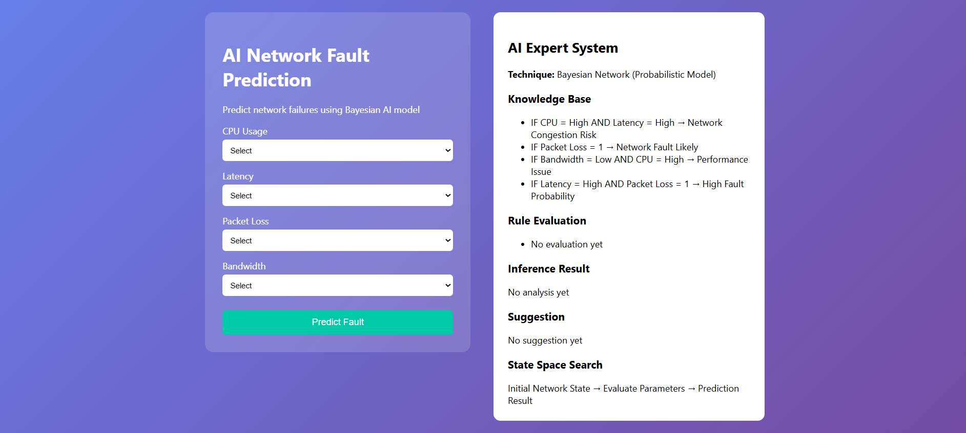
2: An AI expert system that analyzes network parameters using a Bayesian model to predict possible faults and performance issues.
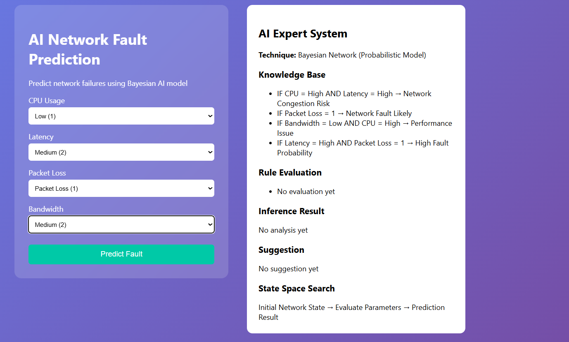
3: An AI-based expert system that evaluates network conditions and predicts faults while providing real-time status and suggestions.
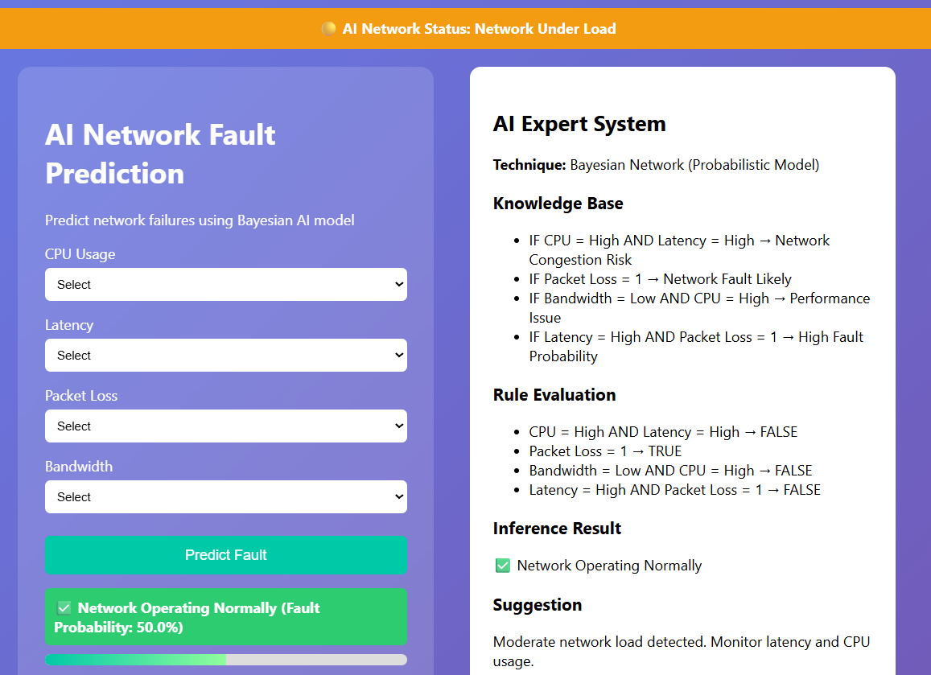
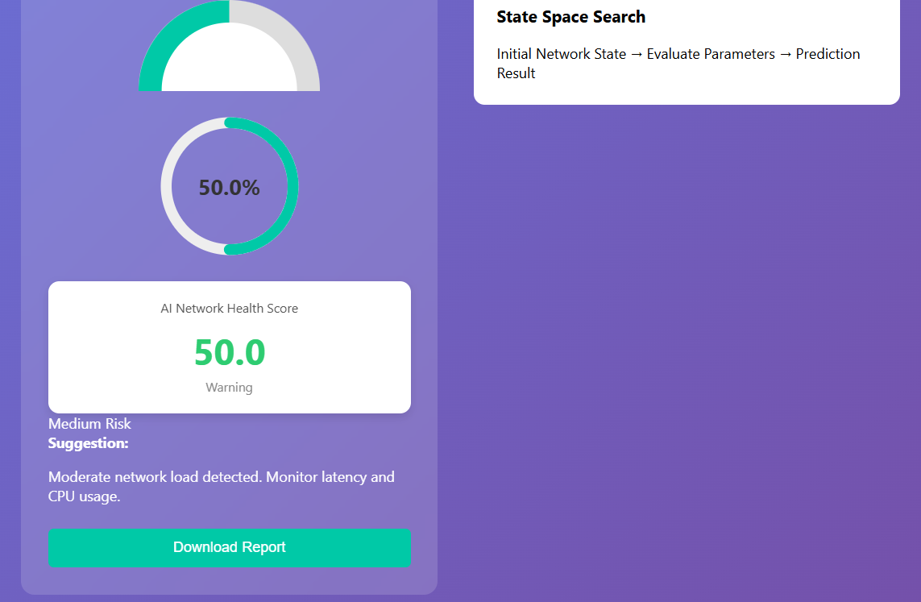
4: A summarized AI-generated report showing network status, fault probability, risk level, and recommendations based on analyzed parameters.

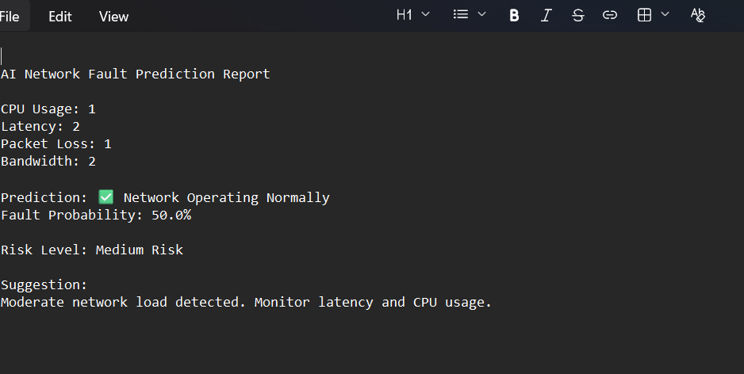
5: A Bayesian network diagram showing how CPU, latency, packet loss, and bandwidth influence the prediction of network faults.

